**Lab Assignment 2**

# IT20281564

M.T Sanju

Docker App Build

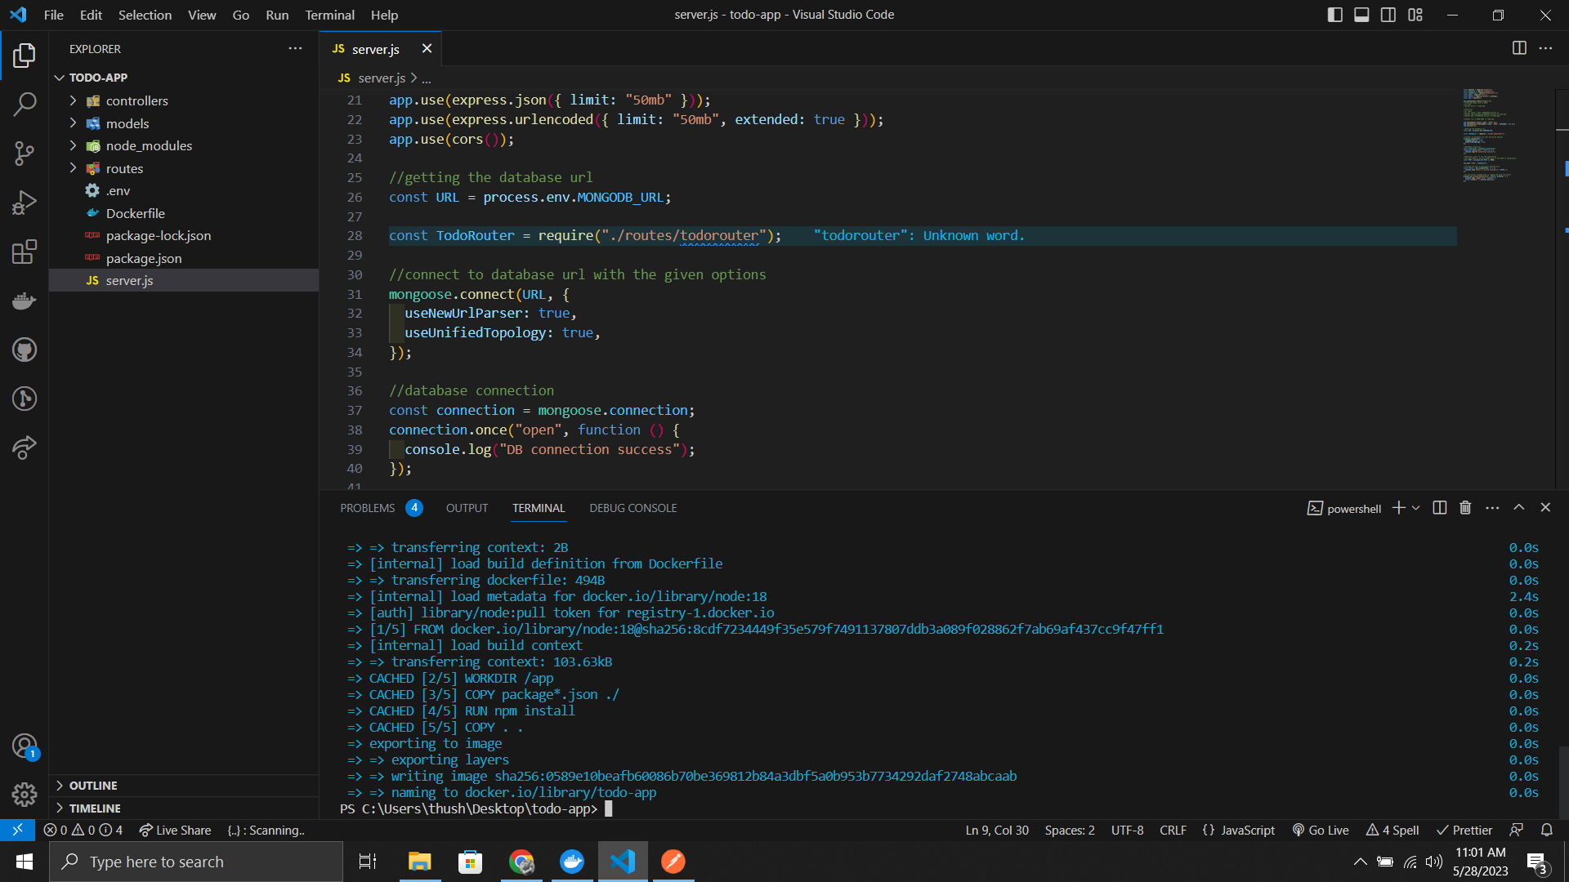

Create Container Registry

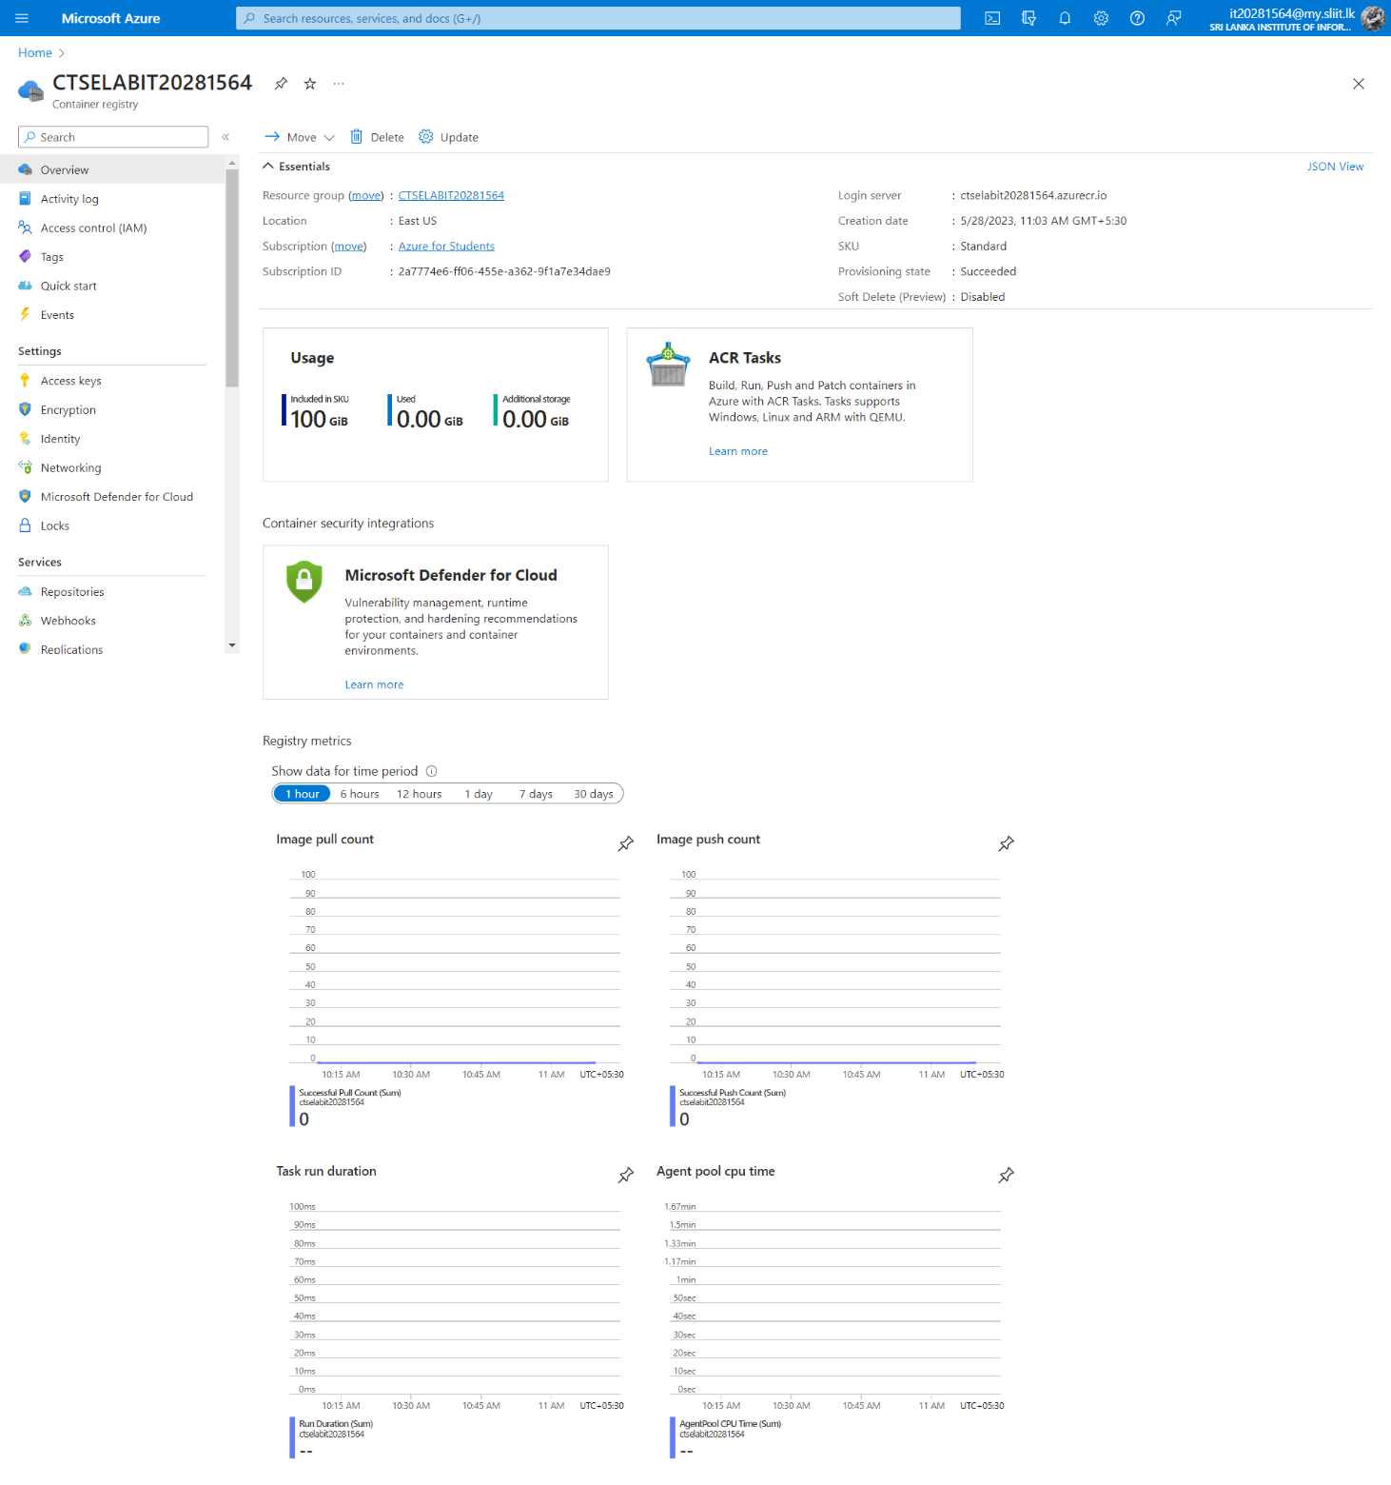

Deployment is completed.

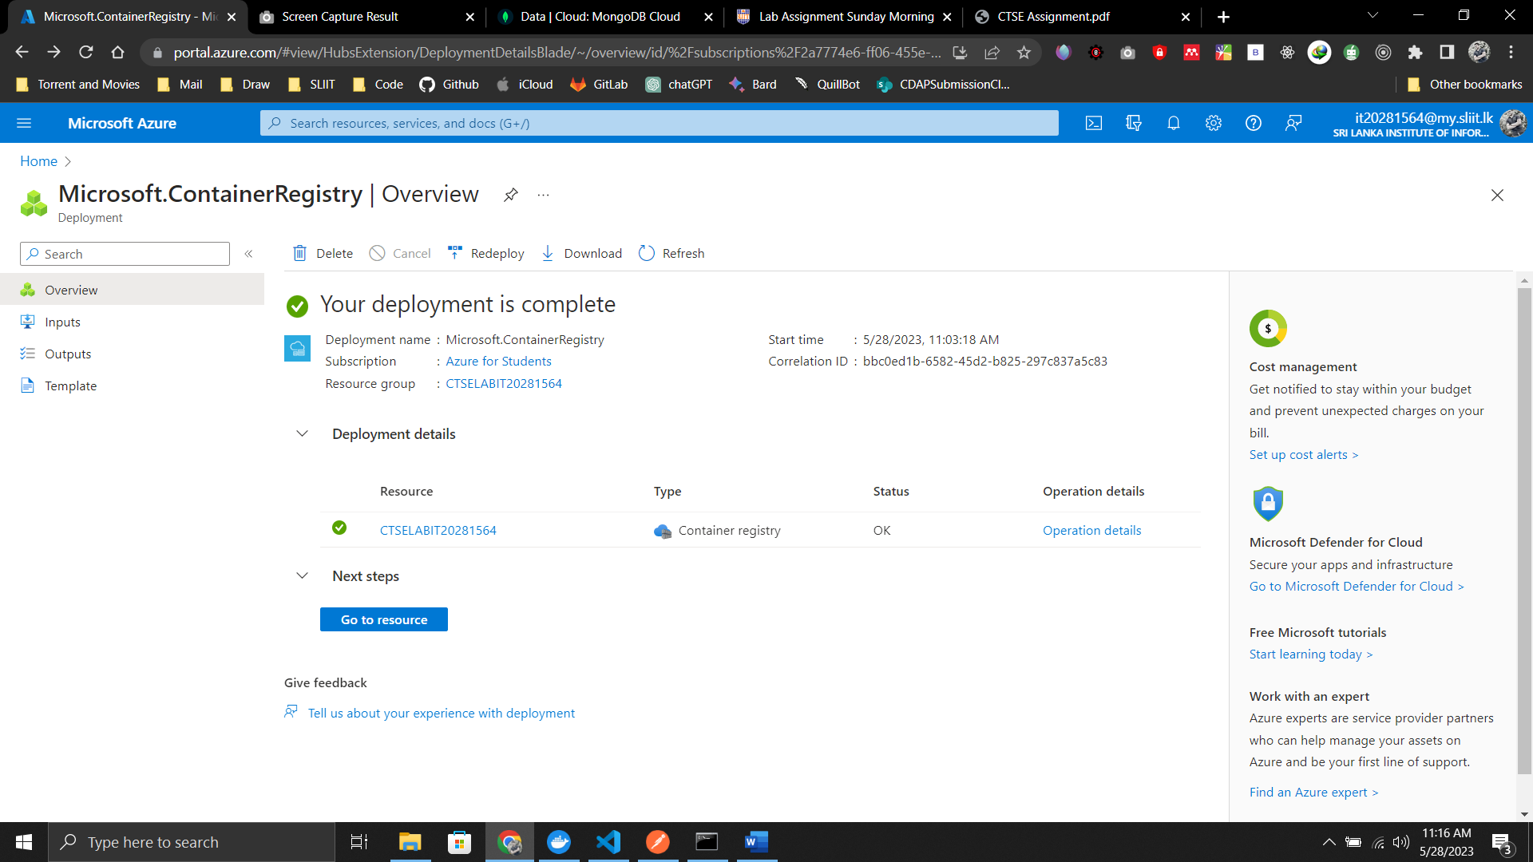

Overview

Azure CLI Login, push,

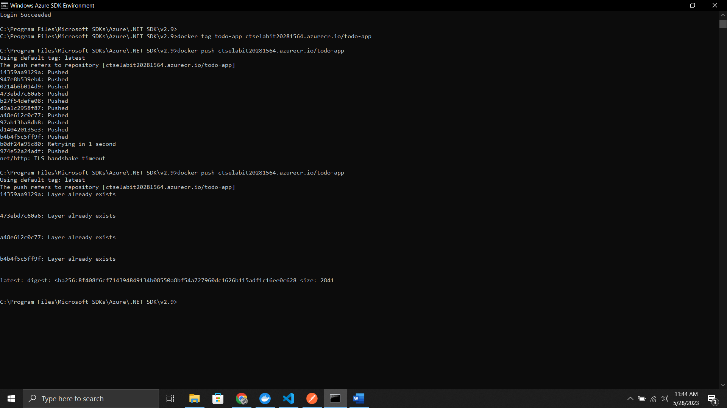

Docker Run local.

Azure Push Image

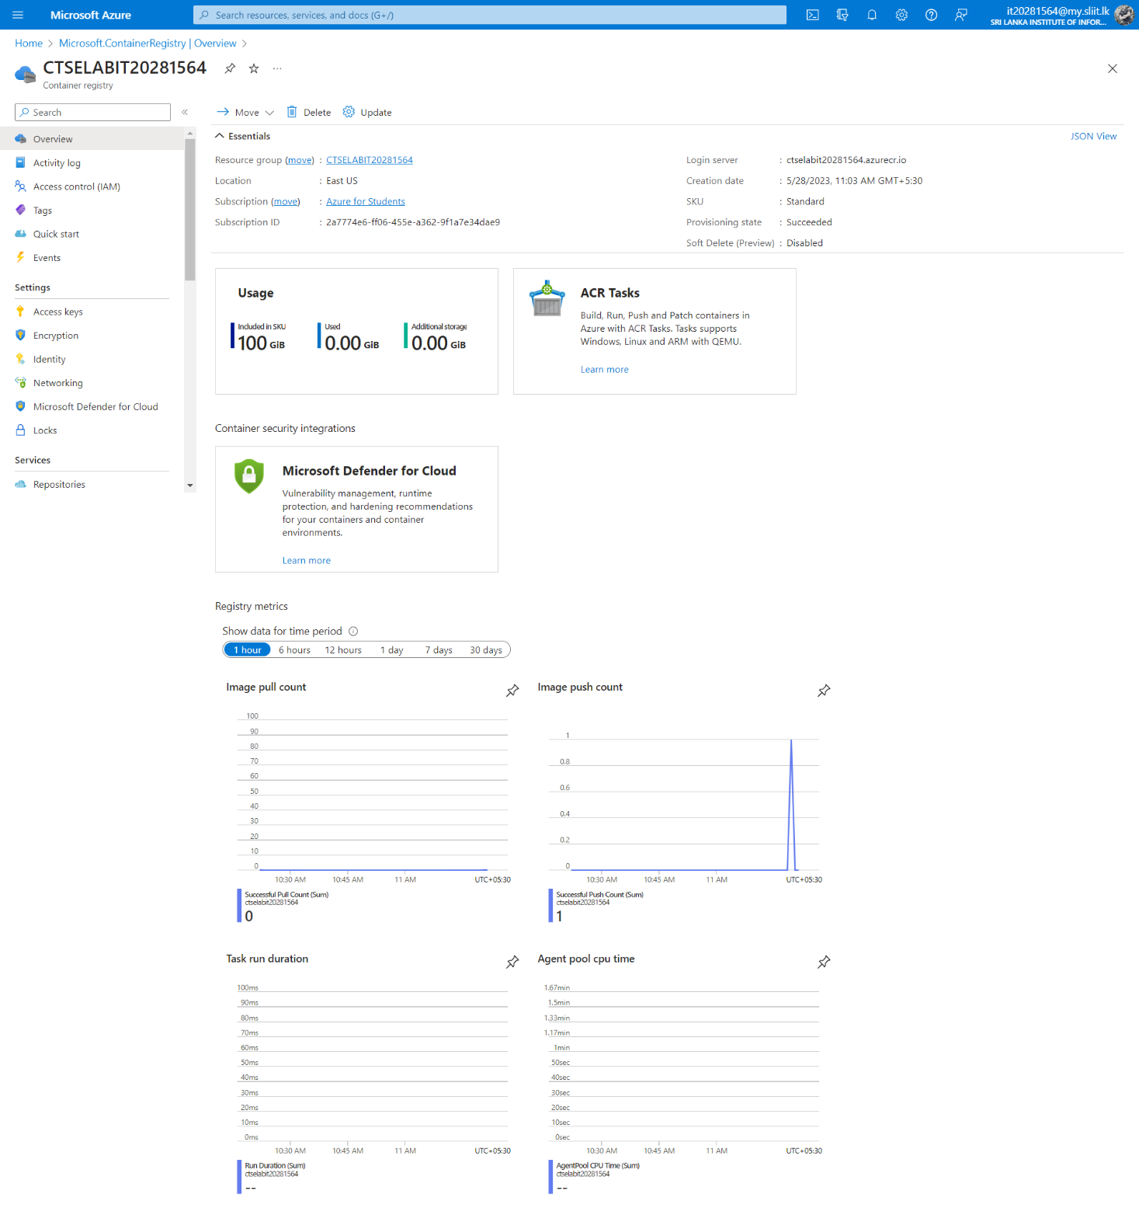

Postman

POST

GET

Docker Container

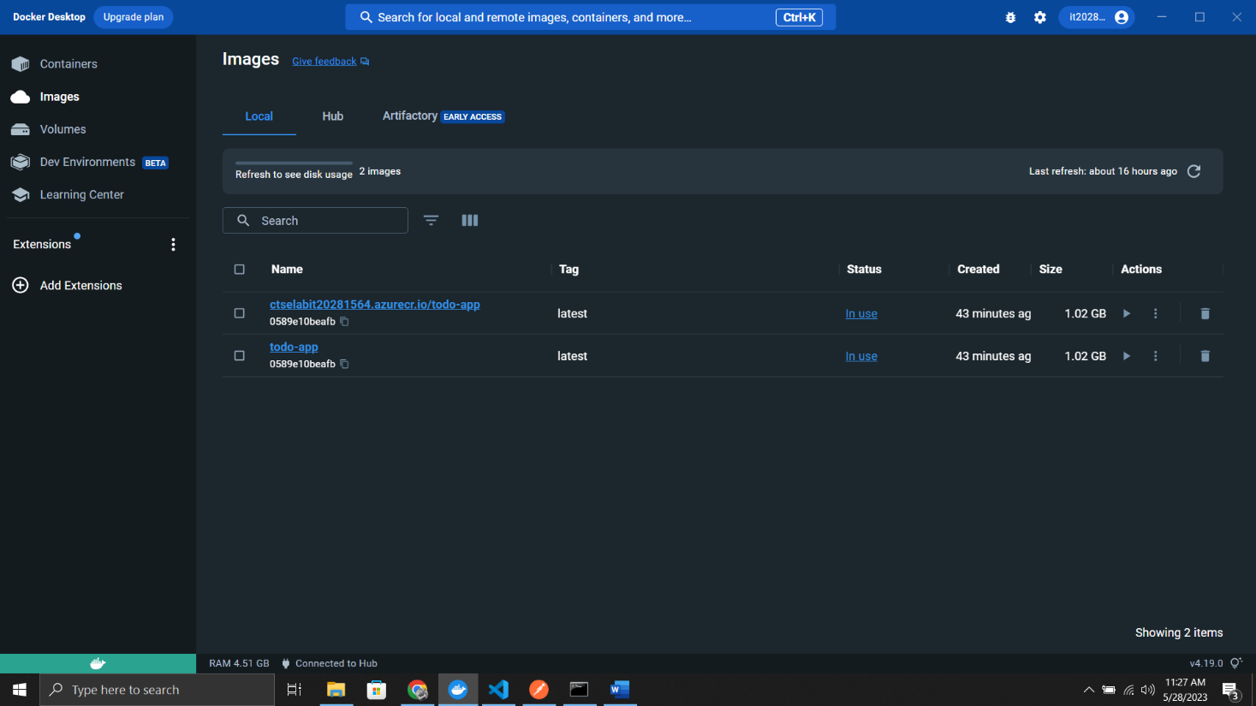

Docker Images

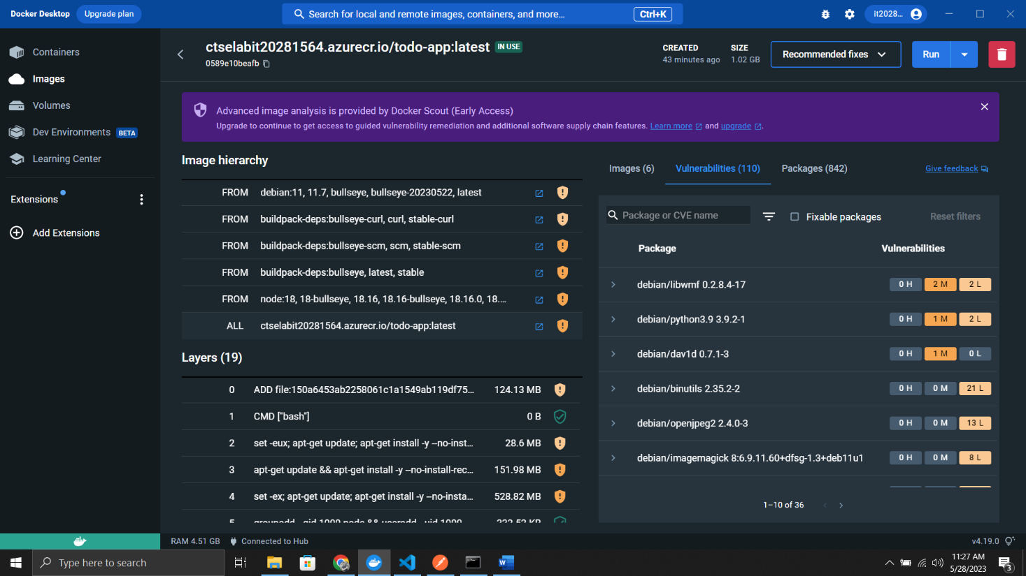

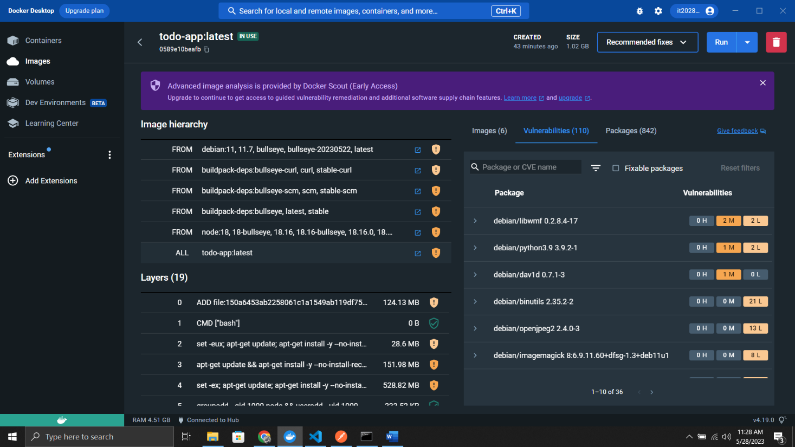

MongoDB Connection

Application

