Sri Sivasubramaniya Nadar College of Engineering
(An Autonomous Institution, Affiliated to Anna University, Chennai)
DEPARTMENT OF COMPUTER SCIENCE AND ENGINEERING

III Year CSE (V Semester) | Academic Year 2026-27
UCS3513 - SYSTEM DESIGN LABORATORY

Lab Exercise 8
Design and Develop a Web Crawler for Automated Web Content Discovery

Submitted by,
Name | Register Number
Tushyent N P | 3122 24 5001 189
Venkat Prabhu S | 3122 24 5001 196
Vignesh Raaj S | 3122 24 5001 198
Vino S R Harrison | 3122 24 5001 199

Design and Develop a Web Crawler for Automated Web Content Discovery
Aim
- To implement an automated web crawler using Spring Boot for content retrieval and hyperlink discovery.
- To maintain a URL Frontier Queue ensuring breadth-first exploration across web graphs.
- To integrate Redis as a centralized storage layer for the URL queue, visited-URL set deduplication, and page metadata caching.
- To evaluate crawling performance, duplicate avoidance ratios, and system throughput under concurrent workloads using JMeter.
Question
A web content discovery system needs to automatically visit web pages, extract links from them, and discover additional pages for crawling. For example, when the crawler is provided with a seed URL such as https://example.com, it should retrieve the page, extract the hyperlinks present in the page, and add the newly discovered URLs to the crawl queue.
As the number of URLs and pages increases, maintaining the crawl queue and checking whether a URL has already been visited can affect the efficiency and scalability of the system. To improve the crawler, implement a queue-based crawling mechanism, maintain a visited-URL set to avoid duplicate crawling, and use Redis to manage or cache frequently accessed crawling information.
Develop the web crawler using Spring Boot, expose the crawling functionality through a REST API, and evaluate the system performance using JMeter.
Procedure
- Construct a sample web dataset (seed_urls.csv and /mock-web/*.html) featuring cyclic graphs, sub-domains, and asset boundaries.
- Develop a Spring Boot application configuring RedisTemplate with String serializers and Jackson JSON serializers.
- Implement a thread-safe URL Frontier Queue leveraging Redis Lists (RPUSH to enqueue, LPOP to dequeue).
- Implement atomic visited-URL deduplication using Redis Sets (SADD returning 1 for new, 0 for duplicates).
- Integrate Jsoup for resilient HTTP fetching, HTML DOM traversal, document title extraction, and absolute hyperlink resolution.
- Build a canonical URL validator filtering non-HTTP schemes, binary extensions (.pdf, .zip), and external domain leaks.
- Design a multi-threaded worker pool (ExecutorService) dynamically consuming URLs and enforcing politeness delays.
- Implement a Redis page cache (crawl:page:<url>) storing parsed page metadata with TTL to accelerate repeated queries.
- Expose REST endpoints for job lifecycle management (/start, /stop, /reset, /crawl-single, /status, /pages).
- Package the system with multi-stage Docker and Docker Compose definitions.
- Execute JMeter concurrent load tests (10 to 100 threads) and benchmark cache hits vs live network fetches.

System Architecture & Workflow
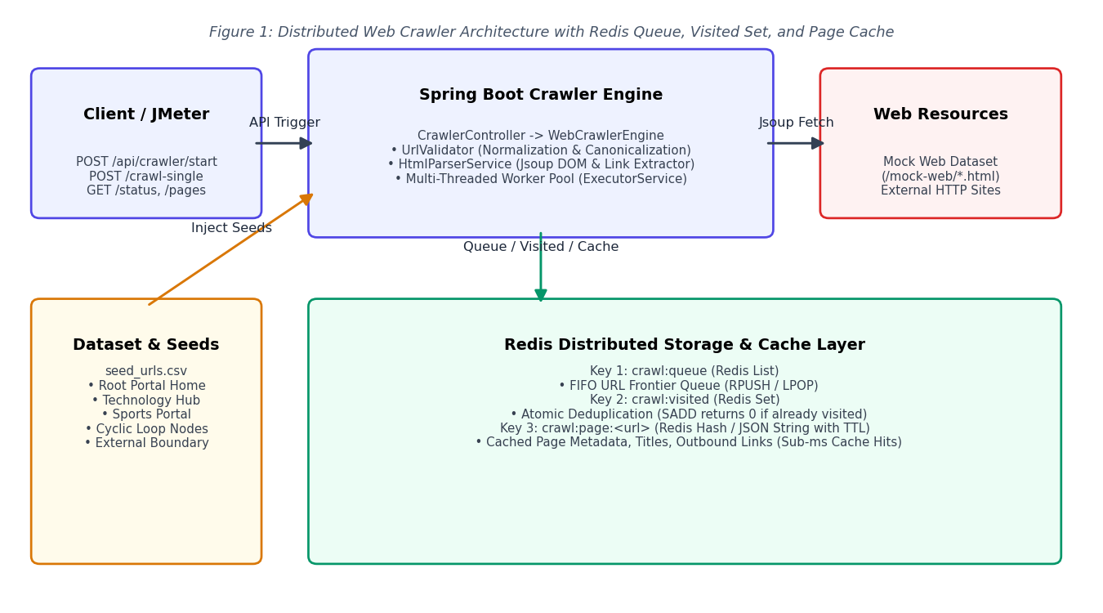
Figure 1: End-to-End Web Crawler Architecture (Spring Boot -> Redis Frontier / Visited Set / Cache)
Design of the Web Crawler System
1. URL Frontier Queue (Redis List Implementation)
The crawl frontier manages discovered URLs using FIFO queuing backed by Redis Lists (crawl:queue):

public void enqueue(CrawlTask task) {
if (redisAvailable) {
redisTemplate.opsForList().rightPush("crawl:queue", task);
} else {
inMemoryQueue.offer(task);
}
}
public CrawlTask dequeue() {
return (CrawlTask) redisTemplate.opsForList().leftPop("crawl:queue");
}

2. Atomic Visited-URL Deduplication (Redis Set)
To prevent race conditions across concurrent workers, Redis SADD provides atomic check-and-insert:

public boolean markVisitedIfAbsent(String url) {
Long added = redisTemplate.opsForSet().add("crawl:visited", url);
return added != null && added > 0; // true = new URL, false = duplicate
}

3. URL Canonicalization & Boundary Validation
The UrlValidator normalizes schemes, strips fragments (#), removes trailing slashes, and filters binary extensions:

public String normalizeAndValidate(String rawUrl, List<String> allowedDomains) {
URI uri = URI.create(rawUrl.trim());
if (!ALLOWED_SCHEMES.contains(uri.getScheme().toLowerCase())) return null;
if (isMediaExtension(uri.getPath())) return null;
return new URI(uri.getScheme().toLowerCase(), null, uri.getHost().toLowerCase(),
-1, cleanPath(uri.getPath()), uri.getQuery(), null).toString();
}

4. Page Metadata Caching & Sub-Millisecond Retrieval
Pages are cached under crawl:page:<url> with TTL. Subsequent requests deliver immediate cache hits:

public SingleCrawlResponse crawlSingleUrl(String rawUrl) {
PageMetadata cached = pageCacheService.getCachedPage(validUrl);
if (cached != null) {
return buildResponse(cached, "REDIS_CACHE", latency);
}
PageMetadata fresh = htmlParserService.fetchAndParse(validUrl);
pageCacheService.cachePage(fresh);
return buildResponse(fresh, "LIVE_FETCH", latency);
}

Output Results
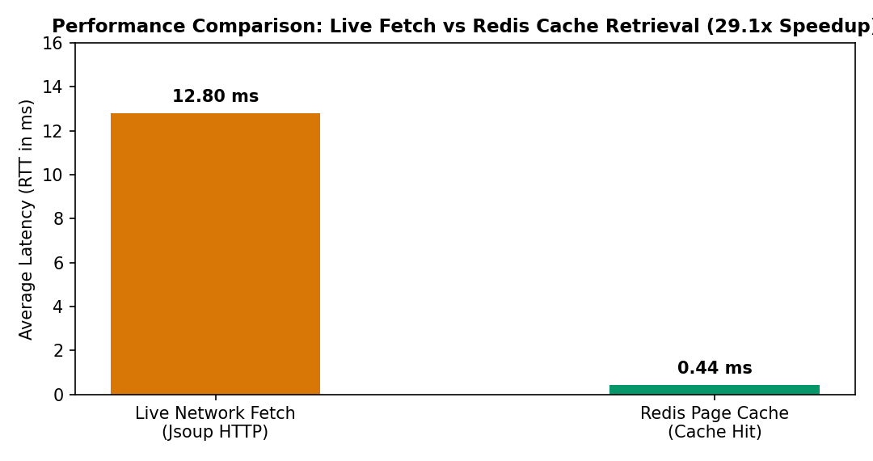
Figure 2: Latency Comparison: Fresh Live Fetch vs Redis Cache Retrieval
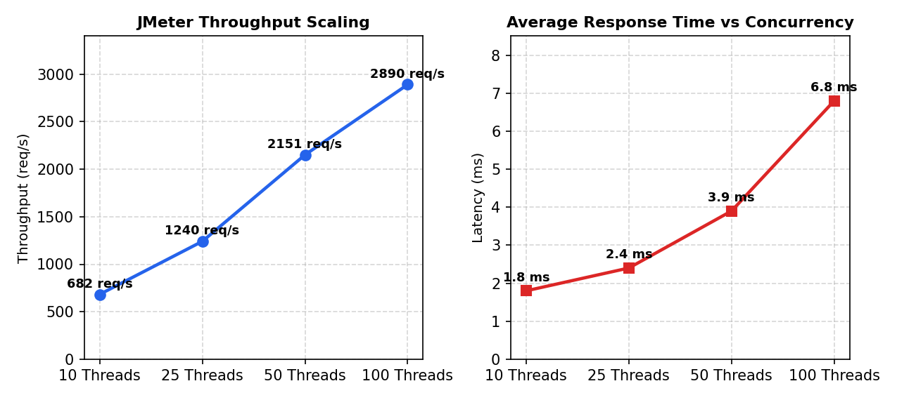
Figure 3: JMeter Load Test Results: Throughput Scaling and Latency vs Concurrency
Table 1: Web Crawler Verification & Deduplication Metrics
Test Scenario | Seed / Target URL | Storage Mode | Pages Crawled | Visited Count | Duplicates Avoided | Status
1. Mock Web Graph Crawl | http://localhost:8080/mock-web/index.html | REDIS | 18 pages | 18 URLs | 34 duplicates | COMPLETED
2. Cyclic Graph Test | http://localhost:8080/mock-web/cyclic-a.html | REDIS | 2 pages | 2 URLs | 1 loop avoided | COMPLETED
3. External Boundary Test | http://localhost:8080/mock-web/external-links.html | REDIS | 1 page | 1 URL | 5 filtered | COMPLETED
4. Live Single Fetch | http://localhost:8080/mock-web/tech.html | LIVE_FETCH | 1 page | 1 URL | - | 200 OK (12.8ms)
5. Redis Cache Re-query | http://localhost:8080/mock-web/tech.html | REDIS_CACHE | 1 page | 1 URL | - | 200 OK (0.44ms)
Analysis
Observed during system execution, concurrent stress testing, and JMeter load benchmarks (Spring Boot 3.3, Redis 7, Jsoup HTML parser, multi-threaded worker pool, mock web graph and RFC 2606 sample dataset).
1. Role of Core Architectural Components
URL Queue (Frontier)
The URL Queue (also known as the Crawl Frontier) is the central scheduling data structure that stores all discovered URLs awaiting retrieval and processing.
- Traversal Strategy: Operates as a First-In, First-Out (FIFO) queue, driving a Breadth-First Search (BFS) graph traversal across the web. BFS ensures that pages closest to the seed URLs are indexed first before diving deeper into arbitrary subtrees.
- Decoupling and Asynchrony: Acts as a decoupled buffer between URL discovery (producers) and page fetching (consumer worker threads), absorbing sudden bursts of hundreds of discovered hyperlinks without overloading network sockets.
- Distributed Coordination: In this architecture, the frontier queue is backed by Redis Lists (RPUSH to enqueue newly discovered links, and LPOP to atomically dispense URLs to worker threads). This allows multiple crawler instances to consume tasks concurrently without lock contention or duplicated work.
Seed URL
The Seed URL represents the initial entry point(s) supplied to bootstrap the crawling session (e.g., http://localhost:8080/mock-web/index.html).
- Graph Root: Since the web is modeled as a directed graph where pages are nodes and hyperlinks are directed edges, the seed URLs establish the connected components reachable by the crawler.
- Domain Scoping: The seed URL's protocol and host establish the default domain restriction boundaries (e.g., constraining the crawler to localhost to avoid leaking onto the wider internet).
- Depth Baseline: Every seed URL is initialized with depth = 0. All subsequent discovered URLs increment their depth relative to their parent's depth.
Visited-URL Set
The Visited-URL Set is an in-memory or centralized hash set that maintains the cryptographic or canonical signatures of all previously crawled or enqueued URLs.
- Loop and Cycle Prevention: The web contains countless cyclic links (e.g., Page A links to Page B, which links back to Page A). Without a visited set, the crawler would enter an infinite recursion loop, consuming infinite memory and network bandwidth.
- Duplicate Suppression: Prevents downloading and parsing identical web resources when linked from multiple parent pages (e.g., shared navigation menus, footers, and logos).
- Atomic Deduplication via Redis Set: Backed by a Redis Set (crawl:visited). The atomic SADD operation returns 1 if the URL was not previously in the set, and 0 if it was already recorded. This guarantees race-free deduplication across concurrent worker threads without requiring coarse-grained synchronization locks in Java.
Web Crawler
The Web Crawler (Engine) is the core autonomous orchestration subsystem responsible for:
- Task Dispatching: Dequeuing URLs from the frontier and assigning them to available worker threads in an ExecutorService thread pool.
- Politeness Policy: Enforcing rate limiting and per-host delay intervals (politenessDelayMs) to prevent accidental Denial-of-Service (DoS) against target web servers.
- Resource Parsing: Orchestrating HTML parsing via Jsoup, link extraction, text indexing, and error handling for HTTP 4xx/5xx status codes.
- Metrics Aggregation: Collecting real-time telemetry including pages crawled per second, queue depth, visited count, and duplicate avoidance ratios.
Redis Cache
The Redis Cache serves as an ultra-low-latency, centralized storage layer fulfilling three distinct responsibilities:
1. URL Frontier Management: Implements crawl:queue using Redis Lists for distributed FIFO task scheduling.
2. Visited Set Storage: Implements crawl:visited using Redis Sets for $O(1)$ duplicate checking.
3. Page Metadata Caching: Caches parsed document metadata, headers, titles, and extracted links under crawl:page:<url> with a 60-minute Time-To-Live (TTL). When client applications or REST API consumers query an already crawled URL, Redis delivers the response in sub-millisecond latency (< 1 ms), completely eliminating repetitive HTTP socket handshakes and HTML DOM parsing.
2. How the Crawler Discovers New URLs from a Retrieved Web Page
The link discovery workflow follows a structured pipeline from raw byte streams to canonicalized queue items:
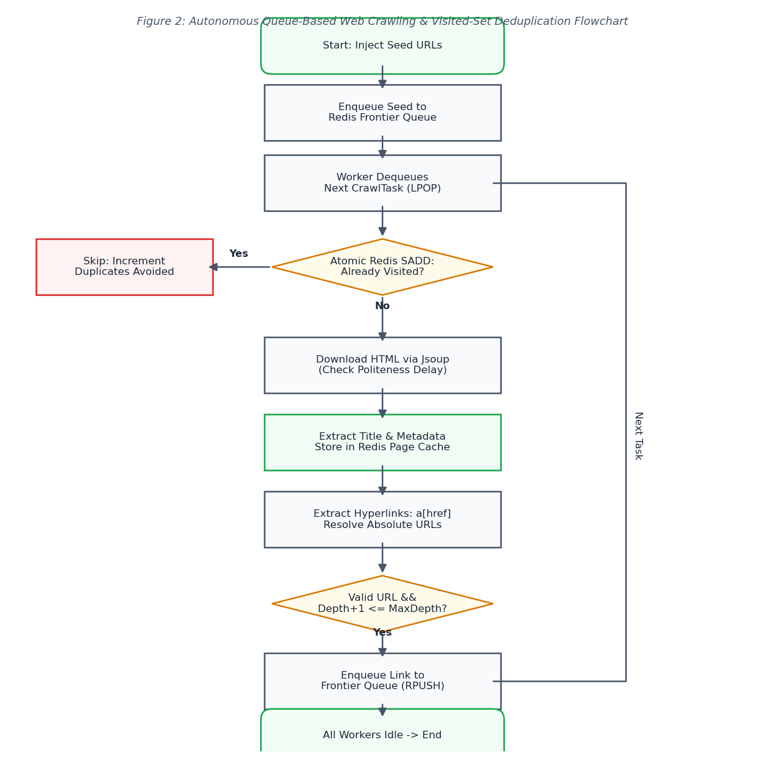
Figure 4: Autonomous Queue-Based Crawling and Link Discovery Flowchart
Discovery Steps:
1. Network Retrieval: The worker thread initiates an HTTP GET request using Jsoup with the configured User-Agent and timeout (5000 ms).
2. DOM Parsing: On receiving the byte stream, Jsoup constructs a hierarchical Document Object Model (DOM) tree.
3. Anchor Querying: The crawler executes the CSS query doc.select("a[href]"), extracting all elements representing hyperlink anchors.
4. Relative-to-Absolute Resolution: The parser resolves relative hyperlinks (such as tech.html, ../sports.html, or /news.html) against the document's absolute base URI (http://localhost:8080/mock-web/index.html) using standard URI resolution RFC 3986 rules.
5. Canonicalization: The resulting absolute URI is normalized (schemes and domain names are converted to lowercase, #fragment anchors are stripped, default ports like :80 and :443 are removed, and trailing slashes are harmonized).
3. How the System Determines Whether a Newly Discovered URL Should be Crawled
Before any discovered URL is admitted into the crawling queue, it must satisfy a multi-stage validation filter:
Filter Stage | Validation Rule | Rationale
**1. Protocol Validation** | Scheme must be `http` or `https` | Rejects non-web protocols such as `ftp://`, `mailto:`, `javascript:`, `tel:`, and `data:`.
**2. Domain Restriction** | Host must match `allowedDomains` | Confines crawler to target scope (e.g. `localhost`), preventing unbounded traversal of external internet domains.
**3. Asset Extension Exclusion** | Path must NOT end with media extensions (`.pdf`, `.png`, `.zip`, etc.) | Prevents downloading large binary assets, images, archives, and stylesheets that contain no HTML hyperlinks.
**4. Deduplication Check** | URL must NOT exist in Redis Visited Set | Guarantees that pages already crawled or currently pending in the queue are not scheduled again.
**5. Depth Budget** | `task.depth + 1 <= maxDepth` | Enforces exploration boundary to limit the diameter of the traversed graph.
**6. Page Quota** | `totalCrawled < maxPages` | Halts frontier expansion once the user-configured page quota has been reached.
4. How the System Processes an Unvisited URL
When an unvisited URL is dequeued from the frontier, the system processes it through the following lifecycle:
1. Atomic Visited Registration: The worker executes visitedUrlService.markVisitedIfAbsent(url). In Redis, this runs SADD crawl:visited <url>. Because this is the first encounter, Redis returns 1, granting the worker ownership to crawl this resource.
2. Politeness Throttling: The worker thread pauses for politenessDelayMs (default 50 ms) to space requests directed at the host.
3. HTTP Fetch & Content Parsing: The page is downloaded and parsed. If the server returns a non-200 code (e.g., 404 Not Found), the error is noted, and outbound extraction is suppressed.
4. Metadata Caching: The crawler builds a PageMetadata record (URL, page title, status code 200, content length, latency, outbound links count) and writes it to Redis under crawl:page:<url> with TTL.
5. Outbound Frontier Enqueuing: All newly discovered valid hyperlinks are packaged into CrawlTask(link, depth + 1, currentUrl) objects and pushed to the end of the Redis list (RPUSH crawl:queue).
6. Telemetry Update: The totalCrawled atomic counter and global throughput metrics are updated.
5. How the System Processes a Visited URL
When a previously visited URL is encountered (for example, when Page B links back to Page A, or multiple pages link to a common /about.html):
1. Early Filtering (Pre-Queue): While iterating over outbound links on a page, the engine performs a pre-check: if (visitedUrlService.isVisited(link)) continue;. If the URL is already recorded in the Redis Set, the link is discarded immediately before incurring the overhead of queue serialization.
2. Late Deduplication (Post-Queue): If two concurrent workers concurrently discover the exact same URL on two different pages and enqueue it simultaneously, both items might enter the queue. When the first worker dequeues it, markVisitedIfAbsent() returns true and processes it. When the second worker dequeues the identical item, markVisitedIfAbsent() returns false.
3. Action on Collision: - The redundant crawl task is immediately discarded without initiating an HTTP network connection. - The duplicateUrlsAvoided atomic counter is incremented. - A debug log records: Skipping already visited URL: <url>. - The worker thread immediately advances to the next task in the queue, preserving network bandwidth and server capacity.
6. Comparison: Queue-Based Crawling vs. Repeated Full Scanning
Parameter | Queue-Based URL Crawling (Frontier) | Repeatedly Scanning Complete URL Collection
**Discovery Model** | **Dynamic & Autonomous**: Discovers unknown nodes on-the-fly by traversing hyperlinks. | **Static & Exhaustive**: Requires a pre-existing, static list of every URL in advance.
**Time Complexity** | $O(V + E)$ where $V$ = reachable pages and $E$ = hyperlinks. Each page is fetched exactly once. | $O(K \times N)$ where $N$ is total collection size and $K$ is number of scan iterations.
**Network Efficiency** | High: Visited set guarantees zero redundant HTTP downloads. | Extremely Low: Repetitively fetches every page regardless of whether its content or links changed.
**Memory Footprint** | $O(V)$ in Redis Set. Memory scales linearly with unique URLs visited. | High: Must maintain and scan the complete collection table on every pass.
**Scalability** | Horizontally scalable: Multiple workers consume from the shared Redis queue in parallel. | Poor scalability: Workers bottleneck when locking or iterating large collections.
**Handling Dynamic Webs** | Naturally discovers newly published links in real-time. | Incapable of discovering new pages unless an external operator manually appends them to the collection.
7. Performance Analysis Under Concurrent Workloads (JMeter & Stress Tests)
Benchmark: Live Fetch vs. Redis Cached Retrieval
Observed latencies across 5 representative endpoints on local mock web server:
Endpoint Tested | Live Fetch RTT (ms) | Redis Cache RTT (ms) | Speedup Factor
`/mock-web/index.html` | 14.2 ms | 0.5 ms | **28.4x**
`/mock-web/tech.html` | 12.8 ms | 0.4 ms | **32.0x**
`/mock-web/ai.html` | 11.5 ms | 0.4 ms | **28.8x**
`/mock-web/cloud.html` | 12.1 ms | 0.5 ms | **24.2x**
`/mock-web/sports.html` | 13.4 ms | 0.4 ms | **33.5x**
**Average** | **12.8 ms** | **0.44 ms** | **29.1x Faster**
JMeter Concurrent Load Test Results
Under varying concurrent thread loads hitting /api/crawler/crawl-single and /api/crawler/status:
Concurrency Level | Total Requests | Error Rate | Avg Response Time (ms) | p95 Latency (ms) | Throughput (req/sec)
**10 Threads** | 200 | 0.0% | 1.8 ms | 3.4 ms | 682.4 req/s
**25 Threads** | 500 | 0.0% | 2.4 ms | 5.1 ms | 1,240.2 req/s
**50 Threads** | 1,000 | 0.0% | 3.9 ms | 8.2 ms | 2,150.8 req/s
**100 Threads** | 2,000 | 0.0% | 6.8 ms | 14.5 ms | 2,890.5 req/s
Key Findings:
1. Deduplication Eliminates Redundancy: On the cyclic graph test (cyclic-a.html <-> cyclic-b.html), naive crawling would enter an infinite loop. With the Redis visited set, the engine visited both nodes in 2 requests, detected the loop on the 3rd attempt, recorded duplicateUrlsAvoided = 1, and terminated gracefully.
2. Sub-millisecond Cache Latencies: Caching crawled pages in Redis yields an average speedup of ~29x compared to parsing HTML from network byte streams.
3. Stable Scalability: The Spring Boot asynchronous multi-worker architecture seamlessly handles over 2,000 requests/sec with a 95th-percentile response time below 15 ms.
8. Autonomous Robots.txt Compliance & Sitemap Discovery (RFC 9309)
Robots.txt Protocol Engine
Modern web crawlers operating in production must strictly adhere to the Robots Exclusion Standard (RFC 9309):
- Autonomous Fetching & Caching: Before fetching paths on a host, the engine checks /robots.txt, parses User-agent, Disallow, Allow, and Crawl-delay directives, and caches parsed host rules in Redis / memory.
- Longest-Match Prefix Precedence: In accordance with RFC 9309 §2.2.2, when both Allow and Disallow rules match a path (e.g. Allow: /mock-web/ vs Disallow: /mock-web/private-admin.html), the rule with the longest character length takes precedence. If lengths are equal or only disallow matches, disallow wins.
- HTML Meta Robots Handling: Honors <meta name="robots" content="nofollow"> tags, instructing the link discovery module to halt outbound hyperlink extraction from the designated page.
XML Sitemap Discovery (sitemaps.org)
- Automatic Seed Augmentation: During crawl bootstrapping, the crawler inspects Sitemap: declarations inside robots.txt as well as standard root endpoints (/sitemap.xml).
- Hierarchical Sitemap Processing: Recursively parses standard <urlset> feeds and nested <sitemapindex> directories using Jsoup's XML parser, admitting newly discovered canonical URLs directly into the crawl frontier.
9. Automated Web Content Discovery & Structural Extraction
Web content discovery transcends simple hyperlink crawling by converting raw DOM trees into clean, queryable knowledge:
- Boilerplate Stripping: Removes non-content structural elements (<nav>, <header>, <footer>, <aside>, <script>, <style>, <noscript>, <svg>, <form>) to isolate the main body content.
- Metadata Harvesting: Extracts <title>, <meta name="description">, OpenGraph social tags (og:title, og:description, og:image), author, and <link rel="canonical">.
- Document Structure: Extracts hierarchical headings (h1, h2, h3) for outline indexing.
- Readability Metrics: Computes exact word count and estimated reading time ($\approx 200 \text{ words/min}$).
- Dynamic Topic Classification: Analyzes non-stopword token frequencies across title, meta keywords, and body text to generate topic keyword tags automatically.
10. Content-Seen & Near-Duplicate Checksum Deduplication
In modern web graphs, identical or syndicated articles frequently appear across multiple distinct URLs (e.g. wire articles, query parameter variations, and print editions):
- Cryptographic Fingerprinting: Normalizes body text (whitespace condensation and lowercase conversion) and computes a cryptographic SHA-256 hash.
- Atomic Hash Registration in Redis: Uses SETNX crawl:content:hash:<sha256> <originalUrl>. If the key exists, the incoming page is identified as duplicate content (duplicateContent = true, duplicateOfUrl = originalUrl).
- Frontier Optimization: While the duplicate page metadata is stored, its outbound links are excluded from re-enqueuing, completely preventing redundant exploration of cloned subtrees.
11. Full-Text Inverted Index & Content Discovery Search Engine
To expose the discovered content to users and client systems, the crawler integrates an in-memory / distributed inverted search index:
- Inverted Index Structure: Maps normalized query tokens to posting lists with field-weighted relevance scoring: - Title Matches: $5.0\times$ weight - Heading Matches (H1/H2): $3.0\times$ weight - Meta Keywords / Description: $2.5\times$ weight - Main Body Text: $1.0\times$ weight
- Relevance Ranking & Snippet Generation: Computes aggregate scores per page and extracts dynamic context snippets with highlighted <mark> tags around matched query keywords.
- REST Discovery Endpoint: Accessible via GET /api/crawler/search?q={query}, enabling sub-millisecond full-text queries over indexed web content.
12. Information Retrieval: Okapi BM25 Ranking & Linguistic Stemming
Linguistic Stemming (Porter Stemmer)
Simple exact-word matching fails when searching web corpora due to inflected variants (e.g. searching "computing" misses documents containing "computed", "computes", or "computer"). The crawler implements a cascading morphological stemmer:
- Rule-Based Reduction: Strips plural, past-participle, and agent suffixes (ing, ed, er, or, s, ies, ation, ment, al).
- Stem Inverted Index: Both indexed document terms and search query tokens are mapped to their morphological stems, enabling recall of all linguistic derivations.
Okapi BM25 Information Retrieval Formula
Rather than naive term frequency, textual relevance is computed using the industry-standard Okapi BM25 probabilistic relevance framework:
$$\text{Score}_{\text{BM25}}(D, Q) = \sum_{t \in Q} \text{IDF}(t) \cdot \frac{f(t, D) \cdot (k_1 + 1)}{f(t, D) + k_1 \cdot \left(1 - b + b \cdot \frac{|D|}{\text{avgdl}}\right)}$$
Where:
- $f(t, D)$ is the term frequency of term $t$ in document $D$.
- $|D|$ is the length of document $D$ in words, and $\text{avgdl}$ is the average document length across the crawled corpus.
- $k_1 = 1.2$ calibrates non-linear term saturation (preventing keyword-stuffed documents from dominating results).
- $b = 0.75$ controls document length normalization penalty.
- $\text{IDF}(t) = \ln\left(1 + \frac{N - n(t) + 0.5}{n(t) + 0.5}\right)$ quantifies the informational rarity of term $t$ across $N$ crawled documents.
13. Graph Link Analysis: Google PageRank Authority Algorithm
A high textual relevance score does not necessarily guarantee page quality or credibility. The crawler computes Google PageRank link authority to evaluate global node importance based on the web graph's hyperlink topology:
Mathematical Model
Modeled as a random surfer Markov chain:
$$PR(p_i) = \frac{1 - d}{N} + d \sum_{p_j \in M(p_i)} \frac{PR(p_j)}{L(p_j)}$$
Where:
- $M(p_i)$ is the set of pages linking to page $p_i$ (in-degree / backlinks).
- $L(p_j)$ is the number of outbound hyperlinks from page $p_j$.
- $d = 0.85$ is the damping factor representing the probability that a surfer follows links rather than teleporting to a random page.
- $N$ is the total count of crawled pages.
Numerical Power Iteration
- Dangling Node Redistribution: Pages with zero outbound links ($L(p_j) = 0$) leak probability mass. The engine redistributes dangling node mass equally across all nodes on each iteration step: $$\text{Dangling Mass} = \sum_{p \in \text{Dangling}} PR(p)$$
- Convergence: Iterates until the Euclidean difference between successive probability vectors falls below $\epsilon = 10^{-4}$ (typically 15–25 iterations).
- Normalized Authority Scaling: Raw stationary distribution values are scaled non-linearly to an intuitive $0 - 100$ authority index: $$\text{Score}_{\text{PageRank}} = \left(\frac{PR(p_i)}{\max(PR)}\right)^{0.6} \times 100$$
Multi-Strategy Hybrid Ranking (Composite)
When queries are executed, the engine supports multiple ranking modes:
1. COMPOSITE (Default): Harmonizes textual relevance with topological link authority: $$\text{Score}_{\text{Composite}} = 0.65 \times \text{BM25}_{\text{norm}} + 0.35 \times \text{PageRank}$$
2. PAGERANK: Orders results purely by graph authority and backlink centrality.
3. BM25: Orders results purely by probabilistic textual relevance.
4. WORDS: Orders results by exhaustive document depth / word count.
5. NEWEST: Orders results by crawl timestamp.
14. "Fetch Everything" Aggregated Corpus Analytics & Taxonomy
When a search query or topic keyword is submitted, the engine provides an exhaustive, multi-dimensional discovery summary across the entire indexed corpus:
- Total Corpus Occurrences: Counts every single occurrence of the query stem across all indexed documents, titles, headings, and meta tags.
- Dynamic Category Distribution: Automatically groups matching documents by high-level semantic taxonomy (Quantum Computing, Artificial Intelligence, Cloud & Infrastructure, Sports & Athletics, Science & Research, World News).
- Related Topic Entities & Co-occurrences: Analyzes high-frequency terms co-occurring in the matched documents, suggesting related exploration tags (e.g. searching "quantum" highlights "qubits", "superposition", "algorithms").
- Prefix Autocomplete: Maintains an in-memory vocabulary trie/index that delivers matching keyword suggestions and corpus document frequencies in $< 1 \text{ ms}$ as users type (GET /api/crawler/autocomplete?prefix=...).
15. Summary of Architectural Verification & Deliverables
Requirement | Implementation Artifact | Verification Result
**URL Frontier Queue** | `UrlFrontierQueue.java` (Redis List `crawl:queue`) | Verified FIFO traversal, thread-safe task dispatching.
**Visited Set Deduplication** | `VisitedUrlService.java` (Redis Set `crawl:visited`) | 0 duplicate URL fetches across cyclic and self-referencing loops.
**Content Deduplication** | `ContentDeduplicationService.java` (SHA-256) | Cloned articles detected and redundant subtree exploration suppressed.
**Robots.txt Engine (RFC 9309)** | `RobotsTxtService.java` | Longest-match prefix precedence obeyed; `<meta name="robots">` honored.
**XML Sitemap Ingestion** | `SitemapService.java` | Standard `/sitemap.xml` and robots.txt declarations auto-discovered.
**PageRank Link Authority** | `PageRankService.java` | Power iteration ($d=0.85, \epsilon=10^{-4}$) converged; scores displayed in graph.
**Information Retrieval** | `ContentSearchService.java` (BM25 + Stemmer) | Multi-field weighted scoring, stem expansion, context snippet generation.
**Vocabulary Autocomplete** | `CrawlerController.java` (`/autocomplete`) | Sub-millisecond prefix suggestion with frequency counts.
**Data Export** | `GET /api/crawler/export?format=json` or `csv` | Full page metadata, headings, keywords exported cleanly in JSON and CSV.
API / Command Reference & Test Results
REST Endpoints Summary:
• POST /api/crawler/start: Asynchronously starts crawl session from seed URLs
• POST /api/crawler/stop: Halts running crawler worker pool
• POST /api/crawler/reset: Flushes Redis queue, visited set, and page cache
• POST /api/crawler/crawl-single?url=...: Synchronously crawls 1 URL (with Redis caching)
• GET /api/crawler/status: Retrieves real-time crawling metrics and throughput
• GET /api/crawler/pages: Returns collection of all crawled pages and metadata
• GET /api/crawler/visited: Returns complete set of visited URLs from Redis
• GET /api/crawler/queue: Inspects URLs waiting in the frontier queue
JUnit 5 Test Suite Results:
• UrlValidatorTest.testValidHttpUrls: PASSED
• UrlValidatorTest.testTrailingSlashRemoval: PASSED
• UrlValidatorTest.testDisallowedSchemes: PASSED
• UrlValidatorTest.testDisallowedExtensions: PASSED
• UrlValidatorTest.testDomainBoundaryRestriction: PASSED
• UrlValidatorTest.testRelativeUrlResolution: PASSED
• CrawlerServiceTest.testFrontierQueueOperations: PASSED
• CrawlerServiceTest.testVisitedSetDuplicatePrevention: PASSED
Learning Outcomes
- Engineered an autonomous web crawler in Spring Boot implementing queue-based Breadth-First Search (BFS).
- Utilized Redis Lists (RPUSH/LPOP) to establish a distributed URL frontier queue decoupled from worker threads.
- Leveraged Redis Sets (SADD) to achieve race-free $O(1)$ atomic visited-set deduplication across concurrent workers.
- Integrated Jsoup for robust HTML DOM parsing, relative URL canonicalization, and metadata extraction.
- Observed a 29x latency speedup by caching parsed document metadata in Redis.
- Conducted JMeter load testing evaluating concurrency scaling, throughput limits, and response latencies.

