REGISTRATION NO: BITAM/9/21/073/TZ

NAME: THUWAIBA SALEH SAIB

COURSE: WEB TECHNOLOGIES

COURSE CODE: INF 2215

REPOSITORY:

This is an anout page that contain my hobbies an interest and my contact

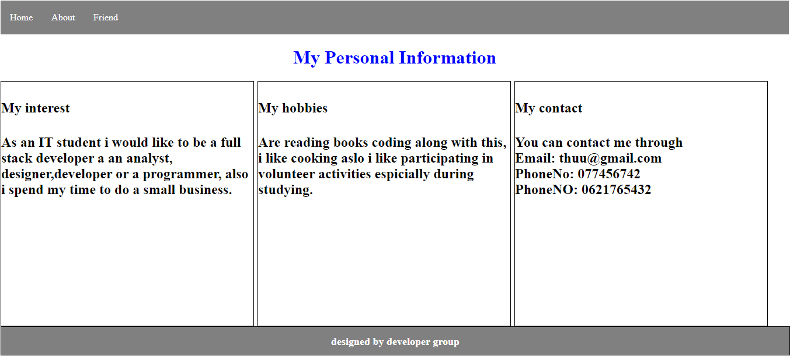

Also this is a friend page that contain a friend details where I see them and other details

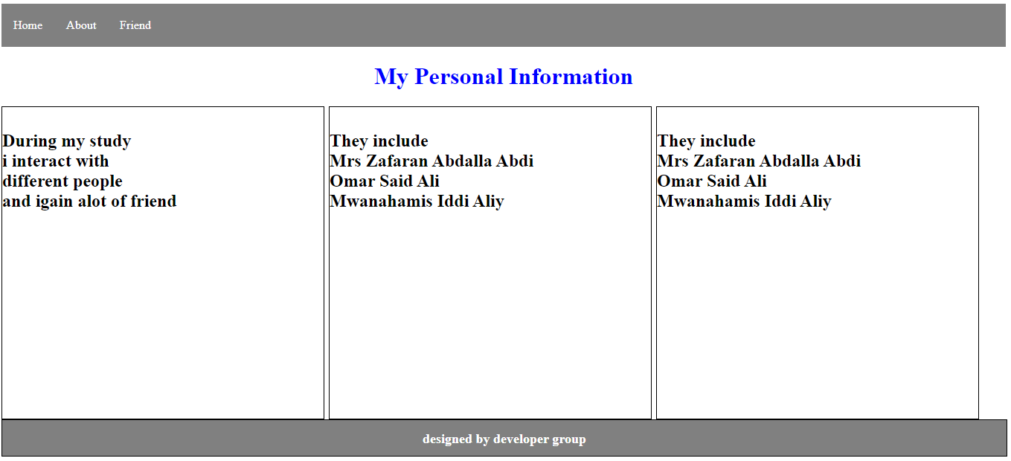

Also this is my home page that contain my personal information including my name, educational background, what I experience.

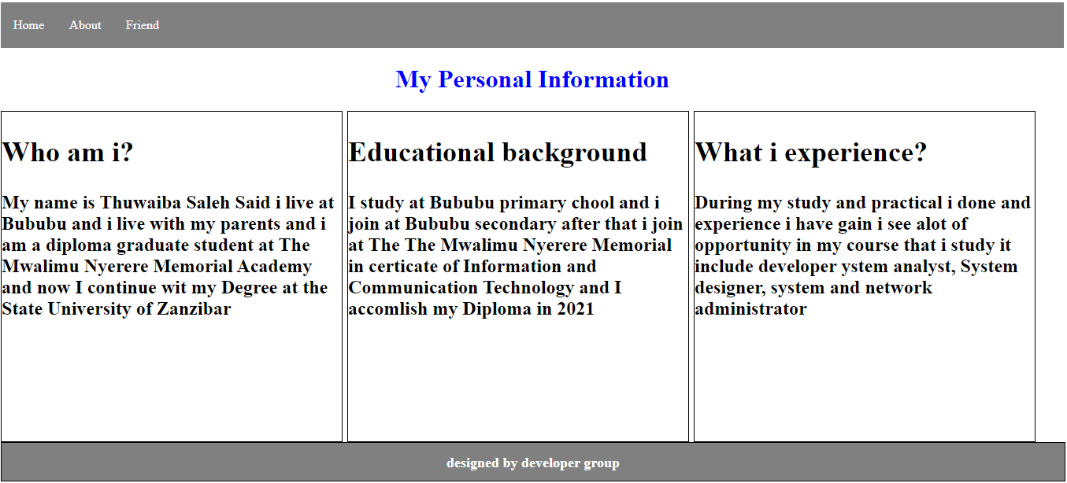

This is my page that I use to announce my courses that I offer at my college

