Lab report – Project Management

**LAB REPORT**

**Software Project Management**

**Student Name: Phạm Thị Thùy Nhi**

**ID: 21054781**

**Class: DHKTPM17B**

**Course:**

Lab report – Project Management

**MỤC LỤC**

Module 1: 3

Exercise 1: Creating a link 3

Exercise 2: Setting duration 4

Exercise 3: Creating phases 5

Exercise 4: Noah - Linking 6

Exercise 5: Pyramid - Multi level grouping 7

Exercise 6: Creating a plan for Staff Training 8

Exercise 7: Recurring task 9

Exercise 8: Travelling task calendar 10

Phạm Thị Thùy Nhi

Lab report – Project Management

# Module 1:

## Exercise 1: Creating a link

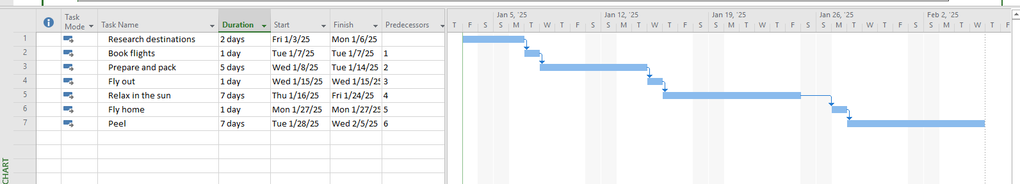

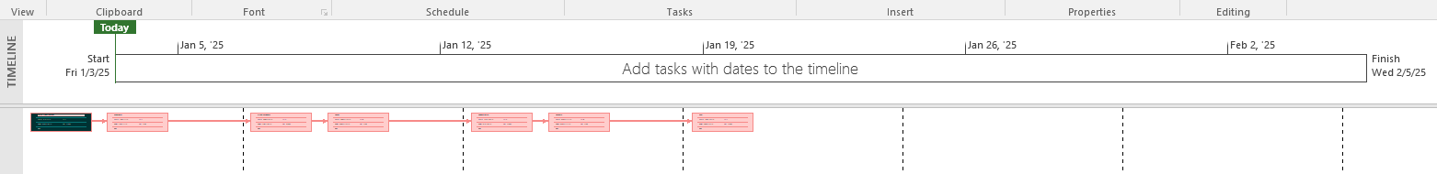

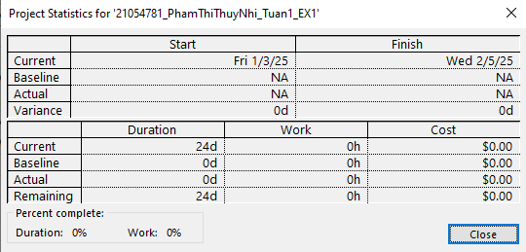

## Exercise 2: Setting duration

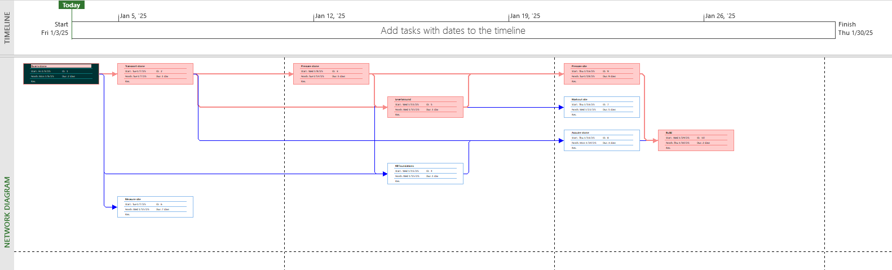

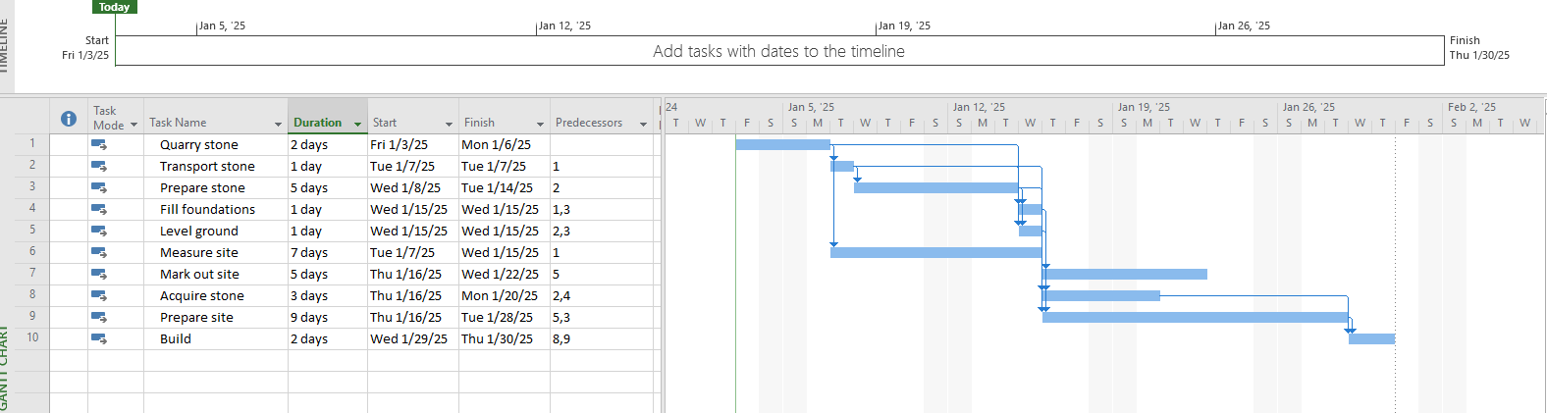

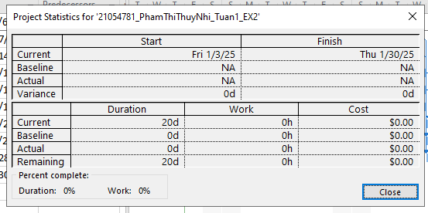

## Exercise 3: Creating phases

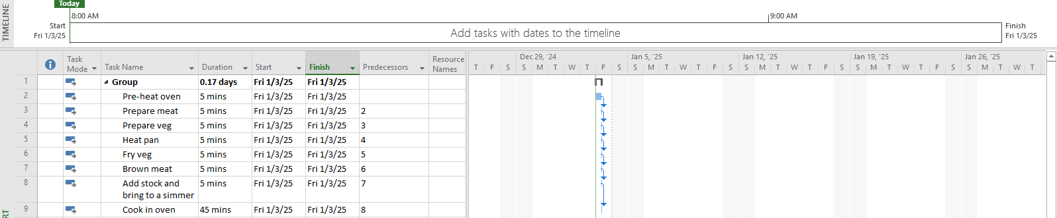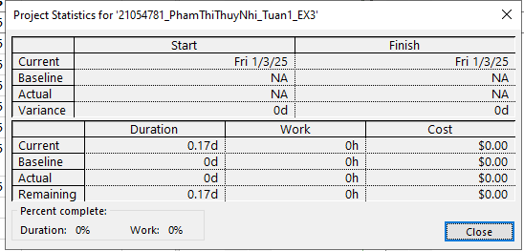STUDENT NAME **3**

Lab report – Project Management

## Exercise 4: Noah - Linking

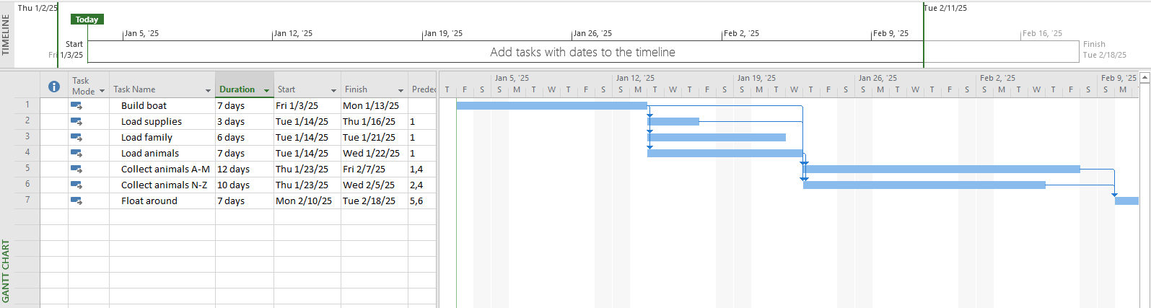

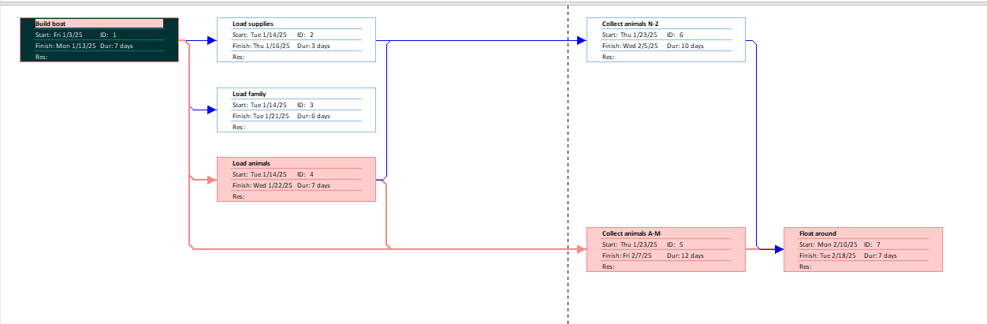

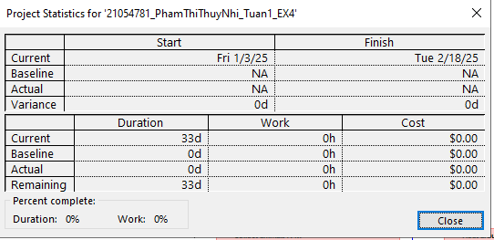

## Exercise 5: Pyramid - Multi level grouping

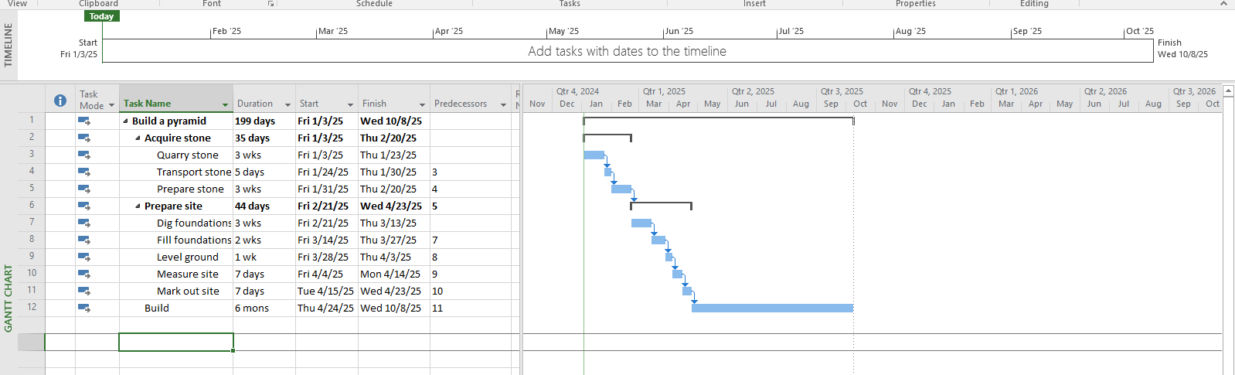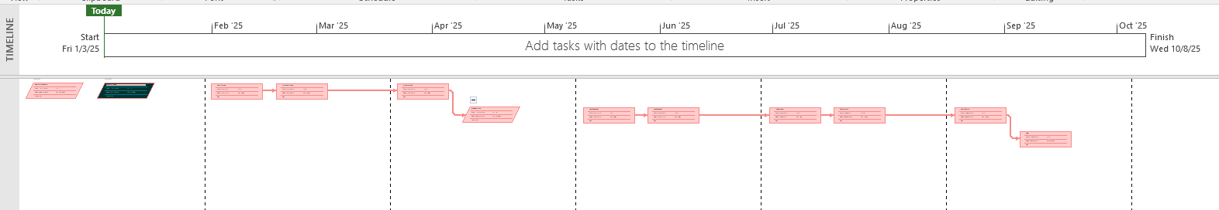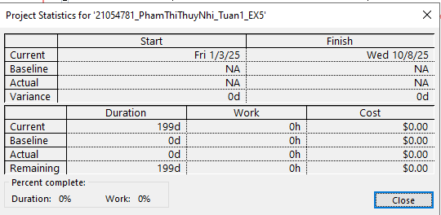STUDENT NAME **4**

Lab report – Project Management

## Exercise 6: Creating a plan for Staff Training

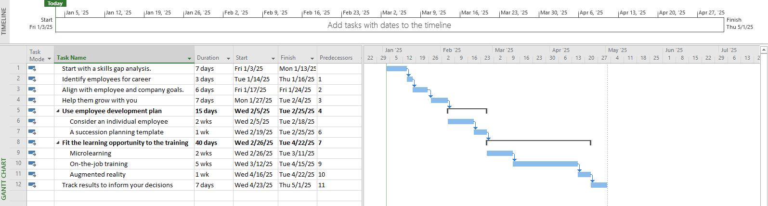

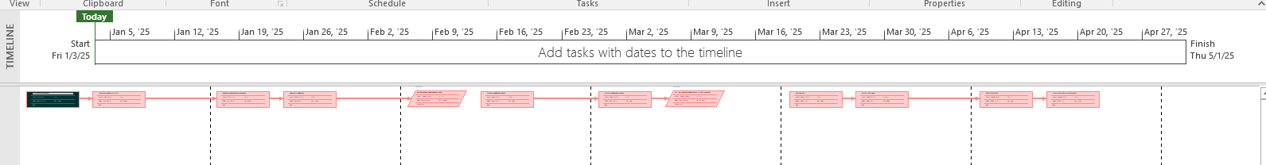

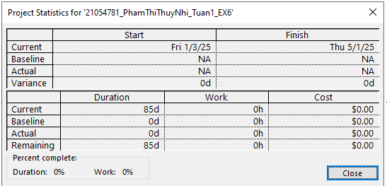

## Exercise 7: Recurring task

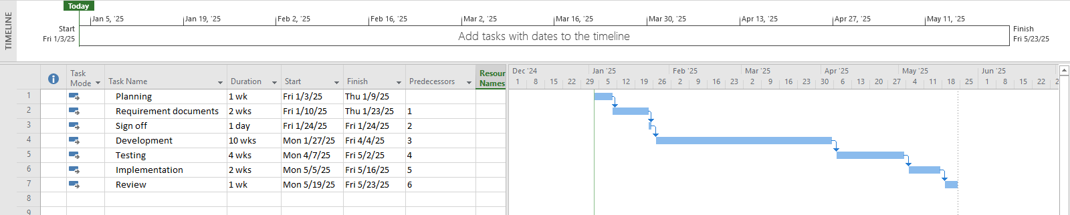

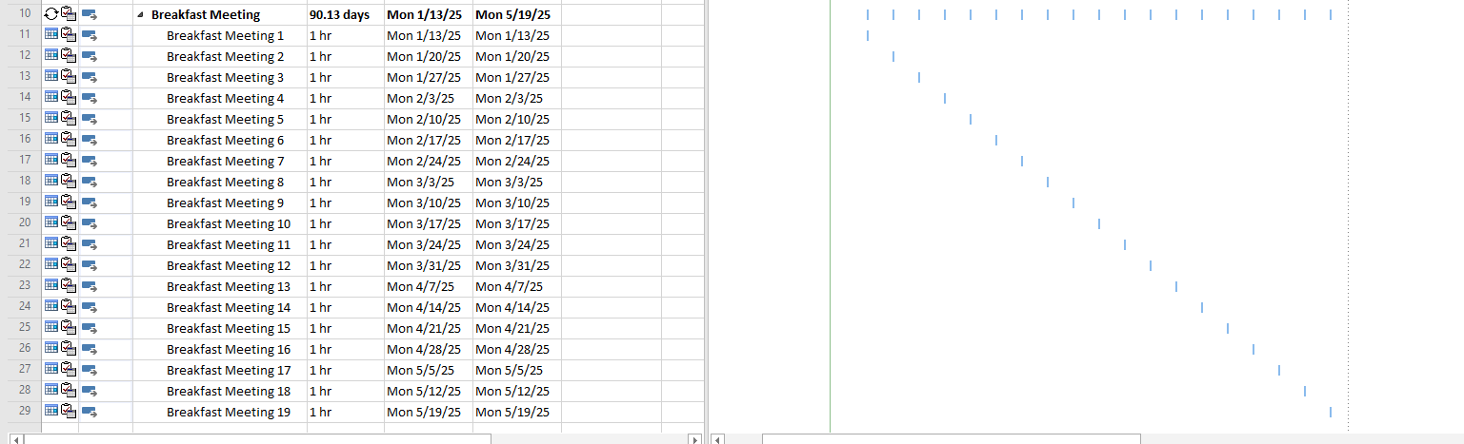

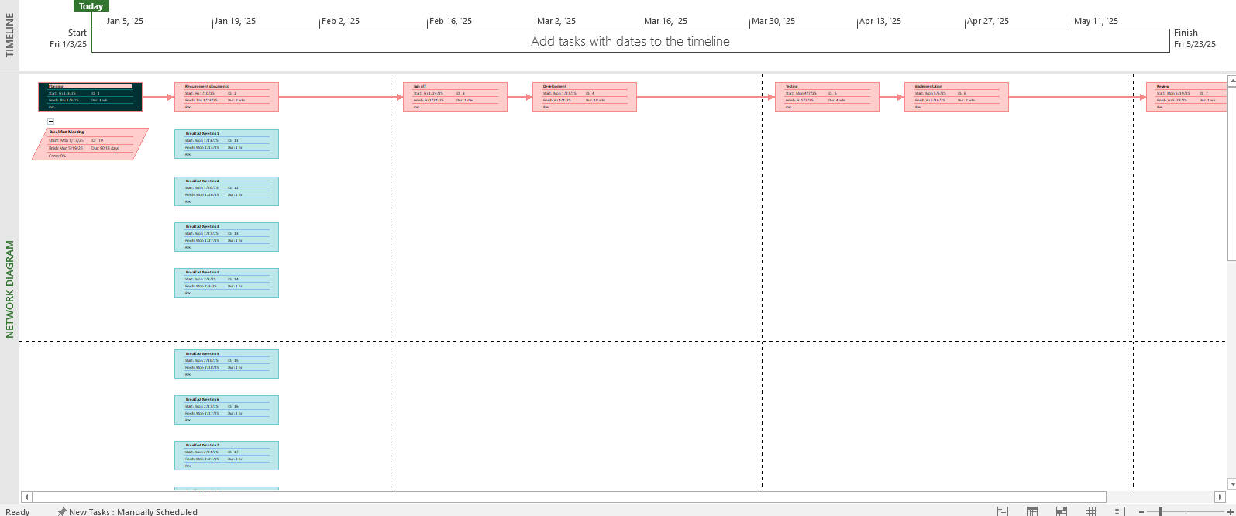

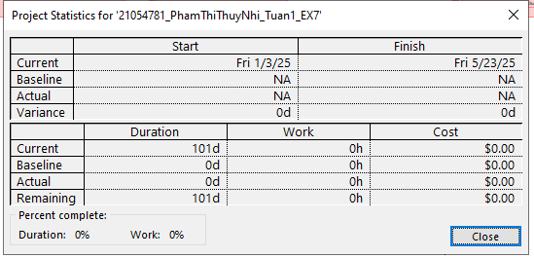

## Exercise 8: Travelling task calendar

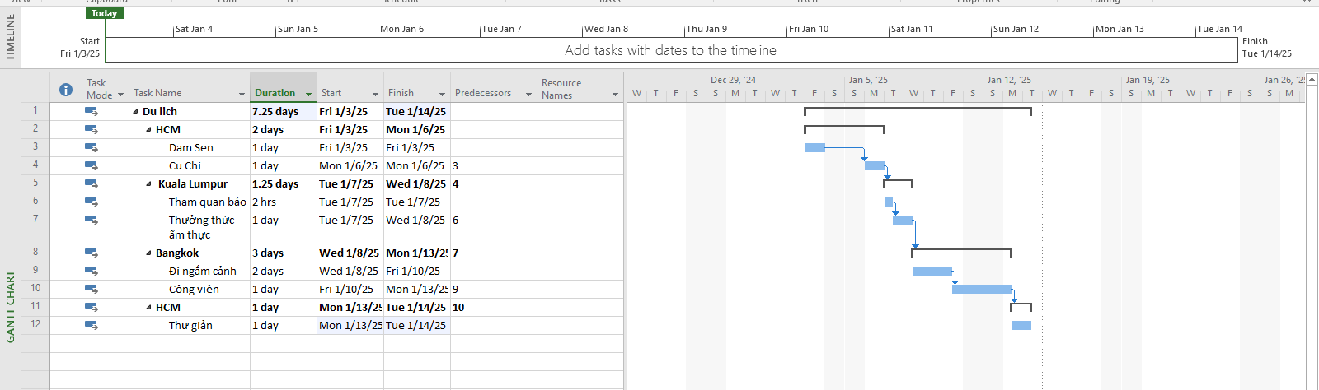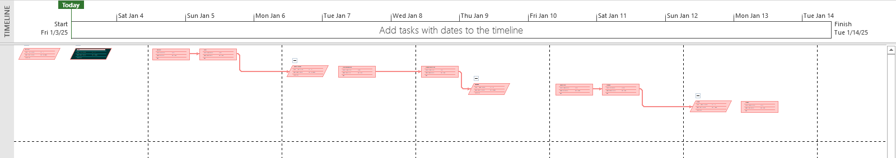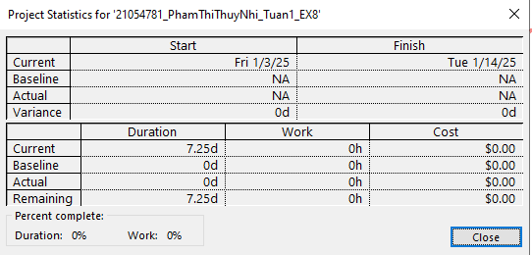

STUDENT NAME **5**

Lab report – Project Management

**Module 2: CALENDARS AND SCHEDULING**

**Exercise 1: Changing Working Time**

1) Santa's workshop has two machines for making toys - the first job of the year is to prepare them for work. Using the diagram below as a guide, create a list of tasks to model this job.

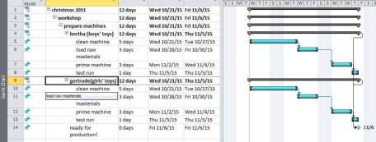2) Try collapsing some of the task groups to make sure you've got the indenting right.

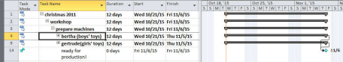

**Exercise 2: Changing Working Time**

1) Using the diagram below, create a list of tasks to model this process.

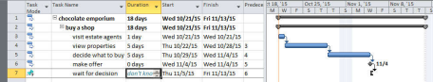2) We decide to put in a rough estimate for how long we have to wait for a decision. Add a task to the list, as shown in the diagram below:

STUDENT NAME **6**