Lab report – Project Management

**LAB REPORT**

**Software Project Management**

**Student Name: Triệu Quốc An**

**ID: 21048321**

**Class: DHKTPM17B**

**Course:**

STUDENT NAME **1**

Lab report – Project Management

**Contents**

Module 1:................................................................................................................................................3 Exercise 1: Creating a link...................................................................................................................3 Exercise 2: Setting duration .................................................................................................................3 Exercise 3: Creating phases .................................................................................................................3 Exercise 4: planning to do one of the HCM to Nha Trang bike rides ....................................................4 Exercise 5: Noah - Linking ..................................................................................................................4 Exercise 6: Pyramid - Multi level grouping..........................................................................................4 Exercise 7: Creating a plan for Staff Training ......................................................................................5 Exercise 8: Recurring task ...................................................................................................................5 Exercise 9: Travelling task calendar....................................................................................................5

Triệu Quốc An

Lab report – Project Management

**Module 1:**

**Exercise 1: Creating a link**

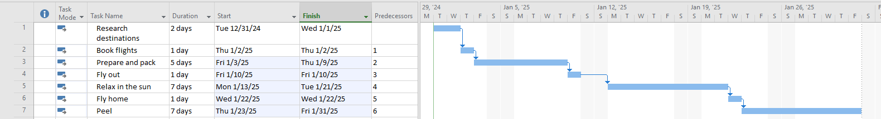

**Exercise 2: Setting duration**

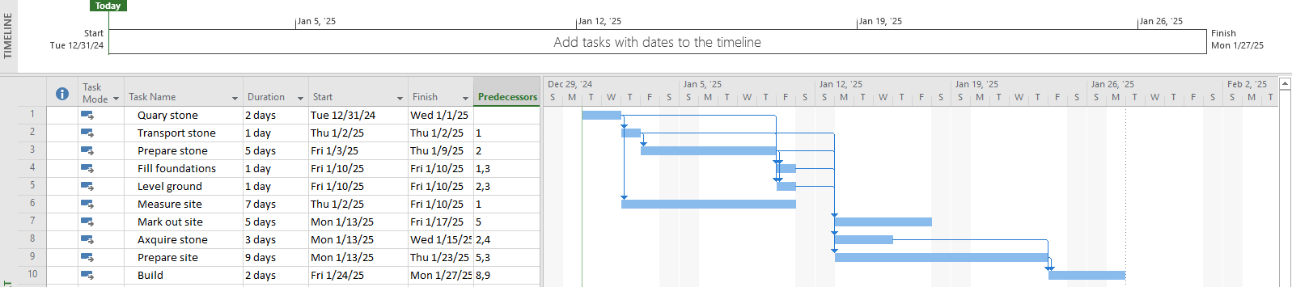

**Exercise 3: Creating phases**

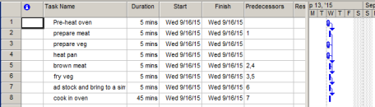STUDENT NAME **3**

Lab report – Project Management

**Exercise 4: planning to do one of the HCM to Nha Trang bike rides**

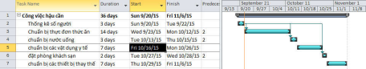

**Exercise 5: Noah - Linking**

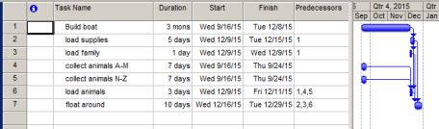

**Exercise 6: Pyramid - Multi level grouping**

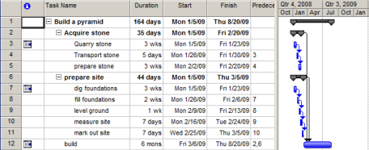STUDENT NAME **4**

Lab report – Project Management

**Exercise 7: Creating a plan for Staff Training**

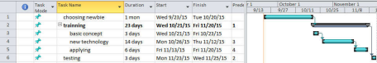

**Exercise 8: Recurring task**

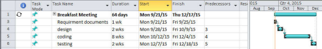

**Exercise 9: Travelling task calendar**

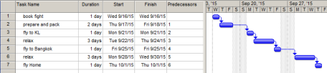STUDENT NAME **5**

Lab report – Project Management

**Module 2: CALENDARS AND SCHEDULING**

**Exercise 1: Changing Working Time**

1) Santa's workshop has two machines for making toys - the first job of the year is to prepare them for work. Using the diagram below as a guide, create a list of tasks to model this job.

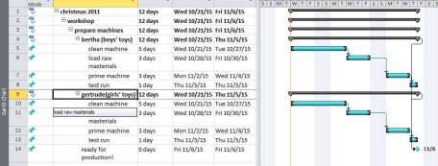2) Try collapsing some of the task groups to make sure you've got the indenting right.

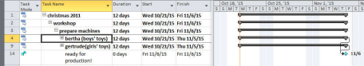

**Exercise 2: Changing Working Time**

1) Using the diagram below, create a list of tasks to model this process.

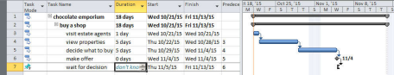2) We decide to put in a rough estimate for how long we have to wait for a decision. Add a task to the list, as shown in the diagram below:

STUDENT NAME **6**