Lab report – Project Management

**LAB REPORT**

**Software Project Management**

**Student Name: Phạm Thị Thùy Nhi**

**ID: 21054781**

**Class: DHKTPM17B**

**Course: Quản lý dự án**

Lab report – Project Management

**MỤC LỤC**

Module 1 : Management Studio 4

Exercise 1: Creating a link 4

Exercise 2: Setting duration 5

Exercise 3: Creating phases 6

Exercise 4: Noah - Linking 7

Exercise 5: Pyramid - Multi level grouping 8

Exercise 6: Creating a plan for Staff Training 9

Exercise 7: Recurring task 10

Exercise 8: Travelling task calendar 11

Module 2 : CALENDARS AND SCHEDULING 12

Exercise 1. Part Time - creating new calendar 12

Exercise 2: Changing Working Time 14

Exercise 3: Changing Working Time 19

Exercise 4: Changing Working Time 23

Exercise 5: Create the private Time for a project 26

Module 3 : Working with Tasks 31

Exercise 1. Changing Working Time (Start Date 1/3/2025) 31

Exercise 2. Changing Working Time (Start Date 1/3/2025) 33

Exercise 3. Scheduling – Task dependencies 35

Module 4 : Assigning resources to the tasks in Project 38

Exercise 1. Entering Resources 38

Exercise 2. Entering resources 39

Exercise 3. Entering resources 40

Exercise 4. Entering resources 42

Exercise 5. Resources with the private working Time 50

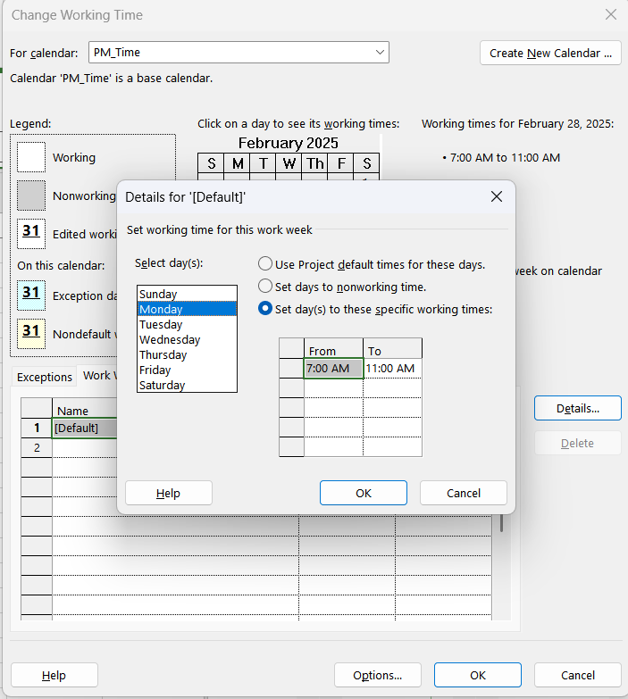 50

1. Management Studio

Exercise 1: Creating a link

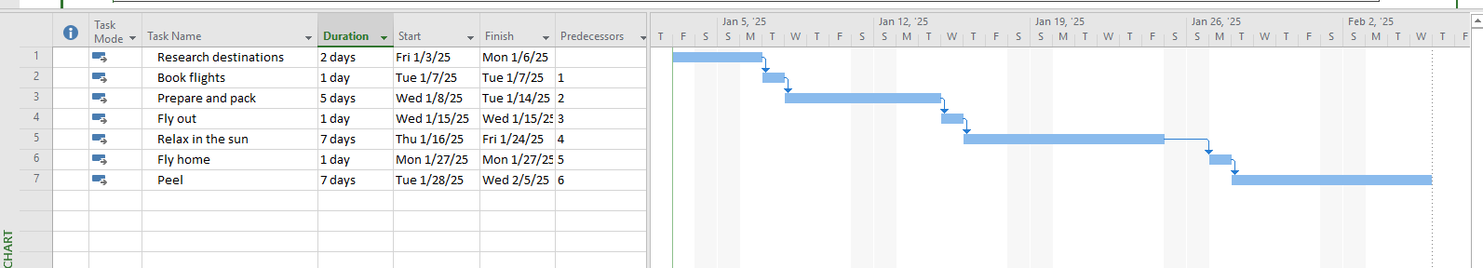

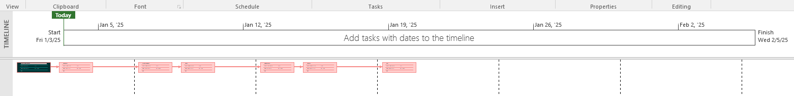

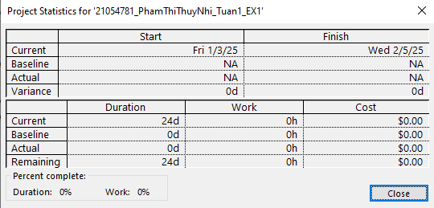

Exercise 2: Setting duration

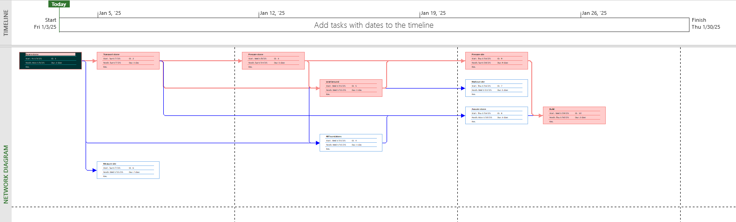

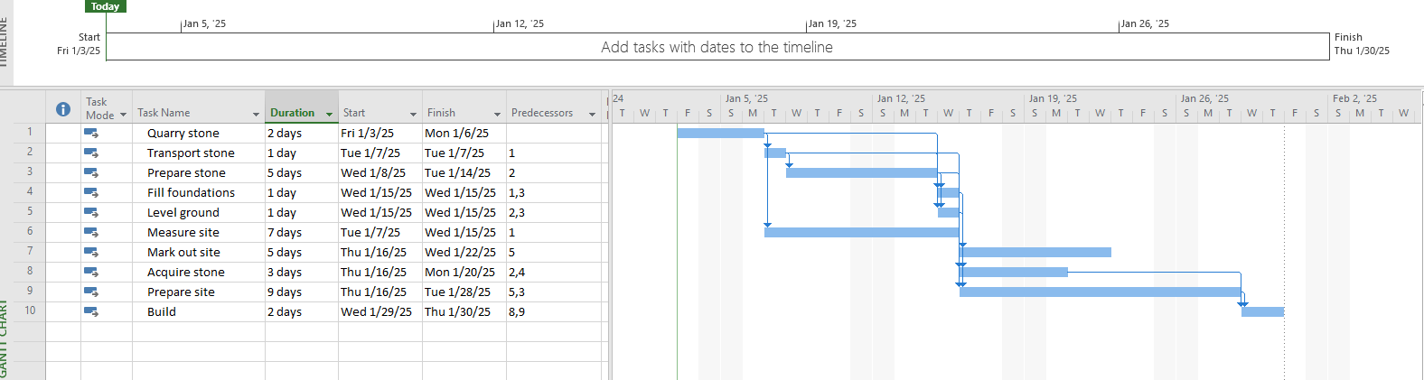

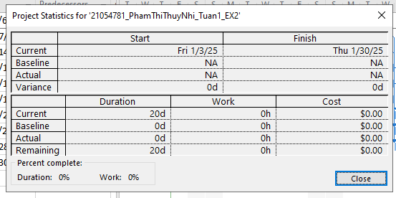

Exercise 3: Creating phases

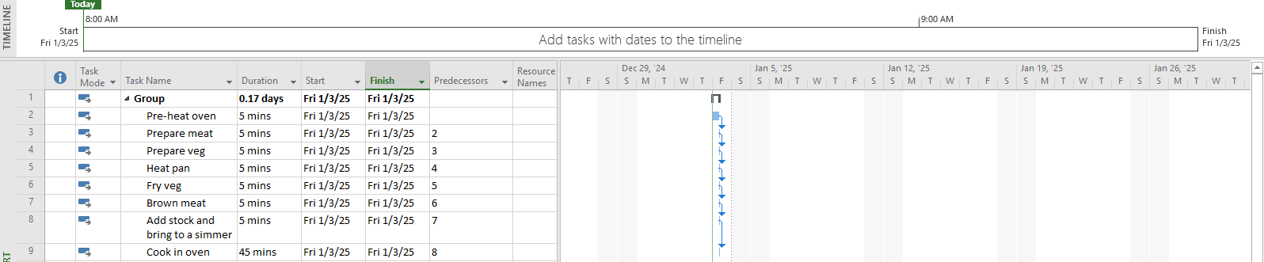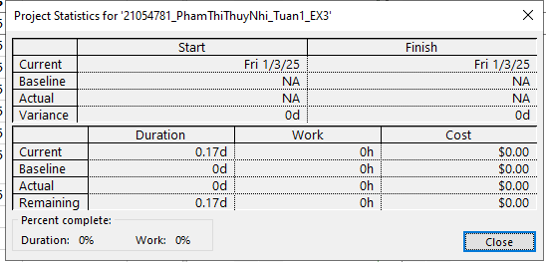

Exercise 4: Noah - Linking

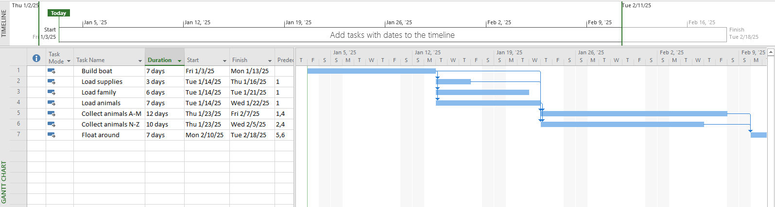

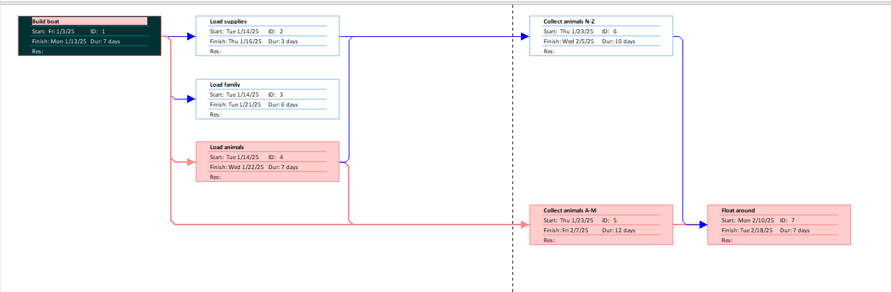

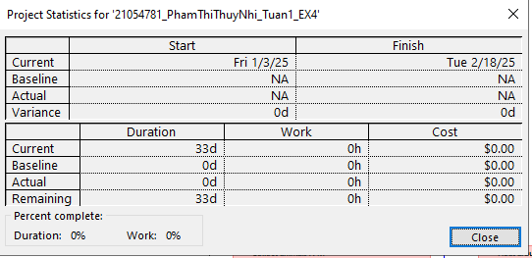

Exercise 5: Pyramid - Multi level grouping

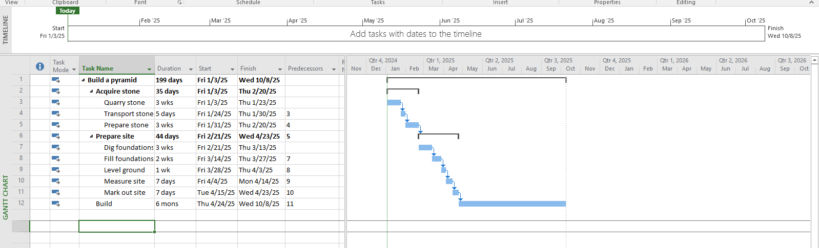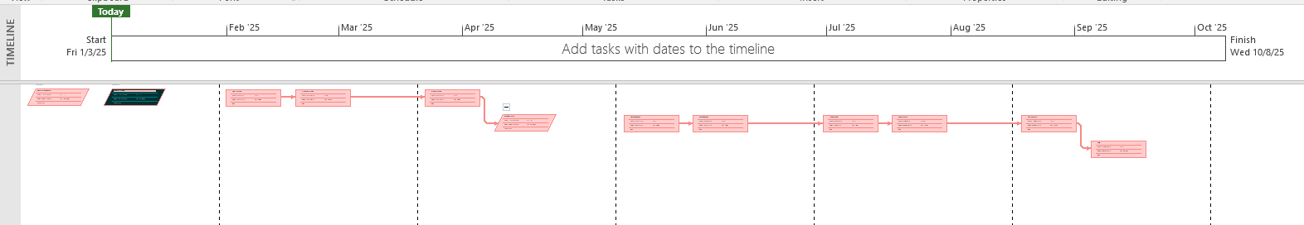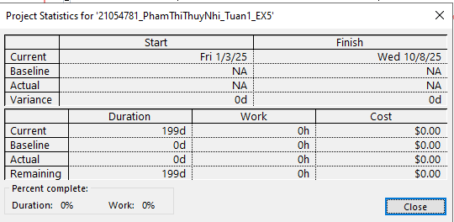

Exercise 6: Creating a plan for Staff Training

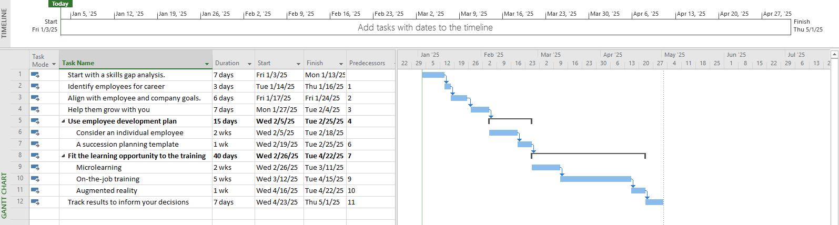

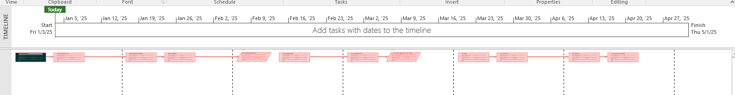

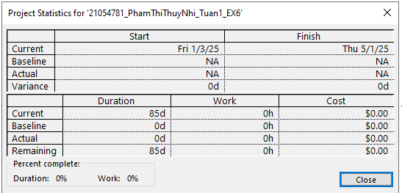

Exercise 7: Recurring task

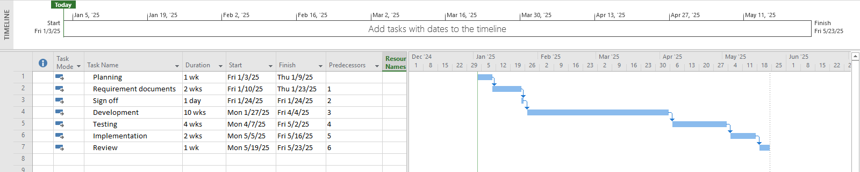

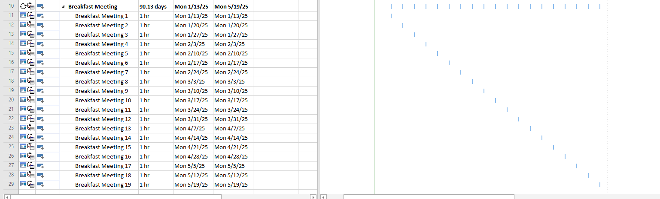

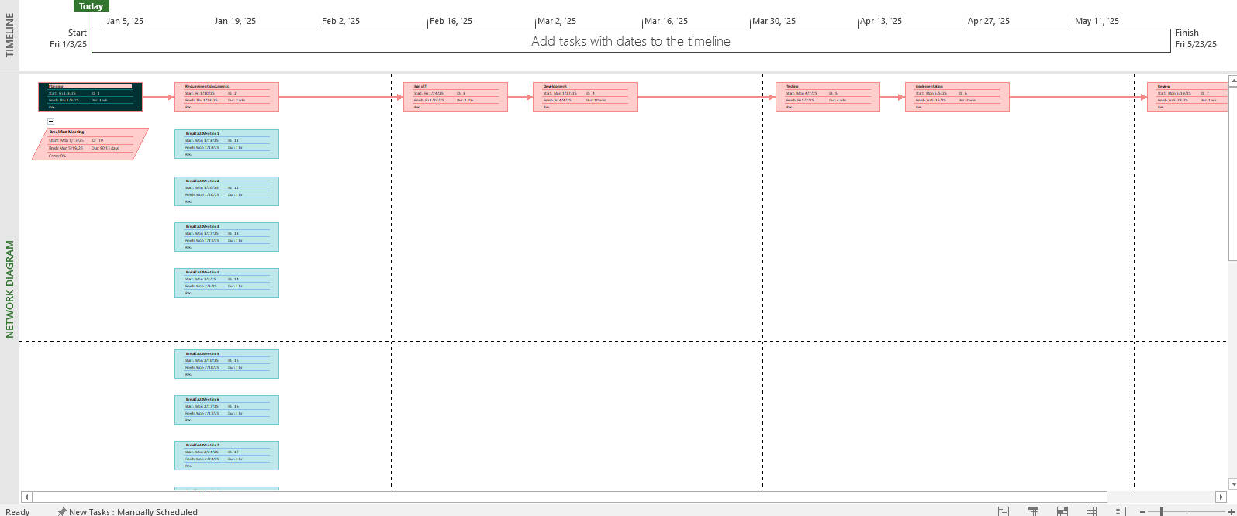

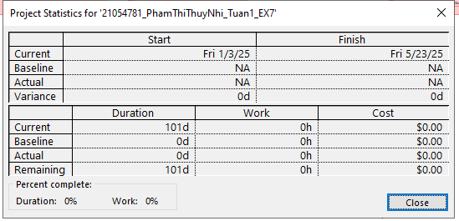

Exercise 8: Travelling task calendar

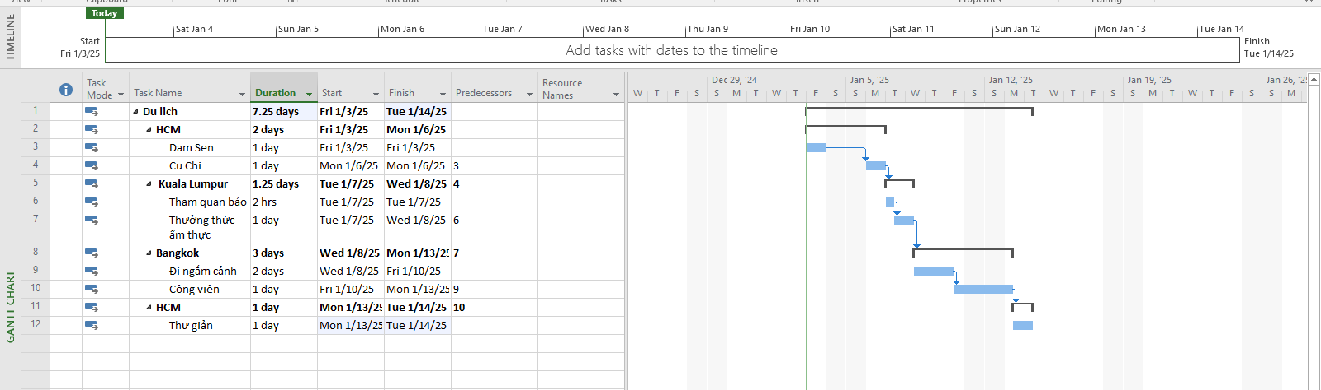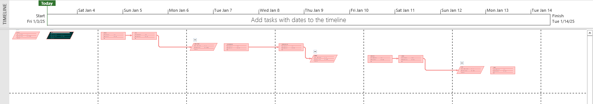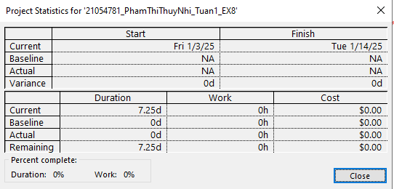

1. CALENDARS AND SCHEDULING

Exercise 1. Part Time - creating new calendar

A part-time worker will be used on this project. Go to the Change Working Time dialog box and create a new copy of the Standard calendar, calling it "Part Time".

* Update the working time of your new calendar so that:
* Mondays to Fridays are nonworking time

The remaining 2 weekdays have working time of 10:00 to 16:00 ( no breaks)

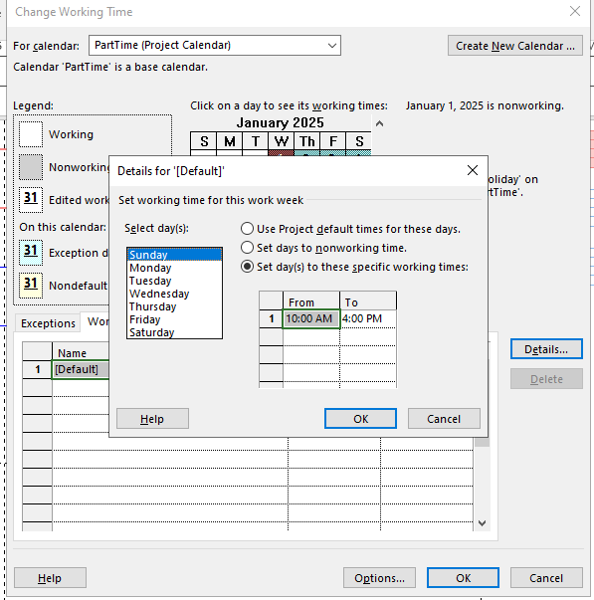

The Part time has also booked a holiday from 1 to 5 Jan. Create an Exception to their calendar with a Holiday name and these days as nonworking

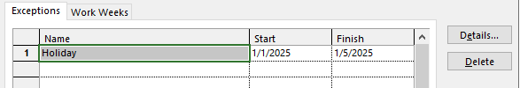

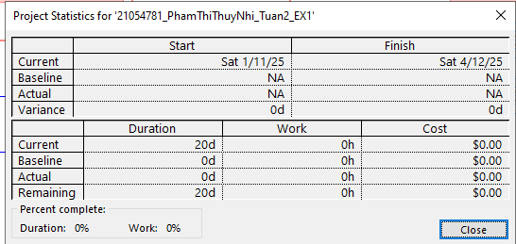

Kết quả

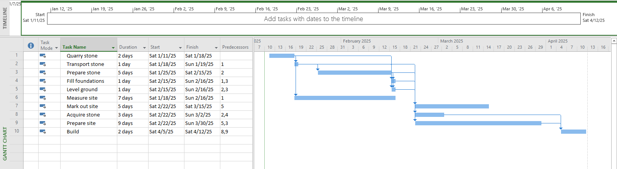

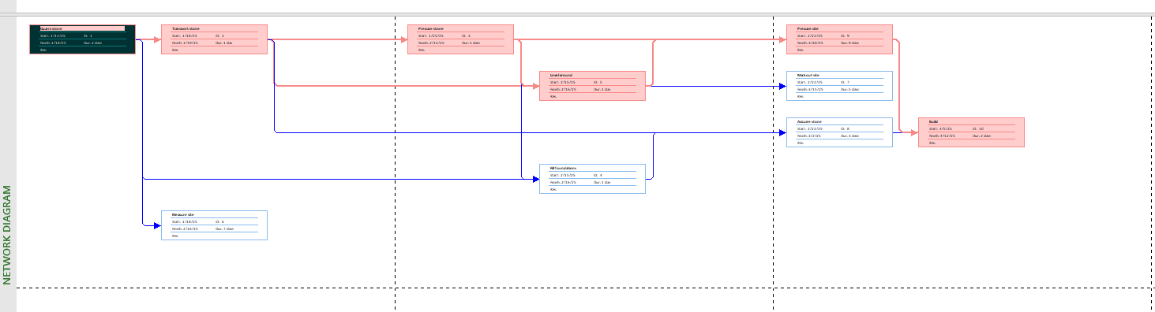

Exercise 2: Changing Working Time

Go to the Change Working Time dialog box and create an Exception called "Tet Holidays" during from 25 Dec 2024 to 3 Jan 2025 into nonworking time.

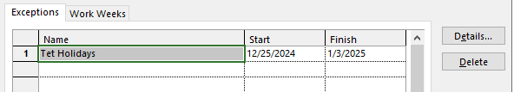

Change Work Weeks time of Standard calendar's default working week. This project's standard working time are:

08:30 to 17:30 Monday to Thursday (no lunch break)

08:30 to 16:00 on Fridays (no lunch break)

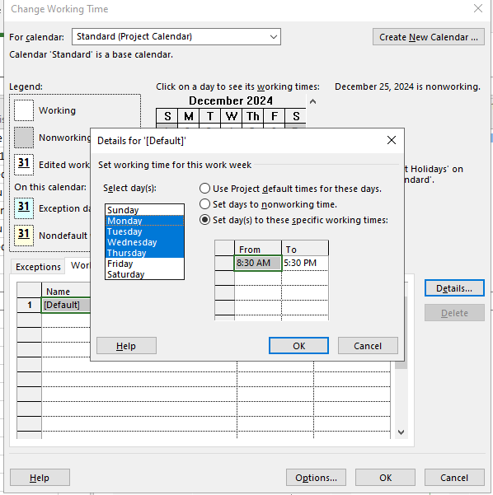

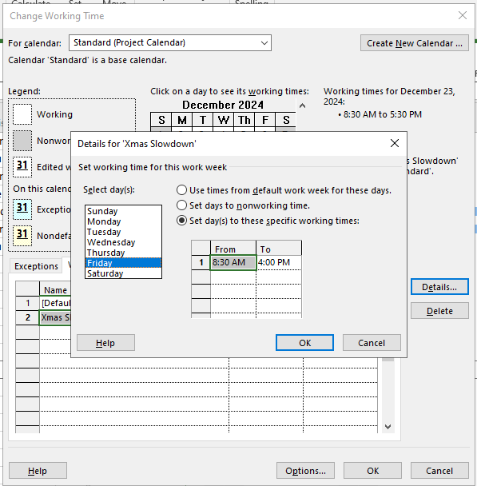

Add a new Work Week to the Standard calendar named "Xmas Slowdown". Use this to model a 12:30 finish on every weekday from 23 Dec 2024 to 5 Jan 2025

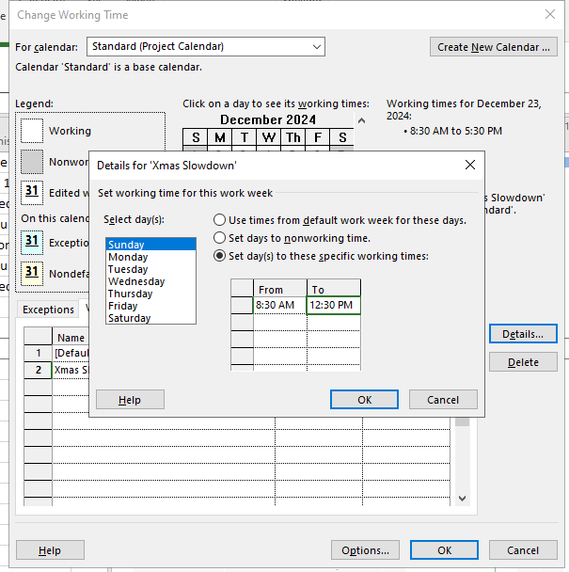

**Kết quả**

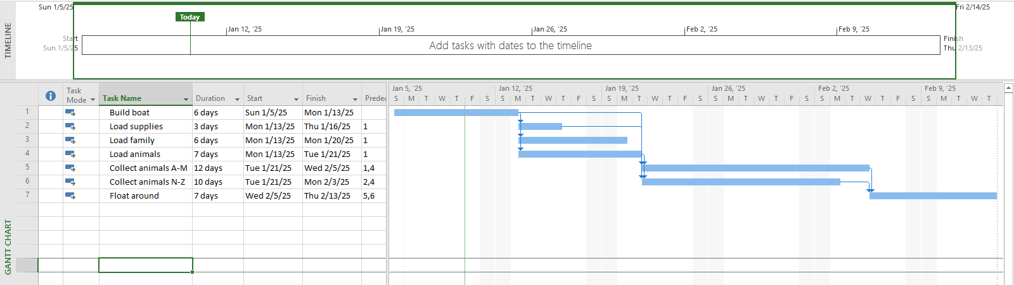

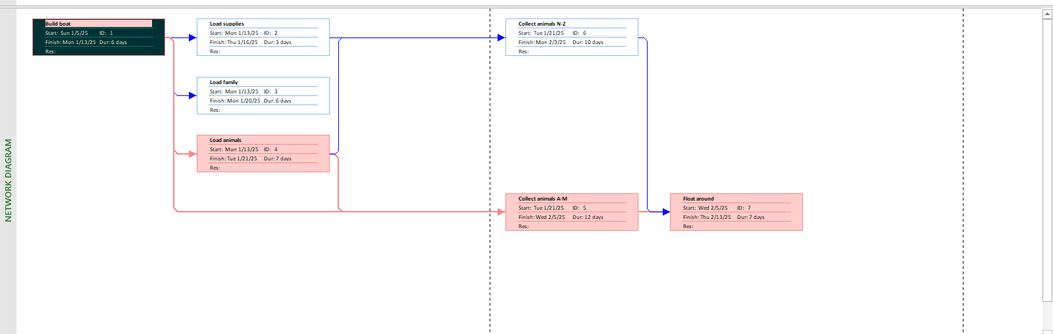

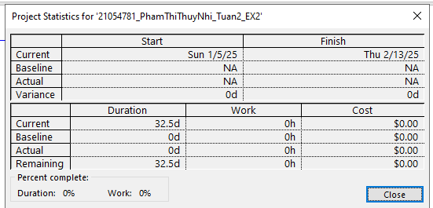

Exercise 3: Changing Working Time

The office will shut down for 2 weeks in the summer. Use the Change Working Time dialog box to create an Exception called "Summer Shutdown" and make the first 14 workdays of August nonworking time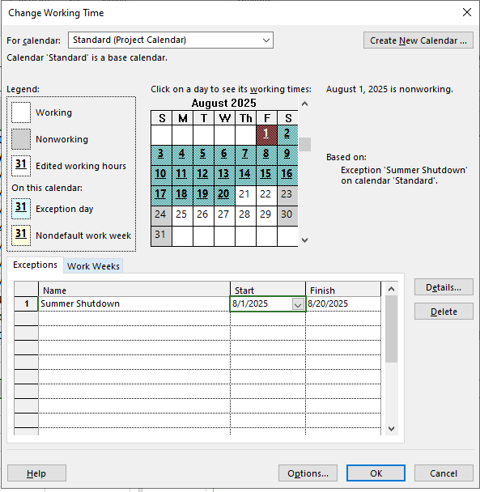

Create an Exception called “Independence Days” is 2 Sep nonworking time.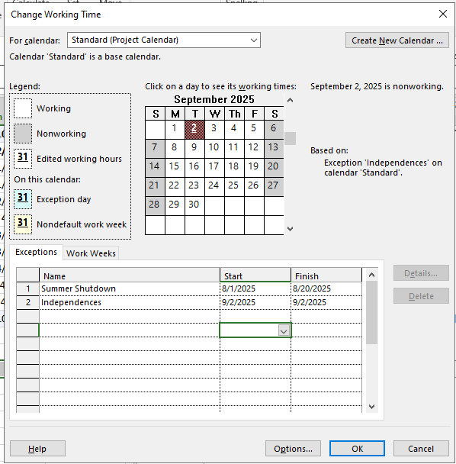

Create an Exception called “International Labor days” is 30 Apr and 1 May nonworking time

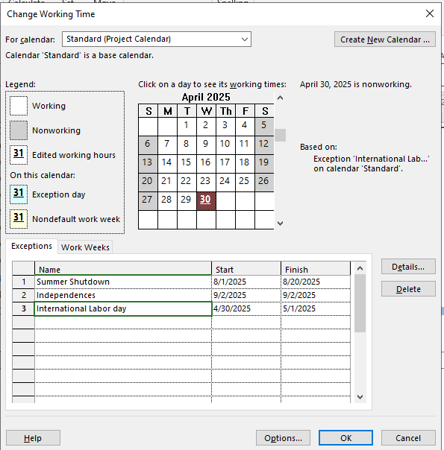

**Kết quả**

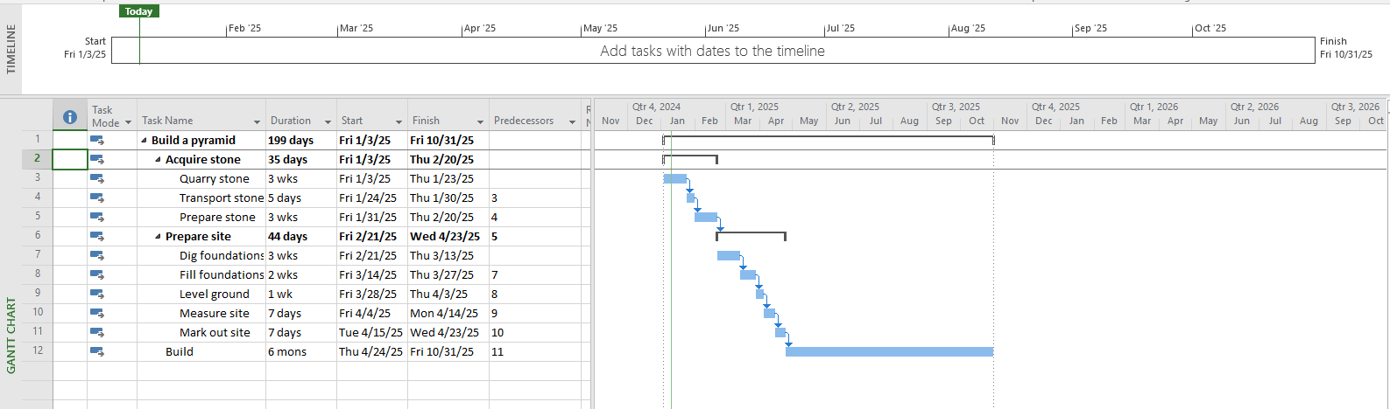

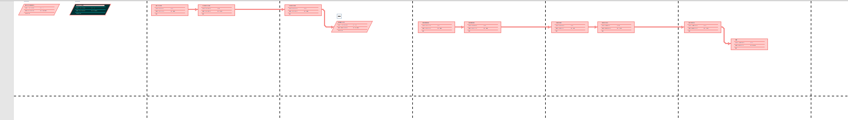

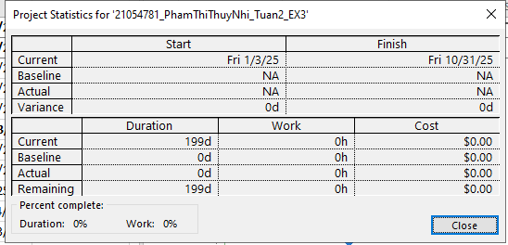

Exercise 4: Changing Working Time

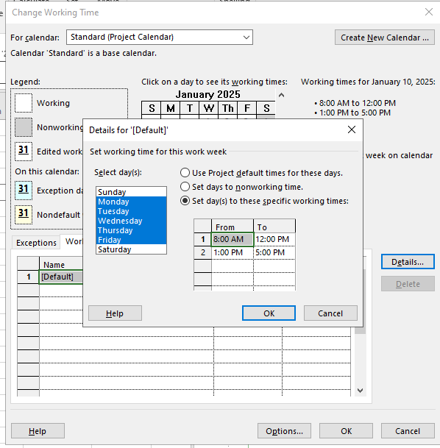

Add an exception in the Standard calendar called Recovery with in 7 lates workdays of March is non-working days

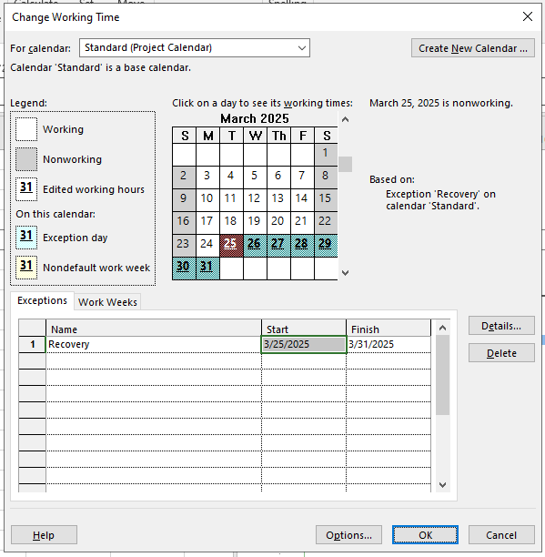

**Kết quả**

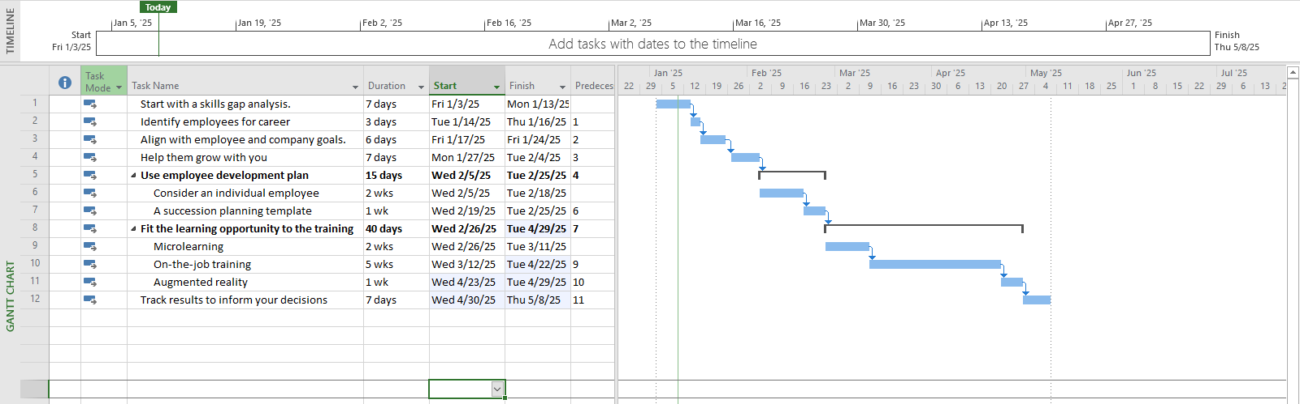

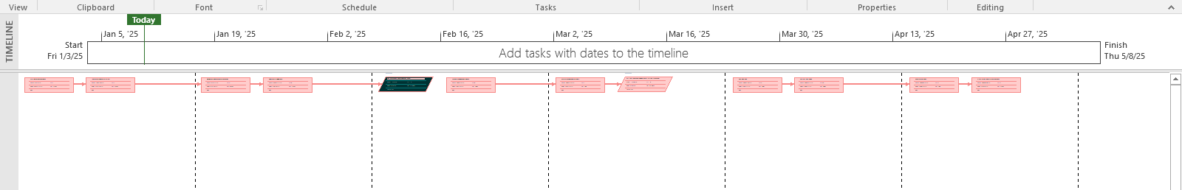

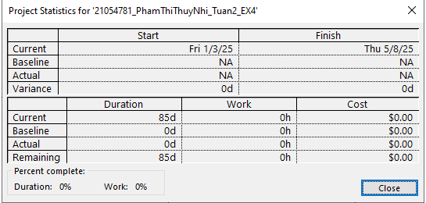

Exercise 5: Create the private Time for a project

Create the new Time Work for your project. [NameTimeProject]

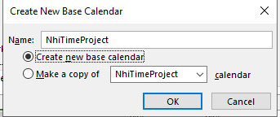

Change Work Weeks time of Standard calendar's default working week. This project's standard working time are:

* 08:00 to 12:00 on Mon, Wed, Fri
* 13:00 to 16:00 on Tue, Thu, Sat

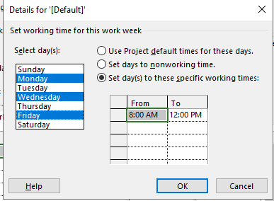

**Create an Exception called “International Labor days” is 30 Apr and 1 May nonworking time**

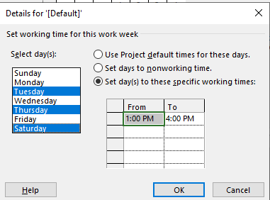

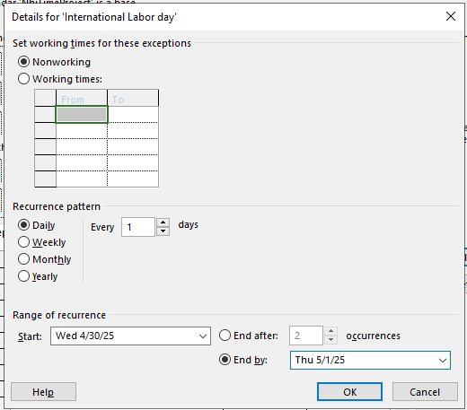

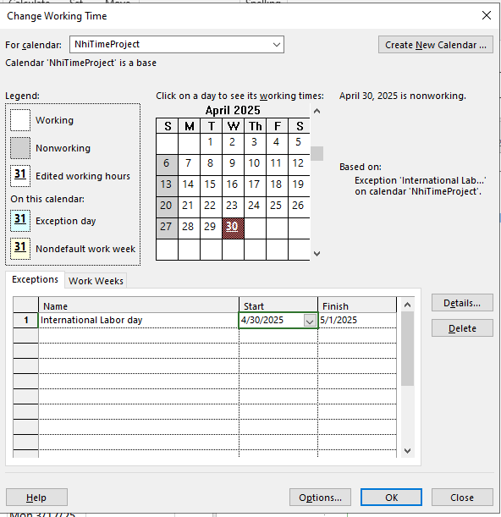

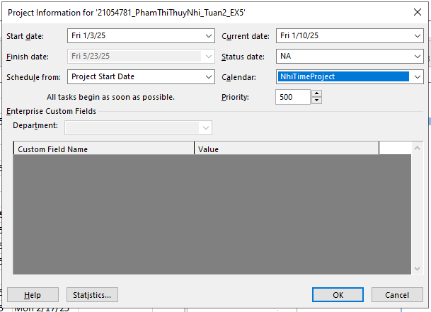

**Kết quả**

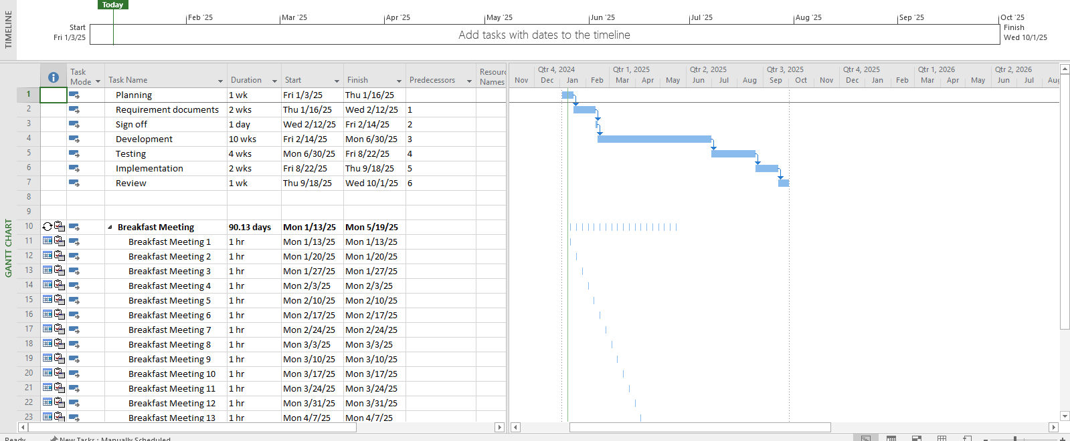

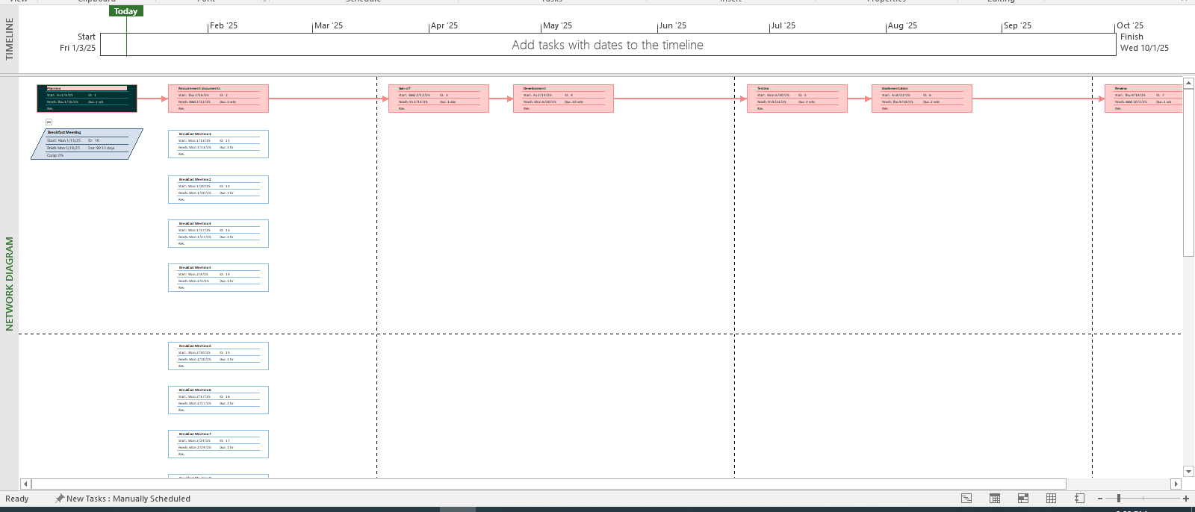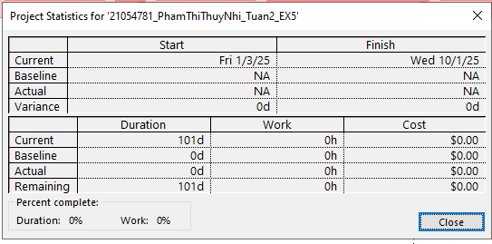

1. Working with Tasks

Exercise 1. Changing Working Time (Start Date 1/3/2025)

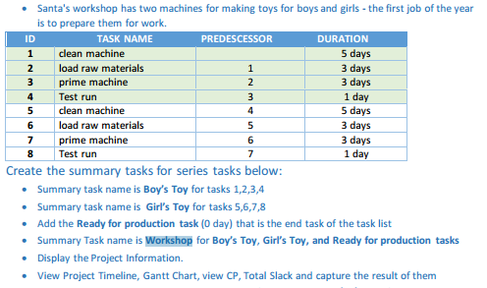

**Kết quả**

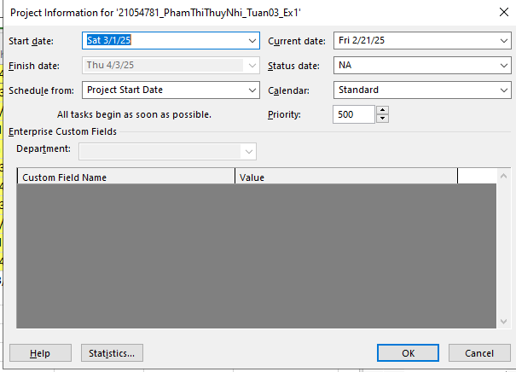

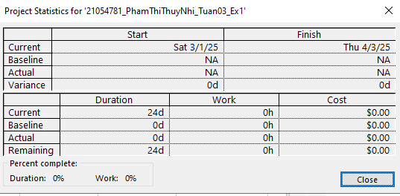

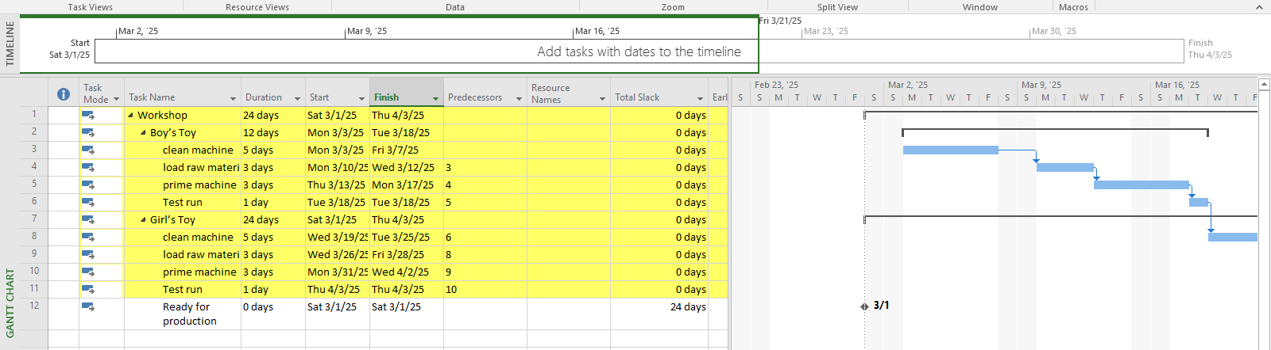

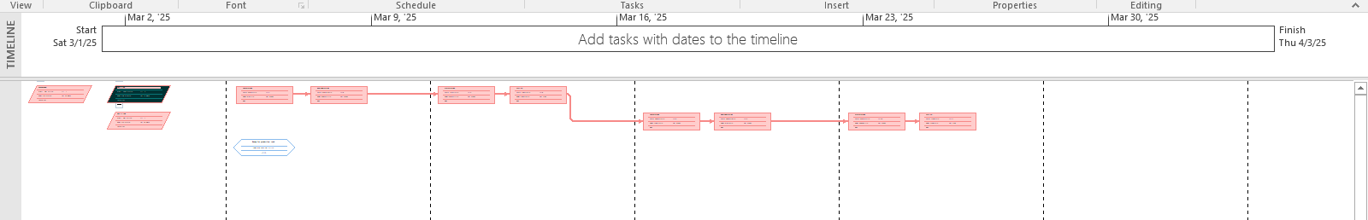

Exercise 2. Changing Working Time (Start Date 1/3/2025)

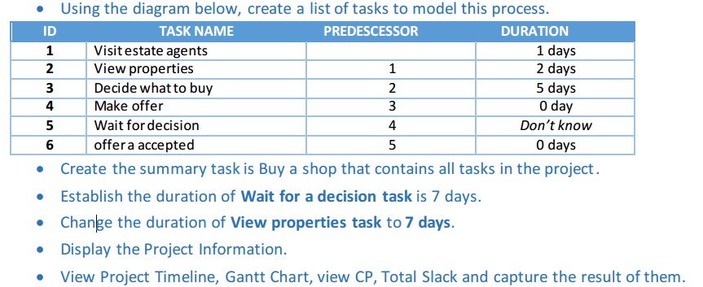

**Kết quả**

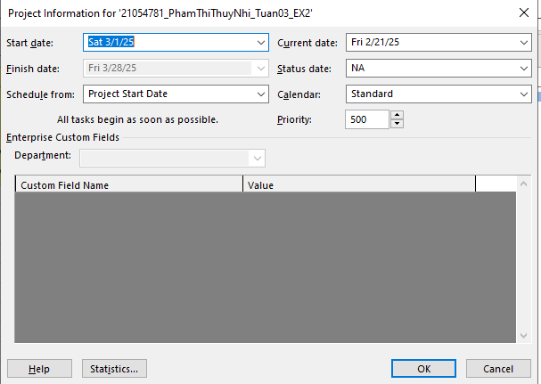

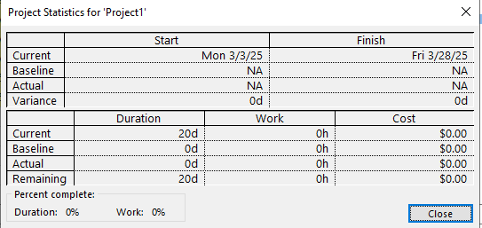

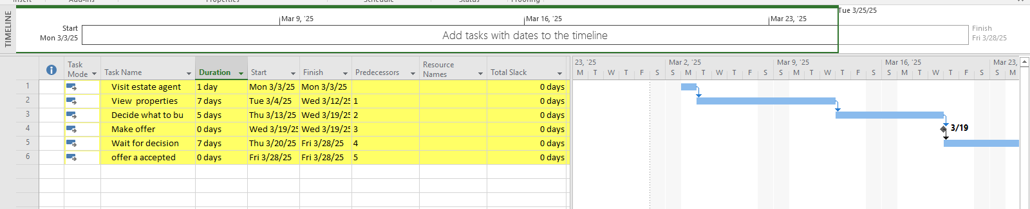

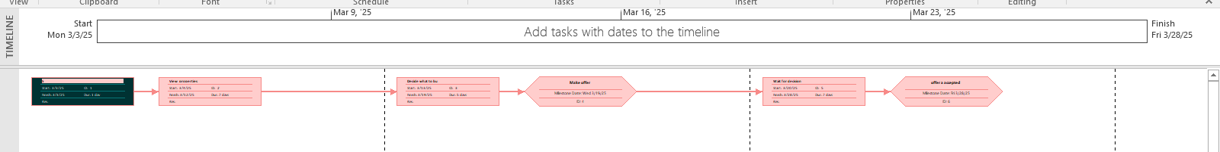

Exercise 3. Scheduling – Task dependencies

Kết quả

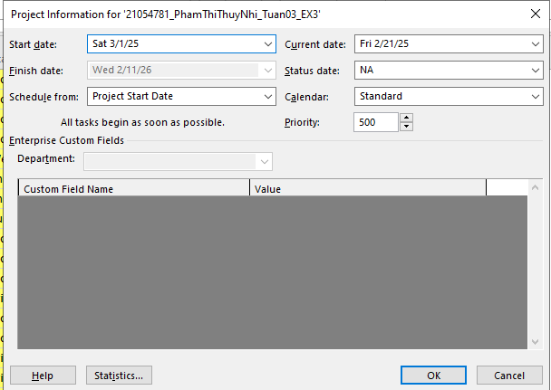

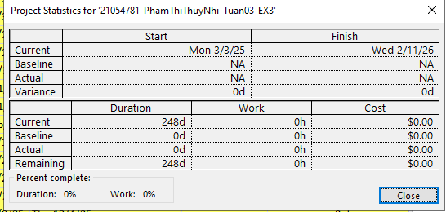

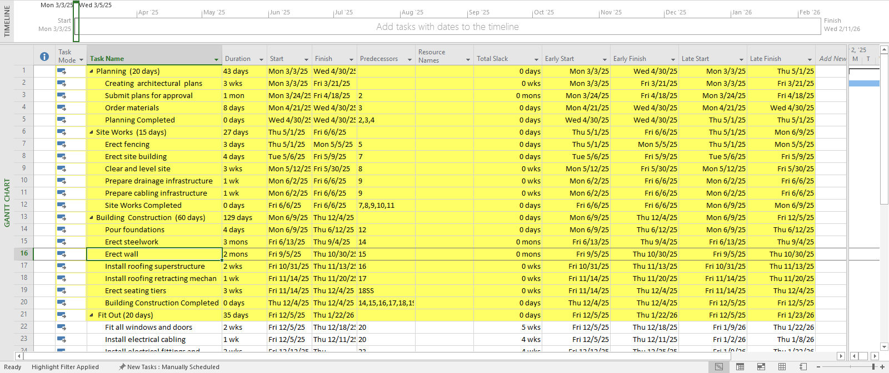 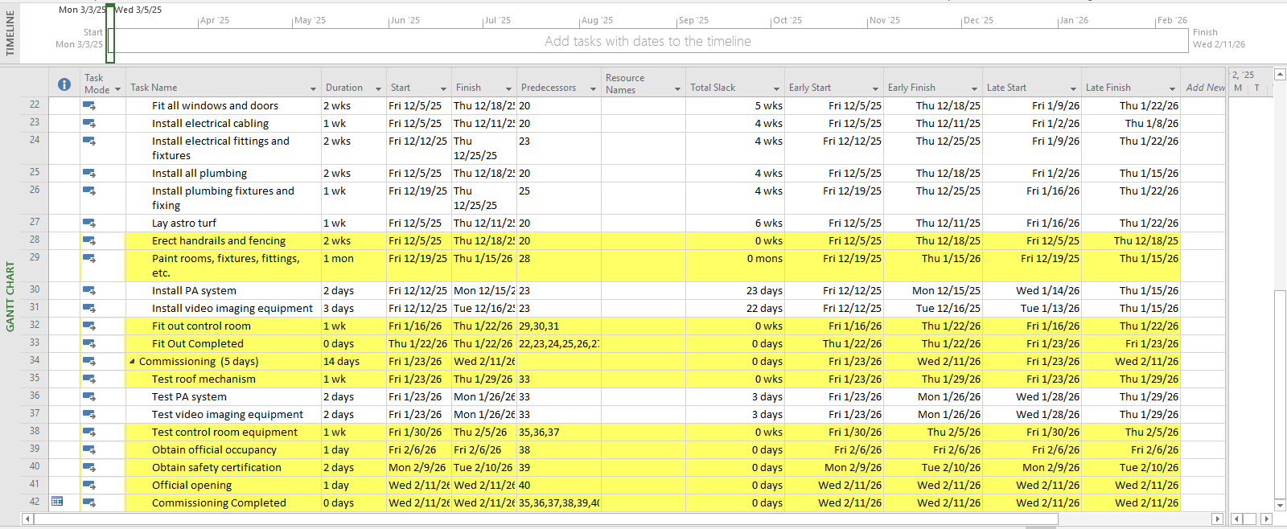

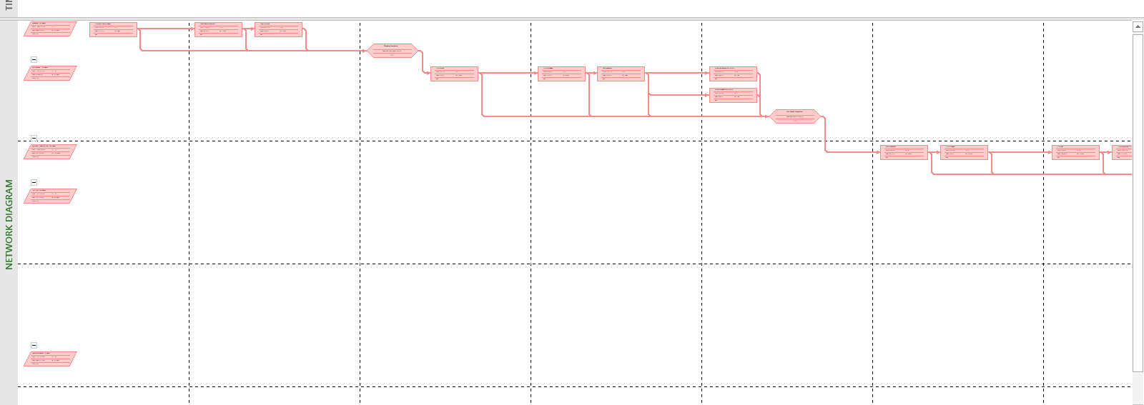

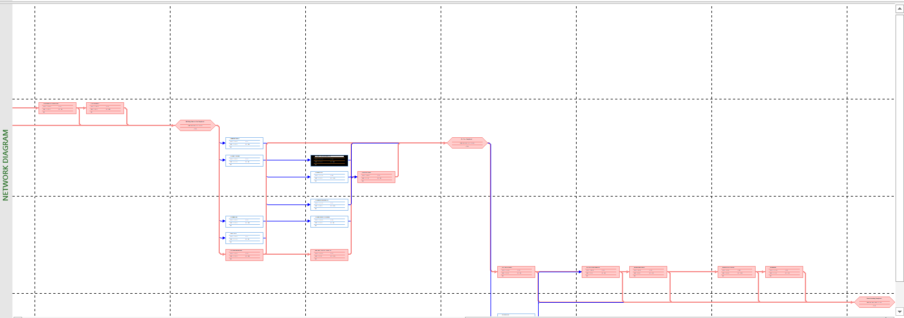

Check on Slack in Bar Styles slack lines in non-critical tasks

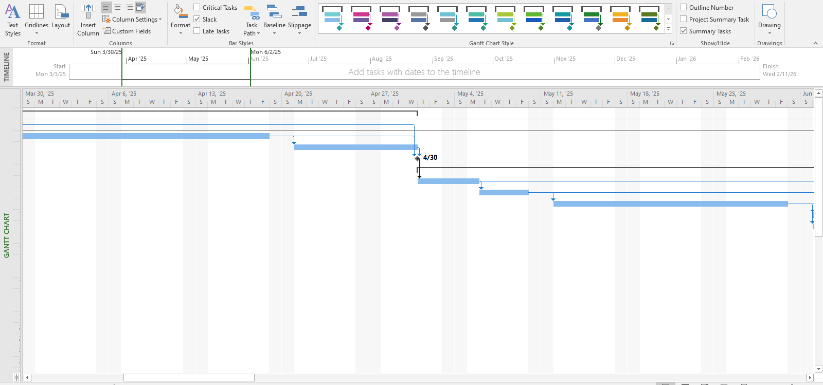

1. MODULE 4: Assigning resources to the tasks in Project

Exercise 1. Entering Resources

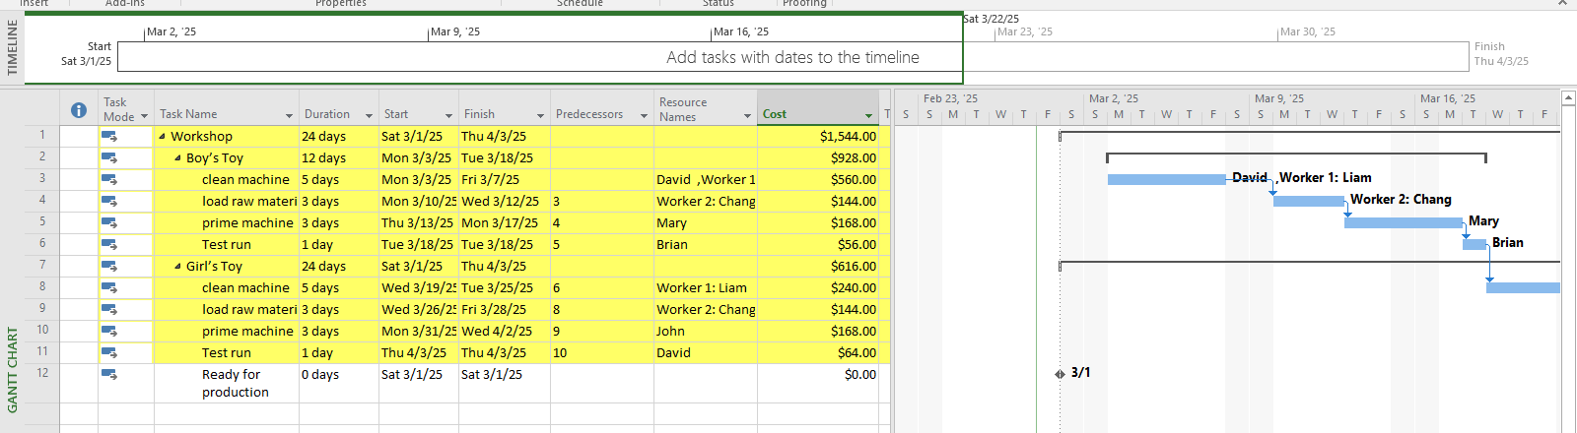

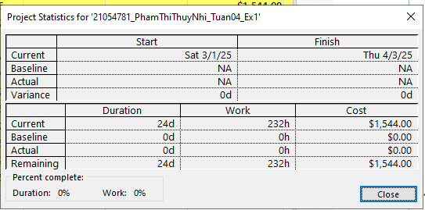

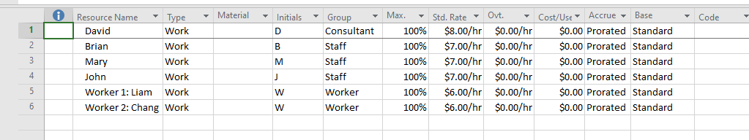

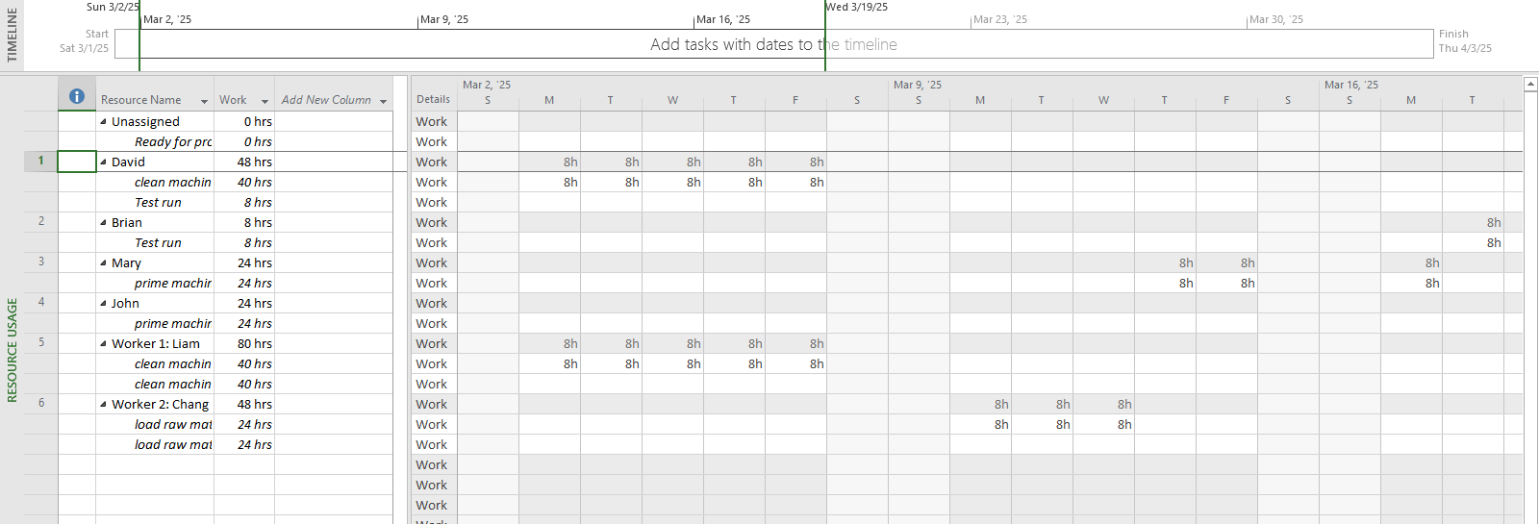

Exercise 2. Entering resources

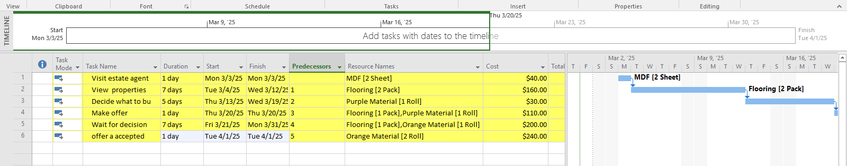

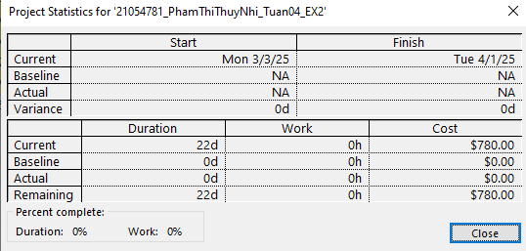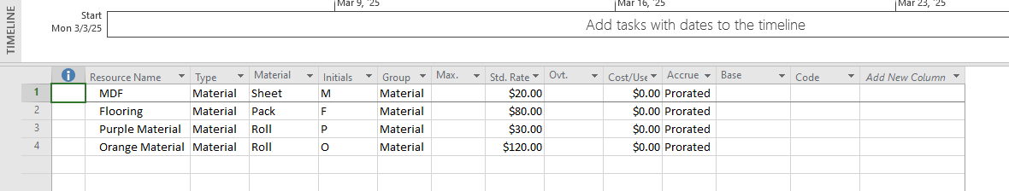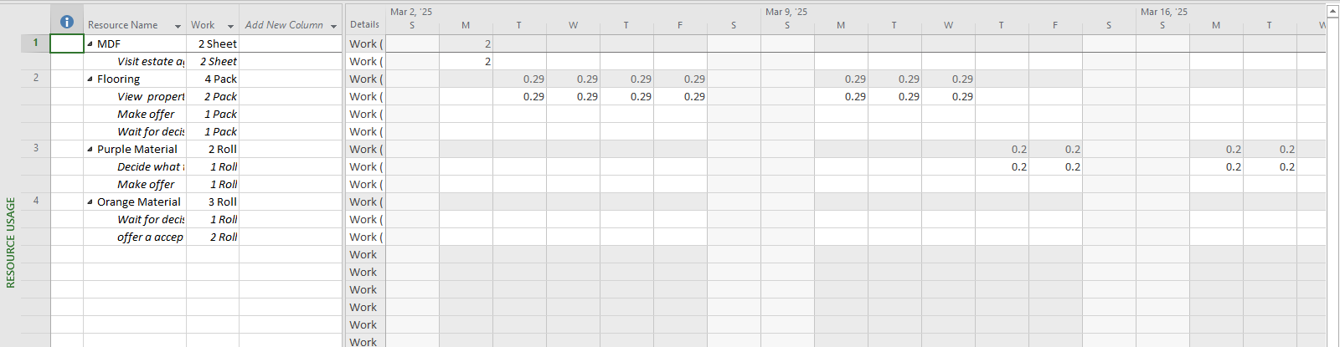

Exercise 3. Entering resources

- Create the project bellowing

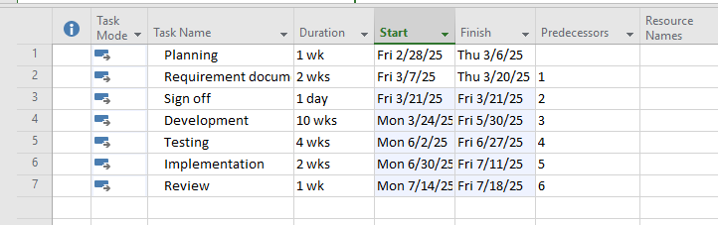

- Tab View - Resource Sheet / Tab Task - Resource Sheet

Add the resources this project bellow: Work/Material

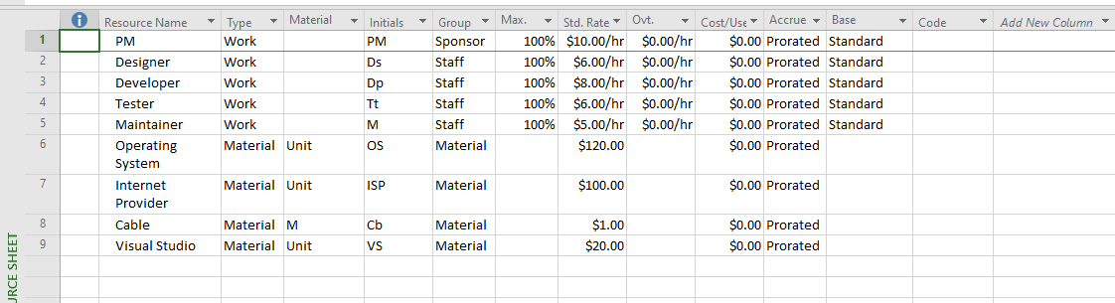

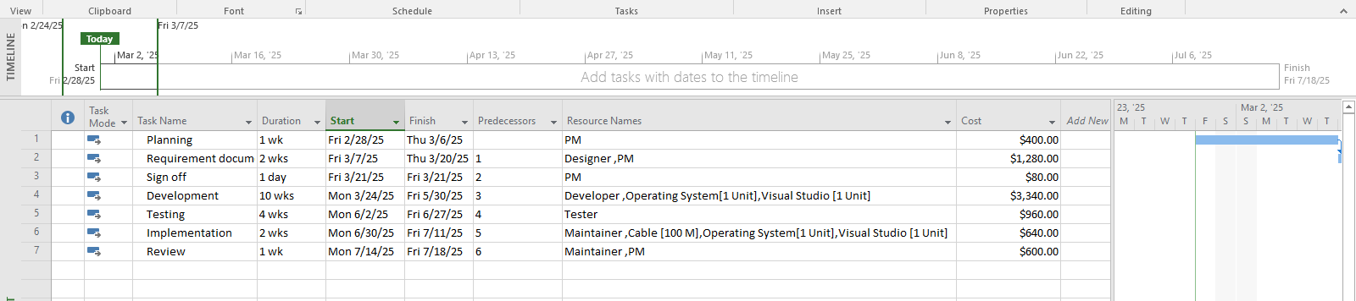

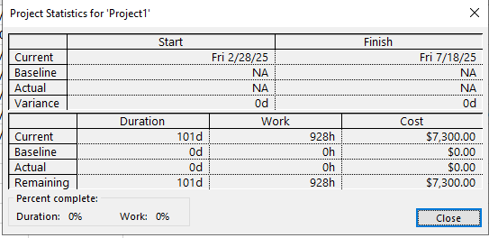

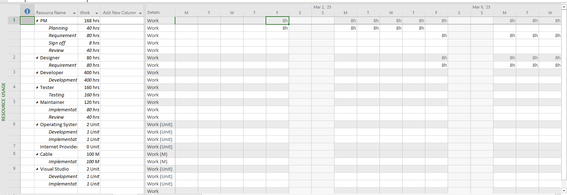

Exercise 4. Entering resources

• Tab View →Resource Sheet → Resource Views

Add the resources that type is work (default) for the project below:

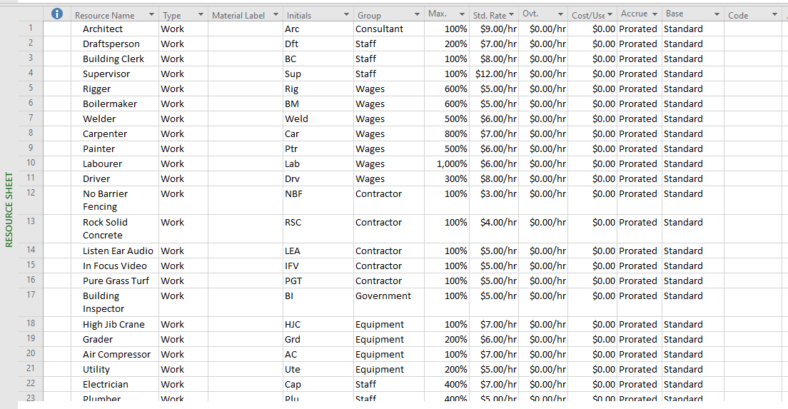



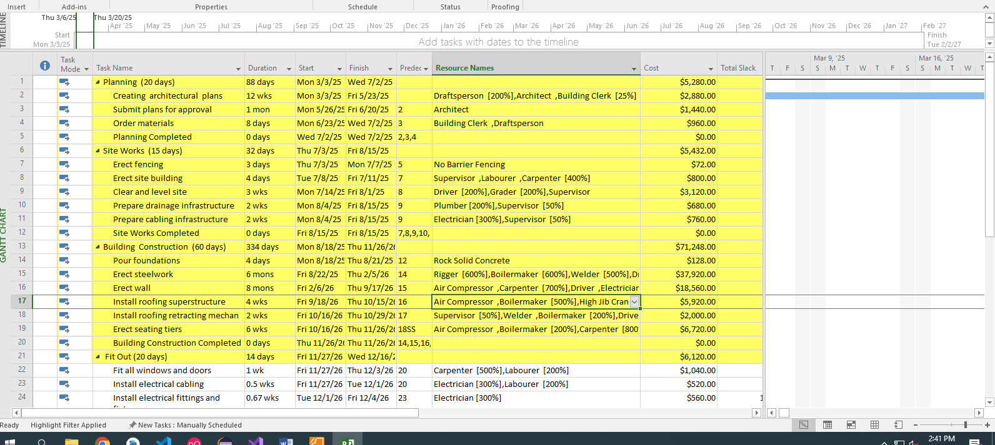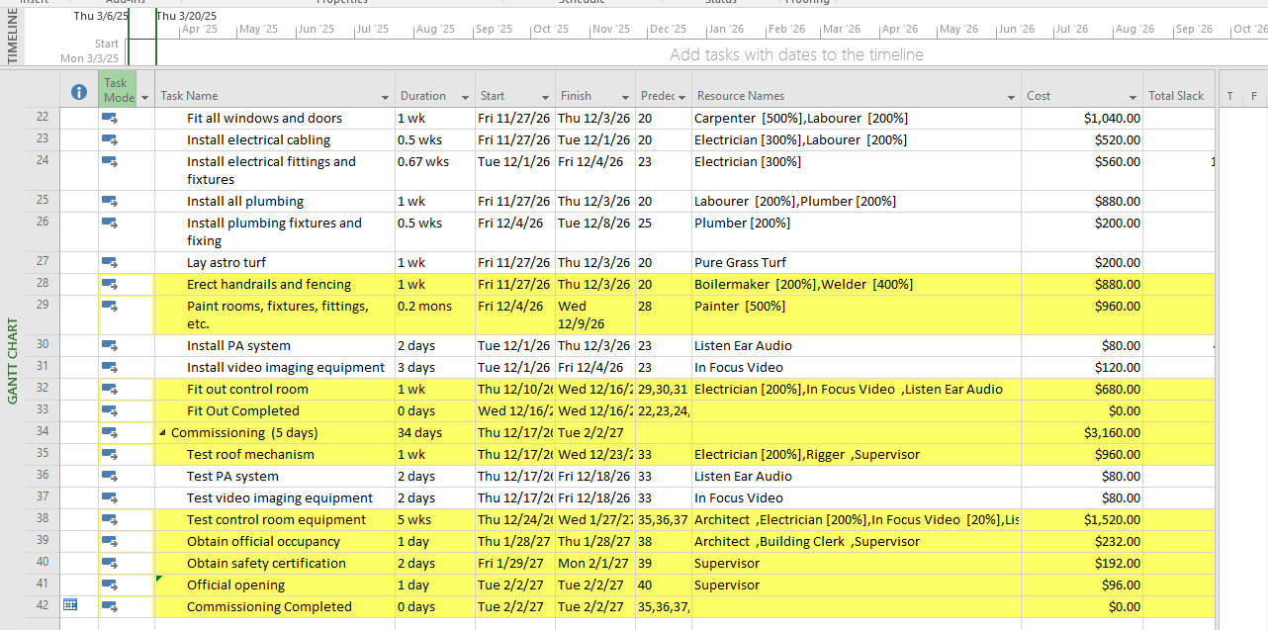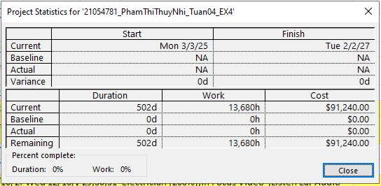

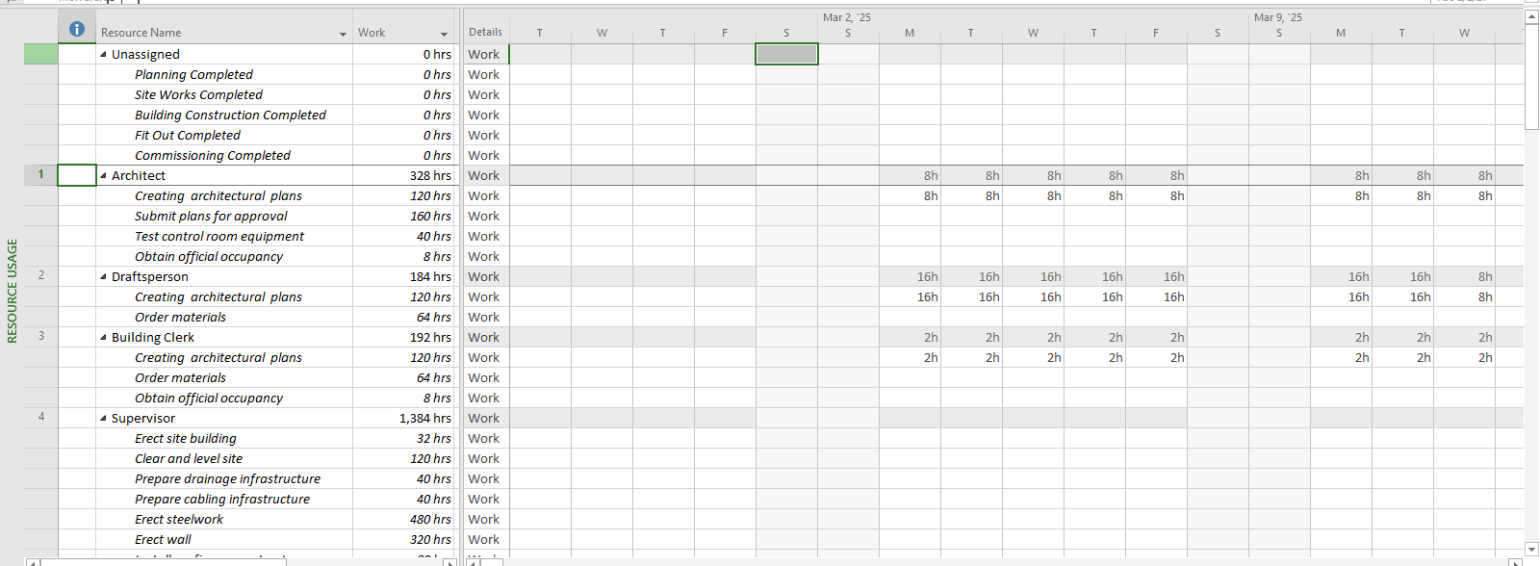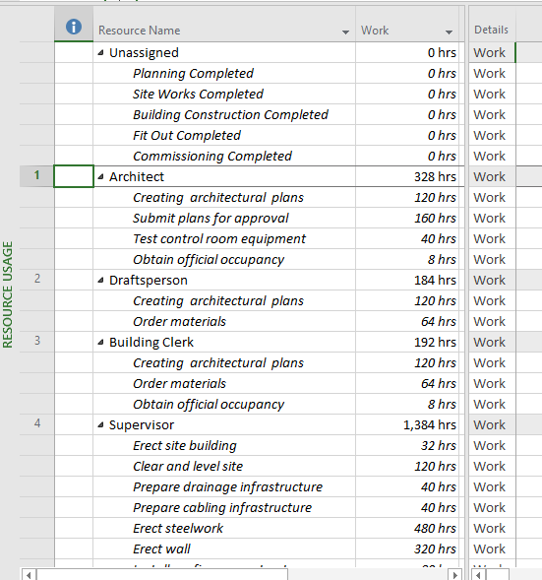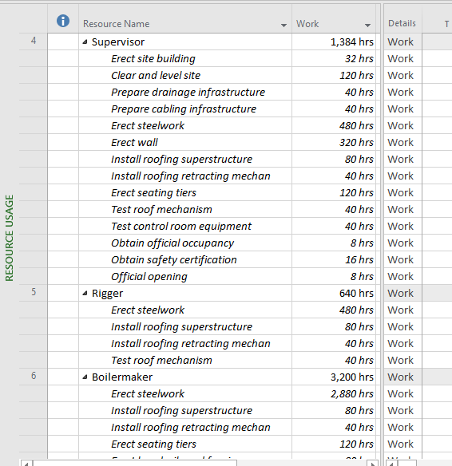 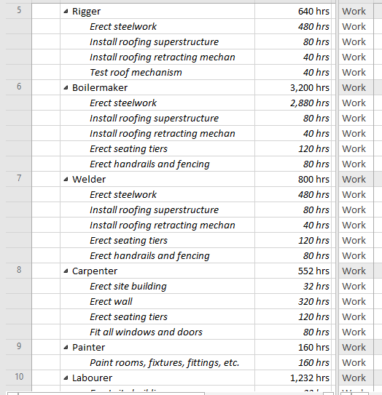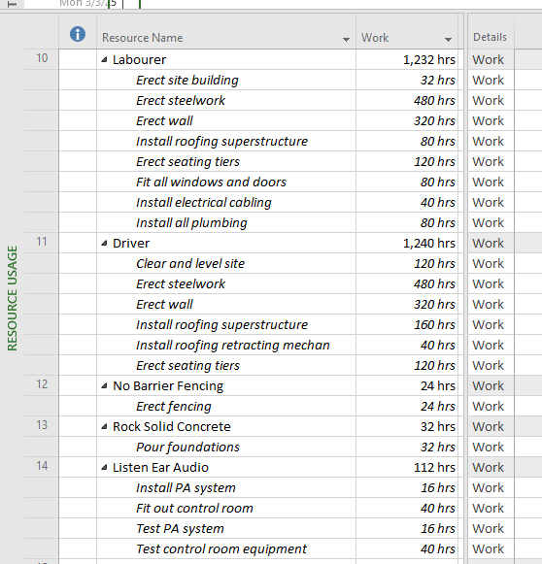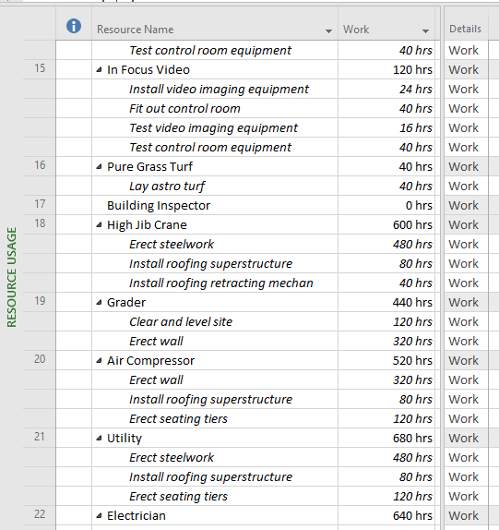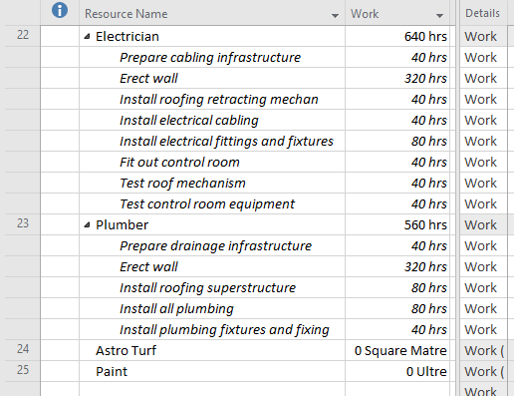

Exercise 5. Resources with the private working Time



