**UML EXERCISES**

**Give the description of some applications. The details is in the PDFs files that attached.**

**Requirements:**

1. Read the system description.

2. Re-design them.

**UML Diagrams for Online Banking System**

**Use Case Diagram**

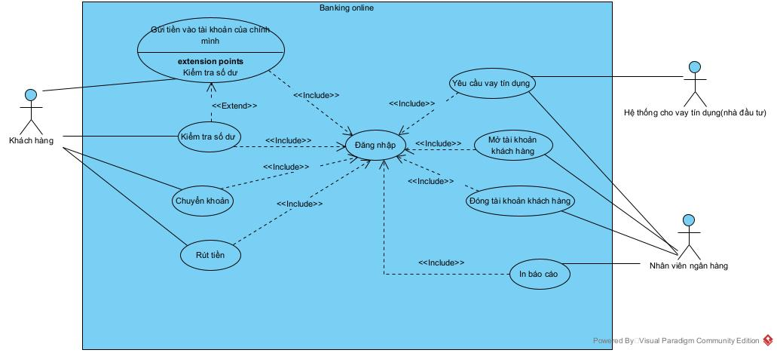

**Sequence Diagram**

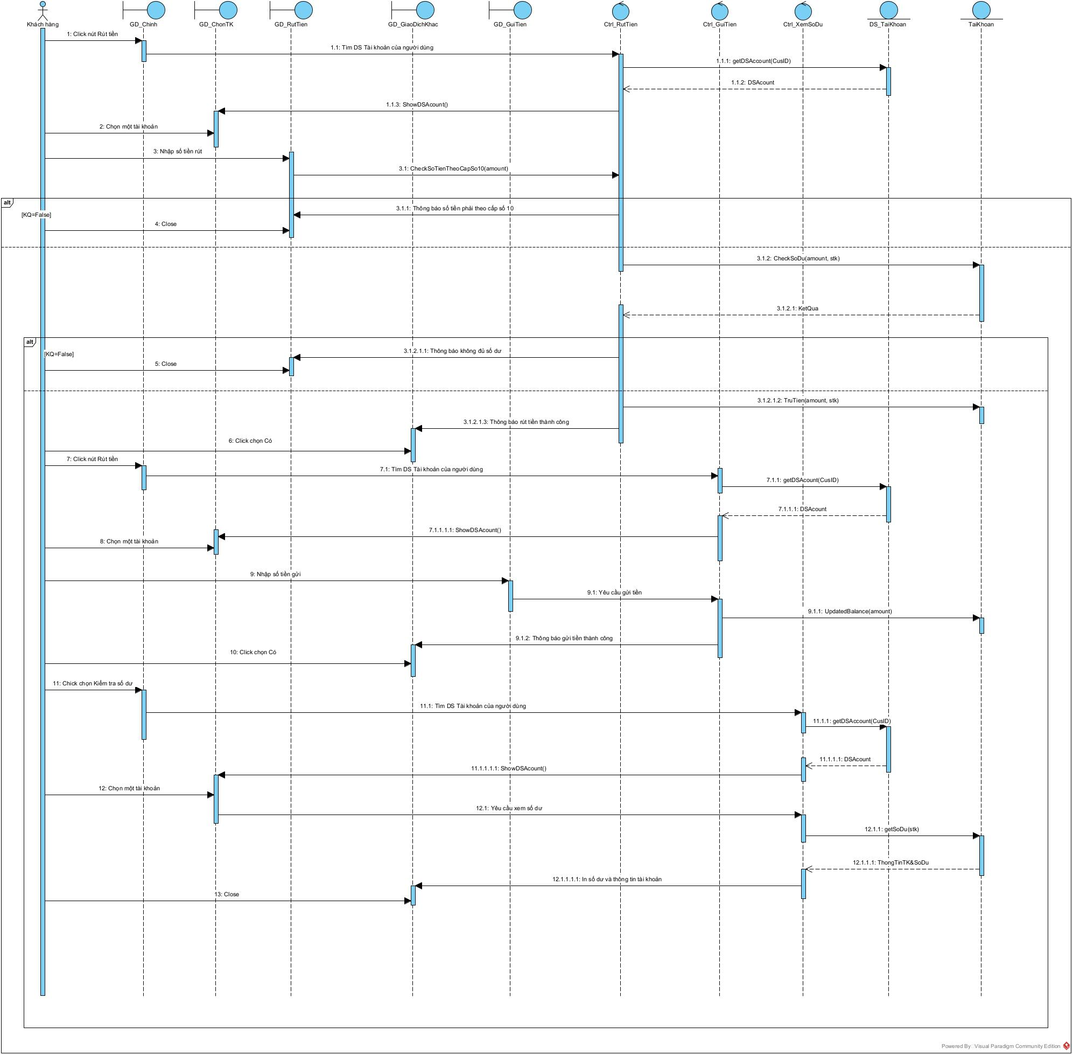

**Class Diagram**

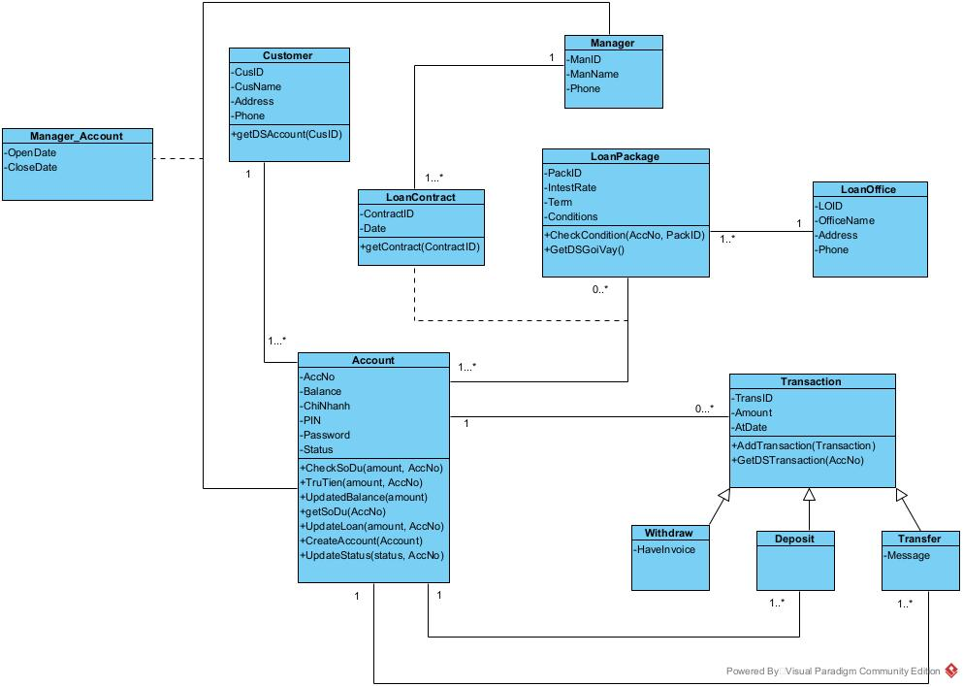

**Statechart Diagram**

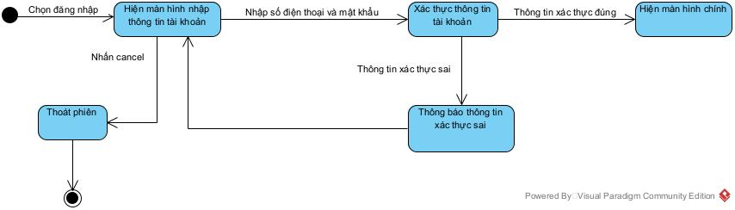

**Activity Diagram**

