Sơ đồ phân rã chức năng

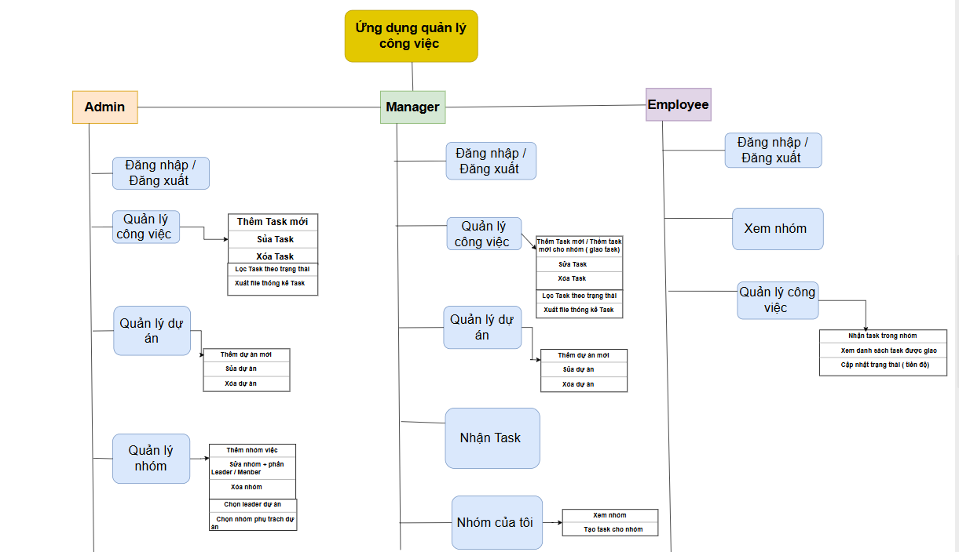

- Sơ đồ luồng hoạt động Giao Task

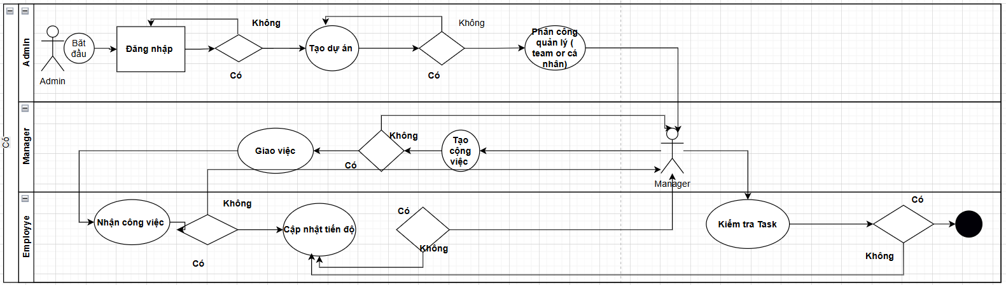

DATABASE

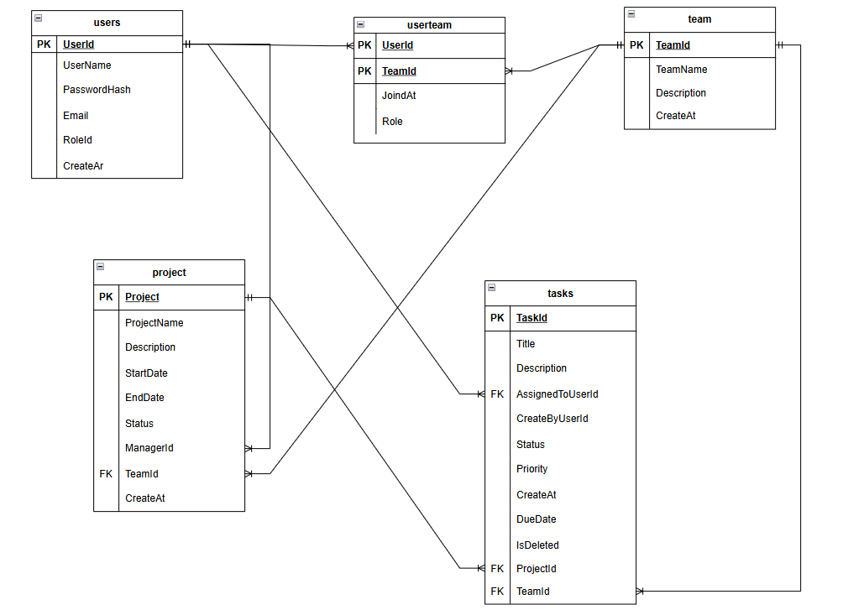

Table: Users
Column Name | Data Type & Constraints
UserId | INT, PRIMARY KEY, AUTO_INCREMENT
UserName | VARCHAR(50), NOT NULL, UNIQUE
PasswordHash | VARCHAR(256)
Email | VARCHAR(255)
RoleId | VARCHAR(50)
CreateAt | DATETIME

Table: team
Column Name | Data Type & Constraints
TeamID | INT, PRIMARY KEY, AUTO_INCREMENT
TeamName | VARCHAR(50), NOT NULL, UNIQUE
Description | VARCHAR(255), NOT NULL
CreateAt | DATETIME

Table: userteam
Column Name | Data Type & Constraints
UserId | INT, PRIMARY KEY, AUTO_INCREMENT
TeamId | VARCHAR(100), PRIMARY KEY,
JoinedAt | DATETIME
Role | VBRCHAR(50)

Table: project
Column Name | Data Type & Constraints
Project | INT, PRIMARY KEY, AUTO_INCREMENT
ProjectName | VARCHAR(100), NOT NULL
Description | TEXT
StartDate | DATENAME
EndDate | DATENAME
Status | VARCHAR(50)
ManagerId | INT ,FOREIGN KEY
TeamId | INT,FOREIGN KEY
CreateAt | DATETIME

Table: task
Column Name | Data Type & Constraints
TaskId | INT, PRIMARY KEY, AUTO_INCREMENT
Title | VARCHAR(150), NOT NULL
Description | TEXT
AssignedToUserId | INT
CreateByUserId | INT
Status | VARCHAR
Priority | VARCHAR
CreateAt | DATETIME
DueDate | DATETIME
IsDeleted | INT
ProjectId | INT, FK -> project(projectId)
TeamId | INT, FK -> team(teamId)
IsActive | BOOLEAN, DEFAULT 1

