**Outcomes of Patients with Acute Leukemia Undergoing Bone Marrow Transplant**

**Introduction**

Allogeneic hematopoietic stem cell transplant is a standard therapy of choice for curative intent for many acute leukemias but also poses life-threatening complications. Therefore, patient, donor, and protocol factors associated with event-free survival must be identified. Examples of patient and donor factors include French-American-British (FAB) classification (based on morphology), stage of disease, development of acute graft versus host disease (aGVHD), and recovery of platelets. Donor factors include age, sex, and cytomegalovirus (CMV) status. Examples of transplant protocol factors include donor source, post-transplant methotrexate, and time from diagnosis to transplantation. We sought to evaluate event-free survival in a multicenter study of adult patients with leukemia who underwent a radiation-free condition regimen with busulfan and cyclophosphamide. This study aims to identify factors associated with event-free survival and the development of aGVHD, which may inform clinician decision-making for therapeutic options.

**Methods**

This multicenter study included patients with acute leukemia that underwent bone marrow transplantation between March 1, 1984, and June 30, 1989. These patients were enrolled from four different hospitals in the US and Australia. Baseline information regarding the recipient, donor, and transplant-related information was collected. All patients received an identical conditioning regimen of oral busulfan and intravenous cyclophosphamide. Additionally, the presence of aGVHD was obtained. The patients were followed over time, and the collected outcomes were relapse and death. The primary outcome of interest for this study was disease-free survival, and the secondary outcomes were relapse and aGVHD.For multivariable analysis, we included the recipient's age, sex, disease group, methotrexate use, wait time, and CMV status in the recipient. These variables were chosen based on prior literature that supports their association with outcomes in patients with acute myeloid leukemia.(1) We run a diagnostic model to determine whether the proportional assumption holds true for all variables. Given the small sample size, a p-value of <0.10 was considered significant. R studio Version 2022.12.0+353 (2022.12.0+353) (R Foundation for Statistical Computing, Vienna, Austria) was used for the analysis.

Disease Free Survival

We used the non-parametric Kaplan-Meier approach to estimate the median disease-free survival. Deaths and relapse were considered events, while loss of follow-up or the end of the study without an event were censored. Kaplan-Meier curve was constructed using base R function.

Baseline information

Baseline information, including recipient, donor, and transplant-related variables, were summarized as mean with standard deviation or counts with percentage, depending on the data type. In addition, the information was stratified by disease group or FAB classification. The summarized data is presented in two separate tables. Depending on the data type, a Chi-squared test, Fisher exact test, or t-student test was performed for univariable analysis. For mean comparison between more than two groups, an ANOVA test with Bonferroni correction was performed.

Association of baseline variables with differences in disease-free survival

In the first Cox model (unadjusted), each variable that included baseline information from the recipient, donor, and transplant was individually evaluated in relationship with the disease-free survival outcome. After that, all variables were included in the Cox model (adjusted). The hazard ratio, 95% confidence intervals of the estimate, and p-value were reported.

Association between the occurrence of aGVHD after transplantation and disease-free survival.

We considered aGVHD a time-varying factor because aGVHD occurs after transplantation and is not present at baseline. Patients have to live long enough to develop aGVHD and therefore contribute to survival time both before and after the development of aGVHD. We consider the time-varying covariate: tx.tv =1 if occurred aGVHD by time t and 0 otherwise. In addition, we consider recipient age, sex, disease group, methotrexate use, wait time, and CMV status in the recipient are potential confounders since they're associated with the risk of GVHD (1), they may impact the prognosis for recovery, and they are not in the causal path of the associations of interest. We will fit a time-dependent Cox model adjusting for the time-varying covariate, recipient age, sex, disease group, methotrexate use, wait time, and CMV status in the recipient to assess the association between the occurrence of aGVHD after transplantation and disease-free survival. Then, we ran a Wald test to test the null hypothesis that there is no association between the occurrence of aGVHD after transplantation and disease-free survival.

Association between the occurrence of aGVHD after transplantation and risk of relapse.

Similarly, we fit a time-dependent Cox model adjusting for the time-varying covariate and the same potential confounders to assess the association between the occurrence of aGVHD after transplantation and the risk of relapse. To test the null hypothesis that there is no association between the occurrence of aGVHD after transplantation and the risk of relapse after adjusting for the confounders, we perform a Wald test with a 10% significance level.

Association Between Baseline Factors and Disease-Free Survival Among Patients Who Developed aGVHD

To determine whether any of the measured baseline factors are associated with the differences in disease-free survival among patients with aGVHD, we first fitted a Cox Proportional model for each baseline factor. We fitted a model that included all the baseline factors to determine which were significantly associated with the differences in disease-free survival among patients with aGVHD. We fitted the final Cox Proportional Model with baseline variables significantly associated with the outcome (disease group, donor age, methotrexate, and wait time). We also included patients' age and sex despite not being significantly associated with the outcome considering the exploratory nature of this analysis and patients' CMV status due to its known effects on morbidity and mortality from previous research.

Association Between Baseline Prophylactic Use of Methotrexate and Increased or Decreased Risk of aGVHD

To determine whether the prophylactic use of methotrexate was associated with an increased or decreased risk of acute aGVHD, we first fitted a survival object with the time until aGVHD as the follow-up time of interest and the occurrence or non-occurrence of aGVHD as the primary outcome. Using this survival object, we fitted a Cox PH model with methotrexate only as the main exposure. Then we fitted another Cox proportional hazards model with methotrexate as the main exposure adjusting for variables significantly associated with the outcome of interest (donor CMV status and disease groups) and other relevant variables such as patients' CMV status, age, and sex and also compared the time until the onset of aGVHD between those who received methotrexate and those who did not by plotting the Kaplan-Meir curve for each subgroup.

Association Between Platelet Recovery and Disease-Free SurvivalWe considered platelet recovery a time-varying factor because recovery occurs after transplantation, is not present at baseline, and patients contribute survival time before and after platelet recovery. We consider the time-varying covariate if platelet recovery occurred by time t and 0 otherwise. To prevent potential confounders, we fit a time-dependent Cox model adjusting for age, sex, wait time, disease group, methotrexate prophylaxis, and CMV status to assess the association between platelet recovery and disease-free survival. These factors were pre-determined and based on existing knowledge. Then, we ran a Wald test to test the null hypothesis that there is no association between the occurrence of platelet recovery after transplantation and disease-free survival.

**Results**

Disease Free SurvivalA total of 137 patients with acute leukemia that underwent bone marrow transplantation were included in the analysis. Of those patients, 57 (42%) were women, with an average age of 28±10 years and a positive CMV serostatus of 68 (50%). Of the donors on the other side, 49 (36%) were women, with a mean age of 28 (±10) years old, and 58 (42%) had positive CMV serostatus.

The median disease-free survival of the entire cohort was 481 days (95% CI: 363-748). There is a significant decline in disease-free survival within the first two years of follow-up, followed by a more steady rate of deaths and relapses afterward **(Figure 1)**.

Baseline informationPatient baseline information was similar among patients with a severe type of acute myeloid leukemia with FAB classification 4 and greater versus those with FAB classification less than 4. The distribution of disease group was different between the two groups, with the FAB group 4-7 having more cases of AML with high-risk features (60% versus 20%). Patients in the lower FAB group were more frequently on methotrexate treatment (35% versus 18%) **(Table 1)**.

Additionally, patients with AML high risk were older (30±11 versus 24±7 years), and the time to transplant was faster (269±211 versus 477±599 days) than those with ALL (**Table 2)**. Similarly, patients with low-risk AML had shorter wait times to transplant (138±74 versus 477±599 days) than those with ALL. The FAB group, hospital, and methotrexate distribution differed among the three groups (ALL, AML low risk, and AML high risk), evidenced by statistical p-values. Patients with ALL appeared to be more frequently on methotrexate for GVHD prophylaxis.

Association of baseline variables with differences in disease-free survival. We found that certain baseline factors were associated with differences in disease-free survival (**Table 3**).

*FAB grade*

In an unadjusted analysis, in comparison to FAB 1 to 3, FAB 4 to 5 was associated with an 89% higher hazard of dying or having a relapse (HR 1.89, 95% CI 1.22-2.92, p=0.004). With a significance level of 0.1, we ruled out the null hypothesis that disease-free survival in those patients with FAB 4 to 5 is not different from those with FAB 1 to 3. After adjustment for potential confounders, this significant difference and the direction of the association remain present (HR 2.23, 95% CI 1.28-3.88, p=0.004).

*Disease group*

In an unadjusted analysis, in comparison to ALL, AML with low-risk features was associated with a 34% lower hazard of dying or having a relapse (HR 0.56, 95% CI 0.32-0.98, p=0.045). With a significance level of 0.1, we ruled out the null hypothesis that disease-free survival in those patients with AML with low-risk features is not different from those with ALL. After adjustment for potential confounders, this significant difference and the direction of the association remain present (HR 0.35, 95% CI 0.17-0.71, p=0.004).

*Methotrexate use*

In an unadjusted analysis, the use of methotrexate was associated with a 48% higher hazard of dying or having a relapse (HR 1.48, 95% CI 0.93-2.37, p=0.094). With a significance level of 0.1, we ruled out the null hypothesis that the disease-free survival in those patients taking methotrexate is not different from those not taking this drug. After adjustment for potential confounders, this significant difference was no longer present. With a significance level of 0.1, in the adjusted analysis, we failed to rule out the null hypothesis that the disease-free survival in those patients taking methotrexate is not different from those not taking this drug (HR 1.34, 95% CI 0.81-2.20, p=0.251).

Association between the occurrence of aGVHD after transplantation and disease-free survivalWe estimate that patients who had aGVHD by a given time have a 59% higher hazard of death or relapse than patients who had not aGVHD after adjusting for recipient age, sex, disease group, methotrexate use, wait time, CMV status in the recipient. The estimated hazard ratio is 1.59 (95% CI: 0.86 - 2.92) with a p-value of 0.14; at a 10% significance level, we fail to reject the null hypothesis that there is no association between the occurrence of aGVHD after transplantation and disease-free survival after adjusting for those potential confounders.

Association between the occurrence of aGVHD after transplantation and risk of relapse.

We estimate that patients who had aGVHD by a given time have a 34% lower hazard of relapse than patients who had not aGVHD by that time after adjusting for recipient age, sex, disease group, methotrexate use, wait time, CMV status in the recipient. The estimated hazard ratio is 0.66 (95% CI: 0.24 - 1.81) with a p-value of 0.42 at a 10% significance level; we fail to reject the null hypothesis that there is no association between the occurrence of GVHD after transplantation and the risk of relapse after adjusting for recipient age, sex, disease group, methotrexate use, wait time, CMV status in the recipient.

Association Between Baseline Factors and Disease-Free Survival Among Patients Who Developed aGVHD. Among the patients who developed aGVHD, we found that certain baseline factors were associated with differences in disease-free survival.

*Disease-group*When comparing patients with low-risk AML to patients with ALL, results from the fitted model show that patients with disease AML low risk had 6.24 (95%CI: 0.66-59.22) times higher hazard of either dying or relapsing from acute leukemia adjusting for patients age, sex, methotrexate use, wait time and patients CMV status and donors age; However, this difference was not statistically significant at a significance level of 0.1 (p-value: 0.1106). Conversely, when adjusting for the same variables, patients with AML high risk had a 20.40 (1.85-224.68) times higher hazard of either dying or relapsing from acute leukemia when compared to patients with ALL, and at the significance level of 0.1, this difference is statistically significant (p-value: 0.013).

*Prophylactic use of methotrexate*

Adjusting for patients' age, sex, methotrexate use, wait time and patients' CMV status, and donors' age, results from this analysis show that patients who received prophylactic treatment with methotrexate had 8.45(95%CI: 1.54-46.33) times higher hazard of either dying or relapsing from acute leukemia when compared to those who didn't receive methotrexate. With a significance level of 0.1, there is strong evidence that this difference is statistically significant (p-value: 0.014).

*Wait time*

Adjusting for patients' age, sex, methotrexate use, wait time and patients' CMV status, and donors' age, results from our model show that when comparing groups of patients whose average wait time period from diagnosis to transplantation differ by one day, patients with more extended wait time period had 1.0014(1.0002-1.003) times higher hazard of either dying or relapsing from acute leukemia than those with shorter wait time, and at a significance level of, 0.1, this difference was statistically significant(p-value=0.0227).

*Donor Age*

Adjusting for patients' age, sex, methotrexate use, wait time and patients' CMV status, and donors' age, results from our model show that when comparing groups of patients whose average donors' ages differ by one year, patients whose corresponding donors were older had 1.1276(1.0055-1.2650) times higher hazard of either dying or relapsing from acute leukemia than those with younger donors, and at a significance level of, 0.1, this difference was statistically significant(p-value=0.0401).

Association Between Prophylactic Use of Methotrexate and Risk Of Developing aGVHD.After adjusting for confounding covariates, the results from our model show that patients who used methotrexate had about 47% decreased instantaneous risk of developing aGVHD compared to patients who didn't use methotrexate (HR=0.53, 95% CI 0.20-1.40) (**Figure 2**). However, at a significance level of 0.1, this difference was not significant (p-value: 0.198). Therefore, in this analysis, we cannot rule out the null hypothesis that aGVHD is the same in those who received prophylactic methotrexate versus those that did not.

Platelet recoveryWe estimate that individuals who recovered platelets by a given time have a 70% lower event-free survival than those who had not recovered platelets by that time after adjustment for potential confounders. The estimated adjusted disease-free survival comparing individuals who had recovered platelets by a given time to those who had not recovered platelets by that time is 0.30 (95% CI: 0.15, 0.58, p-value = 0.0003). In summary, recovery of platelets is associated with decreased disease-free survival.

We estimate that individuals who recovered platelets by a given time have a 1.06 (95% CI: 0.37, 3.7, p-value = 0.93) times higher hazard of relapse than those who had not recovered platelets after adjustment for potential confounders. However, this relationship was not statistically significant. In summary, we cannot reject the null hypothesis that the risk of relapse is the same for those who recovered platelets and those who did not.

**Discussion**

In this multicenter observational cohort study that included patients with acute leukemia that underwent bone marrow transplantation, we found that, as expected, more severe forms of acute leukemia with worse outcomes. Additionally, among patients with high-risk AML, those that developed aGVHD were exposed to methotrexate, or longer wait times for transplant had a higher hazard of death or relapse. Additionally, early platelet recovery was associated with lower disease-free survival. After adjusting for potential confounding factors, recipient age, sex, disease group, methotrexate use, wait time, and CMV status in the recipient, our results suggest insufficient evidence that aGVHD is associated with an improvement in disease-free survival nor a decrease in risk of relapse.

Our results demonstrate that among patients who developed aGVHD, certain baseline factors such as disease group, donor age, methotrexate use, and wait time were significantly associated with differences in disease-free survival. However, it appears that this association is not the same across all levels of the variable disease group because the difference was not significant when comparing patients in disease group 2 to those in disease group 1. In contrast, the difference was significant when comparing patients in disease group 3 to those in disease group 1.

We observed that the use of methotrexate in this study is not associated with a significant difference in reducing the risk of aGVHD after bone marrow transplantation. In contrast, other variables, such as patients' age and disease groups, were significantly associated with increased or lower risk of developing aGVHD. This lack of significance could be partially explained by the small number of patients who received methotrexate (n=40) in this study compared to those who did not use methotrexate (n=97). Since within each group, less than 50% of participants developed the aGVHD; we could not estimate the median time until this complication in both groups (those who received and those who didn't receive methotrexate).

Our results suggest that recovery of platelets was associated with an increased event-free survival but was not associated with a statistically significant difference in hazard or relapse. One explanation for this difference in findings between event-free survival and relapse is that recovery of platelets has a significant difference in survival but not in relapse, as event-free survival includes both death and relapse. Future studies will be necessary to test this hypothesis.

Some of the limitations of this study derive from the fact that this is a non-randomized observational study. Therefore, causal relationships cannot be concluded. Although several potential confounders were accounted for through adjusted models, other existing confounders cannot be excluded, which may bias the estimates. Another limitation is the relatively small sample size which may limit the power of the study. We chose a more liberal alpha of 0.10 to address this limitation. An essential aspect to bear in mind is that the enrolment of these patients might be biased by left truncation. The enrolment in this study depends on the patient's survival, and sicker patients might not live long enough. Therefore, this patient population could represent a healthier cohort. Finally, while most of the analysis interrogated disease-free survival, relapse was also an outcome of interest. In this analysis, we did not account for the competing risk of death. Further studies may include more complex modeling to address this limitation.

**References**

1. Hahn T, McCarthy PL Jr, Zhang MJ, Wang D, Arora M, Frangoul H, Gale RP, Hale GA, Horan J, Isola L, Maziarz RT, van Rood JJ, Gupta V, Halter J, Reddy V, Tiberghien P, Litzow M, Anasetti C, Pavletic S, Ringdén O. Risk factors for acute graft-versus-host disease after human leukocyte antigen-identical sibling transplants for adults with leukemia. J Clin Oncol. 2008 Dec 10;26(35):5728-34. doi: 10.1200/JCO.2008.17.6545. Epub 2008 Nov 3. PMID: 18981462; PMCID: PMC2645611.

**Figures and Tables**

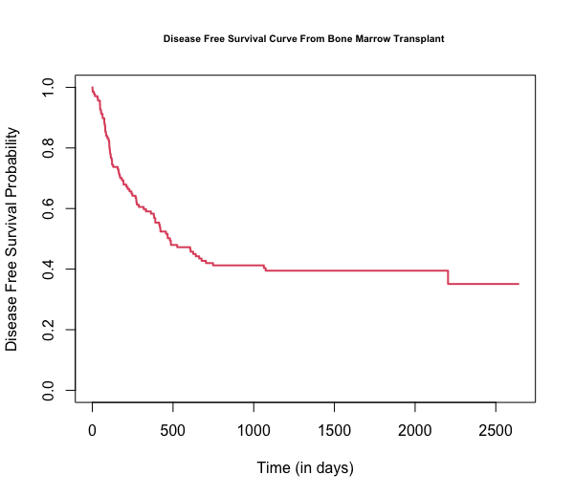

**Figure 1.** Kaplan-Meier graph showing disease-free survival among patients with acute leukemia that underwent bone marrow transplantation.

**Figure 2.** Kaplan Meier graphs showing the survival time until aGVHD for patients who received methotrexate versus those that did not receive the treatment.

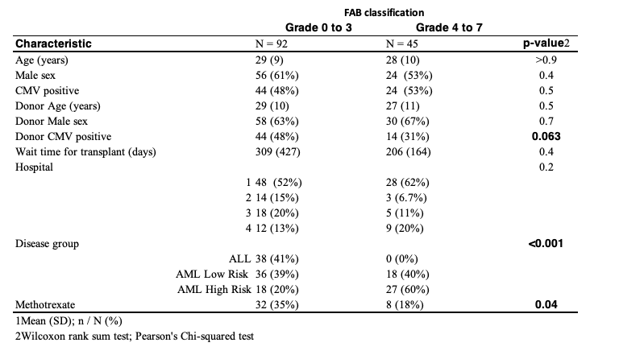

**Table 1.** Recipient, donor, and transplant baseline information according to FAB classification. ALL: acute lymphoblastic leukemia, AML: Acute myeloid leukemia, and FAB: French–American–British.

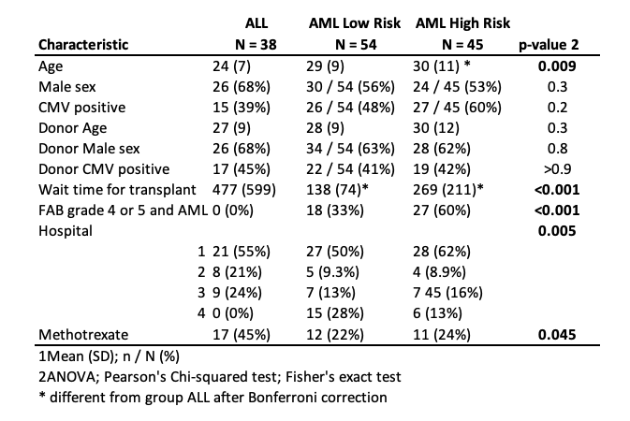

**Table 2.** Recipient, donor, and transplant baseline information according to disease group category. ALL: acute lymphoblastic leukemia, AML: Acute myeloid leukemia, and FAB: French–American–British.

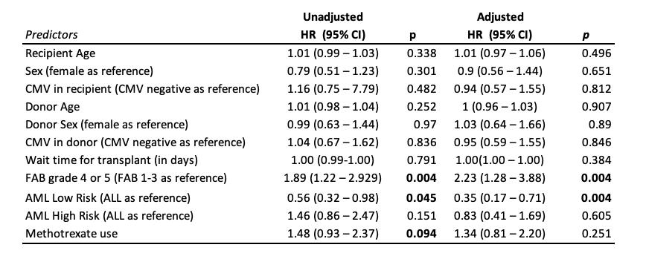

**Table 3.** Unadjusted and adjusted Cox Model estimates for the association between baseline recipient, donor, and transplant information; and disease-free survival as the outcome. HR: hazard ratio; and CI: confidence intervals.