**A**

* **Quản lý nhân viên:**

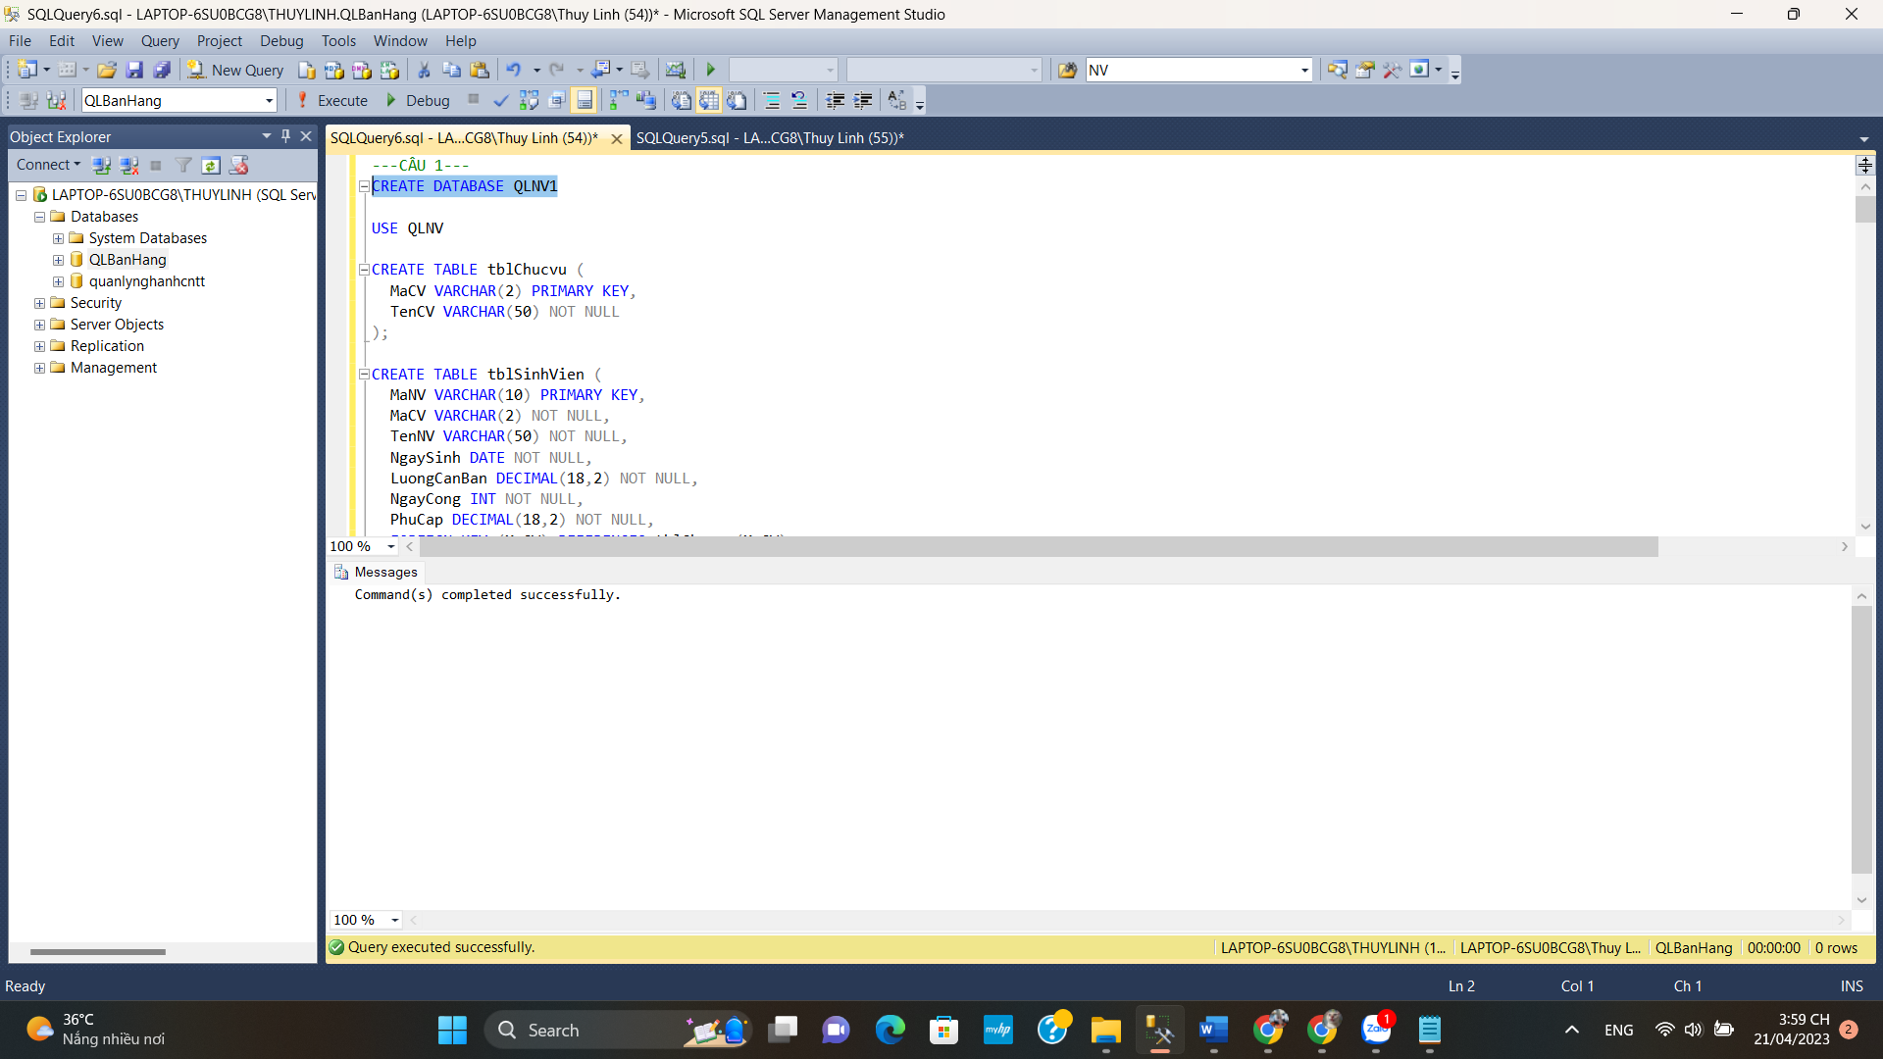

* **Bảng chức vụ:**

* **Bảng Sinh viên**

* **Insert Chức vụ:**

* **Insert Sinh viên:**

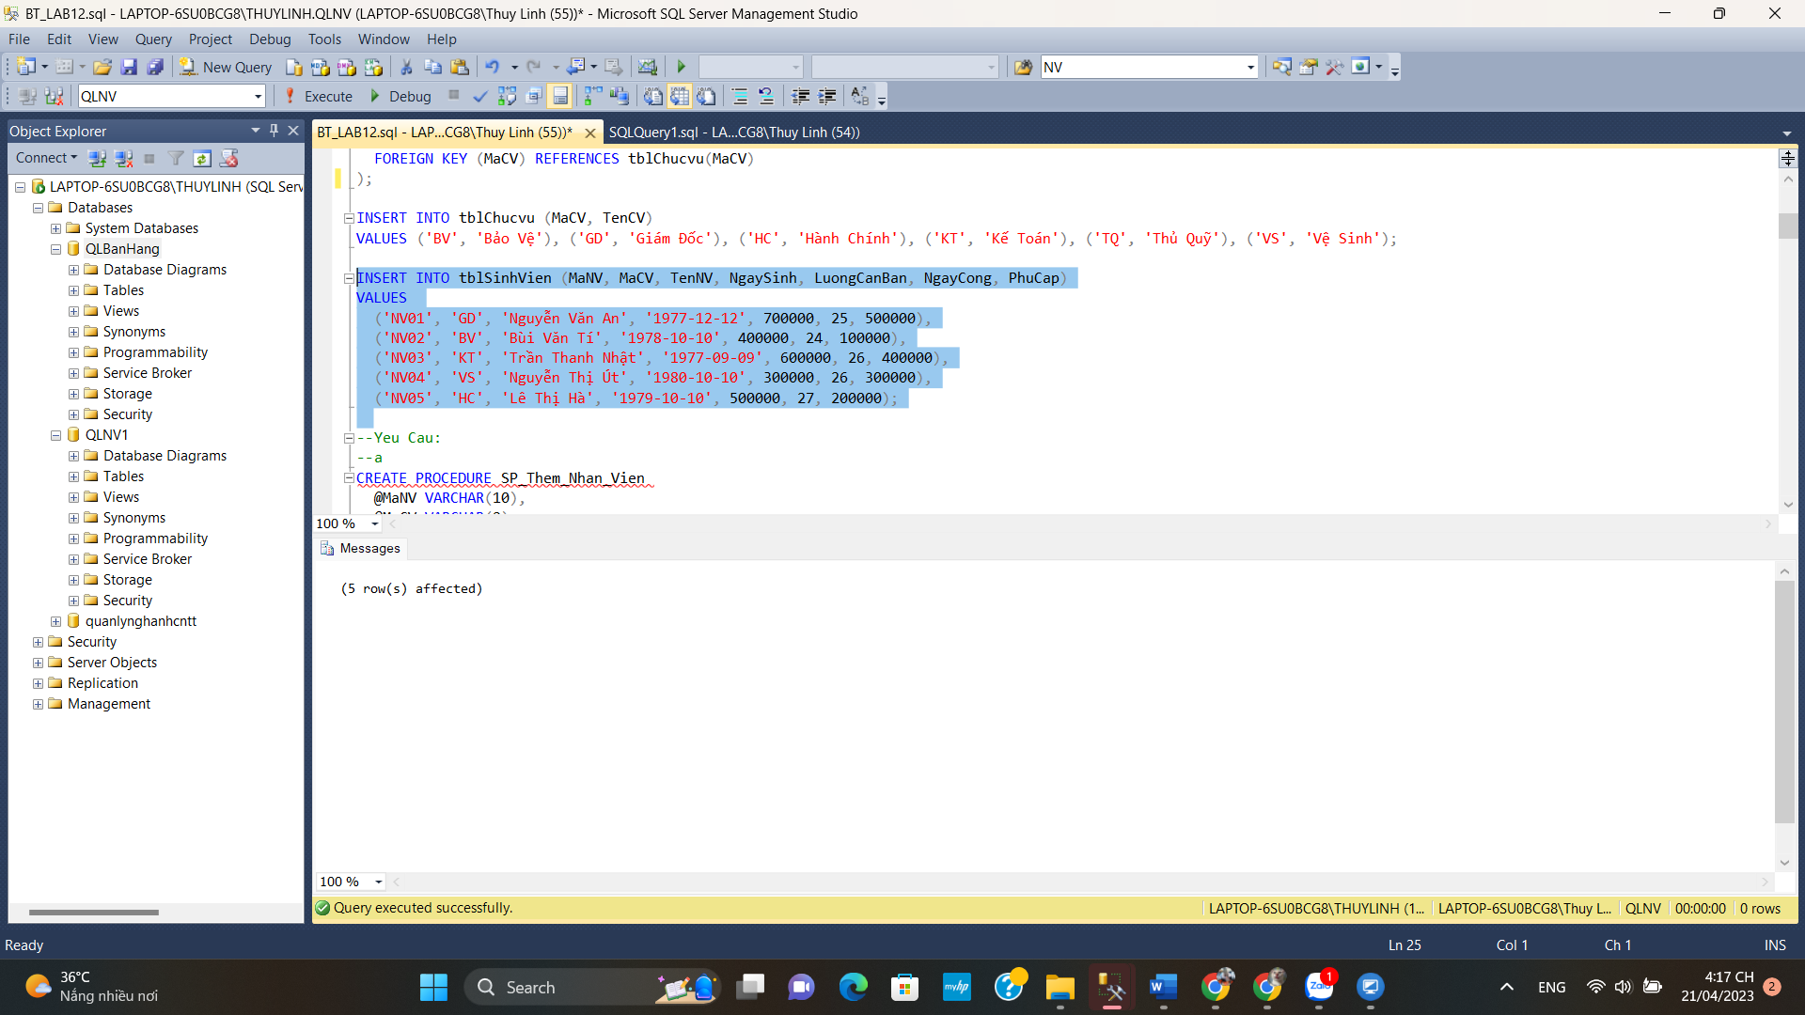

**A**

**B**

**C**

**D**

**1**

**2**

**3**

**4**

**5**

