Câu 1a

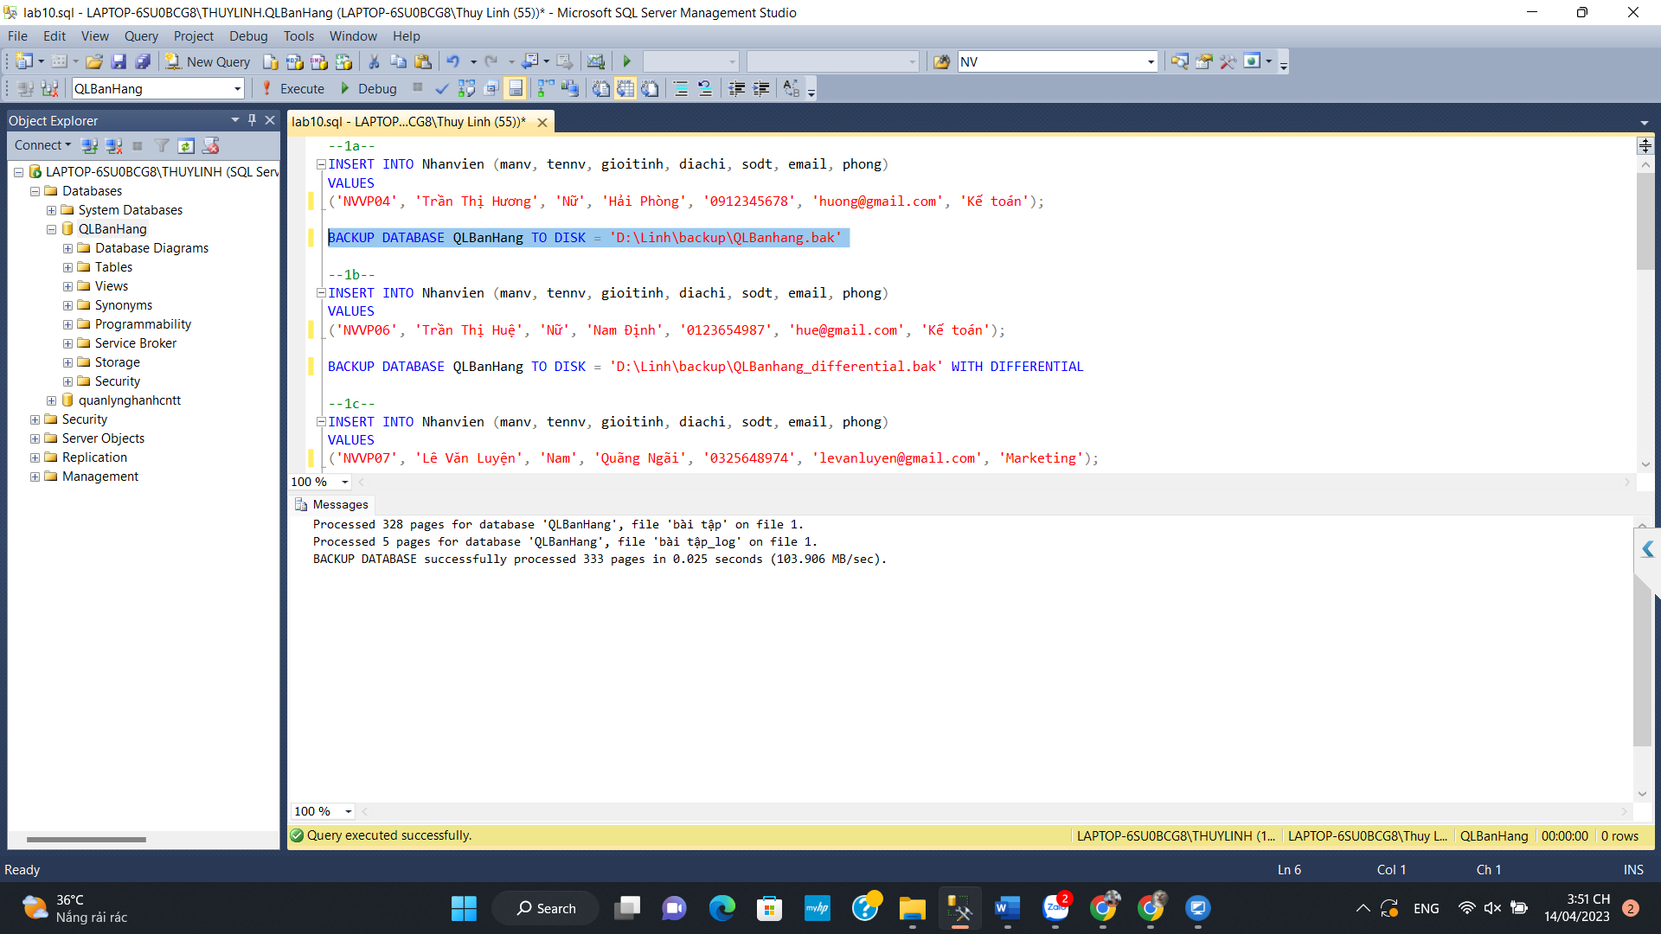

1b

1c

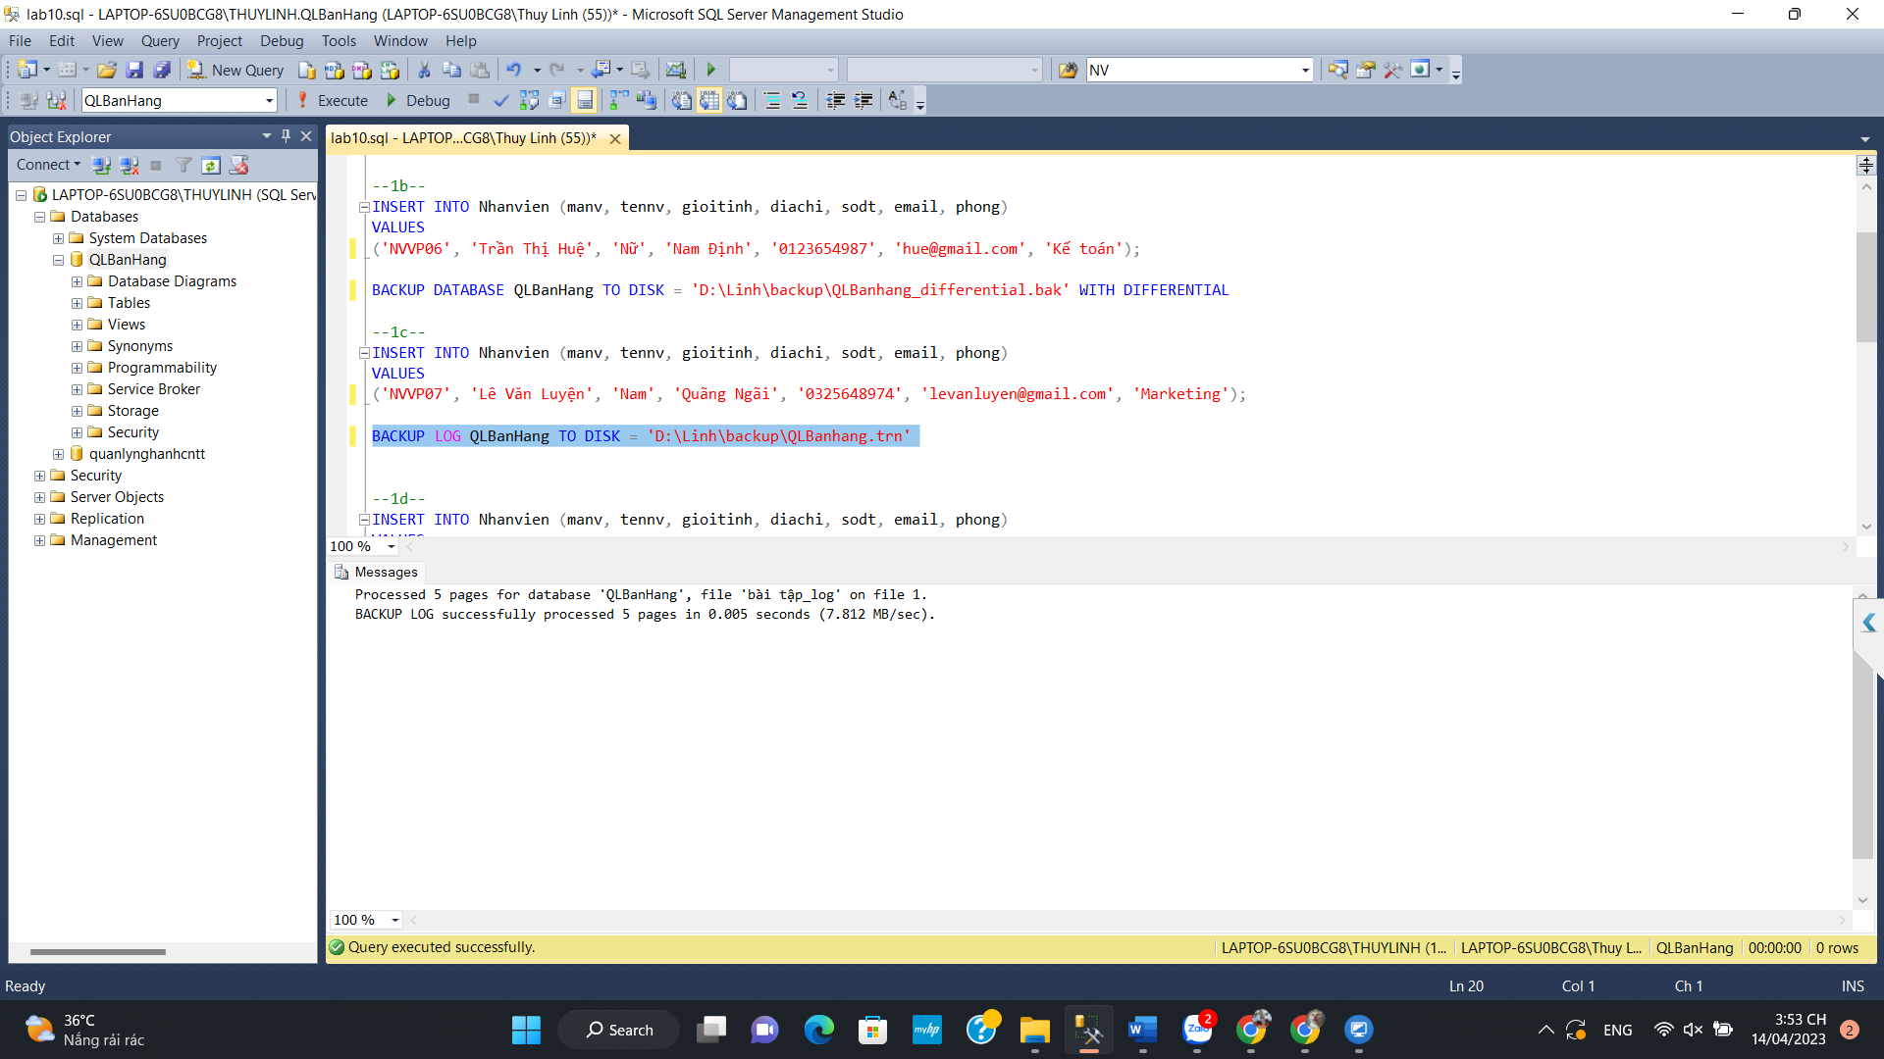

1d

2a

2b

