Topic: Computing Technology

EQ- How can we develop a free online learning website that supports the people who need to improve their IT skills while sharing effective knowledge and resources for community development?

DQ-How can we develop a free online platform which supports in building community resilience through integrated wellness resources for Myanmar?

Aim of website- Aims of ICT The followings are the aims and objectives of ICT implementation in education: 1. To implement the principle of life-long learning / education 2 To increase a variety of educational services and medium / method 3. To promote equal opportunities to obtain education and information. 4 To develop a system of collecting and disseminating educational information 5. To promote technology literacy of all citizens, especially for students. 6 To develop distance education with national contents. 7. To promote the culture of learning at school (development of learning skills. Expansion explansion of optional education, open source of education, etc)

References-

[**https://www.lincolntech.edu/news/information-technology/basic-computer-hardware-essentials-networking-student#:~:text=Internal%20Hardware%20Components,-Internal%20hardware%20components&text=RAM%20provides%20temporary%20storage%20for,all%20the%20internal%20components%20together**](https://www.lincolntech.edu/news/information-technology/basic-computer-hardware-essentials-networking-student#:~:text=Internal%20Hardware%20Components,-Internal%20hardware%20components&text=RAM%20provides%20temporary%20storage%20for,all%20the%20internal%20components%20together)

<https://en.wikipedia.org/wiki/Information_and_communications_technology#:~:text=Information%20and%20communications%20technology%20(ICT,enterprise%20software%2C%20middleware%2C%20storage%20and>

<https://cursa.app/free-online-information-technology-courses>

<https://research.com/software/mobile-vs-desktop-usage#1>

<https://support.microsoft.com/en-us/office/basic-tasks-for-creating-a-powerpoint-presentation-efbbc1cd-c5f1-4264-b48e-c8a7b0334e36>

[Internet Basics: Using a Web Browser](https://edu.gcfglobal.org/en/internetbasics/using-a-web-browser/1/)

Wireframes-

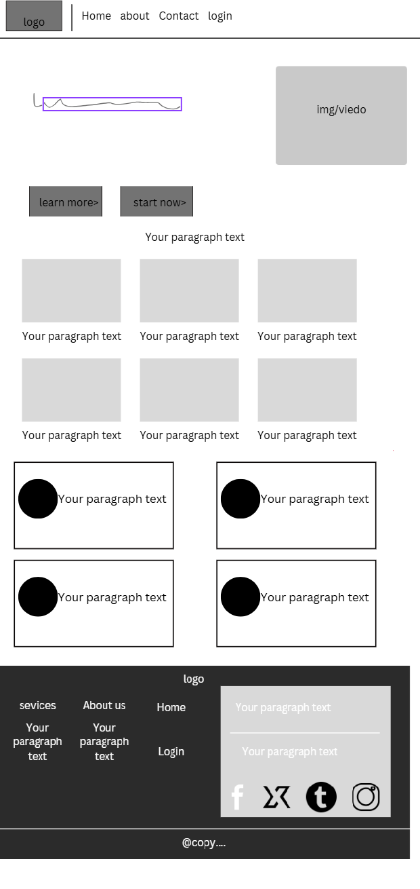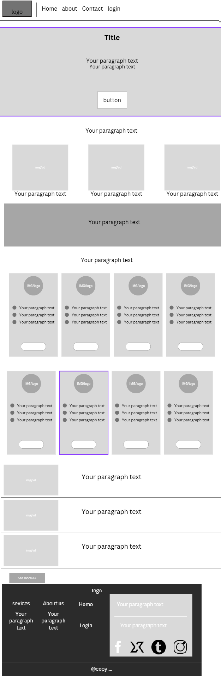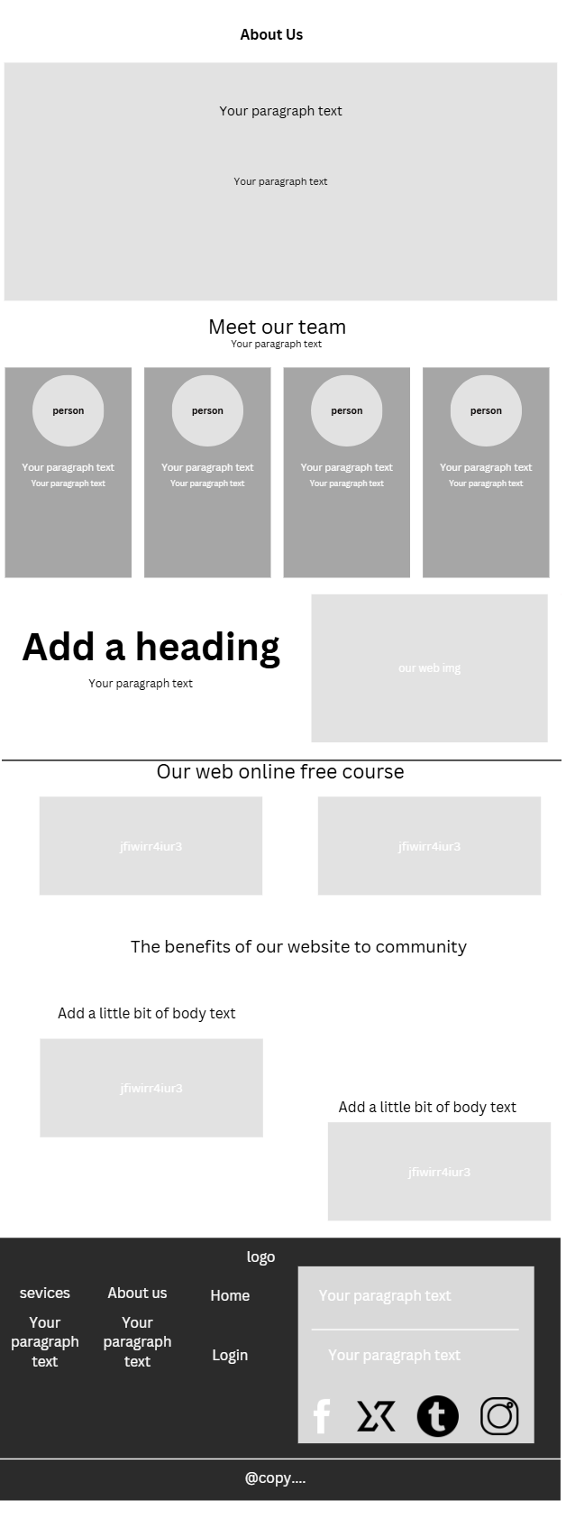

**Index img-**

https://www.21kschool.com/sg/wp-content/uploads/sites/3/2023/09/Discover-the-Bright-Side-The-Surprising-Benefits-of-Online-Learning.png

https://www.lincolntech.edu/sites/default/files/styles/960x_webp_/public/2024-01/0124_Hero-Shot-Basic-Computer%20Hardware%20PC%20Parts_CR-3736.jpg.webp?itok=GX15m51b

https://media.licdn.com/dms/image/C5612AQH08HrV0HjQcg/article-cover_image-shrink_720_1280/0/1520457779451?e=2147483647&v=beta&t=qwlJrPzk_9PIi74MEH4zxgvNJ_uxN_T2zaUgf9J5oy4

https://media.licdn.com/dms/image/v2/D5612AQHSgrNfmwdpuA/article-cover_image-shrink_720_1280/article-cover_image-shrink_720_1280/0/1674493556520?e=2147483647&v=beta&t=iTLzF7Dk4DJHHGoY1e4ORvhaWniVlRuL-y9xyHqS5vM

https://encrypted-tbn0.gstatic.com/images?q=tbn:ANd9GcSoSMJpysFcw_RCxL5jdhcCTpA6nJtAwDVXFk1ubNqx5hynUyAp5VdJbWYsF7urYsvG4DI&usqp=CAU

https://encrypted-tbn0.gstatic.com/images?q=tbn:ANd9GcRxigjOhbXVfa4r-GLrZMLi7uyD6w3xzp7q1w&s

https://encrypted-tbn0.gstatic.com/images?q=tbn:ANd9GcQwRUBjVVHZR3JF_tkNYEGKWGvAcsBSE-uqDA&s

**About img-**

https://i.pinimg.com/736x/4b/7c/ff/4b7cff37fd9d5e1c19613926f7b0b637.jpg

https://encrypted-tbn0.gstatic.com/images?q=tbn:ANd9GcTgDiGnFJnH-X1GJYFMeSCTodNbE-JKNiA3vA&s

https://encrypted-tbn0.gstatic.com/images?q=tbn:ANd9GcShEVlJ0b5NyoyavwCnMMZN0iSXgLyGyt24wVGg_aRSFzudIJMuNo_214wB-iBlCbthd00&usqp=CAU

https://5.imimg.com/data5/KO/UM/GLADMIN-66275087/ms-excel-basic-computer-courses-500x500.png

https://i.pinimg.com/236x/48/1d/ec/481dec5063155aad574618ee48477aa5.jpg

**Video lesson**

<https://www.youtube.com/embed/8_itvuz5Dc4?si=NRwBZ4zja3BSp6N3>

https://www.youtube.com/embed/vBURTt97EkA?si=eunAOt4tgmRwZzmD

<https://www.youtube.com/embed/7DHjtQgOnSs?si=AAriVQjXYE33rwez>

https://www.youtube.com/embed/L2eVCOCKBdk?si=56fJNmBECg80EHJK

https://www.youtube.com/embed/wbJcJCkBcMg?si=gXQz3AbDtPyAa5vd

https://www.youtube.com/embed/2MCmnr2L50o?si=FR9R-QLzLThtqNFQ

**Excel PDF**

https://www.youtube.com/embed/2MCmnr2L50o?si=FR9R-QLzLThtqNFQ

**Word PDF**

**https://www.youtube.com/embed/2MCmnr2L50o?si=FR9R-QLzLThtqNFQ**