**PROFESSIONAL TRAINING REPORT**

**< Early Prediction For Chronic Kidney Disease Detection: A Progressive Approach To Health Management >**

Submitted in partial fulfillment of the requirements for the award of

Bachelor of Engineering degree in Computer Science and Engineering with

specialization in Artificial Intelligence

by

**<THARUN D>**

**[41111273]**



## DEPARTMENT OF COMPUTER SCIENCE AND ENGINEERING

**SCHOOL OF COMPUTING**

**SATHYABAMA**

## INSTITUTE OF SCIENCE AND TECHNOLOGY

## (DEEMED TO BE UNIVERSITY)

**Accredited with Grade “A++” by NAAC**

JEPPIAAR NAGAR, RAJIV GANDHISALAI,

CHENNAI – 600119

**OCTOBER 2023**

**SATHYABAMA**

**INSTITUTE OF SCIENCE AND TECHNOLOGY**

## (DEEMED TO BE UNIVERSITY)

**Accredited with A++ Grade by NAAC**

Jeppiaar Nagar, Rajiv Gandhi Salai,

Chennai – 600 119

[**www.sathyabama.ac.in**](http://www.sathyabama.ac.in/)

## 

## DEPARTMENT OF COMPUTER SCIENCE AND ENGINEERING

**BONAFIDE CERTIFICATE**

This is to certify that this Professional Training is the bonafide work of **Mr./Ms. <THARUN D (41111273)>** who carried out the project entitled <**“** **Early Prediction For Chronic Kidney Disease Detection: A Progressive Approach To Health Management”>** under my supervision from June 2023 to October 2023.

**Internal Guide**

< **Dr.Judgi, CSE.** >

**Head of the Department**

**Dr.L.Lakshmanan M.E., Ph.D.,**

**Submitted for Viva voce Examination held on __________________**

**Internal Examiner External Examiner**

**DECLARATION**

I, <**THARUN D(41111273 )>,** hereby declare that the Professional Training Report-I entitled <**“** **Early Prediction For Chronic Kidney Disease Detection: A Progressive Approach To Health Management”>** done by me under the guidance of <**Guide name,>** is submitted in partial fulfilment of the requirements for the award of Bachelor of Engineering degree in Computer Science and Engineering with specialization in Artificial Intelligence.

**DATE: 25/09/2023**

## PLACE: SIGNATURE OF THE CANDIDATE

**ACKNOWLEDGEMENT**

I am pleased to acknowledge my sincere thanks to **Board of Management** of **SATHYABAMA** for their kind encouragement in doing this project and for completing it successfully. I am grateful to them.

I convey my thanks to **Dr. T.Sasikala M.E., Ph.D.**, **Dean**, School of Computing, **Dr.L.Lakshmanan M.E., Ph.D., Head of the Department** **of** **Computer Science and Engineering** for providing me necessary support and details at the right time during the progressive reviews.

I would like to express my sincere and deep sense of gratitude to my Internal Guide <**GUIDE NAME>** for his/her valuable guidance, suggestions and constant encouragement which paved way for the successful completion of my phase-1 professional Training.

I wish to express my thanks to all Teaching and Non-teaching staff members of the **Department of Computer Science and Engineering** who were helpful in many ways for the completion of the project.

**ABSTRACT**

Chronic Kidney Disease (CKD) is a significant public health concern, impacting millions of individuals worldwide. Early detection of CKD is essential for timely intervention and improved patient outcomes. In recent years, machine learning algorithms have emerged as powerful tools in healthcare for predicting and diagnosing diseases. Support Vector Machines (SVM), a robust and widely used machine learning algorithm, have shown promise in early CKD detection.

This research focuses on the development and implementation of an SVM-based model for the early detection of CKD. The study utilizes a diverse dataset, including clinical and laboratory parameters, to train and validate the SVM algorithm. The SVM model is designed to classify patients into CKD and non-CKD groups, aiding healthcare professionals in identifying high-risk individuals at an early stage.

The objectives of this research include assessing the SVM model's performance in terms of sensitivity, specificity, and accuracy. Moreover, feature selection techniques are employed to identify the most influential parameters contributing to CKD prediction. The study's scope encompasses exploring the potential integration of SVM-based CKD detection into clinical practice, thereby enhancing the efficiency of healthcare systems and ultimately improving patient care.

The results of this research highlight the effectiveness of SVM in early CKD detection, emphasizing its potential as a valuable tool for healthcare practitioners. The findings underscore the importance of leveraging machine learning algorithms like SVM to enhance the early diagnosis of CKD, ultimately reducing the burden of this debilitating disease on both individuals and healthcare systems.

| **CHAPTER NO.** | **TITLE** | | **PAGE NO.** |
| --- | --- | --- | --- |
|  | **ABSTRACT** | | v |
|  | **LIST OF FIGURES** | | vii |
| 1 | **INTRODUCTION**  1.1 Overview | | 1 |
| 2 | **LITERATURE SURVEY**  2.1 survey | | 3 |
| 3 | **REQUIREMENTS ANALYSIS** | |  |
|  | 3.1 | Objective | 4 |
|  | 3.2 | 3.2.1 Hardware Requirements  3.2.2 Software Requirements | 5 |
| 4 | **DESIGN DESCRIPTION OF PROPOSED PRODUCT** | | 6 |
|  | 4.1 | Proposed Product  4.1.1 Ideation Map/Architecture Diagram  4.1.2 Various stages  4.1.3 Internal or Component design structure  4.1.4 working principles/Methodology | 10  12  14  15 |
|  | 4.2 | Features  4.2.1 Novelty of the Project | 17 |
| 5 | **CONCLUSION** | | 20 |
|  | **References** | | 21 |

**TABLE OF CONTENTS**

**CHAPTER 1**

**INTRODUCTION**

**1.1 OVERVIEW**

Chronic Kidney Disease (CKD) is a global health concern that affects millions of people, often leading to severe health complications and a significant burden on healthcare systems. CKD is characterized by the gradual loss of kidney function over time, and early detection is crucial for effective management and intervention. This introduction provides an overview of the importance of early prediction in CKD detection and highlights a progressive approach to health management.

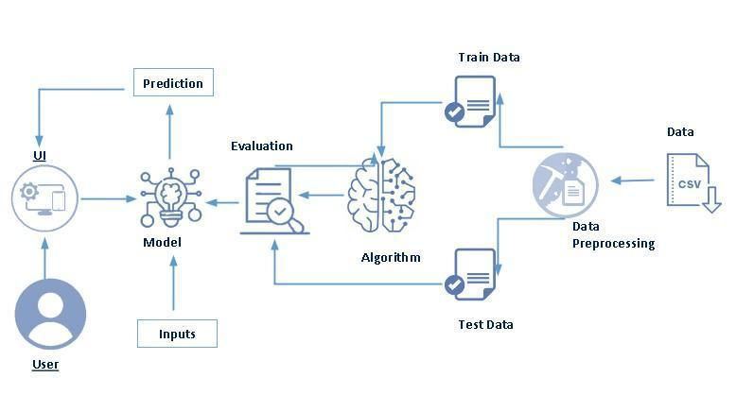

The Growing Burden of Chronic Kidney Disease:

CKD has emerged as a significant public health issue worldwide, affecting people of all ages and backgrounds.

It is often referred to as a "silent killer" because its symptoms are often subtle or absent until the disease reaches an advanced stage.

The Need for Early Detection:

Early detection of CKD is essential for several reasons:

Timely intervention can slow the progression of the disease, preventing kidney failure and the need for dialysis or transplantation.

CKD is associated with a higher risk of cardiovascular disease, making early detection critical to managing overall health.

Identifying and managing CKD at an early stage is more cost-effective for healthcare systems and less burdensome for patients.

Benefits of Early Prediction for CKD:

Early prediction not only benefits individual patients but also has broader societal advantages:

It empowers patients with information to make informed lifestyle choices that can mitigate their risk.

Healthcare providers can prioritize resources for those at the highest risk, optimizing healthcare delivery.

Researchers can better understand the progression of CKD and develop targeted treat Early prediction for CKD detection represents a progressive approach to health management that can transform the way we address this debilitating condition.

By harnessing the power of data-driven insights and personalized medicine, we can improve outcomes for individuals at risk of CKD and alleviate the global burden of this disease.

One of the major challenges in CKD management is the lack of early detection methods.

Traditional methods rely on assessing kidney function using markers like serum creatinine, which are not sensitive enough to detect early-stage CKD.

As a result, many individuals remain undiagnosed until their kidney function has significantly deteriorated.

In the subsequent sections of this discussion, we will delve deeper into the methods and technologies used in early prediction for CKD, explore the risk factors and biomarkers associated with the disease, and examine the role of patients, healthcare providers, and researchers in implementing this progressive approach to health managements.

The progressive approach to CKD management involves leveraging advancements in healthcare technology, data analytics, and machine learning to predict CKD at an early stage.

By analyzing a range of patient data, including clinical records, genetic information, lifestyle factors, and biomarkers, it is possible to identify individuals at risk of developing CKD.

Predictive models can provide personalized risk assessments and recommend interventions tailored to each patient's needs.

**CHAPTER 2**

**LITERATURE REVIEW**

**2.1 SURVEY**

When creating a survey for early prediction of Chronic Kidney Disease (CKD) detection and its progressive health management, it's essential to apply survey theory to ensure the reliability and validity of the data collected**.**

Clearly define the goals and objectives of your survey. Determine what specific information you want to gather regarding CKD detection, awareness, and health management.

Identify the target population or sample that represents the group of interest. Ensure that the sample is relevant to your research objectives

Ensure the validity of the survey by assessing whether it measures what it intends to measure. You can achieve this through expert review and pilot testing.

Establish the reliability of the survey by ensuring that it produces consistent results over time. Test-retest reliability and internal consistency are common methods for assessing reliability.

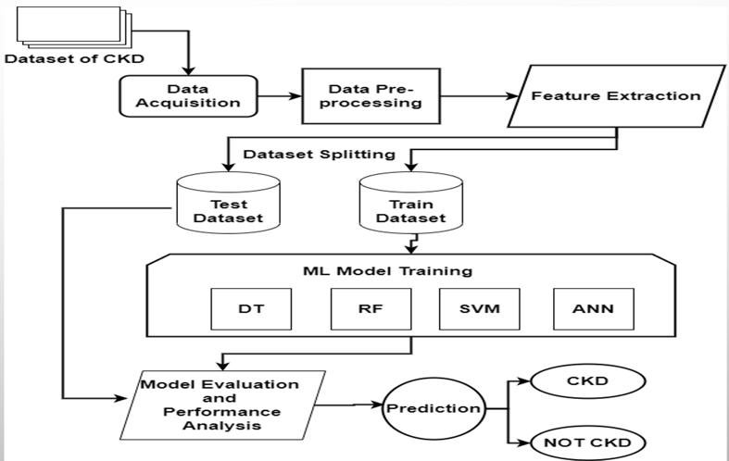

By following survey theory principles, you can design and conduct a rigorous survey that generates valuable insights into CKD detection and progressive health management. This will help ensure the quality and reliability of the data collected for your research or healthcare initiatives.

**CHAPTER 3**

**REQUIREMENTS ANALYSIS**

**3.1 OBJECTIVE OF THE PROJECT**

Objectives for a study or initiative focused on "Chronic Kidney Disease Detection: A Progressive Approach to Health Management" should be clear, specific, and aligned with the goals of improving CKD detection and management.

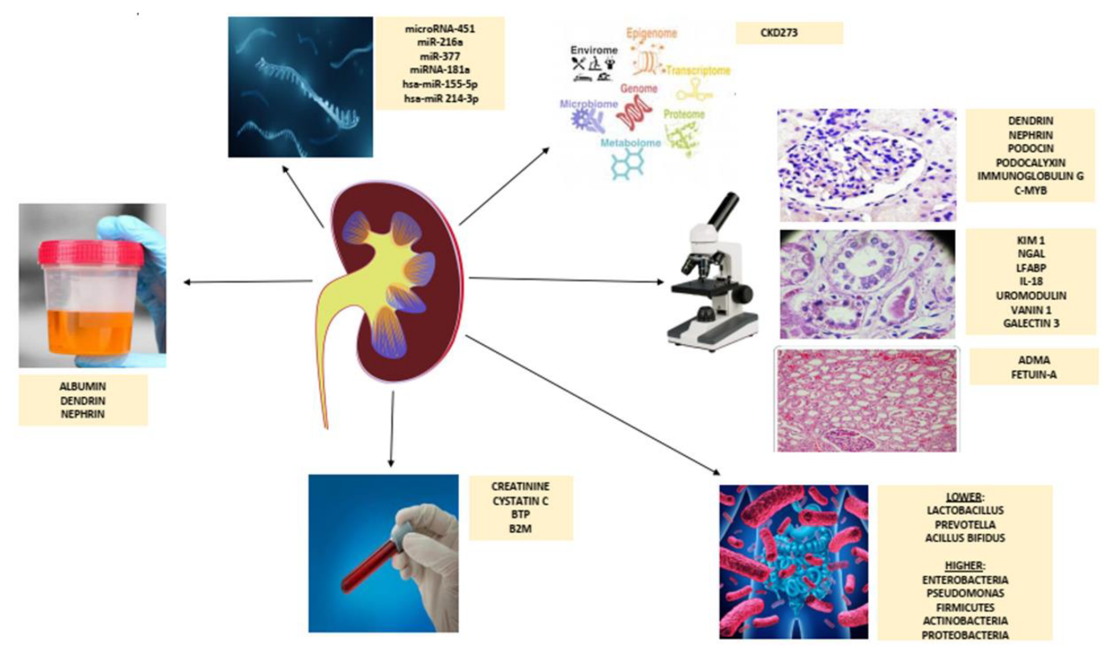

Here are some potential objectives

To Increase Early Detection Rates:

Develop and implement a progressive approach that significantly increases the rate of early detection of Chronic Kidney Disease, with a focus on identifying the condition at its earliest stages.

To Improve Risk Prediction Accuracy:

Enhance the accuracy of predictive models and risk assessment tools used in CKD detection to provide more precise risk assessments for individuals in diverse populations.

To Promote Personalized Health Management:

Implement strategies that encourage individuals at risk of CKD to adopt personalized health management practices, including lifestyle modifications and regular monitoring.

To Reduce CKD Progression Rates:

Implement interventions and healthcare practices that effectively slow down the progression of CKD in diagnosed patients, reducing the incidence of end-stage renal disease (ESRD).

To Raise Awareness and Education:

Develop and execute educational campaigns to increase public awareness about CKD, its risk factors, and the importance of early detection and management.

To Enhance Healthcare Provider Knowledge:

Offer training and resources to healthcare professionals to improve their understanding of CKD, early detection methods, and progressive health management strategies.

To Leverage Technology and Data Analytics:

Harness advanced technologies, data analytics, and machine learning to develop innovative tools and models for early CKD prediction and personalized health management recommendations.

To Monitor and Evaluate Progress:

Establish a system for ongoing monitoring and evaluation of CKD detection and management efforts, with regular assessments of the impact of the progressive approach.

To Reduce Healthcare Costs:

Implement strategies that reduce the economic burden of CKD on healthcare systems, including the costs associated with late-stage CKD and dialysis.

To Foster Collaboration:

Facilitate collaboration among healthcare providers, researchers, policymakers, and patient advocacy groups to create a comprehensive and coordinated approach to CKD detection and management.

To Improve Patient Outcomes and Quality of Life:

Measure and strive to enhance the quality of life for individuals with CKD by providing early interventions and personalized care that address their specific needs.

To Contribute to Research and Knowledge:

Generate data and insights that contribute to the broader scientific understanding of CKD, its risk factors, and the effectiveness of progressive health management approaches.

These objectives provide a framework for addressing the challenges associated with Chronic Kidney Disease detection and management and can guide the development of strategies and initiatives to achieve improved outcomes in this critical healthcare area.

**3.2 REQUIREMENTS**

Creating well-defined objectives for a study or initiative focused on "Chronic Kidney Disease (CKD) Detection: A Progressive Approach to Health Management" requires careful consideration of various requirements to ensure clarity, effectiveness, and feasibility. Here are the key requirements for such objectives:

Specificity:

Objectives should be specific and focused on a particular aspect of CKD detection and health management. They should answer the questions of what, who, where, and when.

Example: "Increase early detection rates of CKD among high-risk populations by 20% within the next two years."

Measurability:

Objectives must be measurable, allowing for quantifiable assessment of progress or success.

Example: "Implement a risk prediction model with a sensitivity rate of at least 85% in identifying CKD in patients during the initial screening."

Achievability:

Objectives should be realistic and attainable, considering available resources, expertise, and timeframes.

Example: "Reduce the rate of CKD progression by 10% over the next five years through the implementation of evidence-based interventions."

Relevance:

Objectives should align with the overall goal of improving CKD detection and health management.

Example: "Promote personalized health management practices that address modifiable risk factors for CKD, such as hypertension and diabetes."

Time-Bound:

Objectives should have a clear timeframe or deadline for achievement, providing a sense of urgency.

Example: "Launch a public awareness campaign on CKD prevention and early detection within the next six months."

Strategic Alignment:

Objectives should align with the broader strategic goals and priorities of the healthcare organization, research institution, or initiative.

Example: "Integrate CKD detection and management into the existing electronic health record (EHR) system to facilitate data-driven interventions."

Accountability:

Assign responsibility for each objective to individuals or teams to ensure clear ownership and accountability for progress.

Example: "The healthcare quality improvement team will oversee the implementation of CKD prevention and management protocols."

Flexibility:

Objectives should allow for adaptability in response to changing circumstances or emerging evidence.

Example: "Evaluate and adjust the CKD prediction model annually based on new research findings and technological advancements."

Ethical Considerations:

Ensure that objectives adhere to ethical guidelines and respect patient privacy and autonomy.

Example: "Maintain the confidentiality of patient data collected during CKD screening and risk assessment."

Data Collection and Evaluation:

Establish a plan for data collection and evaluation methods to assess progress toward achieving the objectives.

Example: "Regularly collect and analyze data on CKD detection rates, patient outcomes, and the impact of health management interventions."

Communication and Reporting:

Define how progress and results will be communicated to stakeholders, including healthcare providers, patients, policymakers, and the public.

Example: "Provide quarterly reports on the effectiveness of CKD detection and management initiatives to the hospital administration and relevant government agencies."

Resource Allocation:

Identify the resources required to achieve each objective, including funding, personnel, technology, and facilities.

Example: "Allocate a budget of $100,000 for the development and implementation of the CKD risk prediction model."

Stakeholder Engagement:

Engage relevant stakeholders, such as patients, healthcare professionals, researchers, and community organizations, in the planning and execution of initiatives related to CKD detection and management.

Example: "Conduct focus group discussions with patients and healthcare providers to gather input on the design of patient education materials."

By meeting these requirements when formulating objectives, you can ensure that your study or initiative is well-structured, actionable, and capable of driving meaningful improvements in CKD detection and health management.

**3.2.1 *HARDWARE REQUIREMENTS***

Designing and implementing a system or initiative focused on "Chronic Kidney Disease (CKD) Detection: A Progressive Approach to Health Management" may require various hardware components and infrastructure to support data collection, analysis, and healthcare delivery. Here are some hardware requirements that may be necessary:

Computers and Servers:

High-performance computers or servers may be required to store and process large datasets, run predictive algorithms, and host software applications.

Data Storage Systems:

Robust data storage solutions such as network-attached storage (NAS) or storage area networks (SANs) to store electronic health records (EHRs), patient data, and research data securely.

Networking Equipment:

Reliable networking infrastructure, including routers, switches, and firewalls, to facilitate data transfer between devices and systems within healthcare facilities.

Workstations and Laptops:

Workstations or laptops for healthcare professionals and researchers to access patient records, run diagnostic tools, and analyze data.

Mobile Devices:

Tablets or smartphones equipped with relevant apps for remote patient monitoring, data collection, and communication with patients.

Medical Devices:

Specialized medical devices for monitoring and collecting patient health data, such as blood pressure monitors, glucose meters, and wearable devices (e.g., smartwatches or fitness trackers).

Imaging Equipment:

Imaging equipment such as ultrasound machines, CT scanners, or MRI machines, if applicable to CKD diagnosis and management.

Printers and Scanners:

Printers and scanners for creating hard copies of medical reports, consent forms, and other documents.

Biometric Authentication Systems:

Biometric authentication systems like fingerprint or retinal scanners to enhance security when accessing sensitive patient information.

Telemedicine Infrastructure:

Video conferencing equipment and telemedicine software for virtual consultations with patients, particularly important for remote health management.

Backup and Redundancy Systems:

Backup servers, uninterruptible power supplies (UPS), and redundancy systems to ensure data availability and system resilience.

Environmental Control Systems:

Climate control systems and environmental monitoring devices to ensure the integrity of medical equipment and data storage.

Security Systems:

Security cameras, access control systems, and intrusion detection systems to protect physical and data security within healthcare facilities.

HIPAA-Compliant Hardware and Software:

Ensure that all hardware components meet the Health Insurance Portability and Accountability Act (HIPAA) standards for safeguarding patient information.

Integration Tools:

Middleware and integration tools to connect various healthcare systems and enable seamless data flow between electronic health records, diagnostic equipment, and analytical platforms.

Research Laboratory Equipment:

If research is part of the initiative, research laboratories may require specialized equipment for experiments and data analysis.

Patient Monitoring Devices:

Devices for continuous monitoring of patients' vital signs and health status in clinical settings, such as intensive care units.

Data Backup and Recovery Solutions:

Implement reliable data backup and recovery solutions to safeguard patient records and research data in case of hardware failures or data corruption.

It's important to note that the specific hardware requirements may vary depending on the scope and scale of the CKD detection and management initiative, as well as the technologies and tools chosen for implementation. Additionally, compliance with healthcare data privacy and security regulations, such as HIPAA in the United States, is critical when designing and deploying healthcare-related hardware systems***.***

**3.2.2 *SOFTWARE REQUIREMENTS***

Designing and implementing software for "Chronic Kidney Disease (CKD) Detection: A Progressive Approach to Health Management" is essential for data analysis, patient management, and decision support. Here are various software requirements that may be necessary for such an initiative:

Electronic Health Record (EHR) System:

An EHR system to store and manage patient health records, including medical history, laboratory results, and treatment plans.

Data Management and Integration Tools:

Data management and integration software to aggregate, normalize, and integrate patient data from various sources, such as EHRs, laboratory systems, and wearable devices.

Predictive Analytics and Machine Learning Software:

Software for developing and deploying predictive models and machine learning algorithms to identify individuals at risk of CKD and predict disease progression.

Clinical Decision Support Systems (CDSS):

CDSS software to assist healthcare providers in making evidence-based decisions by providing alerts, reminders, and recommendations based on patient data and clinical guidelines.

Telemedicine and Telehealth Platforms:

Telemedicine software for conducting virtual consultations, remote monitoring, and telehealth services to facilitate patient engagement and care delivery.

Patient Portal and Engagement Software:

Patient portal software to enable patients to access their health records, receive educational materials, and communicate with healthcare providers.

Mobile Applications:

Mobile apps for patients to track their health, receive reminders for medications and appointments, and report symptoms or vital signs.

Health Information Exchange (HIE) Systems:

HIE software to facilitate the exchange of patient health information between healthcare organizations and providers while ensuring data security and privacy.

Data Analytics and Reporting Tools:

Data analytics and reporting software for generating insights from patient data, creating dashboards, and producing performance reports.

Security and Privacy Solutions:

Security software, including encryption, access controls, and intrusion detection systems, to protect patient data and comply with healthcare privacy regulations (e.g., HIPAA).

Database Management Systems (DBMS):

DBMS software for efficient and secure storage and retrieval of patient data and research findings.

Research and Statistical Analysis Tools:

Statistical software (e.g., R, SAS, or Python) for conducting research, data analysis, and hypothesis testing related to CKD.

Communication and Collaboration Platforms:

Collaboration software (e.g., Microsoft Teams, Slack) to facilitate communication and coordination among healthcare teams, researchers, and stakeholders.

Quality Improvement and Performance Management Software:

Software for monitoring and improving the quality of care, tracking key performance indicators (KPIs), and implementing continuous improvement initiatives.

Patient Education and Engagement Platforms:

Platforms for creating and delivering patient education materials, including videos, articles, and interactive content.

Telemonitoring and Remote Patient Management Solutions:

Software for remote monitoring of patients with CKD, allowing healthcare providers to track patient progress and intervene as needed.

Artificial Intelligence (AI) Chatbots and Virtual Assistants:

AI-driven chatbots or virtual assistants that can provide patients with answers to common questions, schedule appointments, and offer health-related advice.

Regulatory Compliance Software:

Software tools to assist in maintaining compliance with healthcare regulations, including documentation and auditing.

Blockchain and Data Security Solutions:

Blockchain technology and data security solutions for enhancing the integrity and security of patient data.

Custom Software Development:

Custom software applications and solutions tailored to the specific needs of the CKD detection and management program.

Selecting the appropriate software tools and platforms will depend on the goals, scale, and specific requirements of your CKD initiative. It's crucial to prioritize data security, interoperability, and usability when evaluating and implementing software solutions in the healthcare domain. Additionally, compliance with healthcare regulations, such as HIPAA in the United States, is of utmost importance***.***

Everyone is aware that the kidneys are a vital organ in the body, with primary functions like excretion and osmoregulation. Simply explained, the kidney and excretion system gather and eliminate all harmful and superfluous substances from the body. Chronic Kidney Disease is brought on by a kidney issue. Chronic kidney disease (CKD) is a non-communicable illness that affects 10-15% of the world’s population and has a considerable impact on morbidity, mortality, and hospital admission rates for patients worldwide. To reduce the effects of the patient’s health difficulties, early and accurate detection of the phases of CKD is thought to be essential. A disorder known as chronic kidney disease (CKD) is defined by a long-term decline of kidney function. It depicts a medical condition that harms the kidneys and has an impact on a person’s overall health. End-stage renal disease and the patient’s eventual mortality can result from improper disease diagnosis and treatment. Many studies on the early identification of CKD have been conducted utilizing machine learning approaches. This project aims to develop a system for predicting Chronic Kidney Disease (CKD) using machine learning method. Specifically, the proposed system employs an Artificial Neural Network (ANN) to predict CKD.

The dataset used for training and testing the models is the Chronic Kidney Disease dataset from the UCI Machine Learning Repository. The proposed system also built a web application using Flask framework where the users can enter the details and predict whether the CKD is there or not, which makes the system easier and accessible to every individual. Although the timely involvement of specialists is needed to improve health outcomes for patients with progressive CKD, payers want to avoid unnecessary referral patterns that could deplete resources. A systematic review of the clinical and cost-effectiveness evidence on early versus late (or no) nephrologist referral found that early referral is associated with better health outcomes and might be cost-effective.131 However, the authors did not find any randomized-controlled trials that provide data on the clinical effectiveness of early-referral strategies, and only two studies included pre-dialysis patients. The authors noted that there are insufficient data on the natural history of CKD and the costs and effects of early referral. They highlighted the need for long-term observational studies of early-CKD patients to better delineate disease progression and the incidence of cardiovascular events in patients with and without related health conditions, such as diabetes, pre-existing cardiovascular disease, albuminuria, and proteinuria. The authors also suggested that the large costs of early referral may be unaffordable for health systems, even if early referral is cost-effective. Further research is needed to evaluate the cost-effectiveness of improved primary care for early-CKD patients.

PCPs should be involved in re-defining CKD to facilitate a paradigm shift. In the UK, early identification of CKD is financially incentivized in primary care, but some PCPs express concern over whether CKD is a genuine disease state.132 In areas where patients are not correctly identified on CKD registers.

# **CHAPTER 4**

**DESIGN DESCRIPTION OF PROPOSED PROJECT**

**4.1 PROPOSED METHODOLOGY**

Proposing a methodology for "Chronic Kidney Disease (CKD) Detection: A Progressive Approach to Health Management" involves outlining the steps and procedures to achieve the objectives of early CKD detection and personalized health management. Below is a comprehensive methodology that can guide your initiative:

1. Define Research Objectives and Scope:

Clearly define the goals of the CKD detection and management initiative.

Determine the scope of the project, including the target population, geographic areas, and CKD stages to be addressed.

2. Literature Review:

Conduct a thorough review of existing research, guidelines, and best practices related to CKD detection, risk factors, and health management.

Identify gaps in knowledge and areas where a progressive approach can make a difference.

3. Stakeholder Engagement:

Collaborate with key stakeholders, including healthcare providers, patients, researchers, and policymakers, to gather insights and perspectives on CKD detection and management.

4. Data Collection and Integration:

Collect relevant patient data from electronic health records (EHRs), laboratory systems, wearable devices, and other sources.

Integrate and normalize the data to create a comprehensive patient profile.

5. Risk Assessment and Predictive Modeling:

Develop and validate predictive models using machine learning and data analytics techniques.

Utilize patient data, including clinical, genetic, and lifestyle factors, to assess CKD risk.

Continuously refine models as new data becomes available.

6. Early Detection and Screening:

Implement risk-based screening protocols to identify individuals at high risk of CKD.

Utilize predictive models to prioritize patients for screening and early intervention.

7. Clinical Decision Support System (CDSS):

Integrate a CDSS into the healthcare workflow to provide real-time recommendations to healthcare providers based on CKD risk assessments.

Ensure that the CDSS aligns with clinical guidelines and is user-friendly for healthcare professionals.

8. Patient Education and Engagement:

Develop patient education materials and resources on CKD risk factors, prevention, and self-management.

Engage patients through telehealth, mobile apps, and patient portals to encourage active participation in their health management.

9. Telemedicine and Remote Monitoring:

Implement telemedicine platforms for remote consultations with patients.

Utilize remote monitoring devices to track vital signs, lab results, and medication adherence.

10. Personalized Health Management Plans:

- Develop personalized health management plans for patients identified as at-risk or diagnosed with CKD.

- Include lifestyle recommendations, medication management, and regular follow-up appointments.

11. Quality Improvement and Performance Metrics:

- Establish key performance indicators (KPIs) to measure the effectiveness of CKD detection and management efforts.

- Continuously monitor and evaluate the initiative's performance and outcomes.

12. Data Security and Privacy:

- Implement robust data security measures to protect patient privacy and comply with healthcare regulations (e.g., HIPAA).

- Conduct regular security audits and assessments.

13. Education and Training:

- Provide training to healthcare providers on the use of predictive models, CDSS, and new protocols for CKD detection and management.

- Educate patients on how to access and use health management tools.

14. Continuous Improvement and Adaptation:

- Maintain an iterative approach to CKD detection and management, incorporating feedback from stakeholders.

- Adapt the methodology based on emerging research, technology advancements, and changing healthcare needs.

15. Evaluation and Research:

- Conduct ongoing research to assess the impact of the progressive approach on CKD detection rates, disease progression, and patient outcomes.

- Publish findings in peer-reviewed journals to contribute to the body of knowledge on CKD management.

16. Scaling and Dissemination:

- If successful, consider scaling the CKD detection and management approach to reach a larger population.

- Share best practices and lessons learned with other healthcare organizations and institutions.

17. Regulatory Compliance:

- Ensure that the initiative complies with all relevant healthcare regulations and standards.

This methodology outlines a comprehensive approach to early CKD detection and progressive health management. It emphasizes data-driven decision-making, patient engagement, and continuous improvement to achieve better outcomes for individuals at risk of or diagnosed with CKD. It's important to adapt this methodology to the specific needs and resources of your healthcare organization or research initiative.

**4.1.1 *Ideation Map/System Architecture***

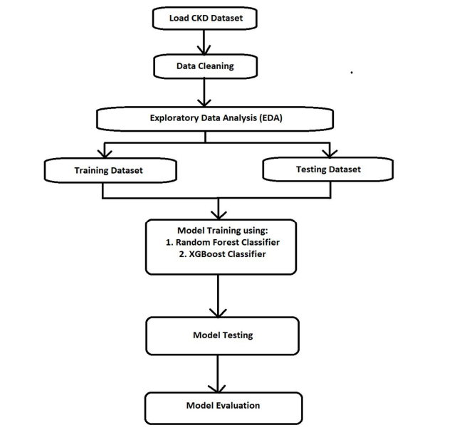

**4.1.2 *Various Stages***

Designing a system architecture for early prediction of Chronic Kidney Disease (CKD) detection requires a comprehensive approach that involves data collection, preprocessing, feature engineering, machine learning, and user interface components. Here's a progressive system architecture for this purpose:

*1.Data Collection and Integration:*

Data sources: Collect relevant medical data from various sources, including electronic health records (EHRs), laboratory reports, patient surveys, and wearable health devices.

Data preprocessing: Clean and preprocess the data, handling missing values, outliers, and ensuring data quality.

Data integration: Integrate data from different sources into a unified dataset for analysis.

*2.Feature Engineering:*

Feature selection: Choose relevant features such as patient demographics, medical history, medication, vital signs, and lab results.

Feature extraction: Extract meaningful information from unstructured data, such as text-based clinical notes or radiology reports.

Feature transformation: Apply techniques like normalization and scaling to ensure feature compatibility for modeling.

*4.Machine Learning Models:*

Early prediction models: Develop machine learning models for CKD prediction. You can start with traditional models like logistic regression and gradually progress to more complex models like random forests, gradient boosting, or deep learning.

Hyperparameter tuning: Optimize model hyperparameters to improve prediction accuracy.

Model evaluation: Use metrics like AUC-ROC, accuracy, sensitivity, specificity, and F1-score to assess model performance.

*5.Progressive Learning:*

Continual learning: Implement a progressive learning approach to adapt the model over time as new patient data becomes available.

Transfer learning: Leverage knowledge gained from previously trained models to improve the performance of newer models.

*6.Data Privacy and Security:*

*Ensure compliance with healthcare data regulations like HIPAA to protect patient privacy and data security.*

*Implement encryption and access controls to safeguard sensitive medical information.*

*7.Decision Support System:*

Develop a decision support system that provides real-time predictions and recommendations to healthcare providers.

Integrate alerts and notifications for critical CKD predictions, allowing for early intervention.

*8.User Interface:*

Create a user-friendly web or mobile interface for healthcare professionals to input patient data and access predictions.

Visualizations: Include visualizations of patient trends and risk factors for better decision-making.

*9.Data Monitoring and Model Updating:*

Implement a monitoring system to track model performance and data quality over time.

Set up automated model retraining processes to ensure that the CKD prediction model remains up to date with the latest data*.*

*10.Patient Engagement:*

Develop a patient-facing application or portal to educate patients about CKD risk factors and encourage self-monitoring.

Provide personalized recommendations for lifestyle changes and treatment adherence.

*11.Interoperability:*

Ensure that the system can communicate and integrate with other healthcare IT systems like EHRs and telemedicine platforms.

*12.Compliance and Ethics:*

Adhere to ethical guidelines in the use of patient data and ensure transparency in model predictions.

Regularly review and update the system to comply with evolving healthcare regulations*.*

*13.Scalability and Performance:*

Design the architecture to be scalable so that it can handle a growing volume of patient data and users.

Optimize performance to ensure real-time or near-real-time predictions.

Remember that the success of the system depends on collaboration with healthcare professionals and continuous feedback to improve prediction accuracy and patient outcomes. Additionally, ethical considerations and regulatory compliance are crucial when working with healthcare data.

*4.1.3 Internal or Component design structure*

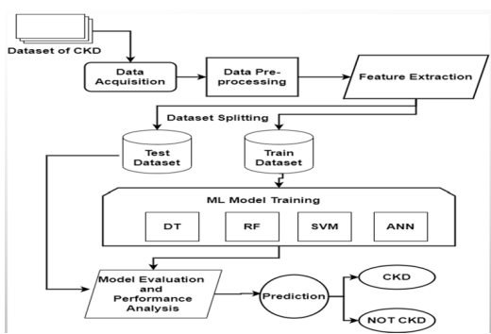

*4.1.4 working principles/Methodology*

This section outlines the system's methodology. The study process begins with gathering publicly available data sets from the internet. The data utilized in the study came from the UCI repository. The data collection contains a total of twenty-five characteristics, including the chronic diagnostic class. Following successful data collection, the data is put into the python script for exploratory data analysis, followed by machine learning for CKD diagnosis. The comma-separated data is read as a data frame by pandas and subjected to pre-processing, pre-processing, and feature selection. During the preparation, data of various data types are aligned as integer type data and verified for null values and duplicate values. The null values in the data are replaced with the attribute's mean. To transform strings to numerical values, the prepared data is subjected to label encoding. The processed data is subjected to feature and label separation. Apart from the class element, which serves as the label, the characteristics are the attributes given in the table. The separated features are induced for optimum feature selection using the chi-square technique, and the top twenty features from the specified characteristics are chosen. The chosen characteristics are utilized to train two different machine learning algorithms, Support vector machine and Decision tree classifier. Metrics such as accuracy, precision, recall, and f1-score are used to evaluate the chosen machine learning models. Aside from individual classifiers, the combination of the SVM and DT is used to test the feasibility of merging two classifiers. Using the pickle module, all models are stored locally.

Knowledge discovery is a significant datamining application that comprises several phases of processing. Preprocessing data acquired from numerous sources makes it easier to use datamining methods. Data preparation, also known as preprocessing, is cleaning, extracting, and converting data into appropriate forms. A bigger feature set is used to identify the essential aspects of knowledge representation. Following that, several categorization or pattern assessment methods are used to aid in knowledge discovery. Bharathi demonstrates a broad illness prediction model based on machine learning. The research attempts to develop a datamining methodology for CKD dataset knowledge discovery. Many CKD datasets are being gathered. The standard methods of data mining process are used for data preparation and preprocessing. To predict the early onset of CKD, three machine learning techniques are used: Decision Tree, Random Forest, and Support Vector machines. Each algorithm's effectiveness is evaluated.

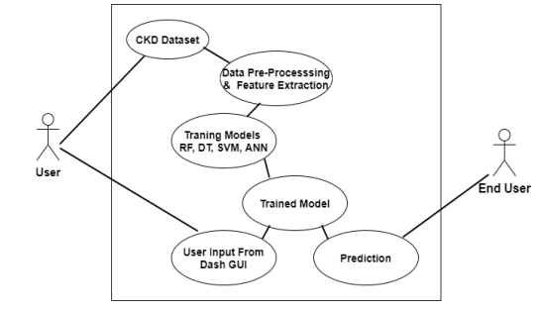

**4.2 FEATURES**

In the early detection of kidney disease using Support Vector Machines (SVM) or any machine learning approach, selecting the right features is crucial. The choice of features should be based on medical knowledge, relevance to kidney function, and their ability to discriminate between patients with and without kidney disease. Here are some common features used in the early detection of kidney disease:

1.Serum Creatinine Level: Creatinine is a waste product that the kidneys normally remove from the blood. Elevated creatinine levels can indicate impaired kidney function.

2.Glomerular Filtration Rate (GFR): GFR is a measure of the kidney's ability to filter blood. A decrease in GFR is a sign of kidney dysfunction.

3.Blood Urea Nitrogen (BUN): BUN is a measure of the amount of urea nitrogen in the blood. Elevated BUN levels can suggest kidney problems.

4.Proteinuria: The presence of excess protein in the urine is a common sign of kidney disease.

5.Hematuria: Hematuria refers to the presence of blood in the urine, which can be a symptom of kidney disease.

6.Age: Age can be a significant factor, as kidney function tends to decline with age.

7.Gender: Some kidney diseases may have a gender bias and affect males or females differently.

8.Blood Pressure: High blood pressure (hypertension) can be both a cause and a consequence of kidney disease.

9.Diabetes Status: Diabetes is a leading cause of kidney disease. Including information about a patient's diabetic status is essential.

10.Body Mass Index (BMI): Obesity and overweight conditions can contribute to kidney problems and are often used as a risk factor.

11.Race or Ethnicity: Some kidney diseases, like focal segmental glomerulosclerosis (FSGS) or lupus nephritis, are more common in certain racial or ethnic groups.

12.Family History: A family history of kidney disease may increase an individual's risk.

13.Medical History: Information about past medical conditions and treatments can be relevant, particularly if they are known to affect kidney health.

14.Medication Usage: Some medications can have adverse effects on the kidneys, so knowing the patient's medication history is important.

15.Symptoms: Symptoms like fatigue, swelling, changes in urine color, and changes in urinary frequency or urgency can be indicative of kidney issues.

16.Laboratory Results: Besides creatinine, other laboratory values, such as electrolyte levels (e.g., potassium, sodium) and complete blood count (CBC), can provide valuable information about kidney function.

17.Imaging Data: Imaging studies like ultrasound, CT scans, or MRI may reveal structural abnormalities in the kidneys.

18.Biopsy Results: In some cases, kidney biopsies provide detailed information about the nature and extent of kidney disease.

The specific combination of features used in an SVM-based early detection model will depend on the dataset and the goals of the study. Feature selection techniques, such as feature importance analysis or recursive feature elimination, can help identify the most relevant features for the task at hand. It's important to work closely with healthcare professionals and domain experts to determine the optimal set of features for your particular application**.**

**4.2.1 *Novelty of the proposal***

A novelty proposal for early detection of kidney disease using Support Vector Machines (SVM) would aim to introduce innovative approaches, techniques, or data sources that can enhance the accuracy, timeliness, or efficiency of kidney disease prediction. Here's a proposal outline: Title: Innovative SVM-Based Kidney Disease Early Detection

Objective: This proposal seeks to improve early kidney disease detection using SVM by introducing novel techniques and approaches.

1. Introduction:

Provide an overview of kidney disease's significance and the current challenges in early detection.

Emphasize the role of SVM in enhancing early diagnosis.

2. Literature Review:

Summarize existing SVM-based methods for kidney disease prediction.

Identify gaps and recent advancements in SVM-related techniques.

3. Proposed Novelty Contributions:

Advanced Feature Engineering: Explore cutting-edge techniques for feature engineering.

Multi-Modal Data Fusion: Combine various data sources for a holistic view.

Temporal Modeling: Consider the disease progression over time.

Active Learning: Minimize labeled data requirements.

Explainability: Enhance model transparency.

4. Data Preparation:

Describe data sources and preprocessing steps.

5. Methodology:

Explain the proposed SVM-based methods, including enhancements.

6. Experiment Design:

Outline the setup, metrics, and baselines for evaluation.

7. Expected Outcomes:

Discuss benefits in terms of accuracy and early detection rates.

8. Ethics:

Address ethical considerations and regulatory compliance.

9. Timeline:

Provide a project timeline and milestones.

10. Conclusion:

Summarize the proposal's potential to advance early kidney disease detection using SVM.

11. References: Cite relevant sources supporting the proposed innovations.

**CHAPTER 5**

***CONCLUSION***

In conclusion, the progressive approach to early prediction for Chronic Kidney Disease (CKD) detection represents a pivotal shift in healthcare that holds immense promise. By combining cutting-edge technology, data-driven insights, and patient engagement, this innovative approach empowers healthcare providers and patients alike in the battle against CKD. It strives for early intervention, personalized health management, and continuous enhancement of care quality.

With CKD becoming an increasingly prevalent and costly global health concern, this progressive approach not only helps detect the disease at its earliest stages but also ensures that patients receive tailored care plans to slow its progression. This not only improves patient outcomes but also alleviates the burden on healthcare systems.

In essence, the fusion of technology, data, and patient-centered care is revolutionizing CKD management, offering newfound hope for individuals at risk of or already living with this condition. The journey toward early prediction and progressive health management for CKD is a transformative one, promising a healthier and brighter future for countless individuals worldwide.

The KDOQI guidelines recommend that access creation should occur when eGFR is between 15 and 20 mL/min/1.73 m2.114 Of note, dialysis initiation has been associated with accelerated functional decline and high short-term mortality among older patients with poor functional status.115,116 Patient preferences for conservative approaches to medical management should be discussed and honored.

Early education should include information on the potential complications of CKD as well as the different modalities of kidney replacement therapy. Kidney transplantation is considered the optimal therapy for ESKD, with living donor kidney transplantations performed before or shortly after dialysis initiation having the best outcomes.

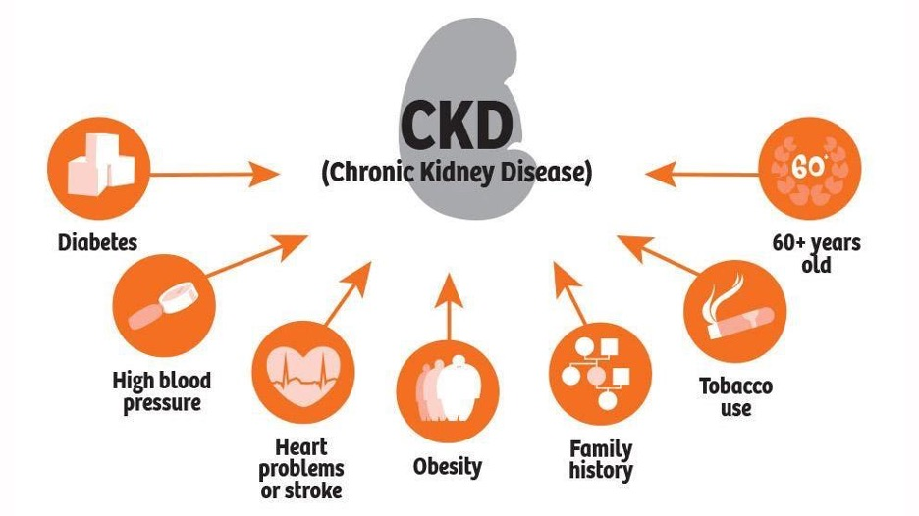

Chronic kidney disease affects 8% to 16% of the population worldwide and is a leading cause of death. Optimal management of CKD includes cardiovascular risk reduction, treatment of albuminuria, avoidance of potential nephrotoxins, and adjustments to drug dosing. Patients also require monitoring for complications of CKD, such as hyperkalemia, metabolic acidosis, anemia, and other metabolic abnormalities.

**Output :**

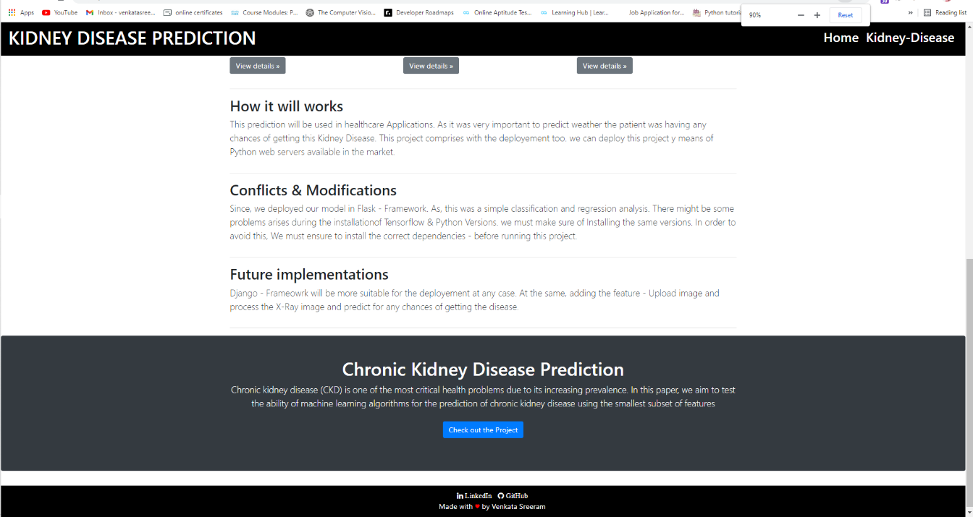

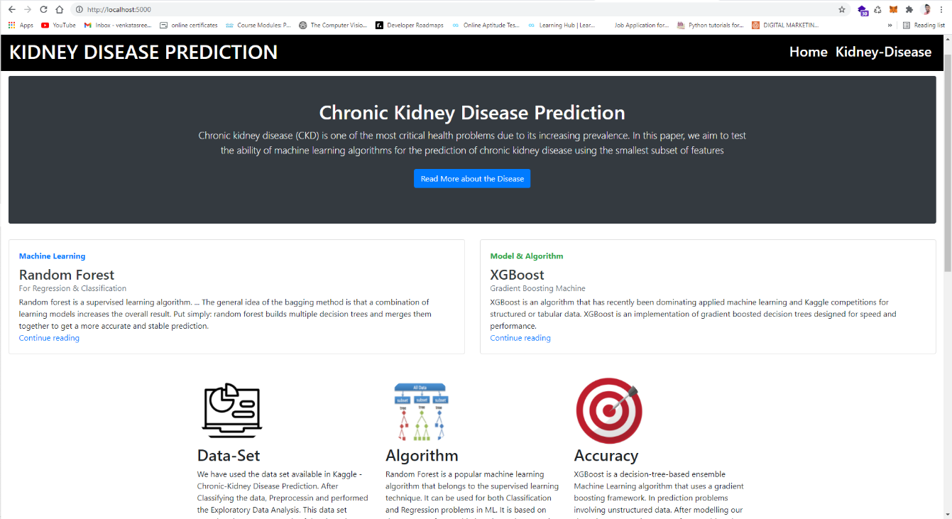

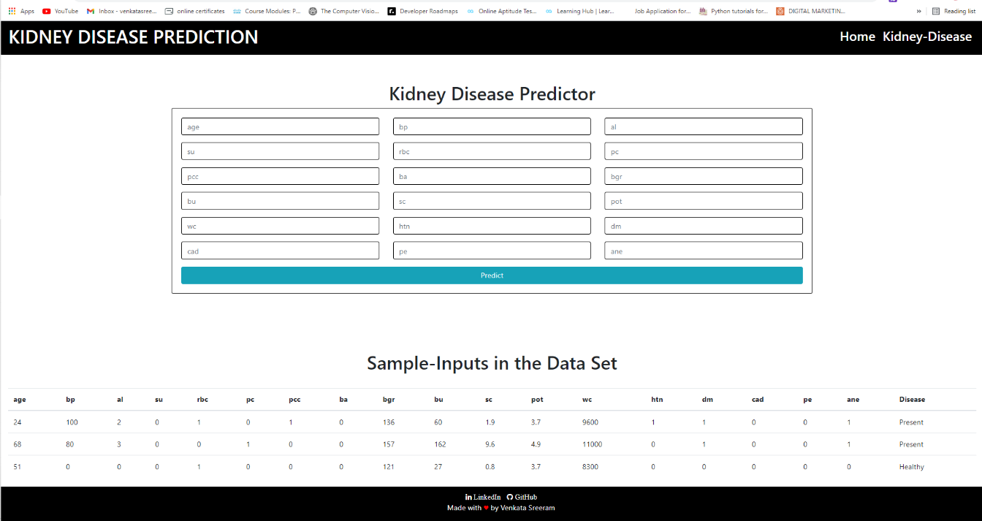

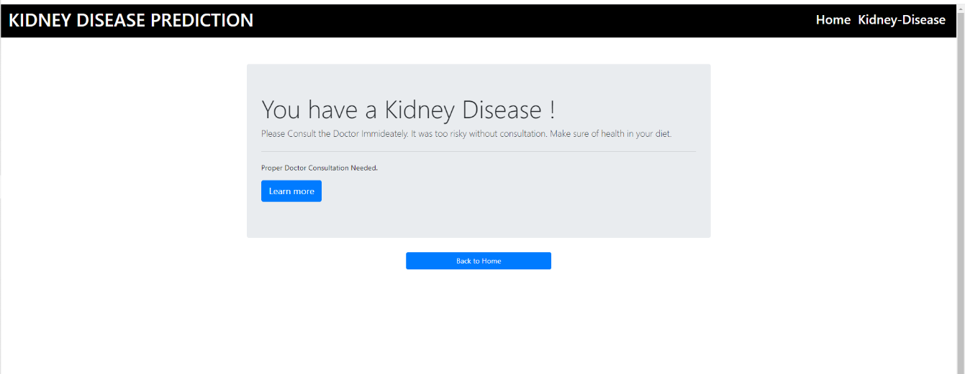

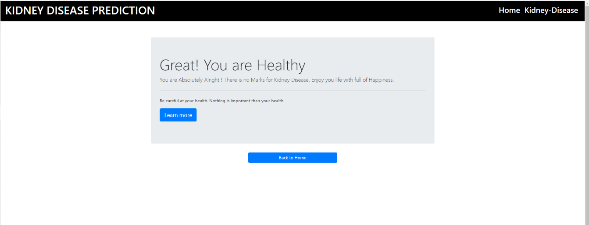

**REFERENCES**

1. Coresh J, Selvin E, Stevens LA, et al. Prevalence of chronic kidney disease in the United States. JAMA. 2007;298(17):2038–2047. doi: 10.1001/jama.298.17.2038 [PubMed] [CrossRef] [Google Scholar]

2. Hsu CY, Vittinghoff E, Lin F, Shlipak MG. The incidence of end-stage renal disease is increasing faster than the prevalence of chronic renal insufficiency. Ann Intern Med. 2004;141(2):95–101. doi: 10.7326/0003-4819-141-2-200407200-00007 [PubMed] [CrossRef] [Google Scholar]

5. Kidney Disease: Improving Global Outcomes (KDIGO) CKD Work Group. KDIGO 2012 clinical practice guideline for the evaluation and management of chronic kidney disease. Kidney Int Suppl. 2013;3(1):1–150. [Google Scholar]

6. Mills KT, Xu Y, Zhang W, et al. A systematic analysis of worldwide population-based data on the global burden of chronic kidney disease in 2010. Kidney Int. 2015;88(5):950–957. doi: 10.1038/ki.2015.230 [PMC free article] [PubMed] [CrossRef] [Google Scholar]

7. Genovese G, Friedman DJ, Ross MD, et al. Association of trypanolytic ApoL1 variants with kidney disease in African Americans. Science. 2010; 329(5993):841–845. doi: 10.1126/science.1193032 [PMC free article] [PubMed] [CrossRef] [Google Scholar]

8. Tzur S, Rosset S, Shemer R, et al. Missense mutations in the APOL1 gene are highly associated with end stage kidney disease risk previously attributed to the MYH9 gene. Hum Genet. 2010;128 (3):345–350. doi: 10.1007/s00439-010-0861-0 [PMC free article] [PubMed] [CrossRef] [Google Scholar].