Level creation/duplication:
The following are all of the options that need to be updated in order to duplicate a level in order to represent a new set of questions. Create 5 text files with the names “levelNMedH” for the medical history, “levelNNotes” for the medical notes, “levelNDIA” for the diagnosis, “levelNMed” for the medication, and “levelNScript” for the question/answer script. Create an image named “LevelN” that contains the provided image from the question sheet with the texture type changed to “Sprite (2D and UI)”. As a baseline for a level, duplicate the scene named “Level1” and change the name of the new scene to “LevelN”. For all the above, N is reflective of the level number.
The format for the “levelNScript” file is as depicted below with each line being no longer than 175 characters…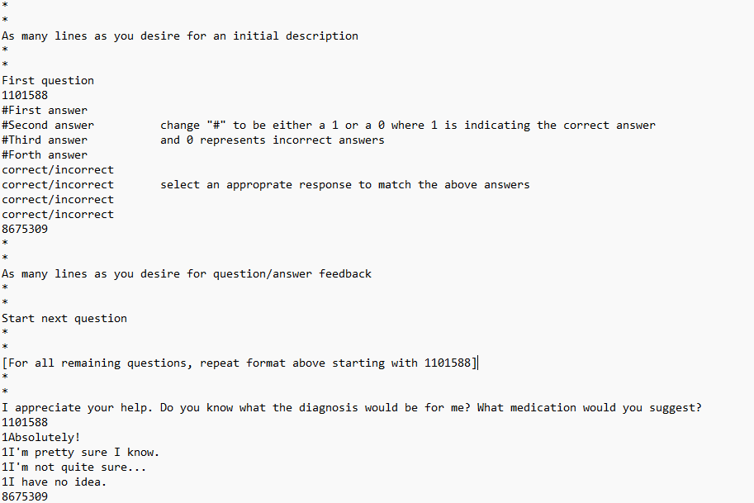

The format for the “levelNDIA” and “levelNMed” files is as depicted below…
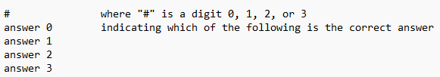
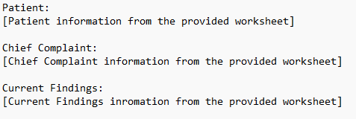
The format for the “levelNMedH” file is as depicted below…

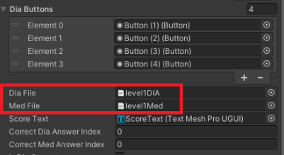
On the new scene, in the hierarchy, select the component named “LevelButtonManager”. In the inspector you should see an attached script that is named “Level Button Manager”. Inside this script locate 2 variables named “Dia File” and “Med File”. Select or drag/drop the newly created text files named “levelNDIA” and “levelNMed” into the respective variable.
Inside the same “LevelButtonManager” component you should see another attached script named “Axium Display”. In the inspector under this script locate the variables named “New Sprite”, “Note Text”, and “Med History Text”. Assign the newly created image named “LevelN” to “New Sprite”, assign ‘levelNDIA” to “Dia File” and “levelNMed” to “Med File”.
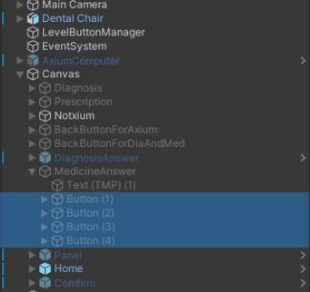
Returning to the Hierarchy, locate and expand the component named “Canvas” and expand the child component name “MedicineAnswer”. You should see 4 buttons that reflect the medicine cabinet answers. Update the image for these buttons by creating and drag/dropping a new image onto each button that is reflective of the respective answer

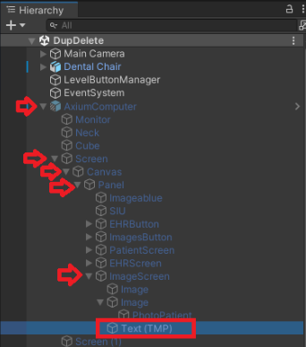
Returning to the Hierarchy, expand the component named “AxiumComputer” and inside this component, expand “Screen” then “Canvas” then “Panel, then “ImageScreen” and select the child component named “Text (TMP).”
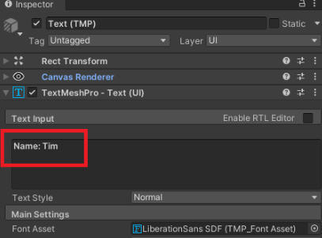
In the inspector you should see a component named “TextMeshPro = Text (UI)” and inside this component you must change the displayed text to reflect the new patient’s name.

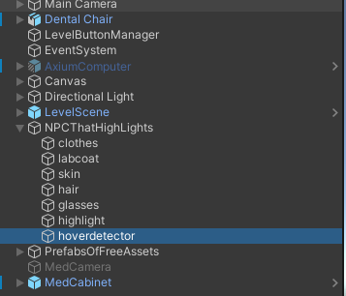
In the Hierarchy, expand the component named “NPCThatHighLights” and select the child component named “hoverdetector”.

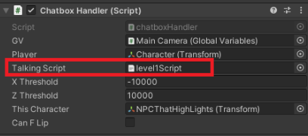
In the inspect you should see an attached script named “Chatbox Handler”. Locate the variable named “Talking Script” and select or drag/drop the newly created text file named “levelNscript”.

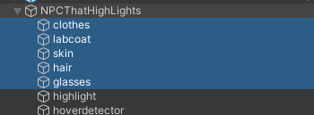
Returning to the Hierarchy, you can change the NPC’s cloths to match the outfit you wish to give them in the Level Selector by changing the materials for the following child components attached to “NPCThatHighLights”.

Level Selector Creation/Duplication
The following are all of the options that need to be updated in order to duplicate the level selection in order to add extra stages. As a baseline for level selection, duplicate the scene named “LevelSelector2ndFloor” and change the name of the new scene to “LevelSelectorNthFloor” where Nth is reflective of the floor it represents.
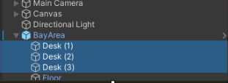
On the new scene, in the hierarchy, expand the component named “BayArea” and locate the child components named “Desk (1/2/3)”. To keep consistency “Deck (1)” represents the largest level number, “Desk 2” represents the middle number, and “Desk 3” represents the lowest number. For reference, in the duplicated scene Desk (1) represents level 6, Desk (2) represents level 5, and Desk (3) represents level 4.

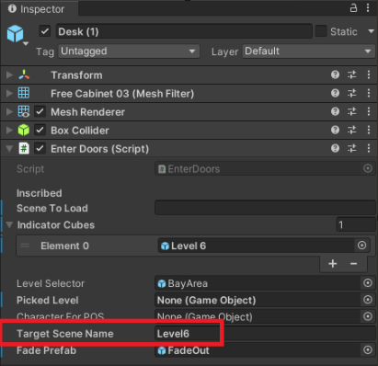
Select a single “Desk” and inside the inspector you should see an attached script that is named “Enter Doors”. Inside this script in the inspector, edit the variable named “Target Scene Name” to be the respective level name for each desk.

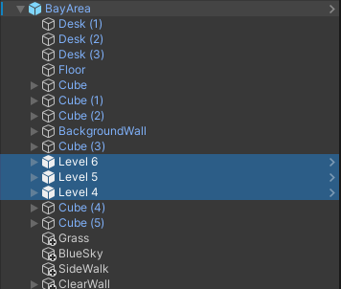
Rename the selected component to reflect the new levels they represent.

The following is to be repeated for each desk/level:
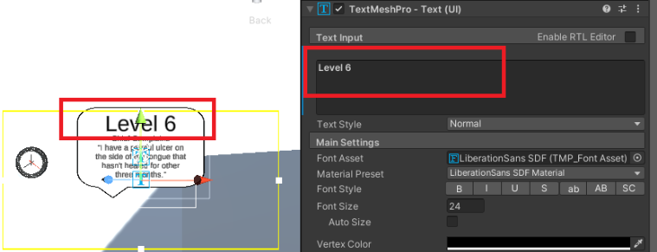
After renaming, expand each component and you should see 2 child components one of which is named “Description” and the other named “Header”. Select “Header” in the hierarchy and in the inspector locate the component named “TextMeshPro – Text (UI)” and change the text box to reflect the new level’ number.

In a similar fashion, select “Description” and change the text box to reflect the new level’s chief complaint from the provided worksheet.

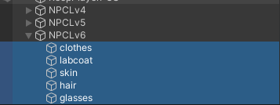
Returning to the hierarchy. Select component named “NPCLvN” and change the materials of the child components to match the materials that were selected in the respective level.

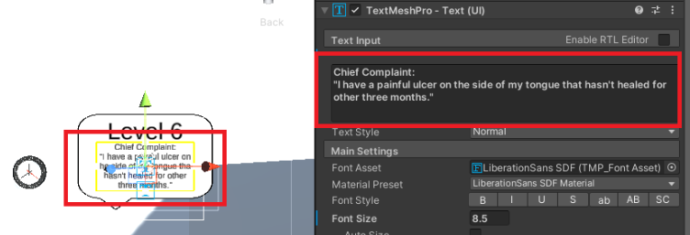
End of repeated changes.

