Below is the working code and the output from figure 10.1.1

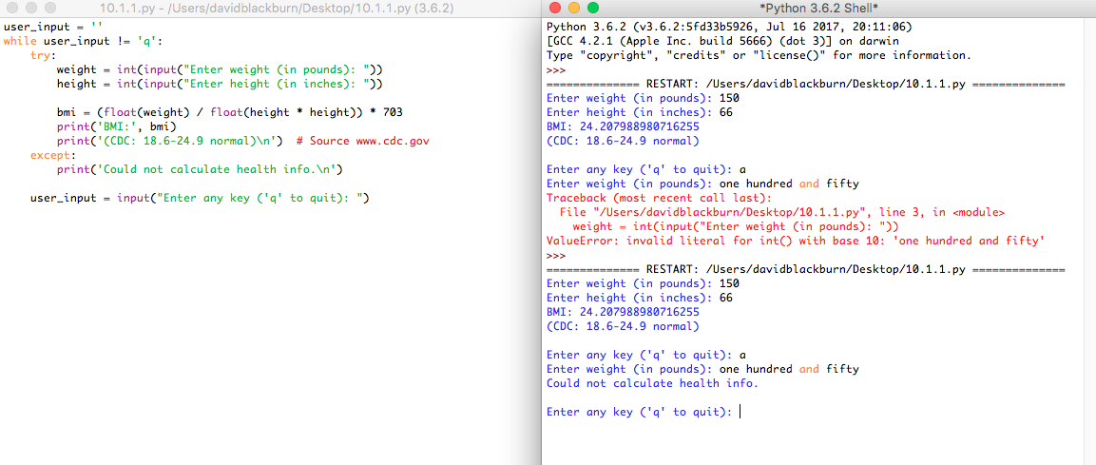

Below is the working code and the output from figure 10.2.1

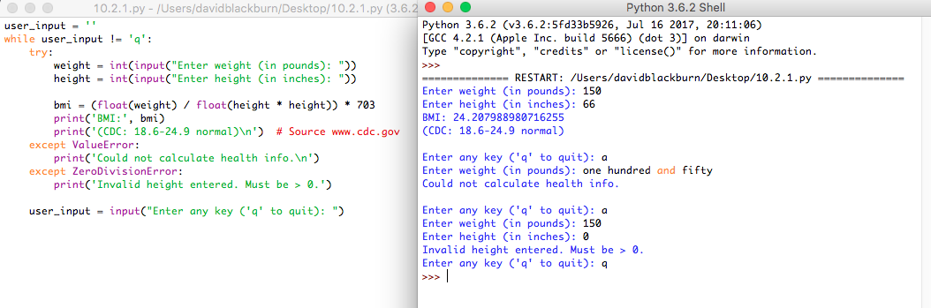

Below is the working code and output from figure 10.3.2

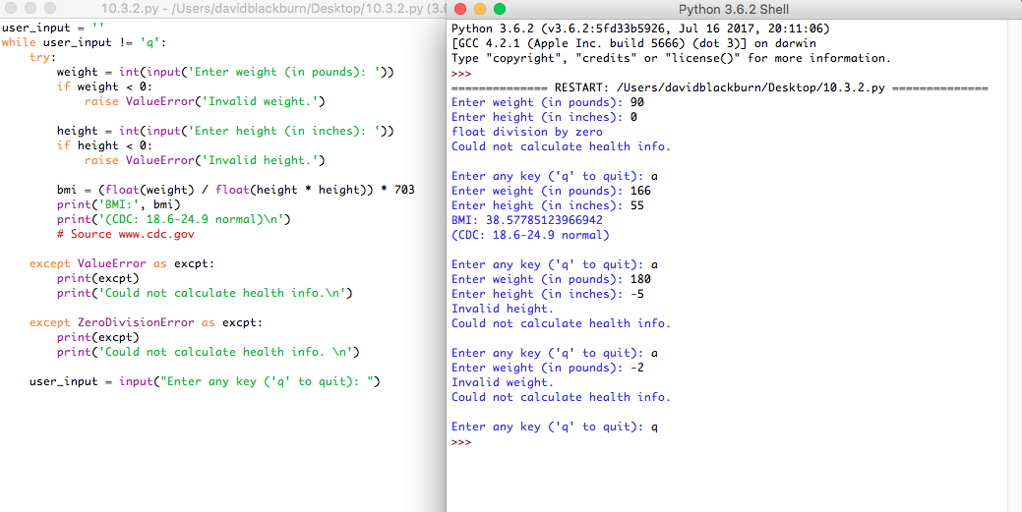

Below is the revised code from 4.9 with a try block integrated.

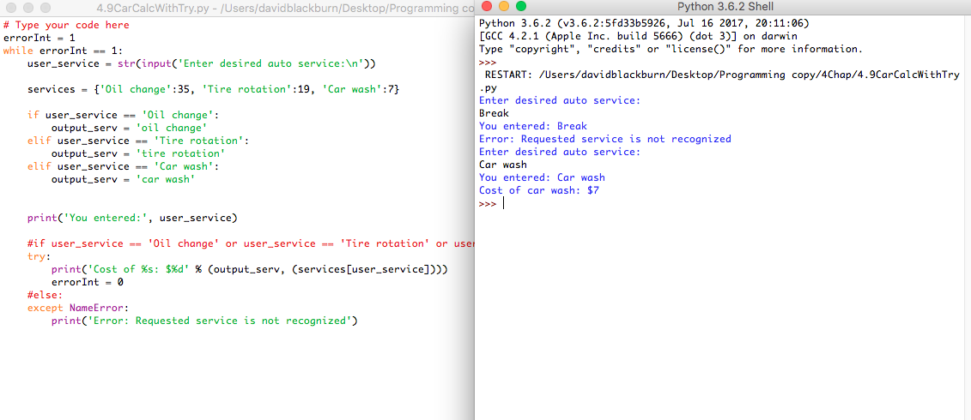

Below is the revised code from 5.14 with a try block.

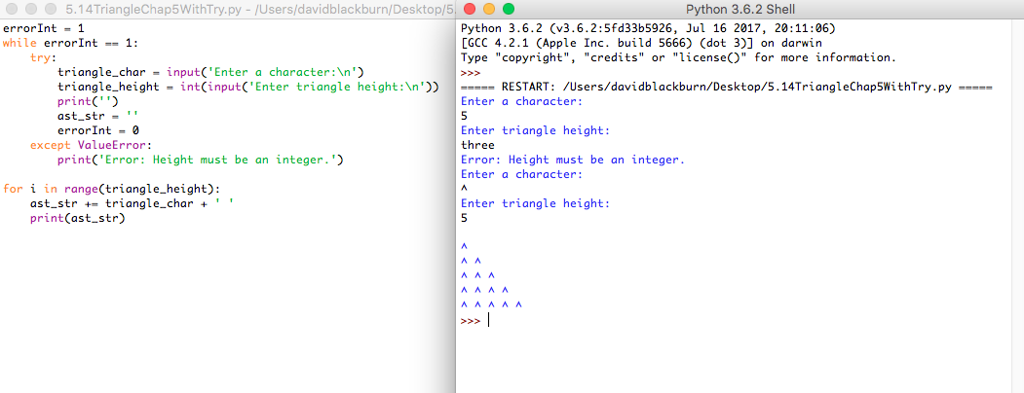

Below is the revised version of 8.16 with a try block integrated.

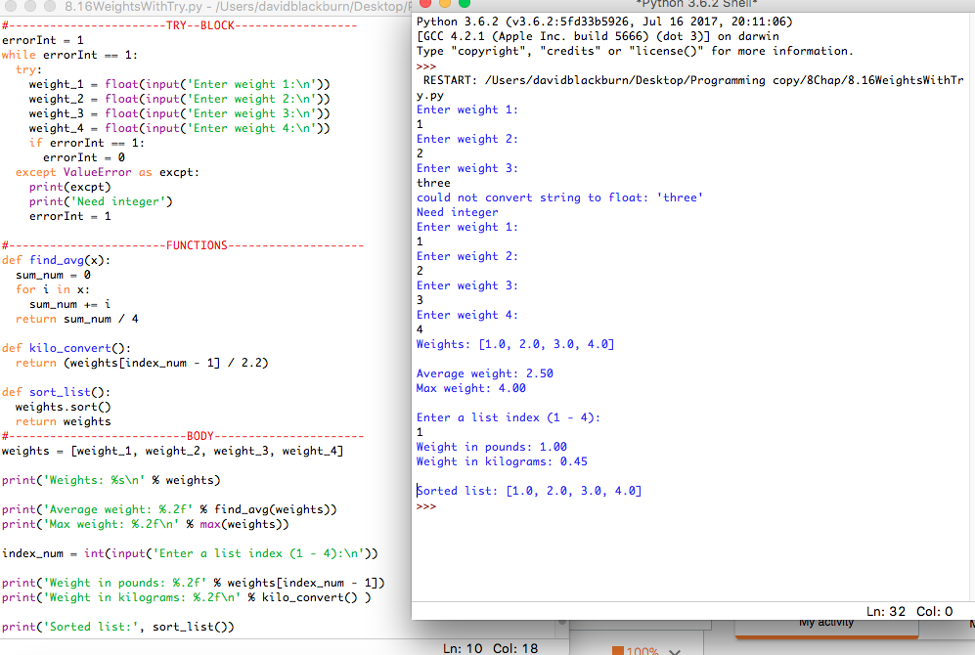

The next picture is of the code from the chapter 12 assignment. The only file that needed a try block was the one that writes to the file because if that can’t fail then the reader should have no problem. So I only took a screenshot of that code running. The files submitted should have the information seen in the screenshot if you need proof.

