Eric Sengvanhpheng
August 23, 2026
CSD 340 Module 3.2

Link to GitHub:
https://github.com/ThyNoi/csd-340.git

URL to Landing Page:
https://thynoi.github.io/csd-340/

HTML code validation screenshot:
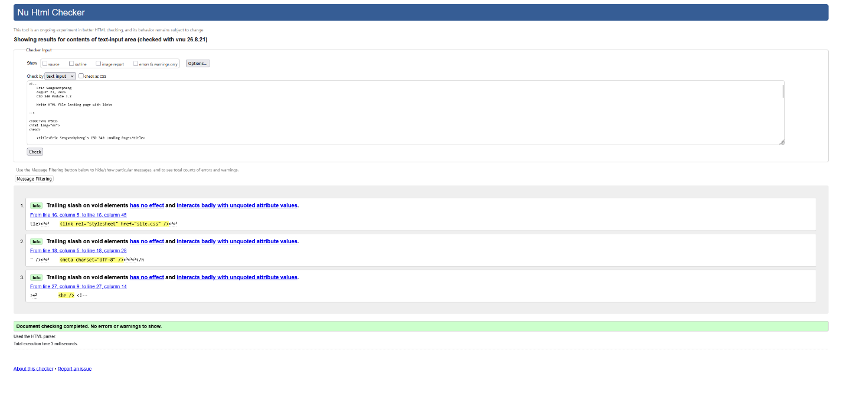

CSS code validation screenshot:
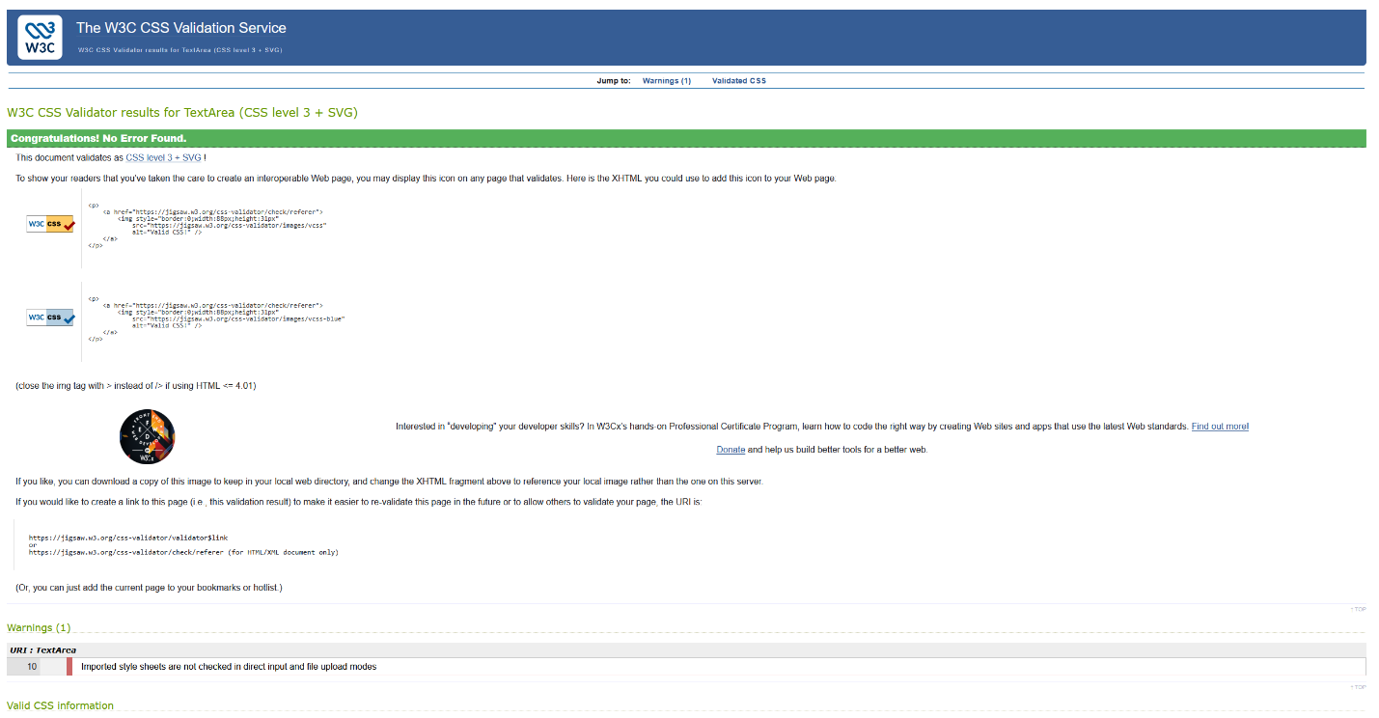

Landing Page webpage opened in browser:
