Eric Sengvanhpheng
August 14, 2026
CSD 340 Module 1.2

Link to GitHub repository:
https://github.com/ThyNoi/csd-340.git

Screenshot of local directory (properly formatted):
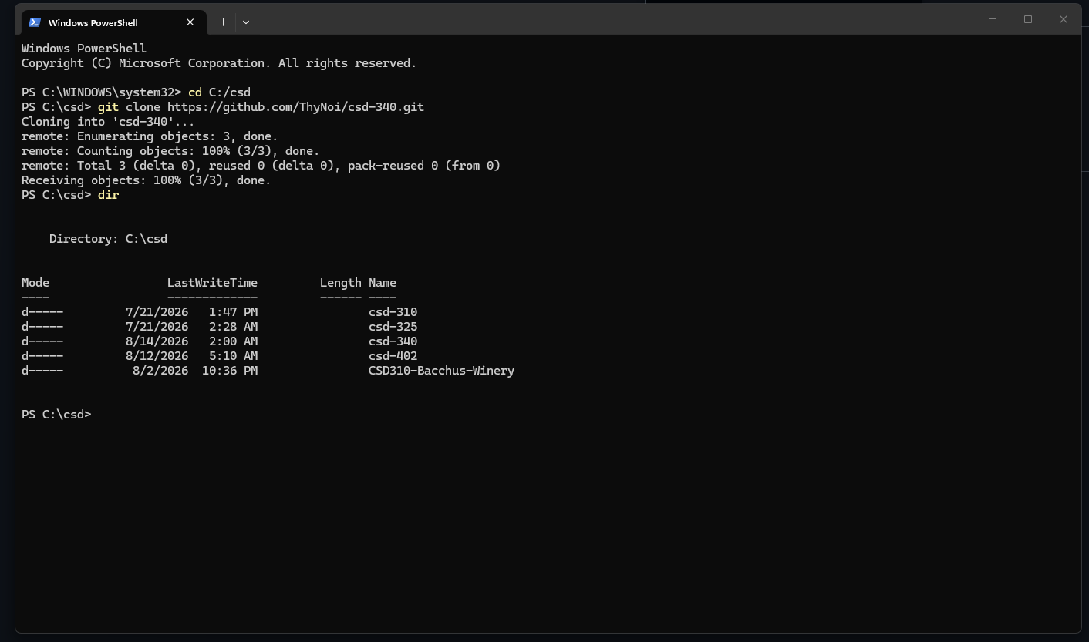

Screenshot of GitHub repository:
