Eric Sengvanhpheng
August 14, 2026
CSD 340 Module 1.3

Screenshot of the validators' results with errors.
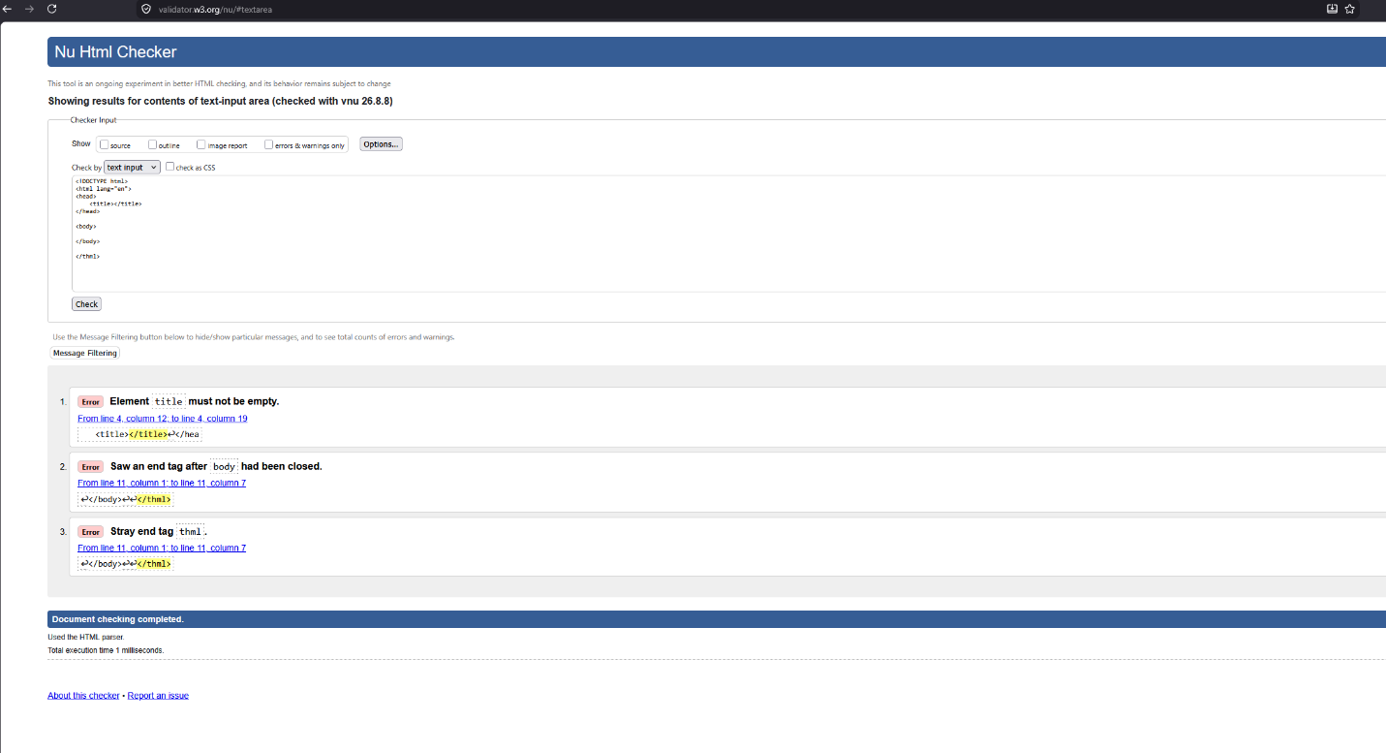

Screenshot of re-validated HTML code with no errors.
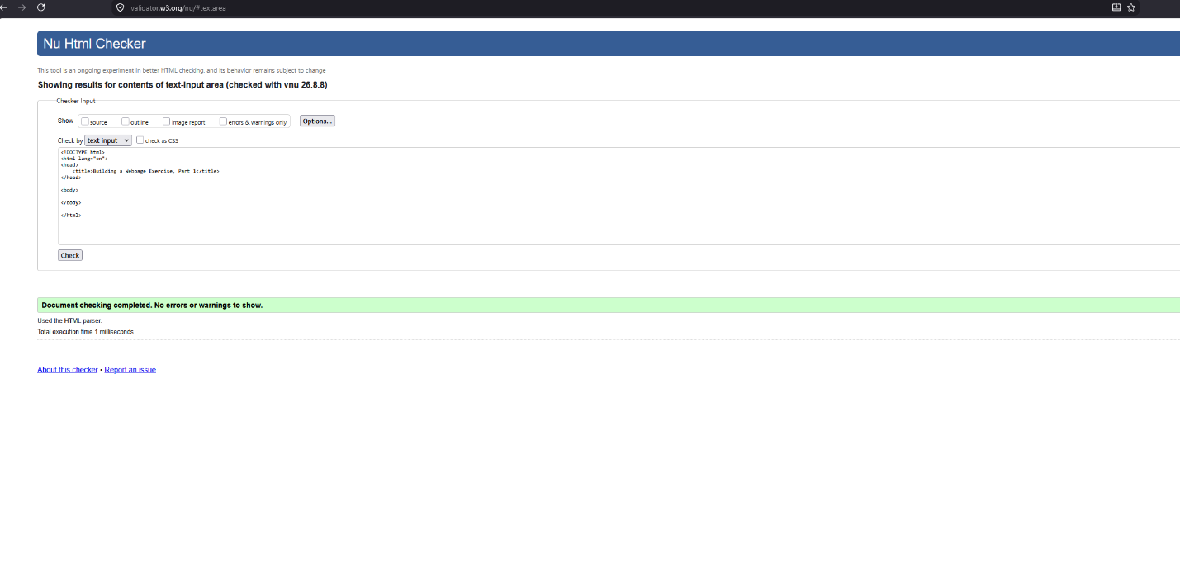

Screenshot of HTML code with updated elements.
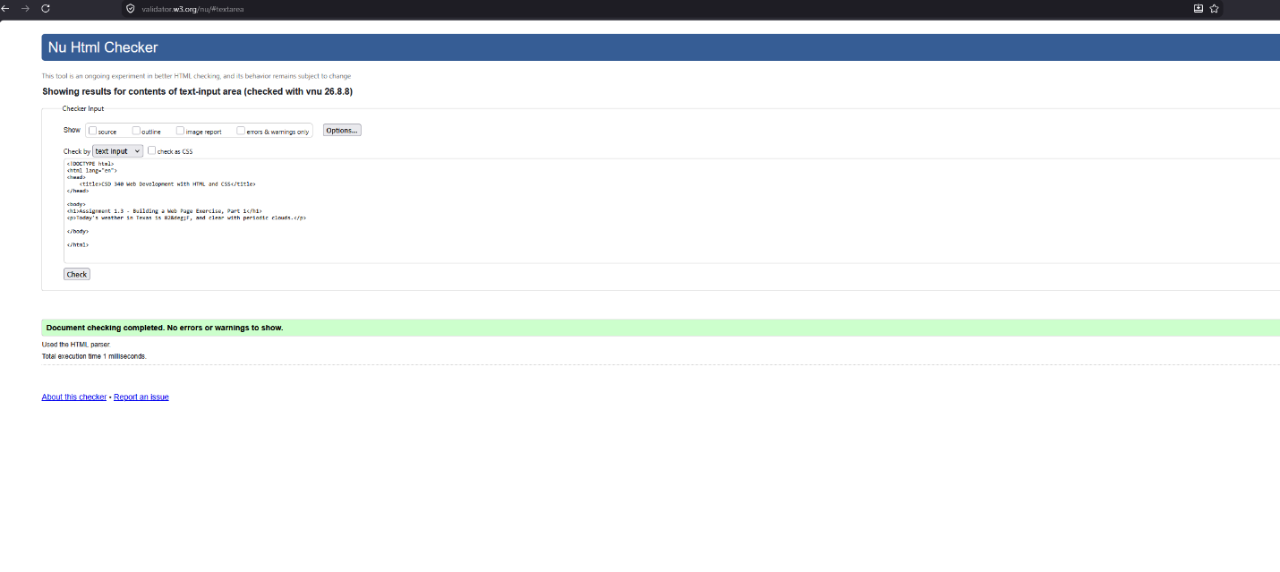

Screenshot of webpage.
