Eric Sengvanhpheng
August 15, 2026
CSD402 Java Module 1.3

Install of Java and Java compiler with versions:
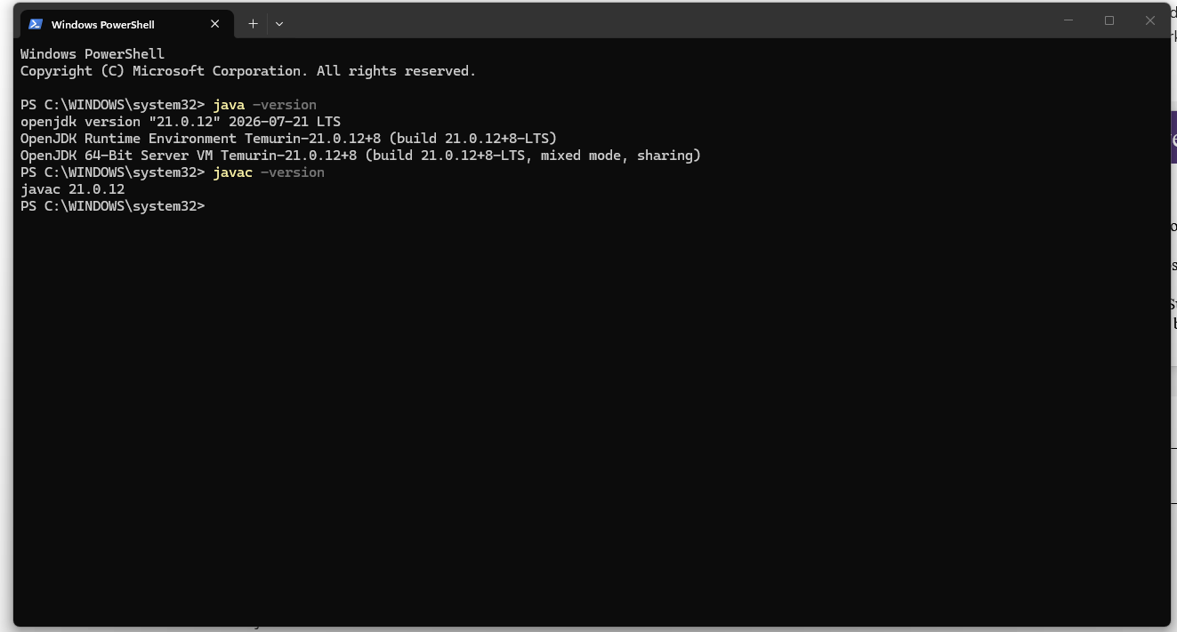

Downloaded JavaFX SDK with screenshot of the libraries:
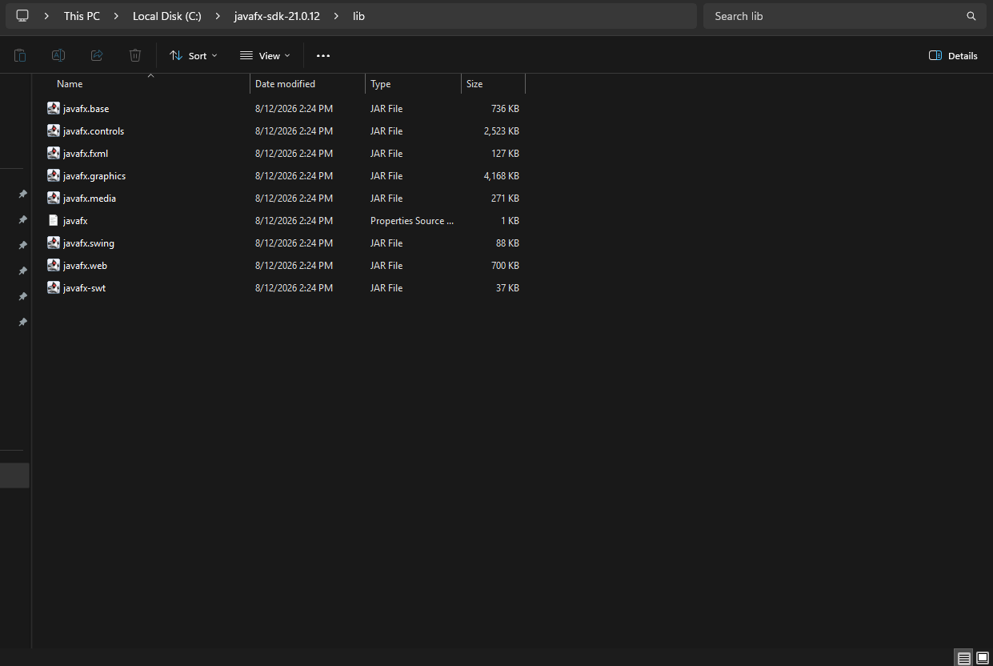

For testing JavaFX in VS code, had to create a Main file which is the actual program to test and alter, a settings file that points to where JavaFX .jar files are, and a launch file that points the running program to where JavaFX is.
Screenshot of test run:
