Description functionality of the Task Manger.

First of all, to summon a task manager you need to right click on task bar and then select **task manager**. Alternative option is to press CTRL+ALT+DELETE and select **task manager.** 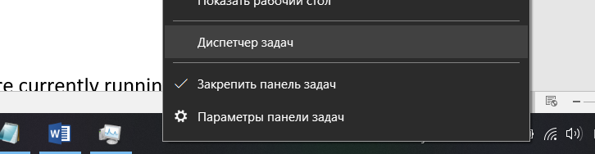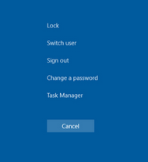

This is task manager:

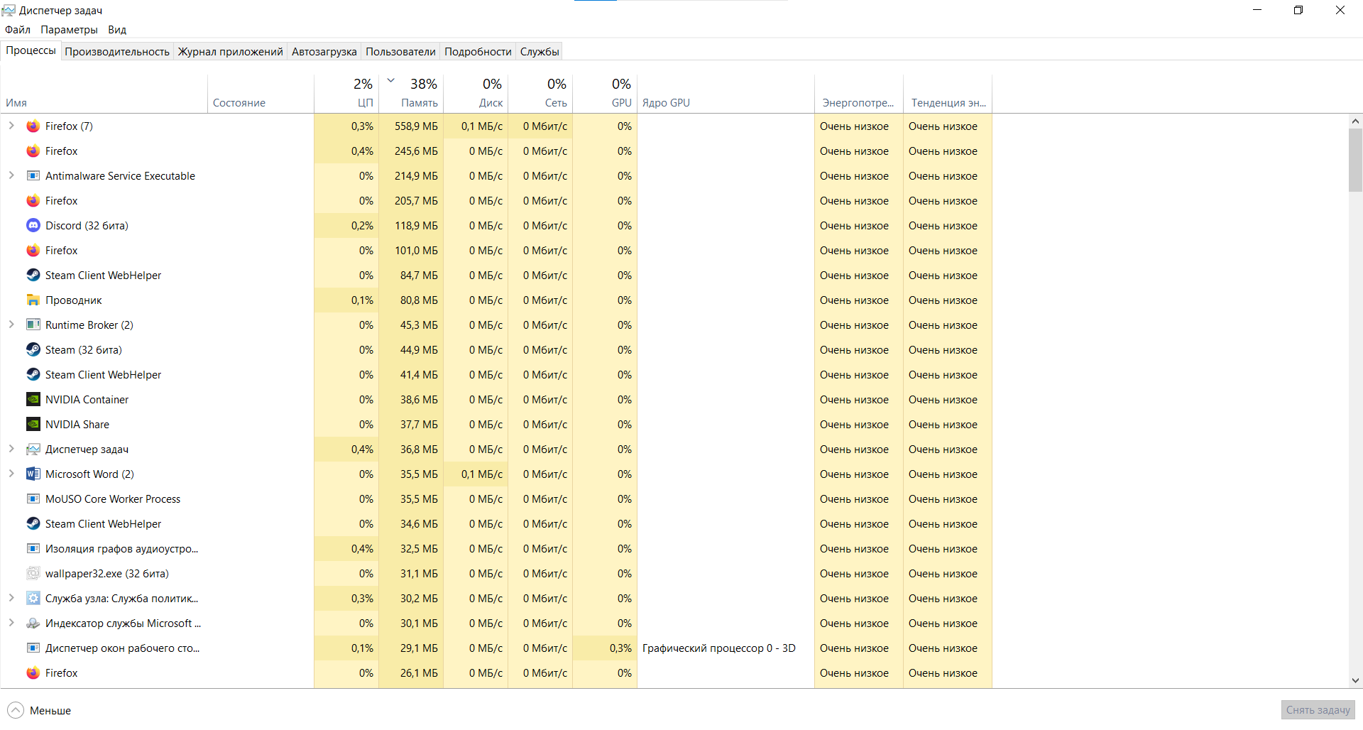

Its function is to show processes that are currently running on computer, resources that are being used by programs, Auto running programs and services;

It can not only show but stop programs, make changes in services and so on;

The first page of a task manager shows us processes that are currently running and how much resources they are taking (CP, RAM, hard drive, Web, GPU, energy consuming);

It is really useful to know what processes are running or making trouble for computer speed. It helps to completely stop program that is not responding or stuck on some process and also recognize virus activity;

This is second page of task manager:

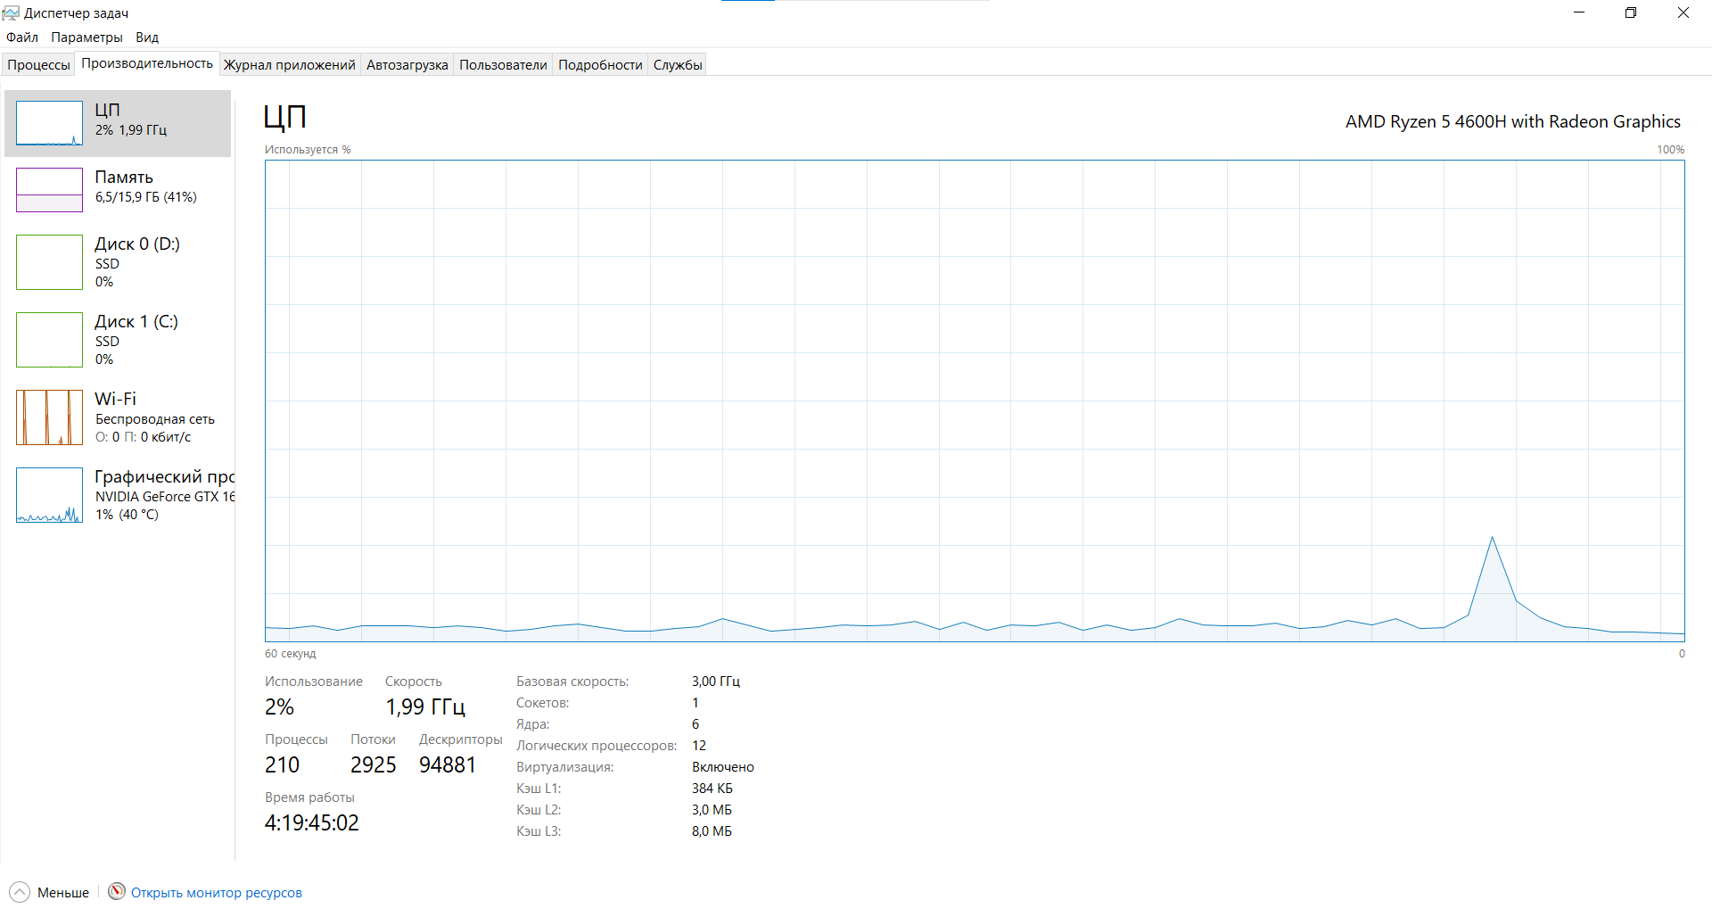

It shows some more details on resources by dynamic graph;

There is another option that can show even more information and graphs:



It opens monitoring of resources:

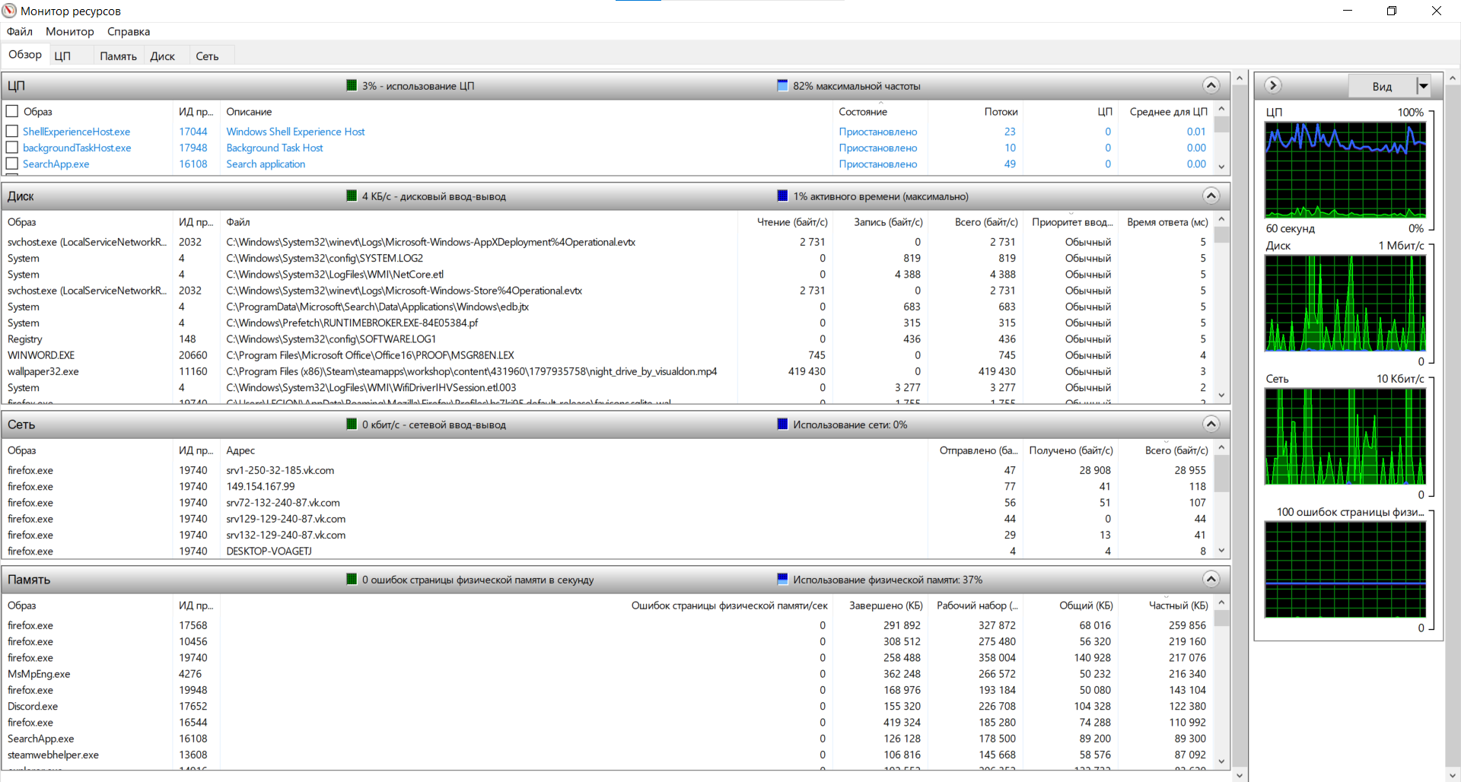

On third page we have app journal:

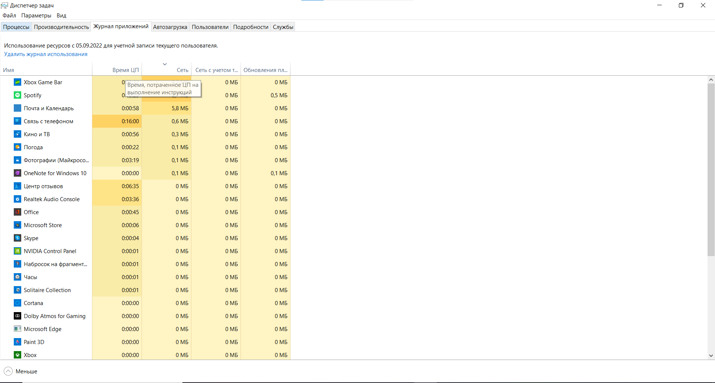

It shows information only about apps universal windows platform(UWP)

Thus it’s not really useful;

On forth page we have Auto running:

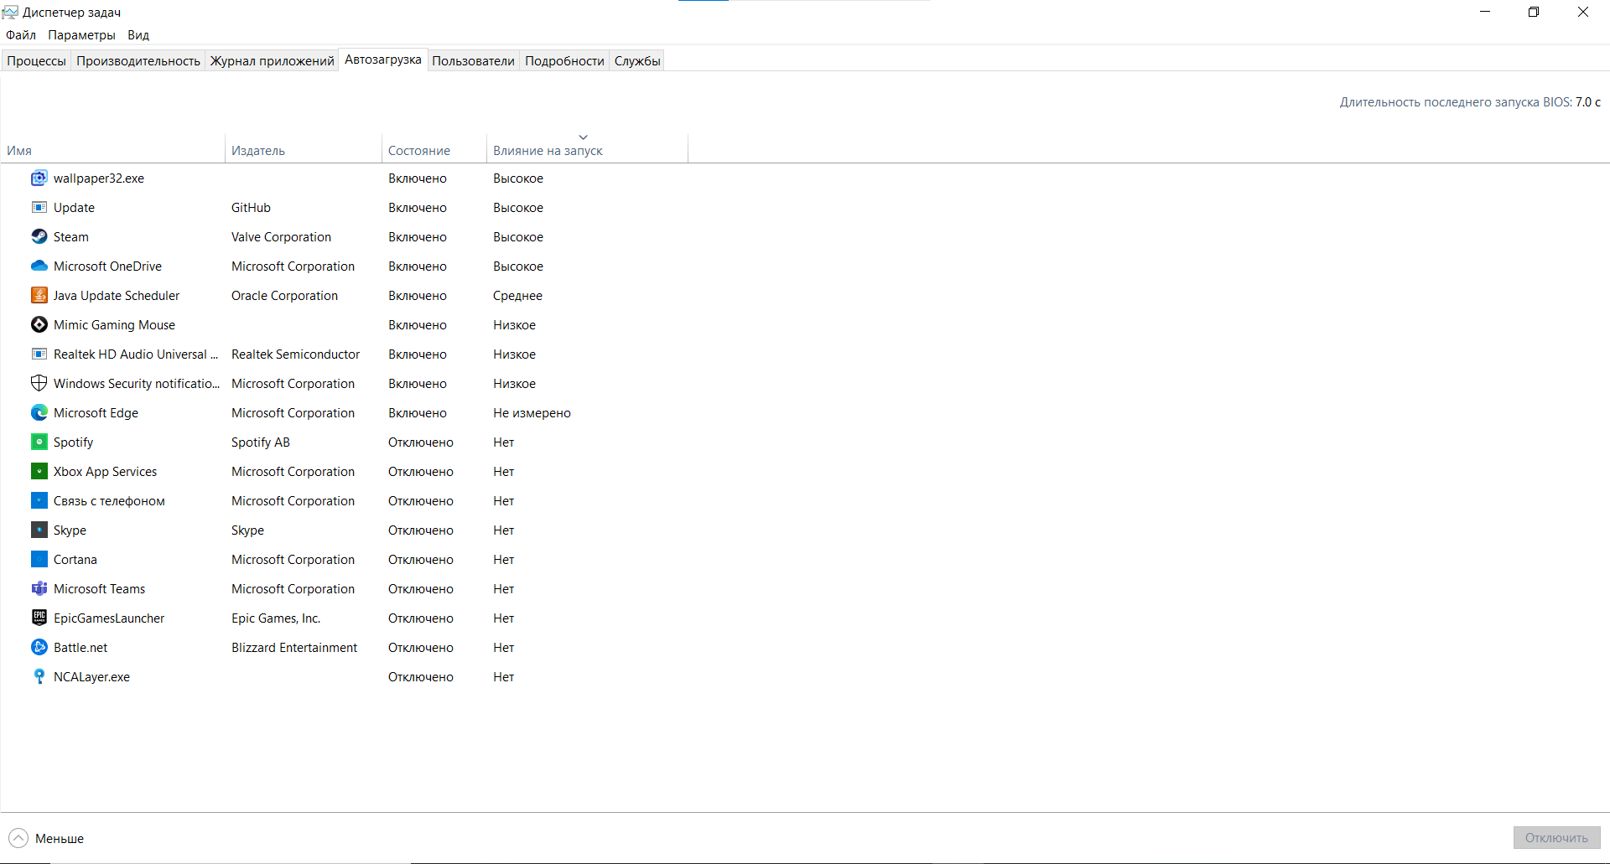

It shows programs that are starting at the powering computer on moment;

This allows us to choose programs that will be automatically executed or ignored at the start of system. Not needed programs will not eat additional ram thus saving us some resources;

next page is users:

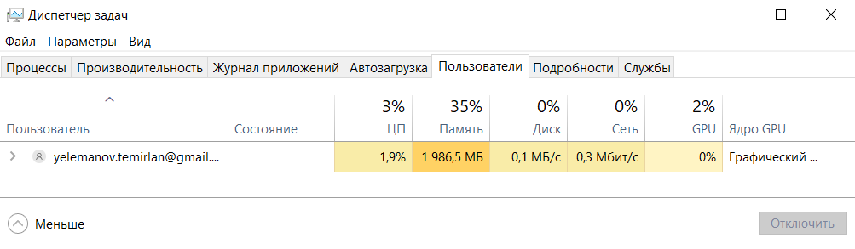

It shows users that are currently using this computer and some information about recourses;

Prelist page is Details:

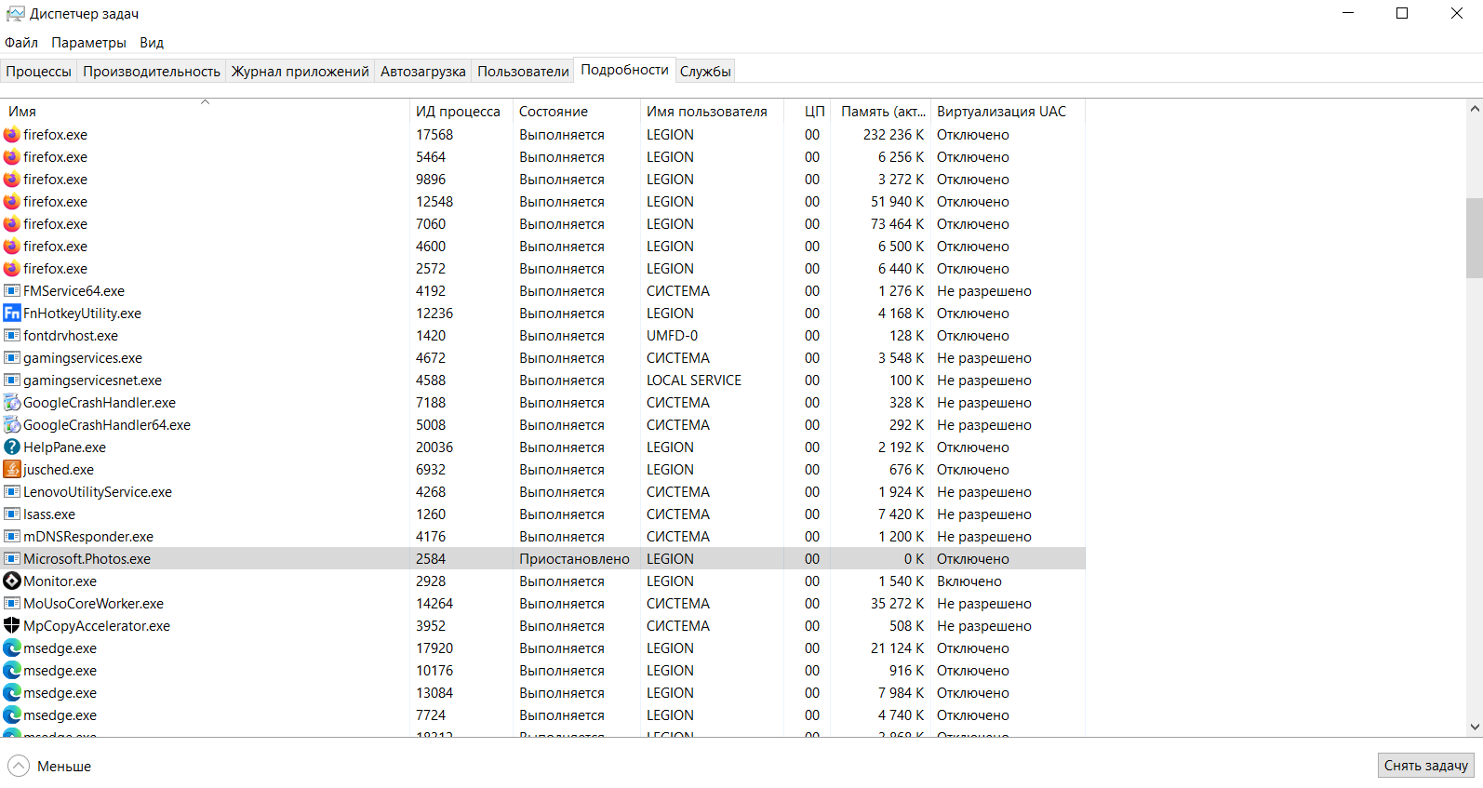

As a name says there are more detailed information about processes. But without showing consumed resources;

Services on the last page:

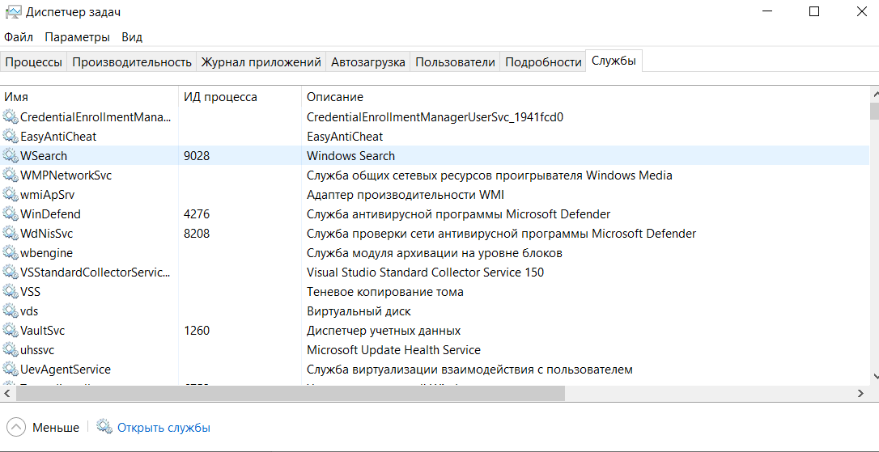

The Services tab displays a list of system services on your Windows system. These are background tasks that Windows runs even if the account is not signed in to a user account. They are controlled by the Windows operating system. Depending on the service, it may start automatically at boot or only when needed;

It is advised not to mess with it if you don’t know what it does;