Compte-rendu : Réseaux, TP1

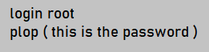
2) I logged in as a root user via these commands :

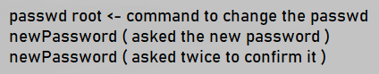
3) I changed the password of root like this :

4) I added an user using this command :


Then I was asked multiples informations about this user to complete its addition, like the password.

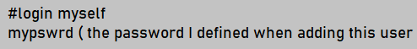
5) I logged in as the user ‘myself’ like this :

6) I used the command ‘exit’ to log out from the current user.

7) I renamed the name of the engine via this command :
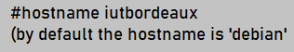

8) After rebooting, I noticed that the name wasn’t saved. It became ‘debian’ again. So I went to the file hostname like this.

9) A network/24, is a network which has a 24 mask, it means that it will communicate with the engine having the exact same first 24 bytes.

10) My first network/24 will be 192.168.10.0 and my second will be 192.168.20.0.

11) I’ll define the IP I need :
-eth0 in opeth : 192.168.10.1
- eth0 in nightwish : 192.168.10.2
-eth0 in zonaria : 192.168.10.3
- eth1 in opeth : 192.168.20.1
- eth0 in alcest : 192.168.10.4

12) I’ll give the IPs I just have chosen :

In opeth.


In nightwish.

In zonaria.

In opeth.


In alcest.

13) I tried to check if the communication between the engines is functionning like this : For my example nightwish send packages to zonaria.
It wasn’t working because eth0 was turned off.

14) To fix this problem I used this command :

15) We can’t make nightwish and alcest communicate because there is no ‘bridge’ to link them.

16) I used this command in alcest and nighwish to make opeth their bridge by default.

17) I tried this command to check if the communication is still not functionning.
I typed this command in nightwish to communicate to alcest, but eth0 is still turned off, so it’s not working.

18)

19) I used open the file ‘hosts’ from nightwish to contact zonaria, alcest and opeth by using their names instead of their IPs.

20) I rebooted each engines, and I noticed that none of them has saved the settings I put.

21) To solve this issue, we need to configure files ‘interfaces’ in each engines.

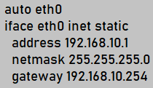
When we are in the file, we add this lines :

We adapt theses lines for each engines. For example for the eth1 network the adress would be 192.168.20.1.


22) We can turn on the eth0 network via this command :

Now the command ping is working.

23) We can also turn it off like this :

24) We check if our configurations are functioning by opening each interfaces files.



25) For opeth, we need to allow it to transfer packages. We add a line in its interfaces file.

And we add this line.

26) I rebooted each engines and re-checked if everything is functioning by using the commands : ip, ifconfing, route and ping. Every settings was saved, so it’s working.

