**LAPORAN PROGRESS HACKERRANK**

**“PEMROGRAMAN WEB”**



Dosen Pengampu :

Asmunin, S.Kom., M.Kom.

Disusun Oleh :

Arum Dewi Ayu Safira Surya (17051204015)

**PRODI S1.TEKNIK INFORMATIKA 2017 A**

**JURUSAN TEKNIK INFORMATIKA**

**FAKULTAS TEKNIK**

**UNIVERSITAS NEGERI SURABAYA**

* **SOAL-SOAL YANG SUDAH TERSELESAIKAN**

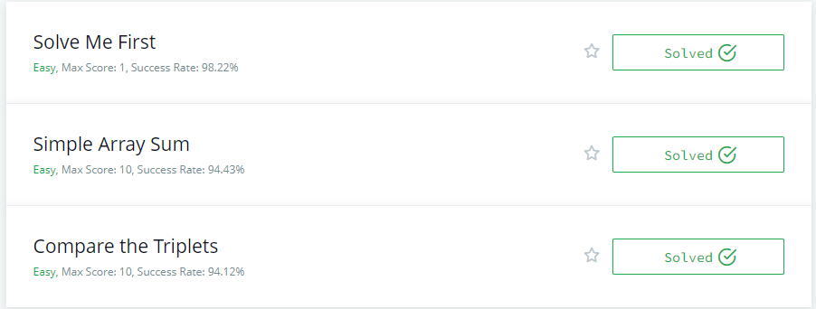

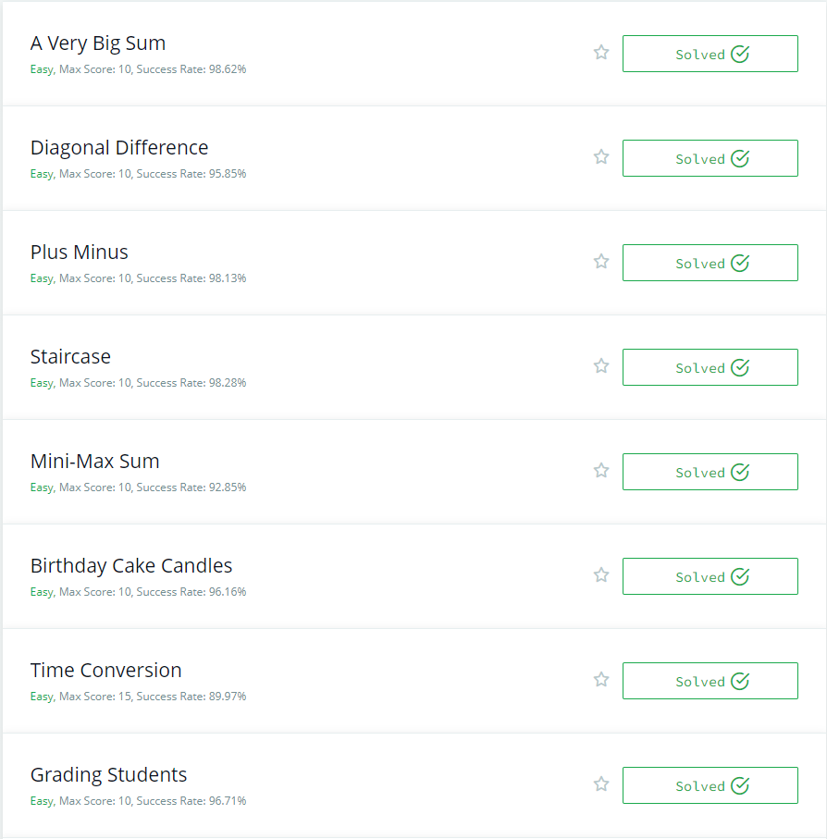

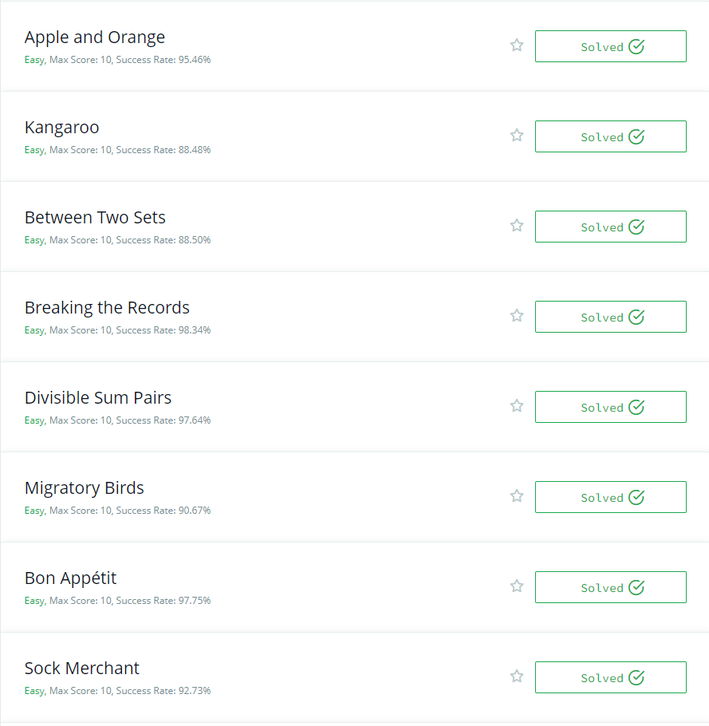

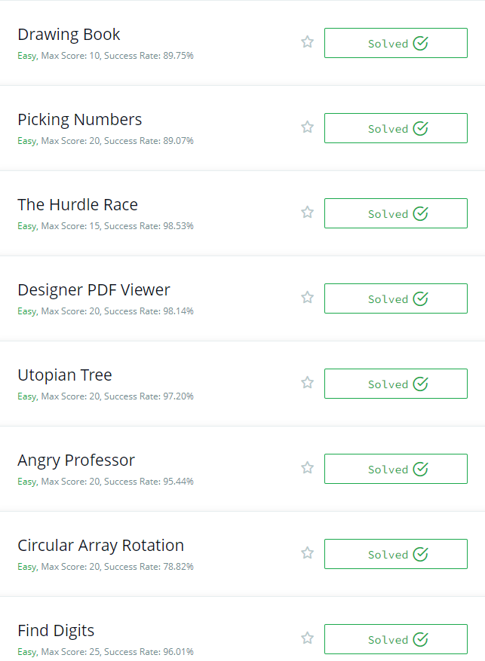

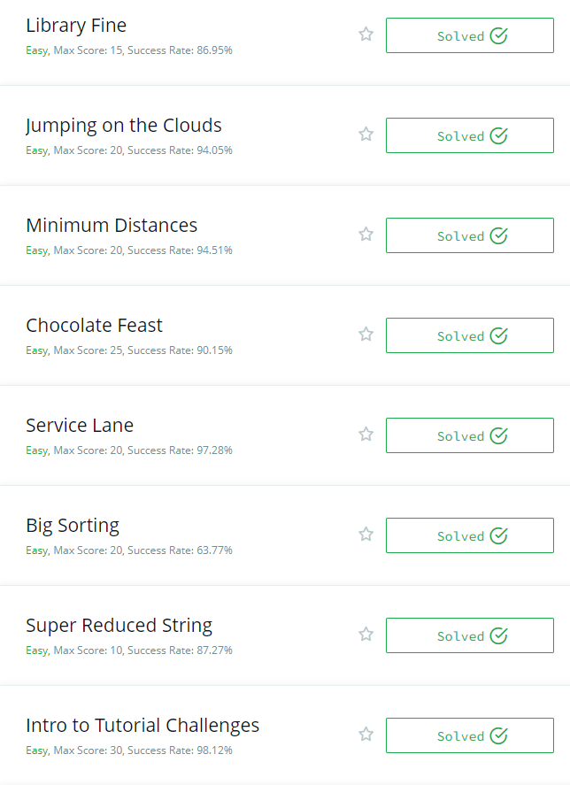

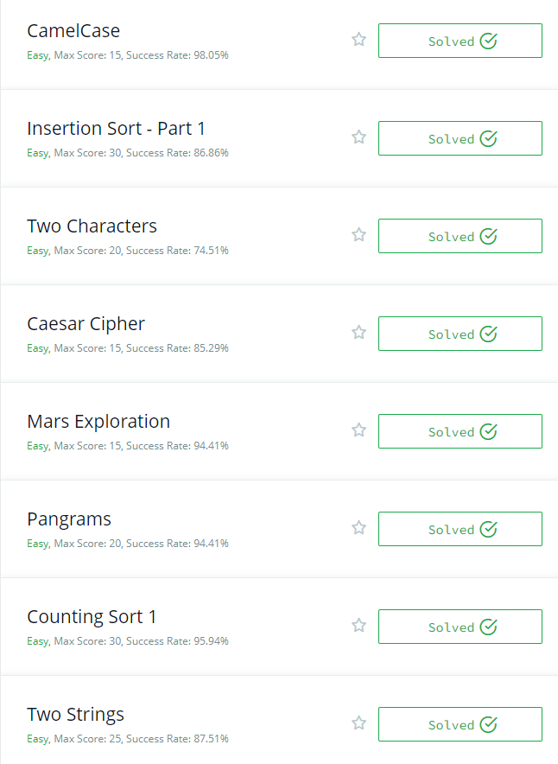

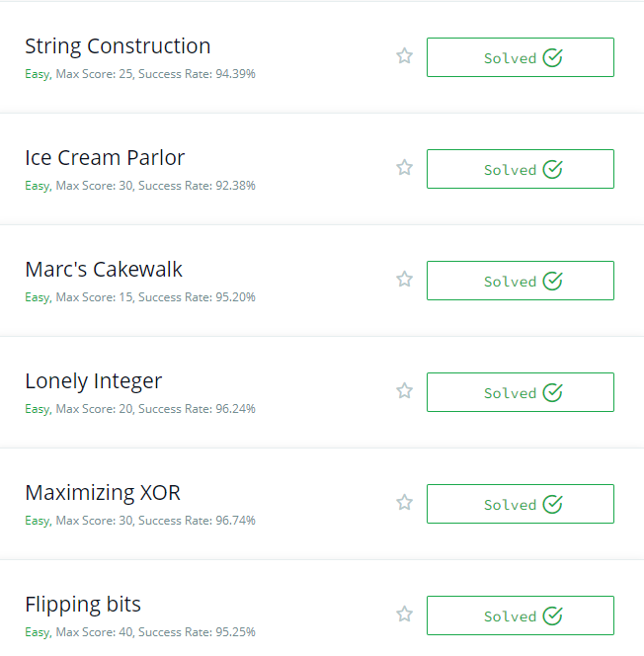

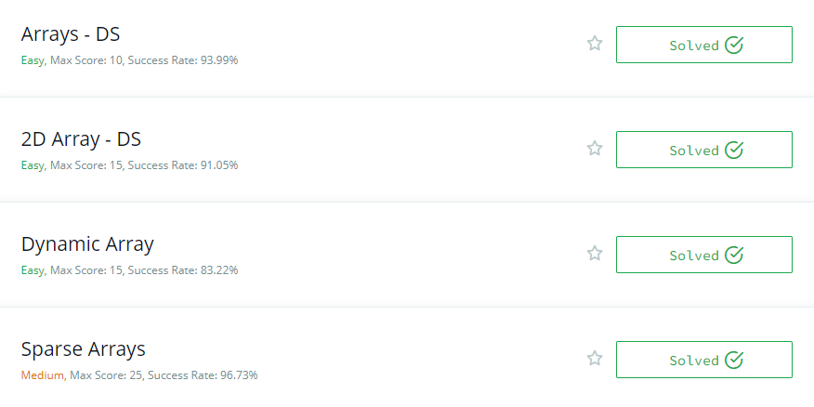

* **SOURCE CODE**
  + - * **Dinamic Array**

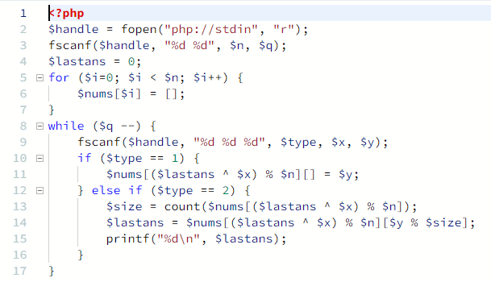

* + - * **Sparce Arrays**

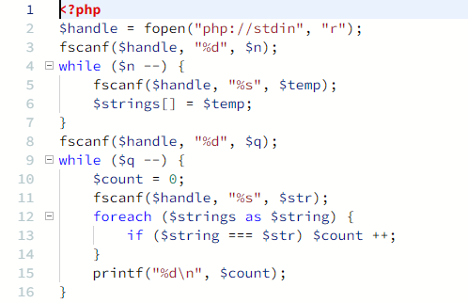

* **2D-Array-DS**

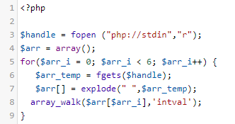

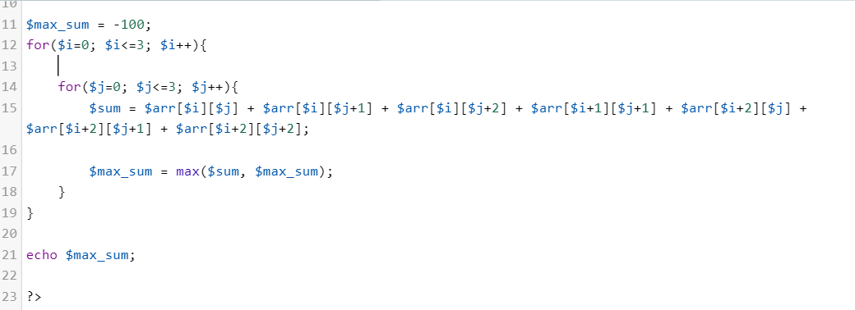

* [**Arrays - DS**](https://www.hackerrank.com/challenges/arrays-ds)

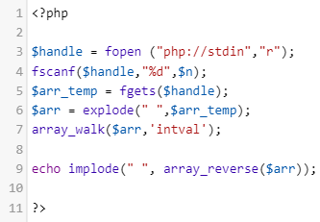

* [**Flipping bits**](https://www.hackerrank.com/challenges/flipping-bits)

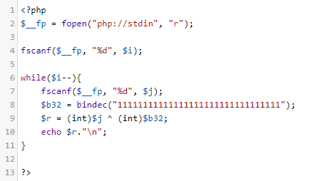

* [**Maximizing XOR**](https://www.hackerrank.com/challenges/maximizing-xor)

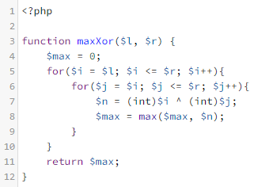

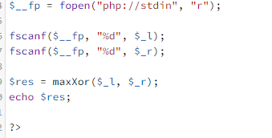

* [**Lonely Integer**](https://www.hackerrank.com/challenges/lonely-integer)

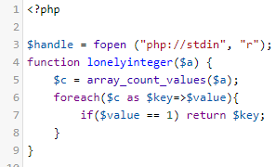

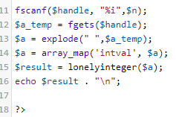

* [**Marc's Cakewalk**](https://www.hackerrank.com/challenges/marcs-cakewalk)

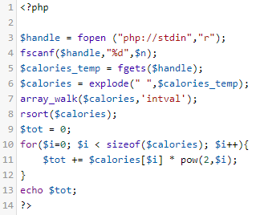

* [**Ice Cream Parlor**](https://www.hackerrank.com/challenges/icecream-parlor)

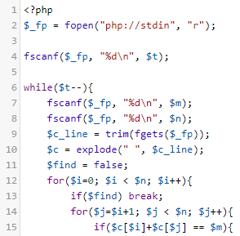

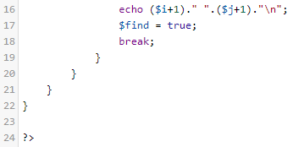

* [**Counting Sort 1**](https://www.hackerrank.com/challenges/countingsort1)

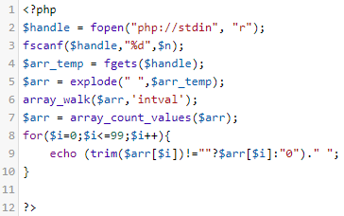

* [**Insertion Sort - Part 1**](https://www.hackerrank.com/challenges/insertionsort1)

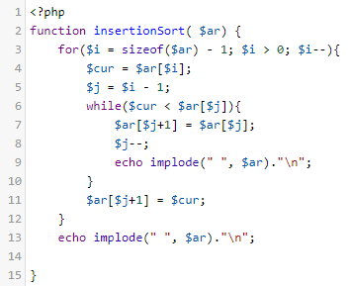

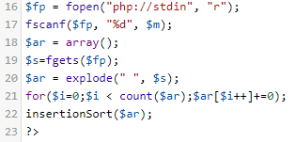

* [**Intro to Tutorial Challenges**](https://www.hackerrank.com/challenges/tutorial-intro)

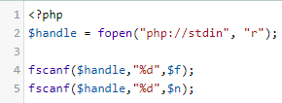

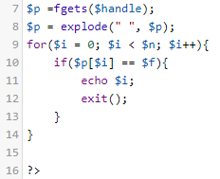

* [**Big Sorting**](https://www.hackerrank.com/challenges/big-sorting)

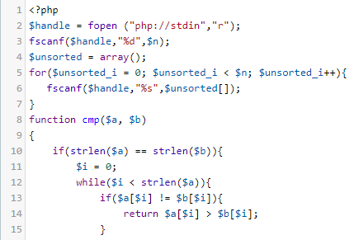

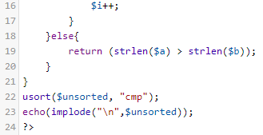

* [**String Construction**](https://www.hackerrank.com/challenges/string-construction)

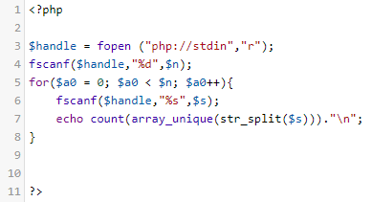

* [**Two Strings**](https://www.hackerrank.com/challenges/two-strings)

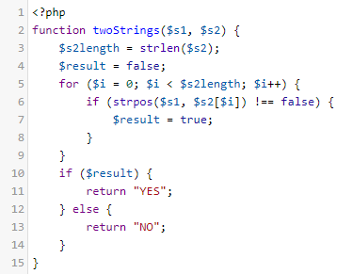

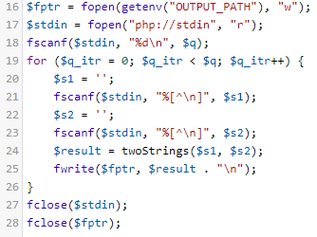

* [**Pangrams**](https://www.hackerrank.com/challenges/pangrams)

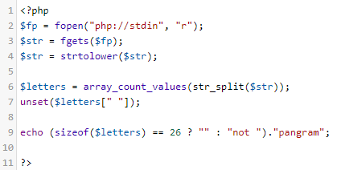

* [**Mars Exploration**](https://www.hackerrank.com/challenges/mars-exploration)

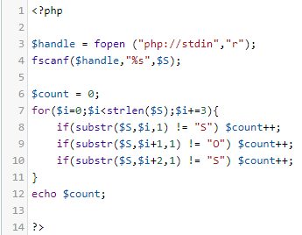

* [**Caesar Cipher**](https://www.hackerrank.com/challenges/caesar-cipher-1)

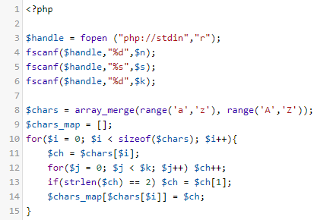

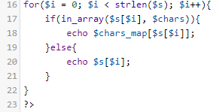

* [**Two Characters**](https://www.hackerrank.com/challenges/two-characters)

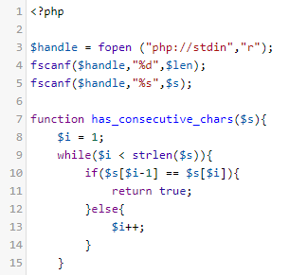

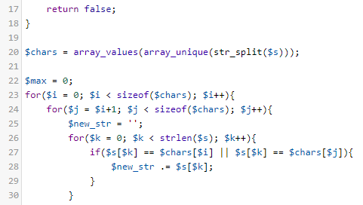

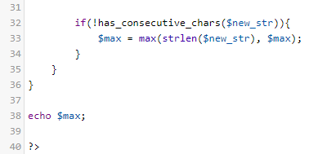

* [**CamelCase**](https://www.hackerrank.com/challenges/camelcase)

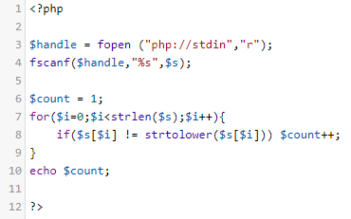

* [**Super Reduced String**](https://www.hackerrank.com/challenges/reduced-string)

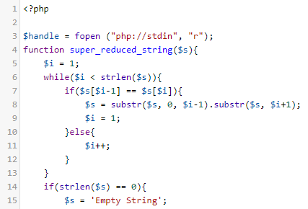

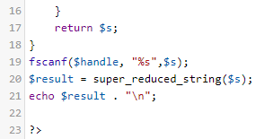

* [**Service Lane**](https://www.hackerrank.com/challenges/service-lane)

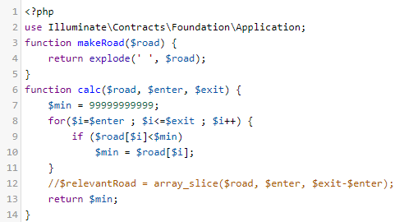

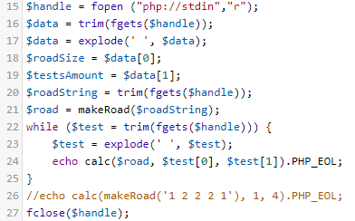

* [**Chocolate Feast**](https://www.hackerrank.com/challenges/chocolate-feast)

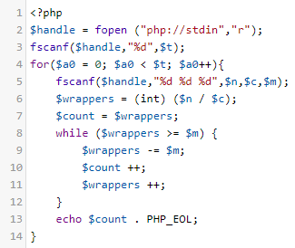

* [**Minimum Distances**](https://www.hackerrank.com/challenges/minimum-distances)

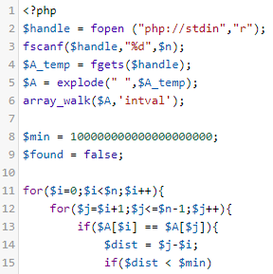

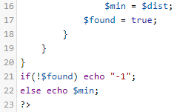

* [**Jumping on the Clouds**](https://www.hackerrank.com/challenges/jumping-on-the-clouds)

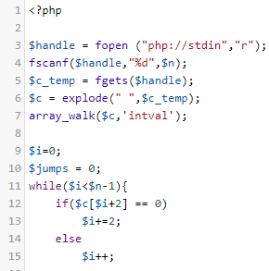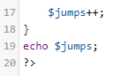

* [**Circular Array Rotation**](https://www.hackerrank.com/challenges/circular-array-rotation)

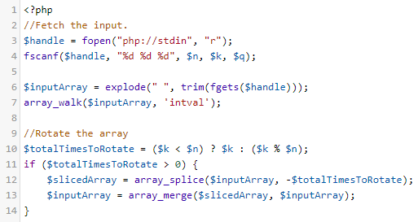

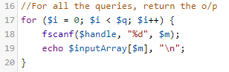

* [**Library Fine**](https://www.hackerrank.com/challenges/library-fine)

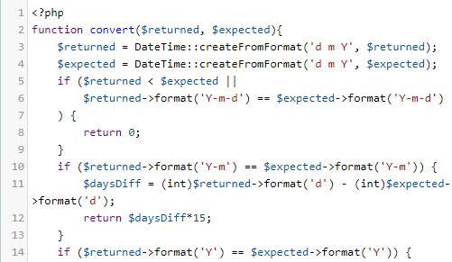

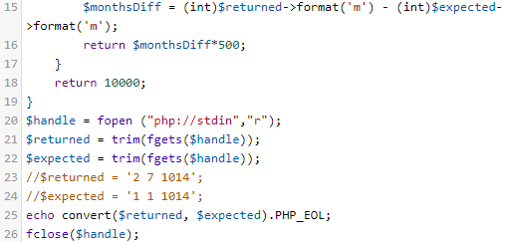

* [**Find Digits**](https://www.hackerrank.com/challenges/find-digits)

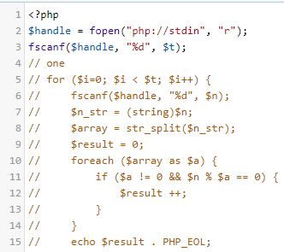

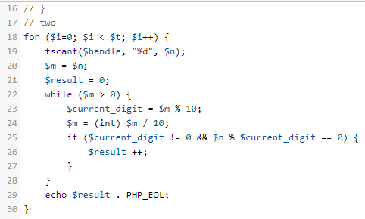

* [**Angry Professor**](https://www.hackerrank.com/challenges/angry-professor)

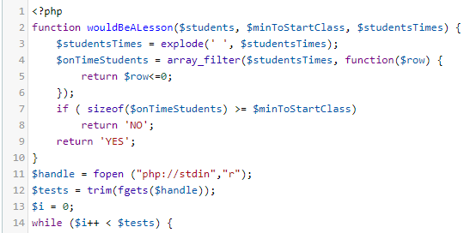

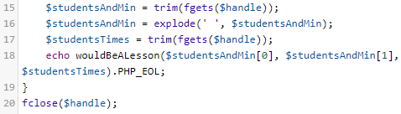

* [**Utopian Tree**](https://www.hackerrank.com/challenges/utopian-tree)

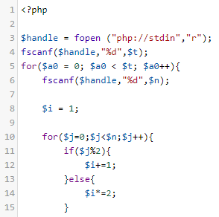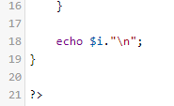

* [**Designer PDF Viewer**](https://www.hackerrank.com/challenges/designer-pdf-viewer)

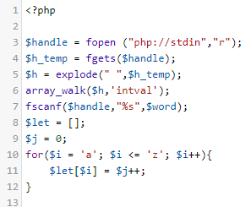

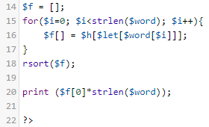

* [**The Hurdle Race**](https://www.hackerrank.com/challenges/the-hurdle-race)

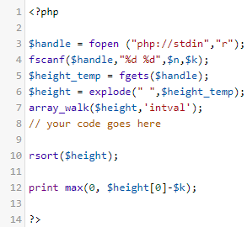

* [**Picking Numbers**](https://www.hackerrank.com/challenges/picking-numbers)

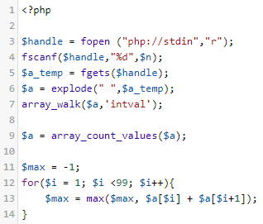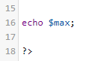

* [**Drawing Book**](https://www.hackerrank.com/challenges/drawing-book)

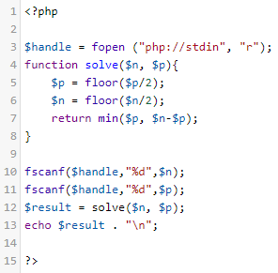

* [**Bon Appétit**](https://www.hackerrank.com/challenges/bon-appetit)

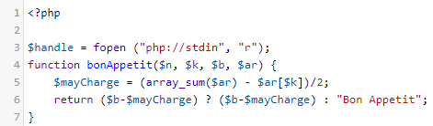

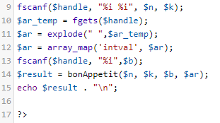

* [**Migratory Birds**](https://www.hackerrank.com/challenges/migratory-birds)

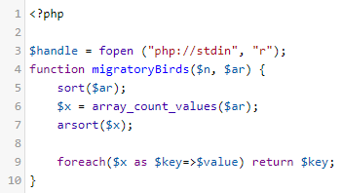

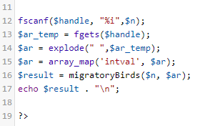

* [**Divisible Sum Pairs**](https://www.hackerrank.com/challenges/divisible-sum-pairs)

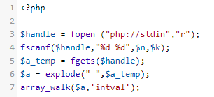

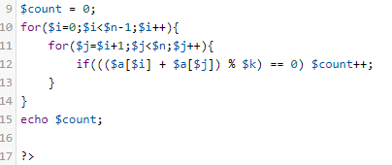

* [**Breaking the Records**](https://www.hackerrank.com/challenges/breaking-best-and-worst-records)

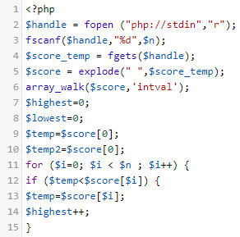

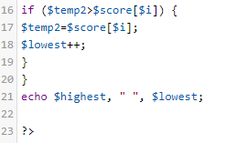

* [**Between Two Sets**](https://www.hackerrank.com/challenges/between-two-sets)

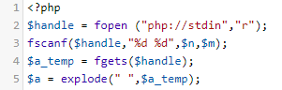

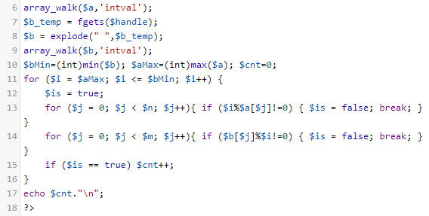

* [**Kangaroo**](https://www.hackerrank.com/challenges/kangaroo)

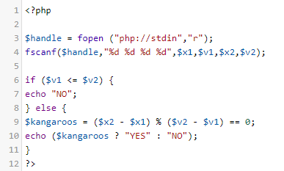

* [**Apple and Orange**](https://www.hackerrank.com/challenges/apple-and-orange)

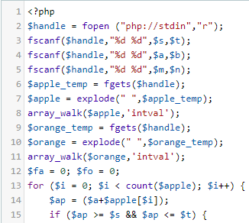

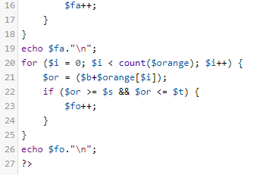

* [**Grading Students**](https://www.hackerrank.com/challenges/grading)

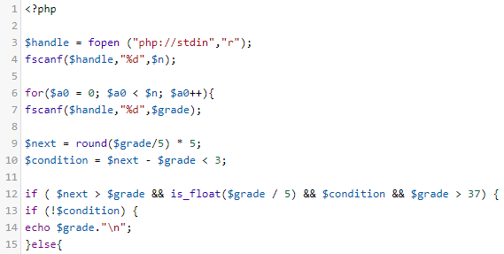

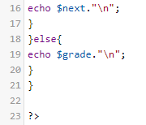

* [**Time Conversion**](https://www.hackerrank.com/challenges/time-conversion)

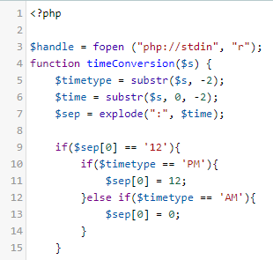

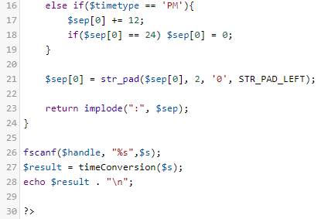

* [**Birthday Cake Candles**](https://www.hackerrank.com/challenges/birthday-cake-candles)

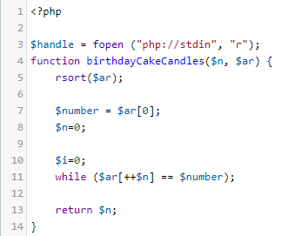

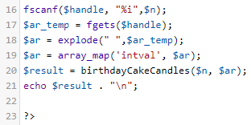

* [**Mini-Max Sum**](https://www.hackerrank.com/challenges/mini-max-sum)

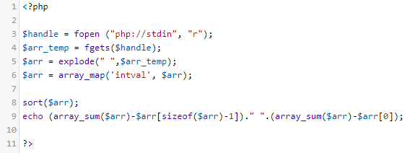

* [**Staircase**](https://www.hackerrank.com/challenges/staircase)

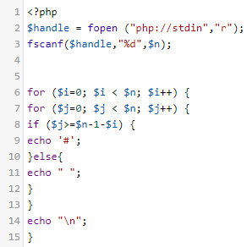

* [**Plus Minus**](https://www.hackerrank.com/challenges/plus-minus)

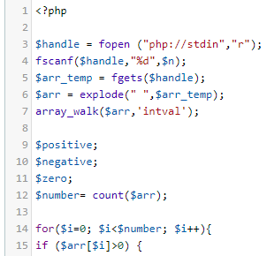

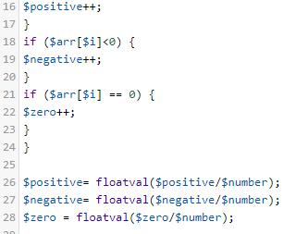

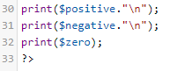

* [**Diagonal Difference**](https://www.hackerrank.com/challenges/diagonal-difference)

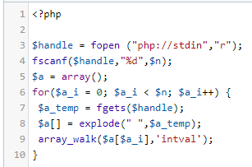

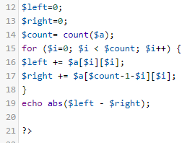

* [**A Very Big Sum**](https://www.hackerrank.com/challenges/a-very-big-sum)

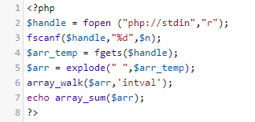

* [**Compare the Triplets**](https://www.hackerrank.com/challenges/compare-the-triplets)

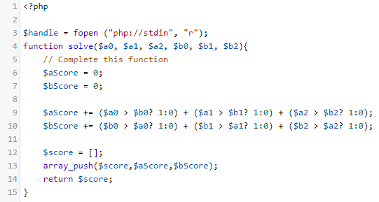

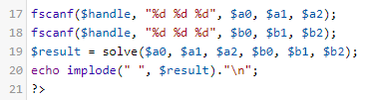

* [**Simple Array Sum**](https://www.hackerrank.com/challenges/simple-array-sum)

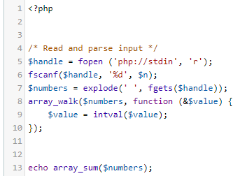

* [**Solve Me First**](https://www.hackerrank.com/challenges/solve-me-first)

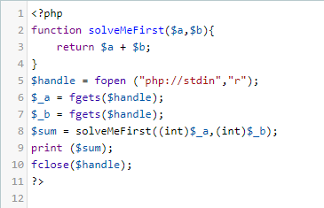

* [**Sock Merchant**](https://www.hackerrank.com/challenges/sock-merchant)

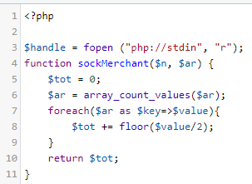

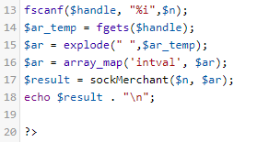

* **History submissions sesuai login anda masing-masing seperti berikut:**

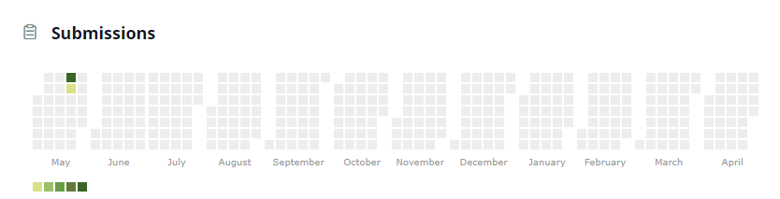

* **Score hackerrank :**

