**FINAL PROJECT**

**PEMROGRAMAN WEB**

**“ Soal PHP di HackerRank “**



Oleh :

Atikah Adawiyyah ( 17051204079 )

TI 2017 A

S1 TEKNIK INFORMATIKA

JURUSAN TEKNIK INFORMATIKA

FAKULTAS TEKNIK

UNIVERSITAS NEGERI SURABAYA

2019

1. Screenshoot Soal – Soal yang telah dikerjakan.

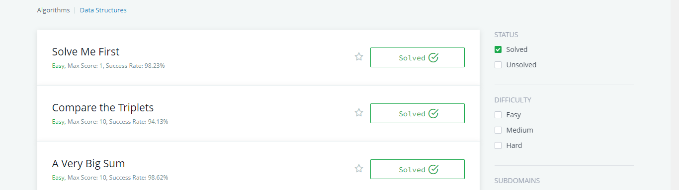

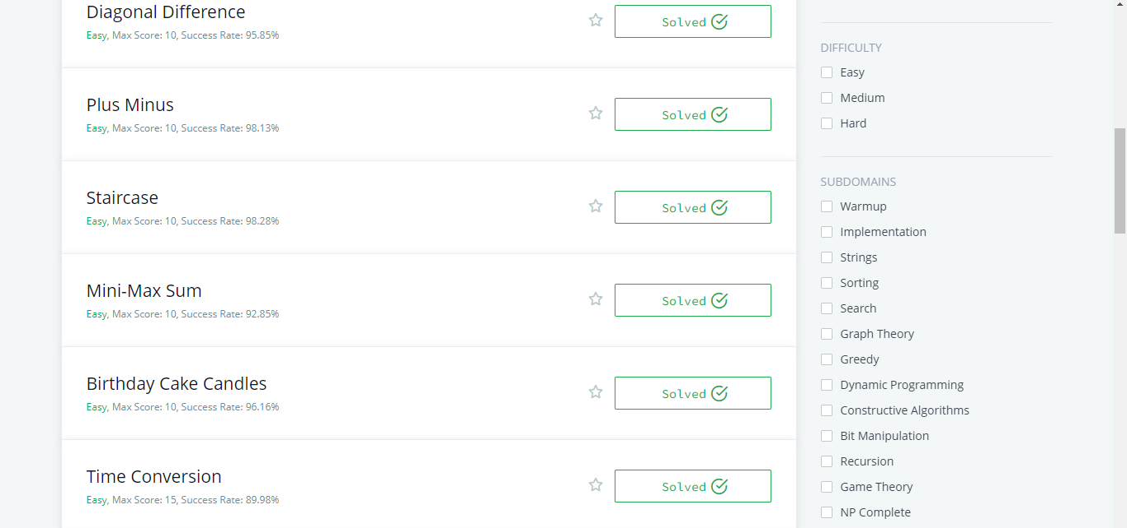

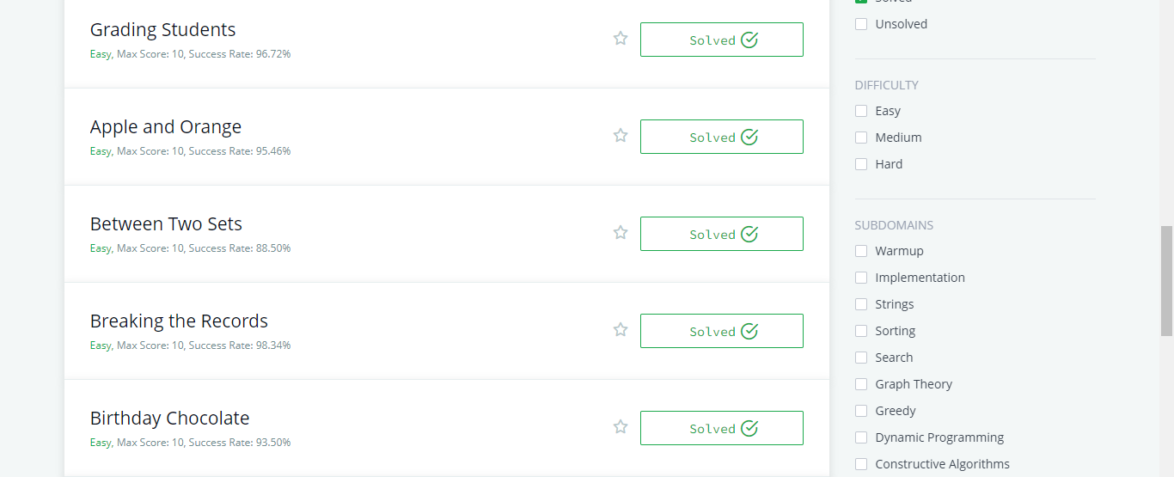

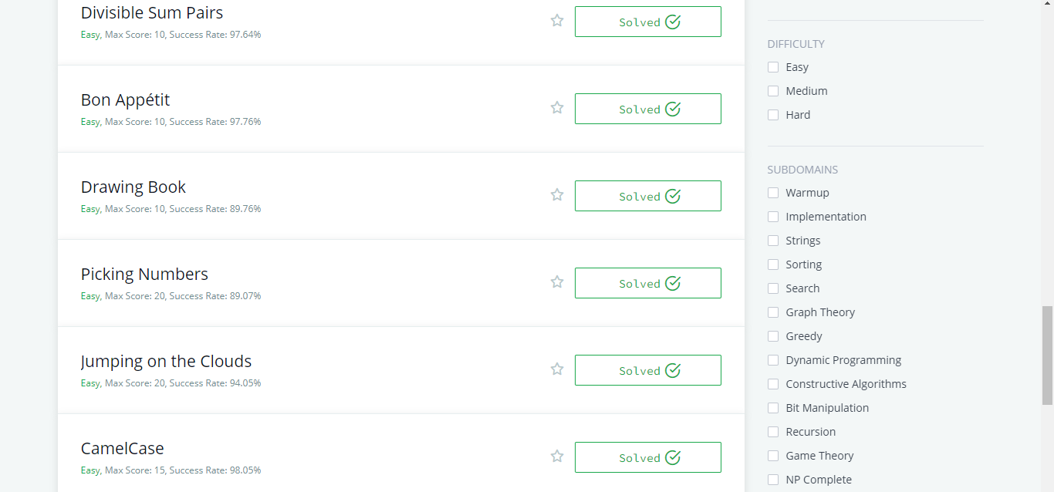

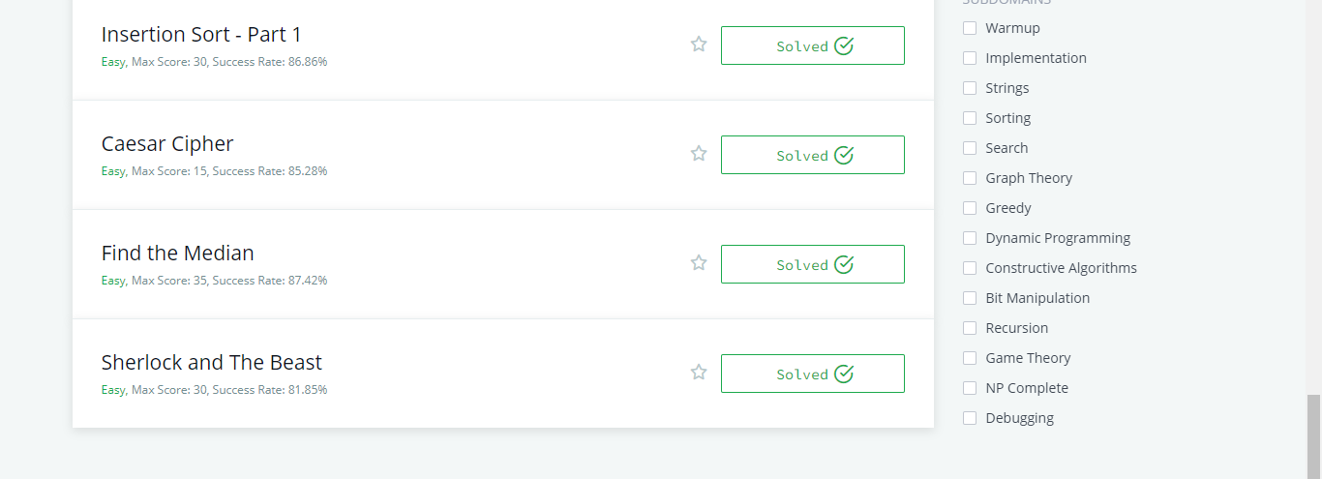

1. Screenshoot Kode Program Pada masing-masing problem pada soal yang telah terselesaikan.

* Solve Me First

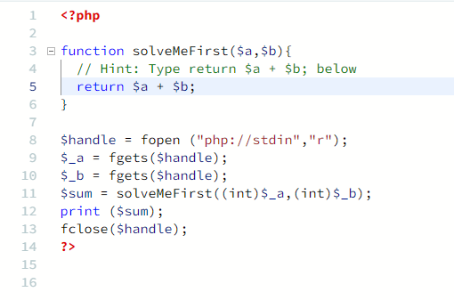

* Compare the Triplets

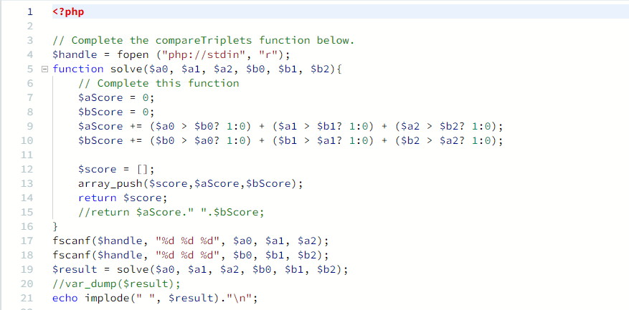

* A Very Big Sum

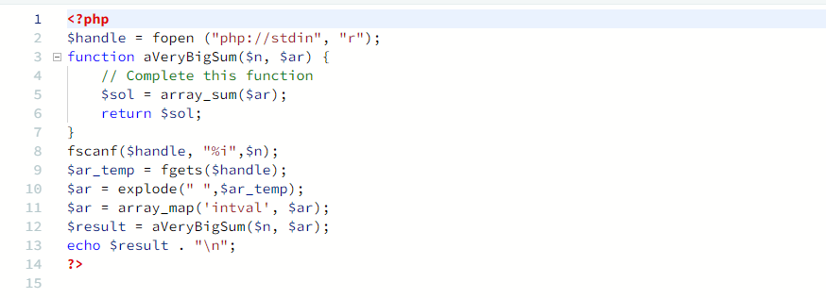

* Diagonal Difference

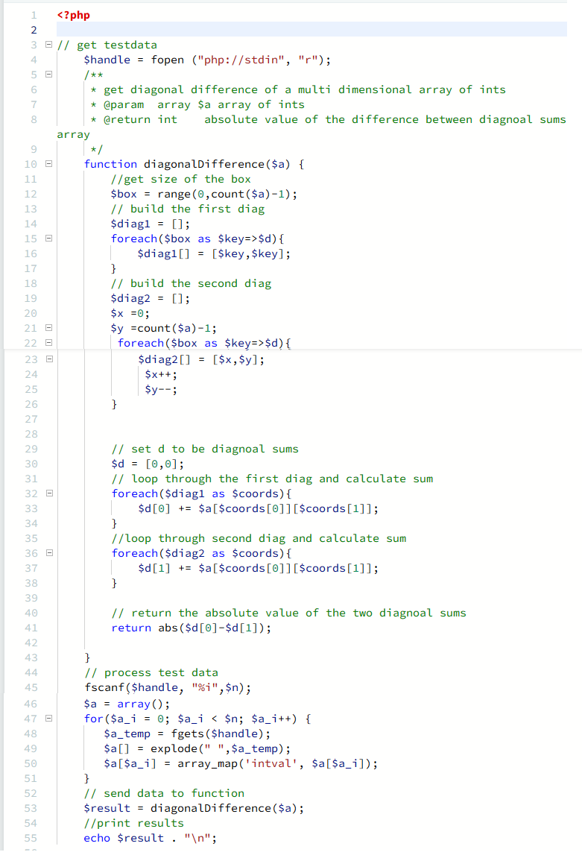

* Plus Minus

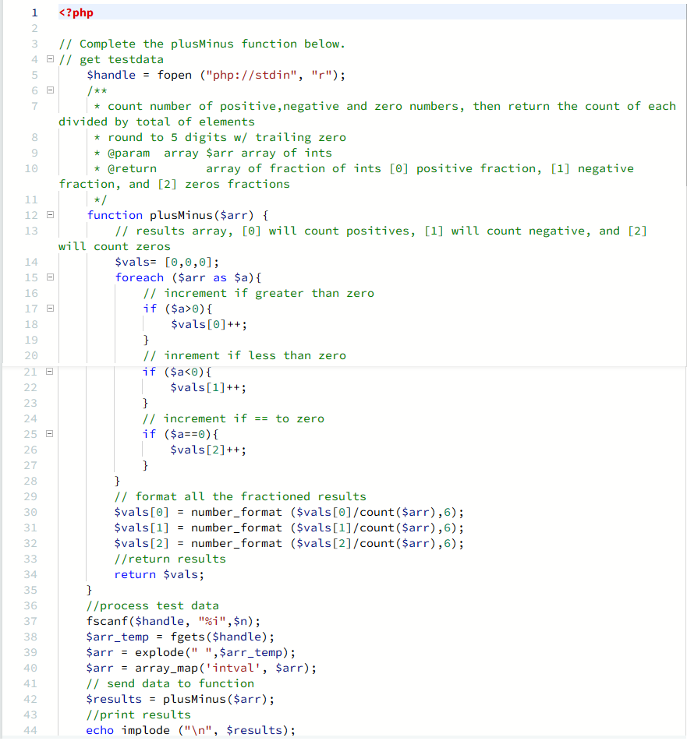

* Staircase

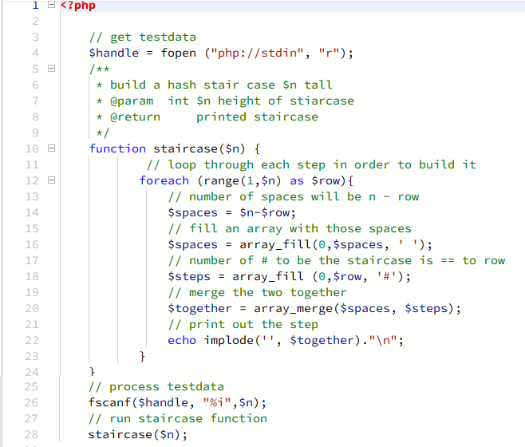

* Mini-Max Sum

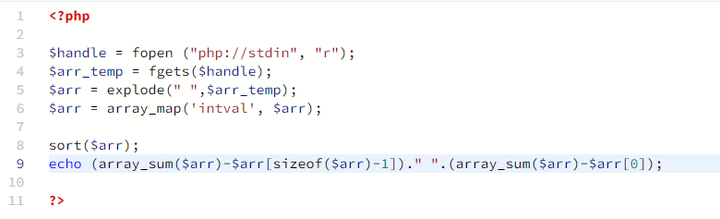

* Birthday Cake Candles

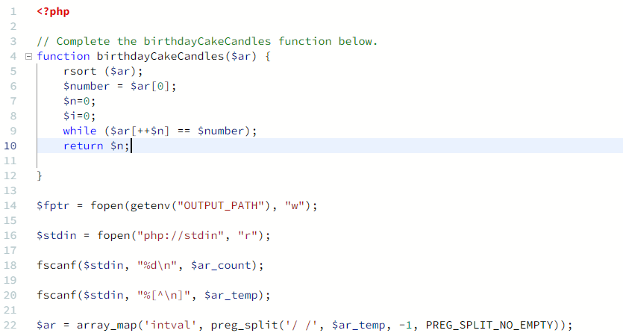

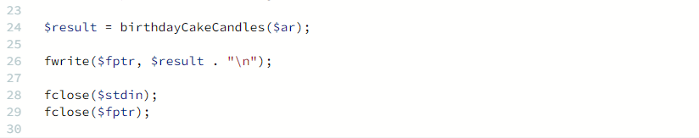

* Time Conversion

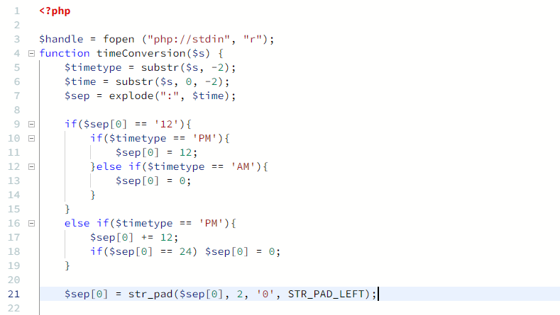

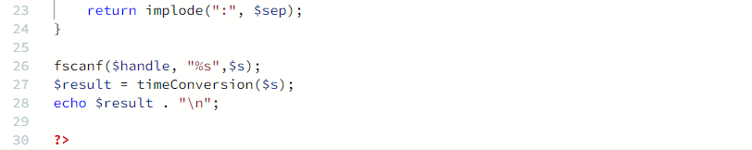

* Grading Students

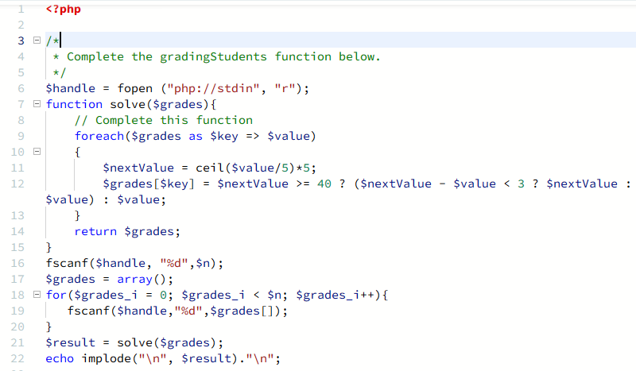

* Apple and Orange

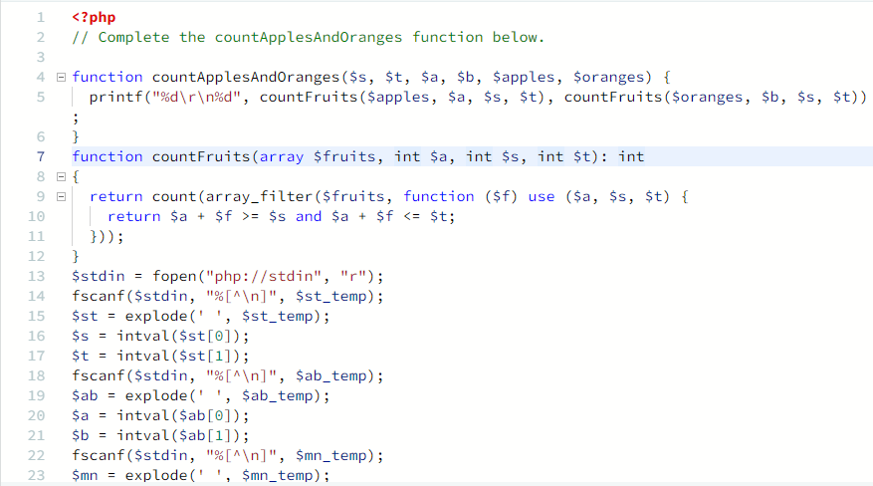

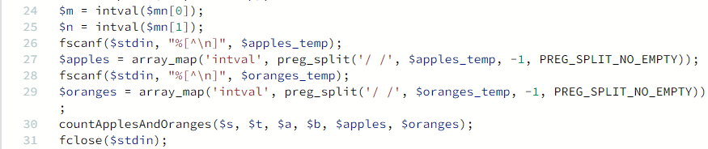

* Between Two Sets

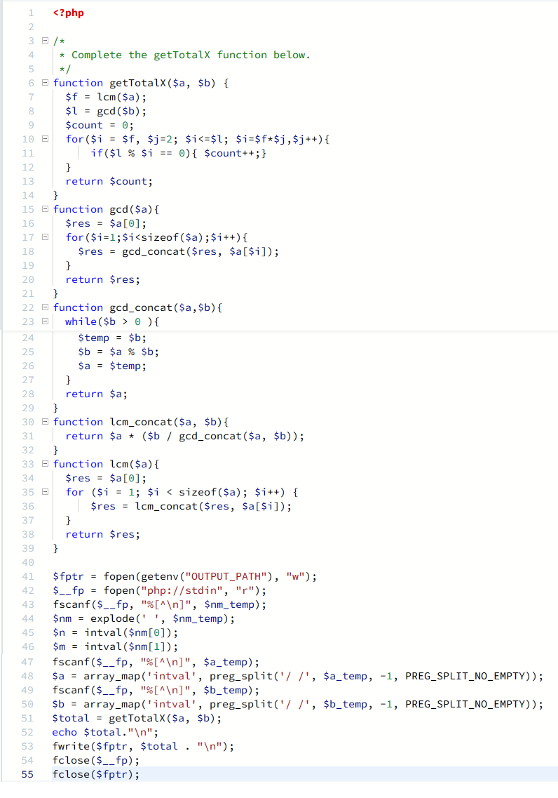

* Breaking the Records

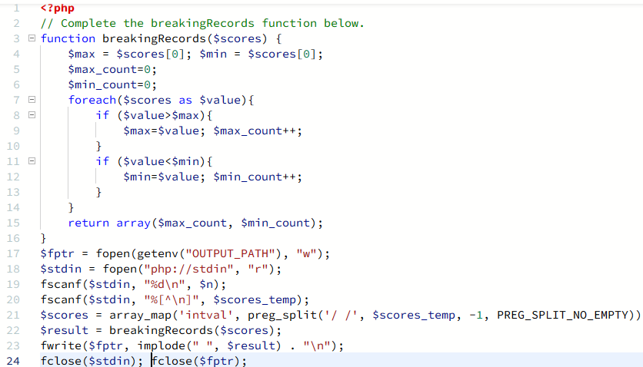

* Birthday Chocolate

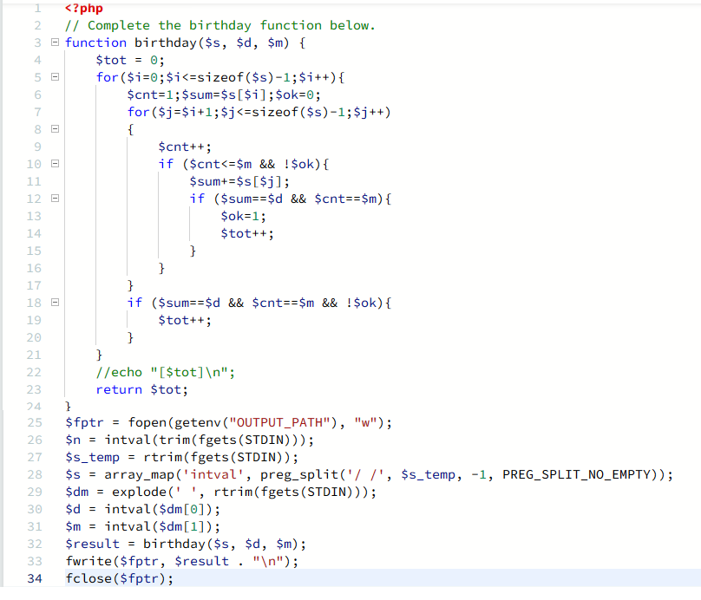

* Divisible Sum Pairs

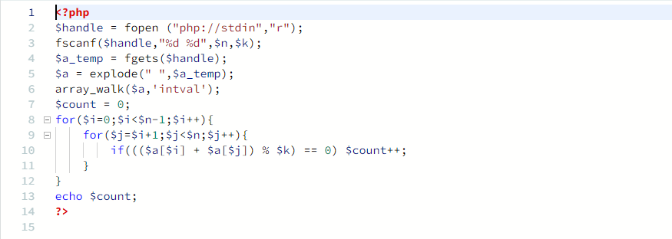

* Bon Appétit

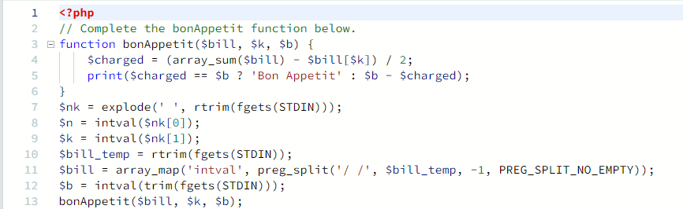

* Drawing Book

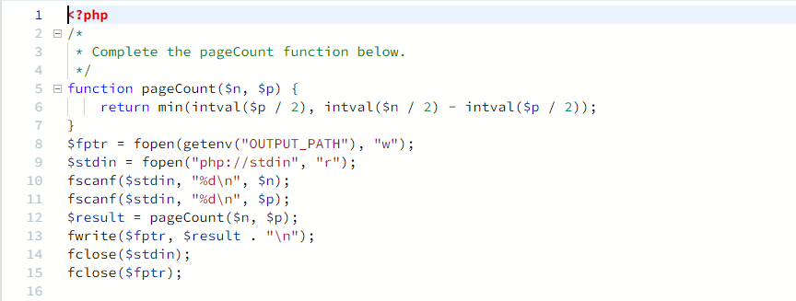

* Picking Numbers

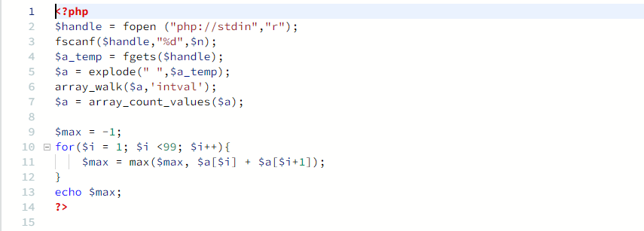

* Jumping on the Clouds

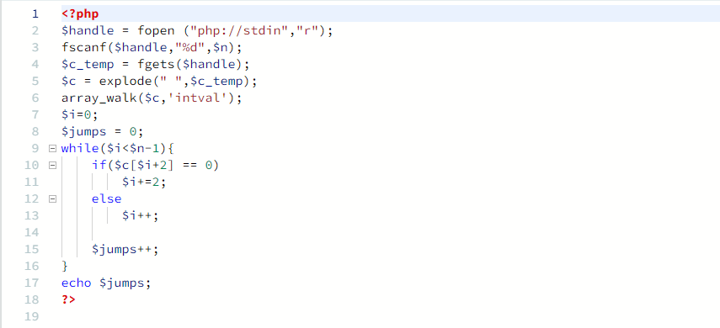

* CamelCase

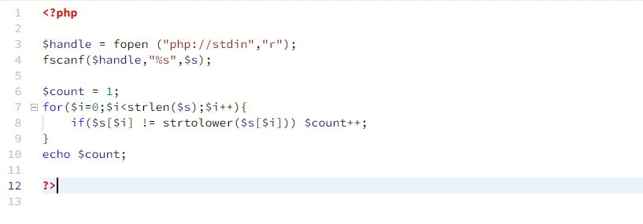

* Insertion Sort - Part 1

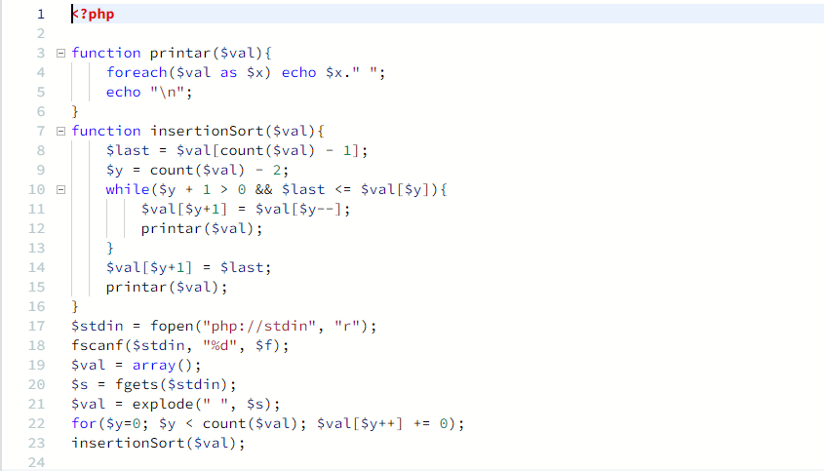

* Caesar Cipher

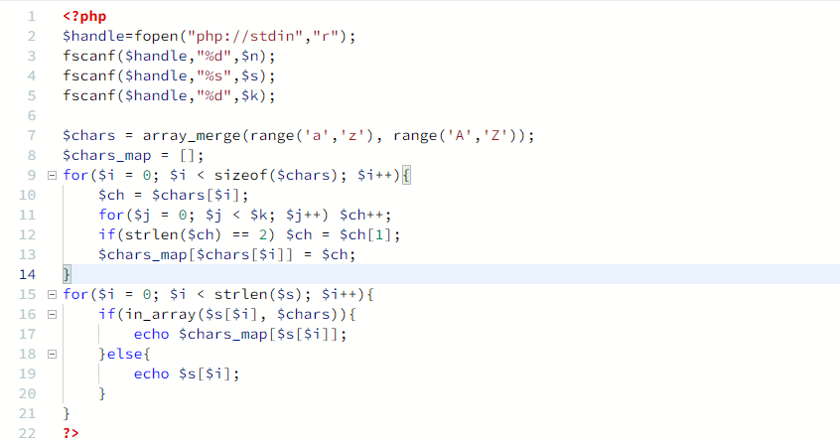

* Find the Median

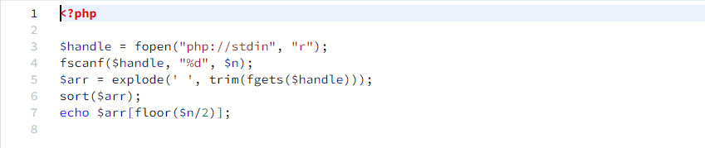

* Sherlock and The Beast

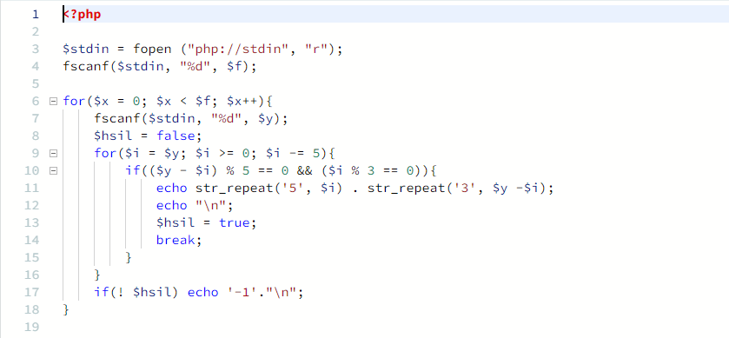

1. Tampilkan History Submission anda.

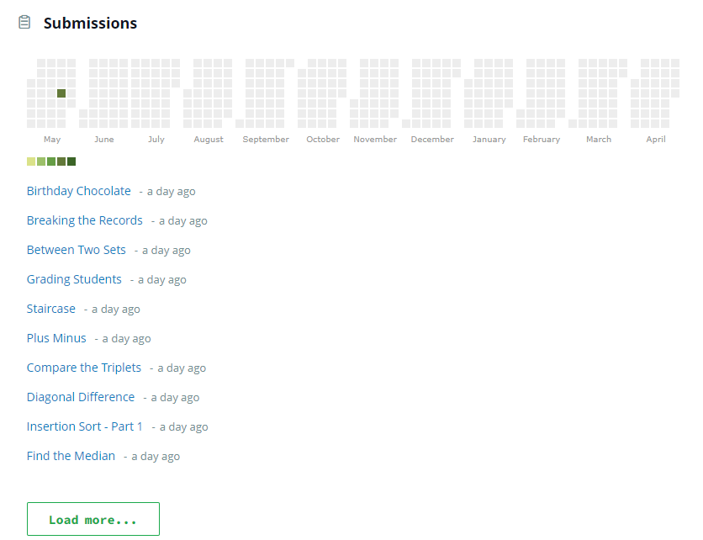

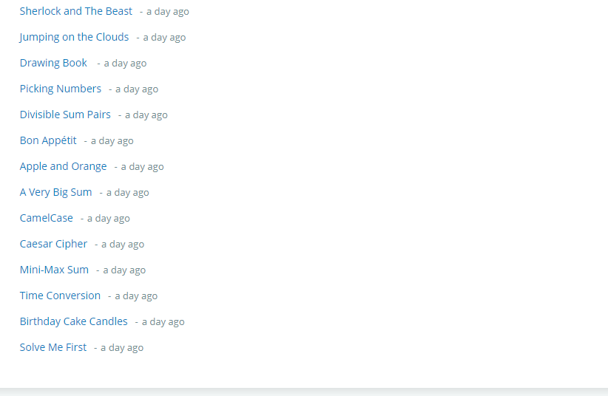

1. Tampilkan Score anda di Hackerrank.

