**PEMROGAMAN WEB**



**Oleh :**

**M. Ridho Wahyudi R**

**Nim : 17051204064**

**Kelas : TI 2017 A**

**TEKNIK INFORMATIKA**

**FAKULTAS TEKNIK**

**UNIVESITAS NEGERI SURABAYA**

**2019**

**PEMROGAMAN WEB**

Ujian Akhir Semester

Soal di HackerRank

1. Penyelesain Masalah :

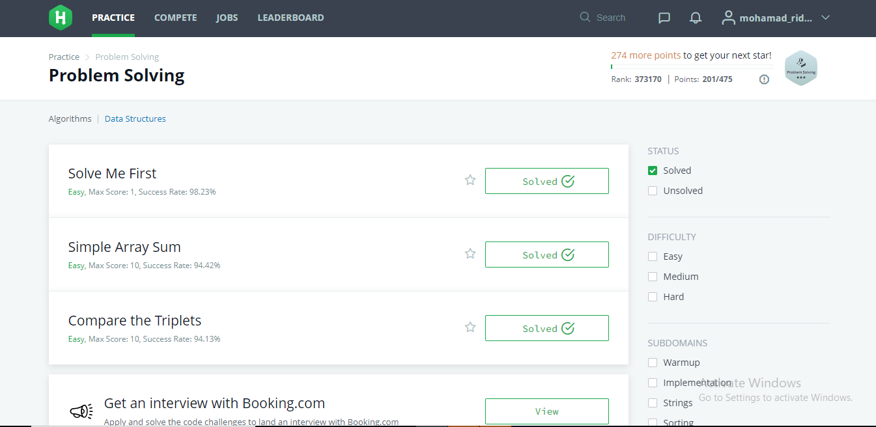

1. Source Code :

# Solve Me First

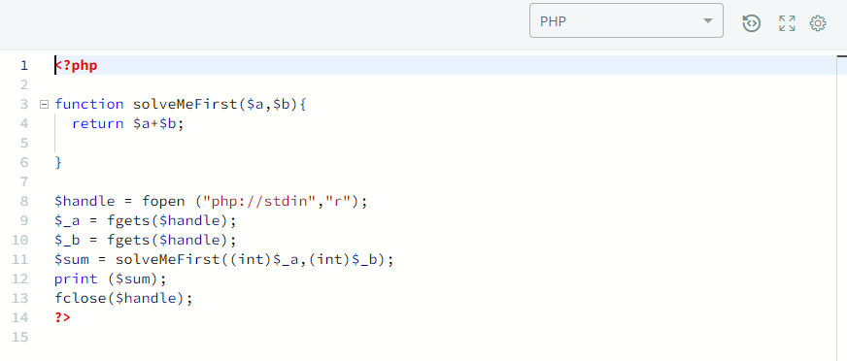

# Simple Array Sum

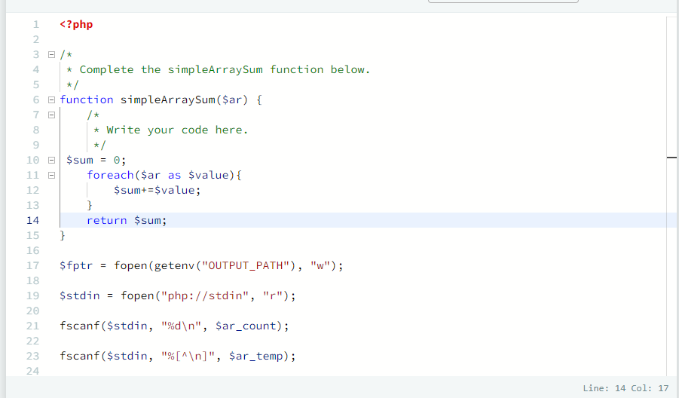

# A Very Big Sum

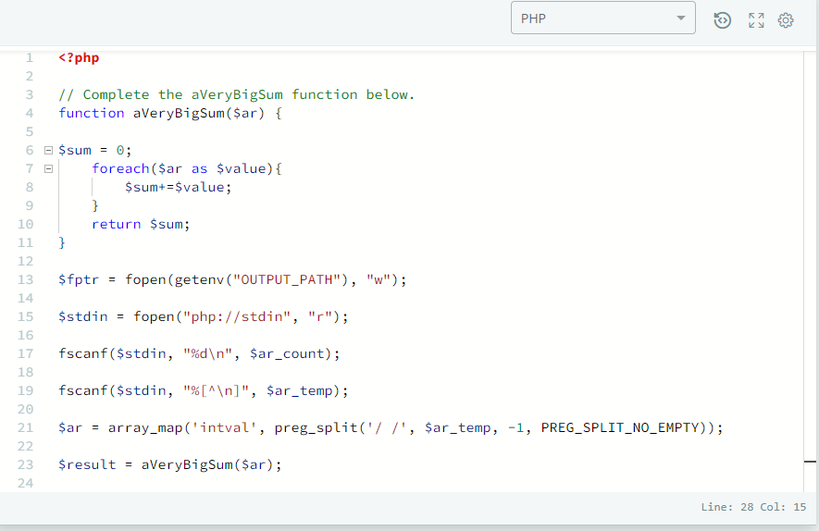

Compare the Triplest

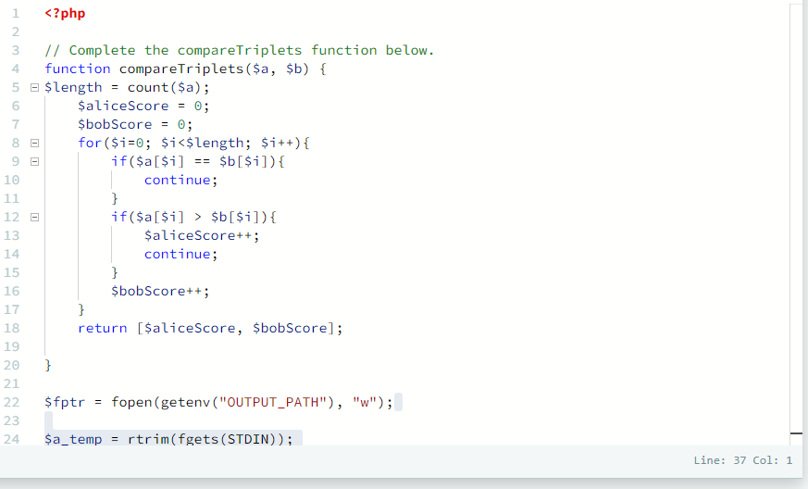

Diagonal Difference

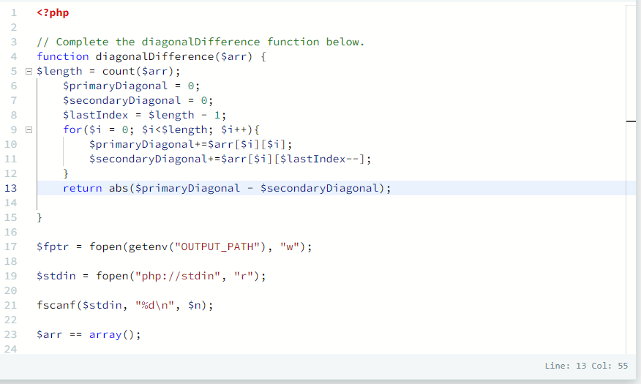

Plus Minus

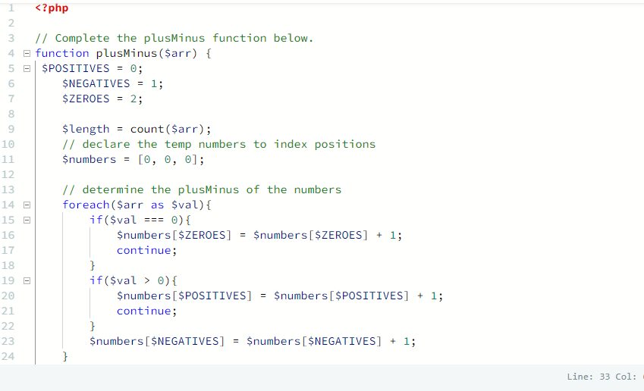

Staircase

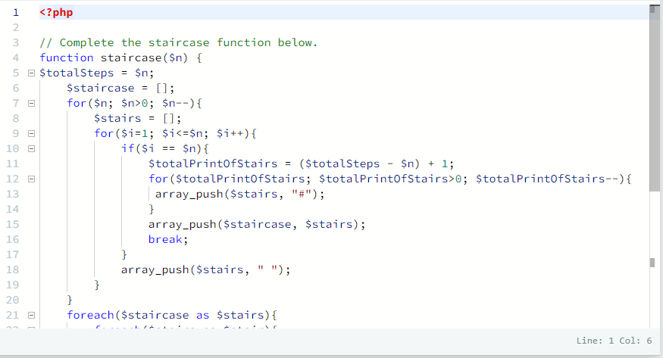

Mini-Max Sum

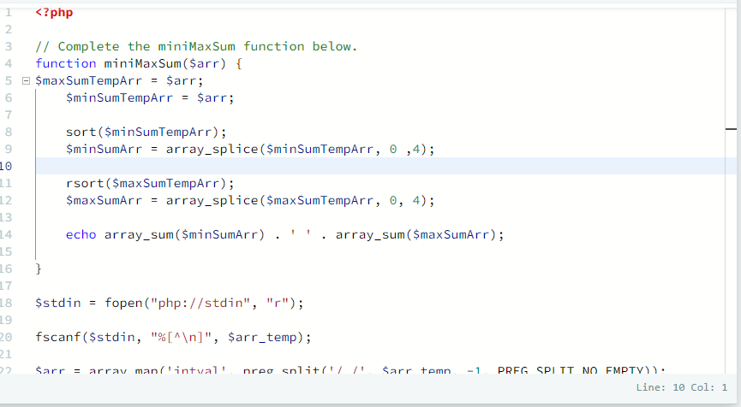

Birthday Cake Candles

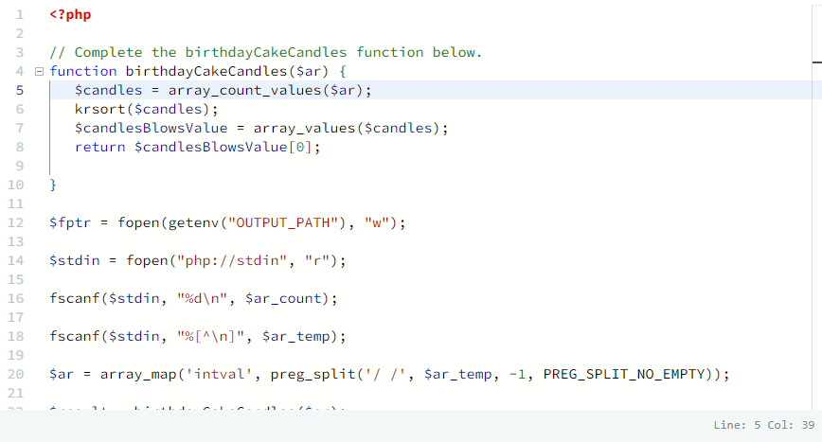

Time Conversion

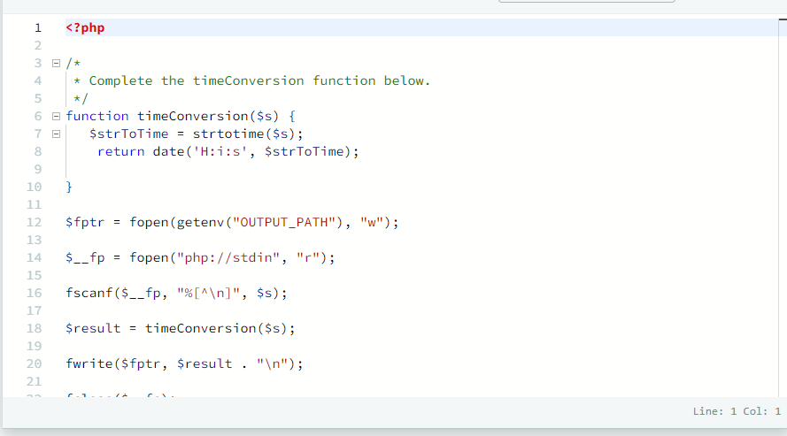

Grading Students

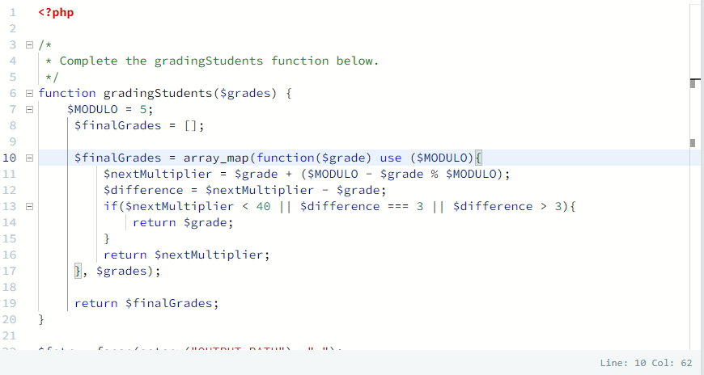

Migratory Birds

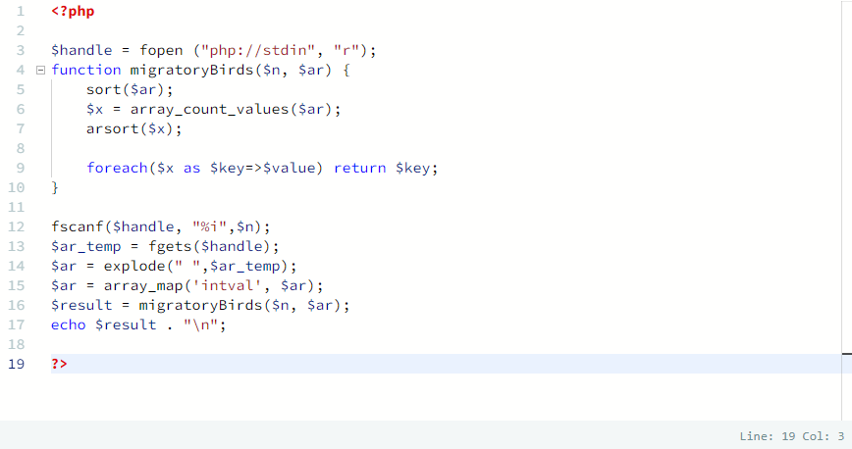

Picking Numbers

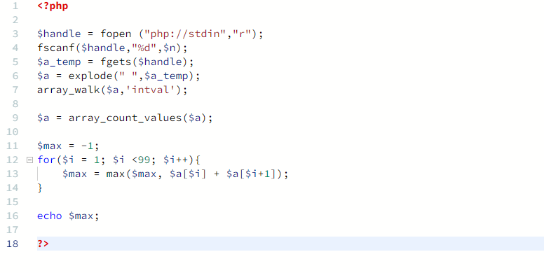

Minimum Distances

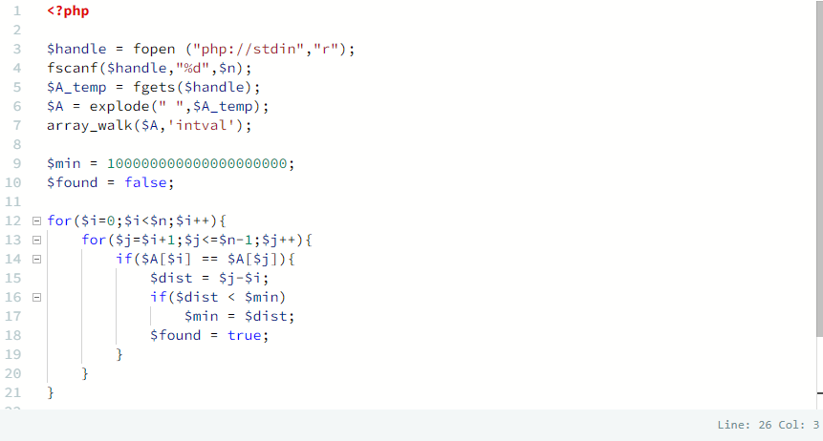

1. History Submissions :

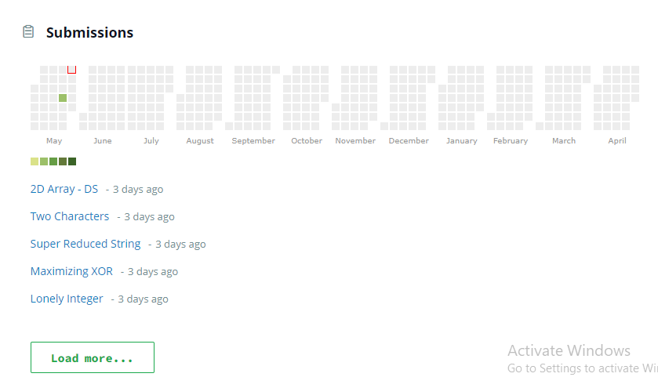

Score Hackkerank :

