class ItemToPurchase:
def __init__(self, name="none", price=0, quantity=0, description="none"):
self.name = name
self.price = price
self.quantity = quantity
self.description = description

def print_item_cost(self):
total = self.price * self.quantity
print(f"{self.name} {self.quantity} @ ${self.price} = ${total}")

def print_item_description(self):
print(f"{self.name}: {self.description}")

class ShoppingCart:
def __init__(self, customer_name="none", current_date="January 1, 2020"):
self.customer_name = customer_name
self.current_date = current_date
self.cart_items = []

def add_item(self, item):
self.cart_items.append(item)

def remove_item(self, item_name):
found = False
for item in self.cart_items:
if item.name == item_name:
self.cart_items.remove(item)
found = True
break
if not found:
print("Item not found in cart. Nothing removed.")

def modify_item(self, item_to_modify):
found = False
for item in self.cart_items:
if item.name == item_to_modify.name:
found = True
if item_to_modify.description != "none":
item.description = item_to_modify.description
if item_to_modify.price != 0:
item.price = item_to_modify.price
if item_to_modify.quantity != 0:
item.quantity = item_to_modify.quantity
break
if not found:
print("No items are in your cart. No modification(s).")

def get_num_items_in_cart(self):
return sum(item.quantity for item in self.cart_items)

def get_cost_of_cart(self):
return sum(item.price * item.quantity for item in self.cart_items)

def print_total(self):
print(f"{self.customer_name}'s Purchases - {self.current_date}")
print(f"Number of Items: {self.get_num_items_in_cart()}")
if not self.cart_items:
print("NO ITEMS IN CART")
else:
for item in self.cart_items:
item.print_item_cost()
print(f"Total: ${self.get_cost_of_cart()}")

def print_descriptions(self):
print(f"{self.customer_name}'s Purchases - {self.current_date}")
print("Item Descriptions")
for item in self.cart_items:
item.print_item_description()

def print_menu(cart):
option = ""
while option != "q":
print("\nMENU")
print("a - Add item to cart")
print("r - Remove item from cart")
print("c - Change item quantity")
print("i - Output items' descriptions")
print("o - Output shopping cart")
print("q - Quit")
option = input("Choose an option:\n").lower()

if option == "a":
print("ADD ITEM TO CART")
name = input("Enter the item name:\n")
description = input("Enter the item description:\n")
price = int(input("Enter the item price:\n"))
quantity = int(input("Enter the item quantity:\n"))
cart.add_item(ItemToPurchase(name, price, quantity, description))

elif option == "r":
print("REMOVE ITEM FROM CART")
name = input("Enter name of item to remove:\n")
cart.remove_item(name)

elif option == "c":
print("CHANGE ITEM QUANTITY")
name = input("Enter the item name:\n")
quantity = int(input("Enter the new quantity:\n"))
cart.modify_item(ItemToPurchase(name=name, quantity=quantity))

elif option == "i":
print("OUTPUT ITEMS' DESCRIPTIONS")
cart.print_descriptions()

elif option == "o":
print("OUTPUT SHOPPING CART")
cart.print_total()

elif option == "q":
break
else:
print("Invalid option, try again.")

def main():
customer_name = input("Enter customer's name:\n")
current_date = input("Enter today's date:\n")
print(f"\nCustomer name: {customer_name}")
print(f"Today's date: {current_date}\n")

cart = ShoppingCart(customer_name, current_date)
print_menu(cart)

if __name__ == "__main__":
main()

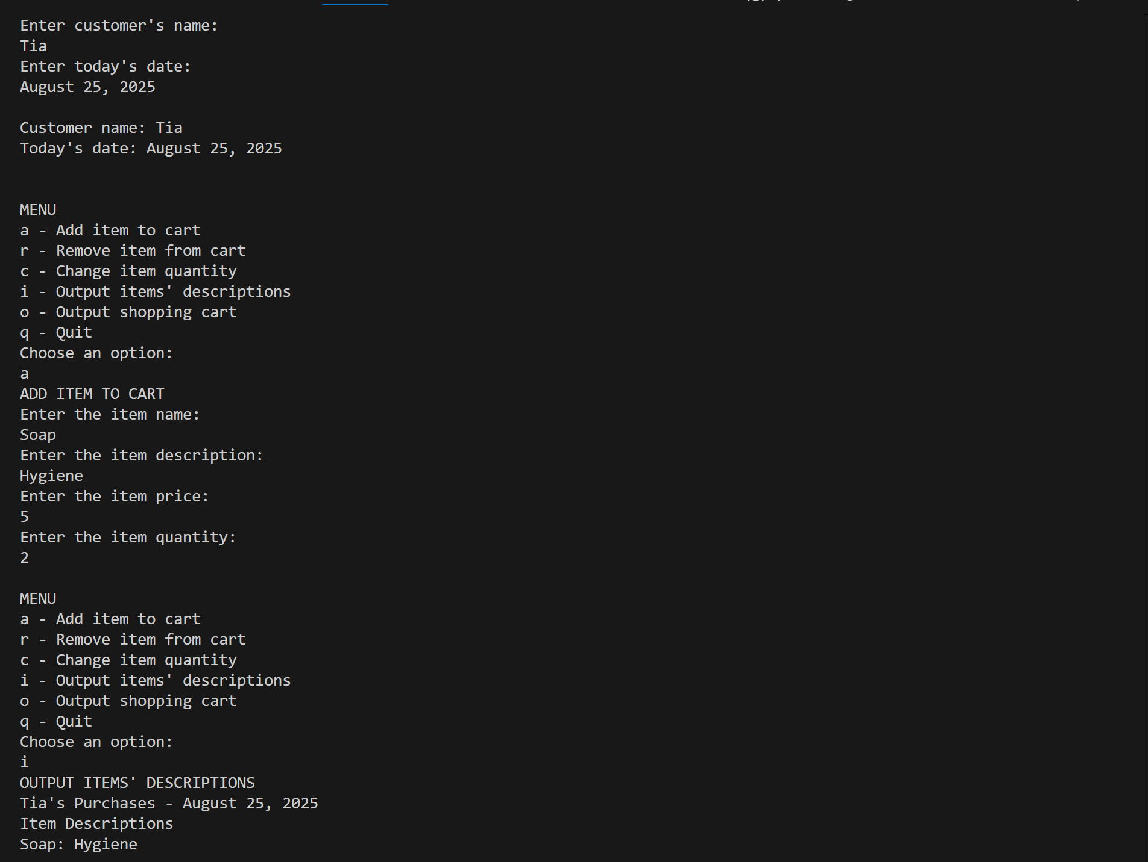
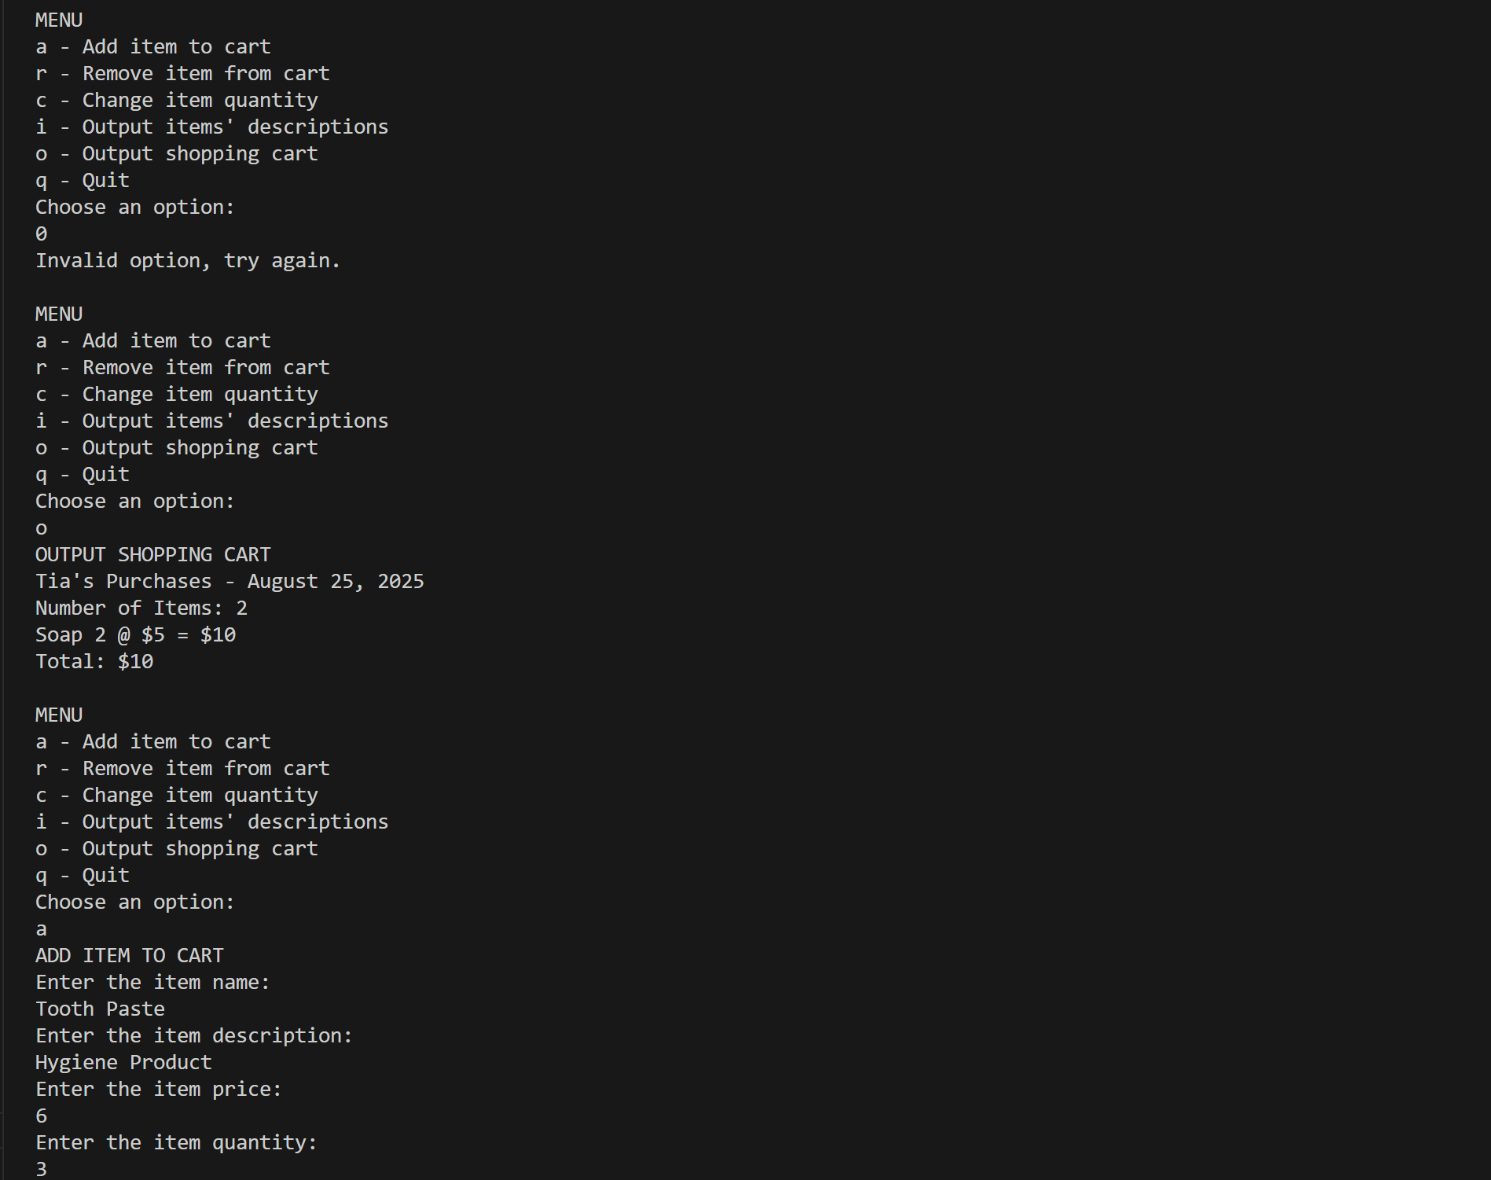
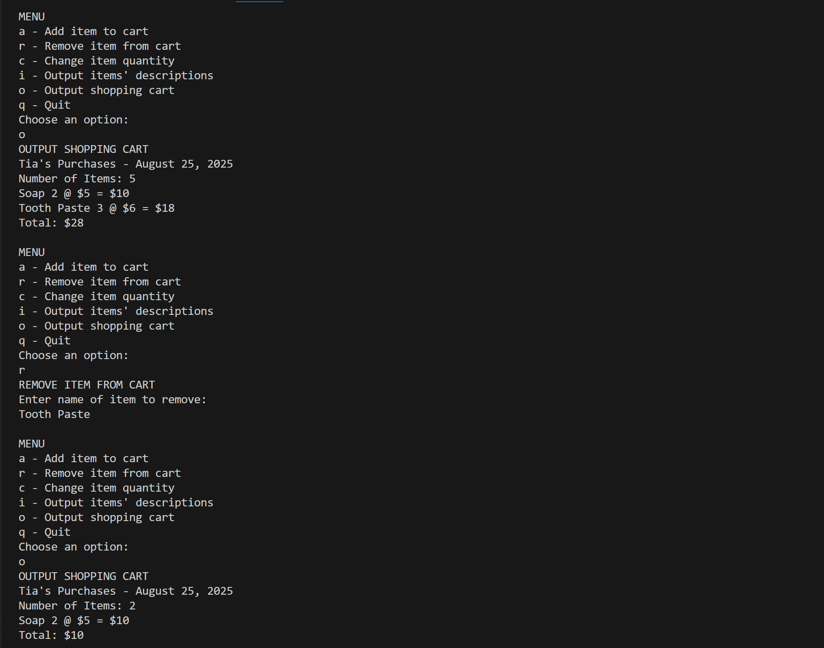

https://github.com/TiaHorton/CSC500/blob/fccbdb42b8736090b2b8381dbfe33835bec484af/Portfolio%20Mildston_WK6.py

