Part 1:
Write a program that uses nested loops to collect data and calculate the average rainfall over a period of years. The program should first ask for the number of years. The outer loop will iterate once for each year. The inner loop will iterate twelve times, once for each month. Each iteration of the inner loop will ask the user for the inches of rainfall for that month. After all iterations, the program should display the number of months, the total inches of rainfall, and the average rainfall per month for the entire period.

def general():
years = int(input("Enter the number of years: "))

total_rainfall = 0.0
total_months = 0

for year in range(1, years + 1):
print(f"\nYear {year}:")
for month in range(1, 13):
rainfall = float(input(f" Enter rainfall (in inches) for the month {month}: "))
total_rainfall += rainfall
total_months += 1

average_rainfall = total_rainfall / total_months
print("\nRainfall Summary")
print(f"\nTotal number of months: {total_months}")
print(f"Total inches of rainfall: {total_rainfall:.2f} inches")
print(f"Average monthly rainfall: {average_rainfall:.2f} inches")

general()

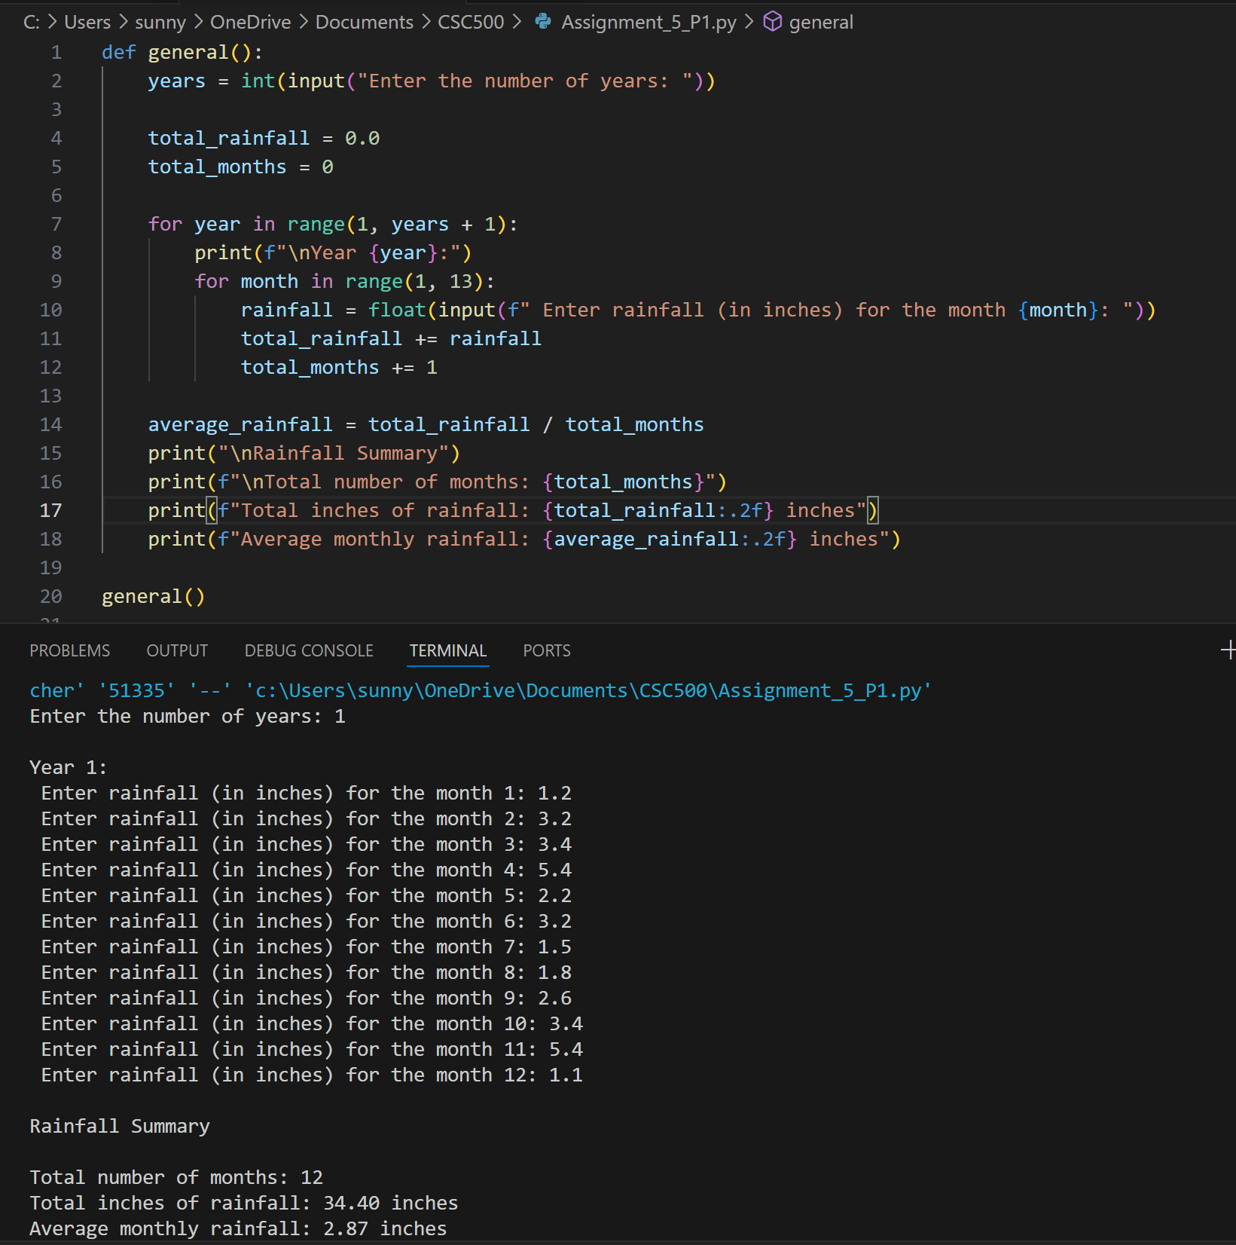
https://github.com/TiaHorton/CSC500/blob/e0e007ea4e2a2c0e934d14ed3394600c8e390f70/Assignment_5_P1.py

Part 2:
The CSU Global Bookstore has a book club that awards points to its students based on the number of books purchased each month. The points are awarded as follows:
- If a customer purchases 0 books, they earn 0 points.
- If a customer purchases 2 books, they earn 5 points.
- If a customer purchases 4 books, they earn 15 points.
- If a customer purchases 6 books, they earn 30 points.
- If a customer purchases 8 or more books, they earn 60 points.
Write a program that asks the user to enter the number of books that they have purchased this month and then display the number of points awarded.

def general():
bookstore_name = "CSU Global Bookstore"

print(f"Welcome to the {bookstore_name}!")

books = int(input("Enter the number of books purchased this month: "))

if books == 0:
points = 0
elif books == 2:
points = 5
elif books == 4:
points = 15
elif books == 6:
points = 30
elif books >= 8:
points = 60
elif books >= 8:
points = 60
else:
points = 0

print(f"You have earned {points} points this month.")

general()

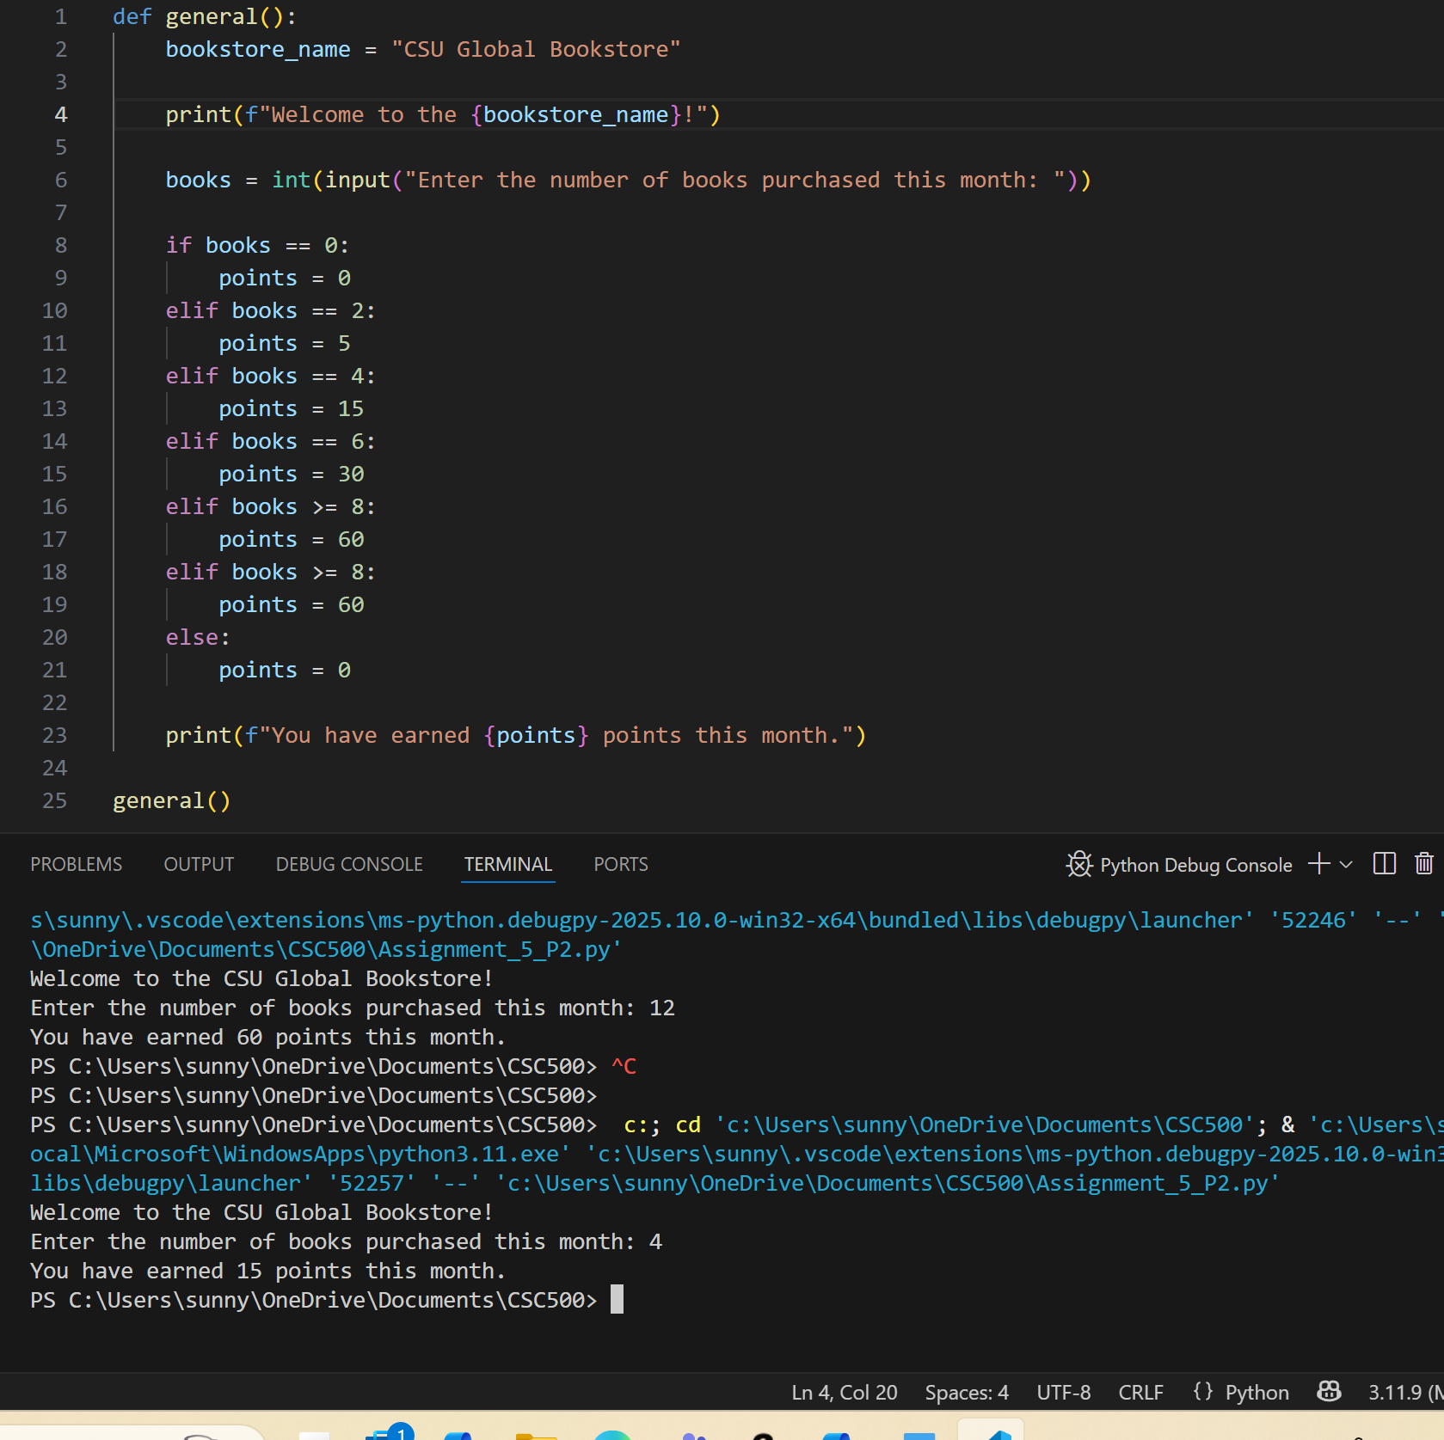
https://github.com/TiaHorton/CSC500/blob/5ee27fb9a90ab863c91d5c210e46308838777f14/Assignment_5_P2.py

