PROJECT PHASE THREE ANALYSIS DOCUMENT 2022

CMPG 223 Phase 3

Tiaan Erasmus

33723176

Table of Contents

1. Physical Data Model 3

2. Physical Process Models 4

3. Entity Relationship Diagram 5

4. All SQL Code 6

Creating Database 6

Creating Tables 6

Insert, Delete, and Update of Event 7

Insert, Delete, and Update of Artist 7

Insert, Delete, and Update of Product 7

Insert, Delete, and Update of Client 7

Insert, Delete, and Update of Event_Details 7

SQL for Reports 7

5. Reports – screen prints 8

6. User Manual 9

7. Diary of work 10

# Physical Data Model

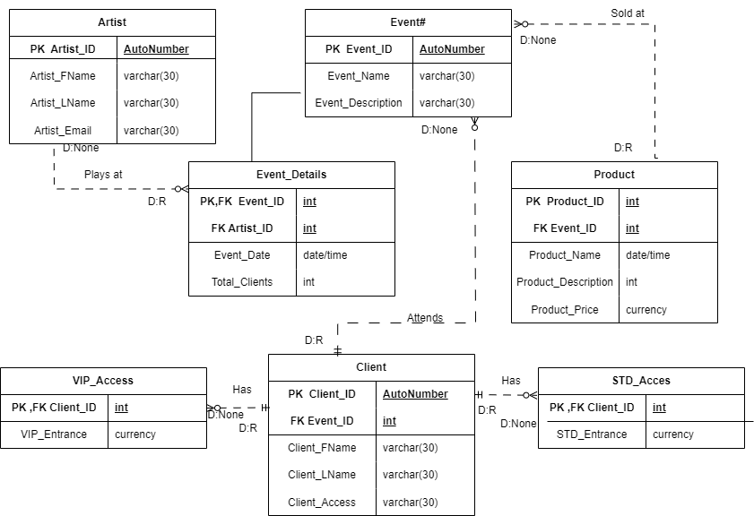

# Physical Process Models

# Entity Relationship Diagram

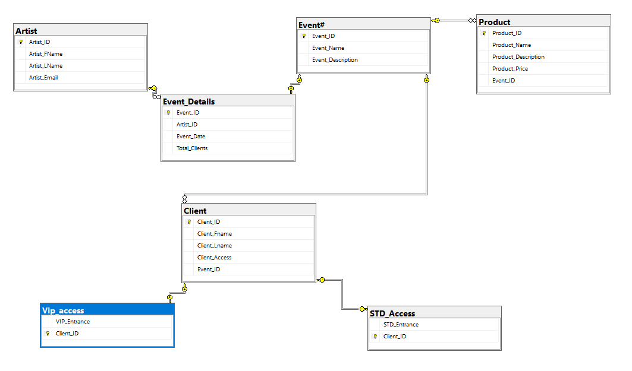

# All SQL Code

## Creating Database

Drop database if Exists NightShift;

Go

Create database NightShift;

Go

## Creating Tables

Use NightShift

Go

Create Table Product

(

    Product_ID int Identity(1,1) Primary Key,

    Product_Name varchar(30),

    Product_Description varchar(30),

    Product_Price money,

    Event_ID int Foreign key references Event#(Event_ID)

);

Create table Artist

(

    Artist_ID int Identity(1,1)primary key,

    Artist_FName varchar(30),

    Artist_LName varchar(30),

    Artist_Email varchar(30)

);

Create Table Event#

(

    Event_ID int identity(1,1) Primary Key,

    Event_Name varchar(30),

    Event_Description varchar(30)

);

Create table Client

(

    Client_ID int Identity(1,1) Primary Key,

    Client_Fname varchar(30),

    Client_Lname varchar(30),

    Client_Access  varchar(30),

    Event_ID int Foreign key references Event#(Event_ID)

);

Create Table Event_Details

(

    Event_ID int Primary Key references Event#(Event_ID),

    Artist_ID int Foreign key references Artist(Artist_ID),

    Event_Date date not null,

    Total_Clients int

);

Create Table STD_Access

(

    STD_Entrance money,

    Client_ID int Primary Key references Client(Client_ID)

);

create table Vip_access

(

    VIP_Entrance money,

    Client_ID int Primary Key references Client(Client_ID)

);

## Insert, Delete, and Update of Event

## Insert, Delete, and Update of Artist

## Insert, Delete, and Update of Product

## Insert, Delete, and Update of Client

## Insert, Delete, and Update of Event_Details

## SQL for Reports

# Reports – screen prints

# User Manual

# Diary of work