EVALUATION OF RULE-BASED LAND COVER CLASSIFICATION AS AN ALTERNATIVE TO SUPERVISED CLASSIFICATION

by

Tiaan Henrico

25872230

Department of Geography and Environmental Studies

Module: GIT 342

Date of submission: 06 October 2025

TABLE OF CONTENTS

FIGURES ii
TABLES ii
1 INTRODUCTION 1
1.1 RESEARCH AIM AND OBJECTIVES 1
1.2 STUDY AREA 1
2 THEORY 2
2.1 GEOBIA VS PER-PIXEL CLASSIFICATION 2
2.2 SEGMENTATION AND OBJECT FEATURES 3
2.3 SUPERVISED VS RULE-SET CLASSIFIERS 4
2.4 ACCURACY ASSESSMENT TECHNIQUES AND LAND COVER CLASSES 4
3 RESEARCH METHODS 5
3.1 DATA AND SOFTWARE DESCRIPTION 5
3.2 DATA PREPARATION 6
3.3 SEGMENTATION 6
3.4 RULE-SET DEVELOPMENT AND LAND COVER CLASSIFICATION 6
3.5 ACCURACY ASSESSMENT POINT GENERATION 11
3.6 ERROR MATRIX DEVELOPMENT AND ACCURACY ASSESSMENT 11
4 RESULTS 12
5 DISCUSSION 14
6 CONCLUSION 14
7 BIBLIOGRAPHY 16
DECLARATION OF GENERATIVE AI AND AI-ASSISTED TECHNOLOGIES IN THE WRITING PROCESS 17

FIGURES
Figure 1: Map of Study Area 2
Figure 2: Workflow Diagram 5
Figure 3: Land Cover Classification Map 12

TABLES
Table 1: Waterbodies Rule-set 7
Table 2: Cultivated Rule-set 7
Table 3: Built-up Rule-set 8
Table 4: Barren Land Rule-set 8
Table 5: Shrubland Rule-set 9
​Table 6: Grassland Rule-set​ 9
Table 7: Forest Land Rule-set 9
Table 8: Wetlands Rule-set 10
Table 9: Mines and Quarries Rule-set 10
Table 10: Second Waterbodies Rule-set 10
Table 11: Built-up Rule-set 11
Table 12: Second Shrubland Rule-set 11
Table 13: Error Matrix 13

INTRODUCTION
Land cover is essential for decision makers in South Africa because it enables quick change analysis for decision making (Department of Forestry, Fisheries and the Environment, 2024). Creating land cover from supervised classification is costly because of the extensive training data requirements which may contain inaccuracies (Albert, 2002). Rule-based land cover classification presents a viable alternative to Geographic Object-Based Image Analysis (GEOBIA), as it requires no training data and can outperform per-pixel analysis (Myint, 2011).

Rule-based land cover classification (using GEOBIA) classifies land cover using rules to determine the object classification. These rules follow the “If, Else, Then” structure (Bolstad, 1992), and can be set manually or automatically through supervised classification. This study aimed to evaluate the performance of a rule-based approach for land cover classification as an alternative to conventional supervised methods.

RESEARCH AIM AND OBJECTIVES
This study aimed to define a rule-set for each of the nine land cover classes and assess the accuracy of the resulting rule-based land cover classification method using the rule-set to classify a Sentinel-2 scene. The classification accuracy will be assessed using high-resolution aerial photography covering the same area. To achieve the research aim, the following objectives have been set:
- To segment the Sentinel-2 image to prepare the dataset for classification.
- To develop a rule-set for each identified land cover class and conduct a rule-based land cover classification.
- To generate 25 sample points for each land cover class and extract corresponding values from both the classified and reference images.
- To analyse the classified and reference data using an error matrix to determine overall accuracy, the kappa coefficient, and the errors of commission and omission for each class.
- To evaluate the results of the error matrix to assess the overall effectiveness of the rule-based classification approach.

STUDY AREA
The study area is a 355 km² section of South Africa’s south coast, encompassing Hermanus and Kleinmond. It contains diverse land cover types. As shown in Figure 1, the area includes farmlands with commercial wine and apples. Urban areas were scattered across the region, with three southward towns. The area contains a lagoon and Atlantic Ocean to the South, and a river flowing into the lagoon. Natural vegetation includes grasses on less steep mountain slopes, wetlands near rivers and lagoons, and fynbos covering most mountains. Barren areas exist on steep mountain slopes northwest of the lagoon.

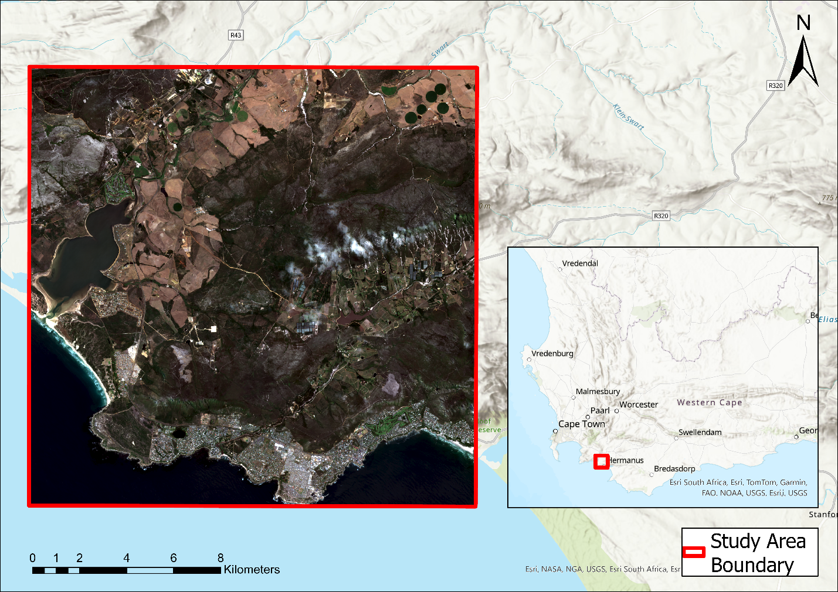
Figure 1: Map of Study Area

THEORY
This study draws on the academic knowledge of GEOBIA and per-pixel classification, segmentation and object features, supervised and rule-set (land cover) classifiers, and accuracy assessment techniques and how they relate to land cover classes.

GEOBIA VS PER-PIXEL CLASSIFICATION
The GEOBIA classification technique classifies images using objects that represent clusters of pixels sharing common characteristics such as brightness or texture (Chen, 2018). These objects become features of interest, because as Chen (2018) states: “... they represent meaningful geographic entities” for classification.

The per-pixel classification technique analyses the spectral properties of each pixel (Weih, 2010) and classifies the images accordingly. According to (Weih, 2010) per-pixel land cover classification can be accurate because of high-resolution imagery, but it has problems such as the salt and pepper effect, meaningless geometry, and limited context from using only spectral information (Whiteside, 2011). These problems render per-pixel classification less accurate, which is why GEOBIA has gained popularity.

GEOBIA eliminates the salt-and-pepper effect by using groups of pixels rather than individual pixels (Liu, 2020). Objects also better represent features due to added context, shape, and texture, allowing improved image analysis and classification (Whiteside, 2011; Liu, 2020). However, the objects must first be delineated through segmentation.

SEGMENTATION AND OBJECT FEATURES
Objects can be delineated through various segmentation types at different scales, including multi-resolution segmentation which, according to Ma (2015), is one of the best types for GEOBIA analysis. However, it is impossible to accurately segment an image at any scale because of the variety in the shape and size of the geographic features (Hay, 1997). The resulting objects have features useful for land cover classification, including shape, size, texture, context, colour, tone, and shadows (Blaschke, 2014).

Blaschke (2014) stated that “shape refers to general form or outline of individual objects” and is useful in land cover classification as it provides an identifiable form for an object of a specific land cover class. For more accurate classification, buildings mostly have a rectangular shape which could be used to identify a built-up class. Image texture refers to the specific frequencies of tonal variations and the spatial patterns they create (Blaschke, 2014). The resulting smooth or rough appearance of the features is useful for land cover classification. For example, because still water appears smooth, it can be used to classify the water class.

These two examples of object features indicate that the extra information provided by objects could be used in rule-sets that could prove useful for land cover classification when compared to supervised classifiers.

SUPERVISED VS RULE-SET CLASSIFIERS
Supervised classifiers use a priori information of land cover classes, such as the statistical information of the pixels in each class, to define land cover types for an unclassified image. Training data are gathered from land cover types to train an algorithm that assigns values to pixels based on the land cover type associated with that pixel (Jog, 2016). The main disadvantage of supervised classifiers over rule-set classifiers is the use of training data.

For supervised classifiers to be accurate, their training data must be accurate, and to ensure their accuracy, the data must be validated which requires fieldwork which could be expensive. When the data are not accurate, they must be corrected; otherwise, the classifier produces errors. This could prove expensive and time-consuming (Albert, 2002).

Rule-set classifiers avoid this problem using expert knowledge to inform classification rules (Antonelli, 2016). These rule-sets can be continually modified using expert knowledge to ensure optimal classification. Once created, a rule-set can autonomously classify many scenes, as shown by Witharana (2016). This means that less time and money are spent with rule-sets than with supervised classifiers. The accuracy of rule-set classifiers can be higher due to the expert knowledge used, which is assessed using accuracy techniques.

ACCURACY ASSESSMENT TECHNIQUES AND LAND COVER CLASSES
Accuracy assessment for land cover classification typically uses an error matrix which is a grid in which columns show true values and rows show image classification. It displays points assigned to each land cover type versus the actual land cover. This enables the calculation of omission and commission errors to show the performance of each land cover class, the overall accuracy of rule-set classification, and the kappa index (Congalton, 2007).

Errors of omission show the probability that a pixel of a class will be classified correctly, whereas errors of commission indicate the probability that a classified pixel is classified correctly. Overall accuracy is the number of pixels that are correctly classified (Congalton, 1991). The kappa index shows model agreement with values from 0-0.4 indicating poor agreement; 0.4-0.55 indicating fair agreement; 0.55-0.7 indicating good agreement; 0.7-0.85 indicating very good agreement; 0.85-1 indicating excellent agreement (Talukdar, 2020).

Therefore, these accuracy assessment techniques provide the basis for the assessment of the land cover classification generated by rule-set classification and, more generally, any classification.

METHODS
To achieve the aim of this study, the objectives laid out in the introduction were followed sequentially, as shown in Figure 2, ensuring the completion of each objective according to scientific standards. The methodological process began with segmentation of the Sentinel-2 image.

Sentinel-2 Image
Final Error Matrix
- Develop a rule-set for each land cover and perform land cover classification using the rule-set.
- Generate 25 points per land cover class and extract values from the classified and referenced image.
- Analyse reference and classified data using the error matrix, to calculate overall accuracy, kappa, and errors of commission and omission per land cover class.
- Evaluate the error matrix to draw conclusions on the effectiveness of rule-based classification.
Figure 2: Workflow Diagram

DATA AND SOFTWARE DESCRIPTION
The data used in this study were acquired from Stellenbosch University, including Sentinel-2 imagery, orthorectified images, and road, farm, and building shapefiles covering the study area. A DEM and slope raster were also provided in the dataset. Segmentation, rule-set development, and image classification were performed using eCognition software. Random points and ground truth values were extracted using ArcGIS Pro with the provided ortho images. An error matrix was created using Excel.

DATA PREPARATION
Prior to classification, Sentinel-2 imagery and thematic data were pre-processed to align spectral, index-based, and ancillary datasets for object-based analysis. Several spectral indices from Sentinel-2 bands have been used to enhance the separability of land cover features.

NDVI, SAVI, and NDMI were used for the vegetation land cover classes. NDVI exploits red and near-infrared reflectance contrast to quantify vegetation vigour, with values ranging from −1 to +1 indicating vegetation density (Campbell, 2021). The SAVI improved vegetation detection in areas with significant soil brightness through its adjustment factor (0.5). The NDMI captures vegetation moisture content to distinguish forest, shrubland, and grassland classes by integrating SWIR and NIR bands (Rujoiu-Mare, 2017).

The Modified Normalised Difference Water Index (MNDWI) enhances water detection by suppressing built-up land signals. For built-up areas, the Built-up Area Extraction Index (BAEI) and Normalised Difference Built-up Index (NDBI) were used to enhance the impervious surfaces and urban structures. These indices were created before segmentation in eCognition to capture spectral and contextual characteristics for the accurate classification of vegetation, water, barren, and built-up classes.

SEGMENTATION
Imagery and thematic data were first inserted into eCognition to perform the segmentation. Multi-resolution segmentation was selected because it is object-based and outperforms other models (Reis, 2015). A scale of 10 was chosen through iteration (Platt, 2008; Conrad, 2010) until the image segments showed internal homogeneity, with pixels predominantly belonging to the same land cover class. This allowed accurate rule-set development to classify objects. The rest of the parameters were kept as default.

RULE-SET DEVELOPMENT AND LAND COVER CLASSIFICATION
The rules for each land cover class were constructed using sentinel-2 image bands, indices, and thematic layers. Through density slicing, the optimal index values for classifying land cover classes within a rule-set were identified by examining the indices and their threshold values. This process continued until the indices distinguished the primary land cover class of interest (Rujoiu-Mare, 2017). Density slicing is a visual tool that enables the systematic evaluation of feature threshold values. This resulted in the rule-sets shown in the following tables.

The rule-sets were performed in the order shown in the tables below and were used with the “assign class” tool to classify the image objects. This allowed for the same values to be used without misclassifying a class as a previous one, as it had already been classified. This approach was useful for constructing different vegetation land cover class rules.

Table 1 lists the rules used to classify the waterbodies. It makes use of the Modified Normalised Difference Water Index (MNDWI) to identify water bodies, and the mean slope was sent to less than 2 to ensure that the ocean and lagoons were classified first.

Table 1: Waterbodies Rule-set
Index/Layer | Operator | Value | Condition
MNDWI | >= | 0.06 | AND
MNDWI | <= | 1 | AND
Mean Slope | < | 2

Table 2 shows that the thematic layer containing polygons of farmlands was used in the construction of the cultivated land cover class and that objects had to have at least an 81% overlap with the polygon layer to be classed as cultivated.

Table 2: Cultivated Rule-set
Index/Layer | Operator | Value | Condition
Total Overlap % with Crop Fields Winter | >= | 81 | AND
Total Overlap % with Crop Fields Winter | <= | 100
To classify objects as built-up, slope and DEM were used, as seen in the table, because most of the towns in the study area are coastal towns, meaning that they are in low-lying areas. The Built-up Area Extraction Index (BAEI) and coastal aerosol indices were used to identify buildings. The distance from the Western Cape (WC) roads shapefile was also used.

Table 3: Built-up Rule-set
Index/Layer | Operator | Value | Condition
Mean Slope | >= | 1.4 | AND
Mean Slope | <= | 16 | AND
BAEI | > | 1.05 | AND
Mean DEM | <= | 100 | AND
Mean Costal Aerosol | >= | 0.05 | AND
Image object pixel distance from WC Roads Outline | >= | 0.05 | AND
Image object pixel distance from WC Roads Outline | <= | 40

To identify barren land, low NDVI and MNDWI values were used in the rule-set, as shown in Table 4, because barren land does not have high values in these indices.

Table 4: Barren Land Rule-set
Index/Layer | Operator | Value | Condition
NDVI | < | 0.2 | AND
MNDWI | < | 0

To classify shrublands, a middling NDVI value range was identified, along with a low Normalised Difference Moisture Index, as shown in Table 5, as identified by the density slicing process described. A mean slope of less than 5 was also used to ensure that shrubs were not misclassified as trees.

Table 5: Shrubland Rule-set
Index/Layer | Operator | Value | Condition
NDVI | >= | 0.3 | AND
NDVI | <= | 0.6 | AND
NDMI | >= | -0.05 | AND
NDMI | <= | 0.15 | AND
Mean Slope | < | 5

The rule-set used to identify grassland made use of high Soil Adjusted Vegetation Index and NDVI values, as seen in Table 6, because grassland is likely to have more moisture than shrublands. A mean slope of less than 7 was also used to ensure that shrubs were not misclassified as trees.

​Table 6: Grassland Rule-set​
Index/Layer | Operator | Value | Condition
SAVI | > | 0.2 | AND
SAVI | <= | 0.7 | AND
NDVI | < | 0.65 | AND
Mean Slope | < | 7

Table 7 presents the rule-set used to classify forest land. It made use of a high NDVI value and a relatively high NDMI value (when compared with other vegetation types).

Table 7: Forest Land Rule-set
Index/Layer | Operator | Value | Condition
NDVI | >= | 0.6 | AND
NDMI | >= | 0.05

The wetland rule-set used many of the same parameters as the other vegetation class rule-sets. However, because they had already been classified, no misclassification occurred.

Table 8: Wetlands Rule-set
Index/Layer | Operator | Value | Condition
NDVI | >= | 0.25 | AND
NDVI | <= | 0.7 | AND
Mean Slope | < | 2 | AND
NDMI | >= | -0.15 | AND
NDMI | <= | 0.1

To identify mines and quarries, a very wide range of built-up indices and SAVI, as shown in Table 9, was used to classify any remaining objects with these values as mines and quarries, as all the other land cover types had been classified.

Table 9: Mines and Quarries Rule-set
Index/Layer | Operator | Value | Condition
NDBI | > | 0.1 | AND
SAVI | < | 0.13

However, the abovementioned rule-sets did not classify all image objects. Therefore, the rule-sets in the tables below were created and applied to classify the remaining objects.
The remaining waterbody objects appeared to be surrounded by vegetation. Therefore, NDVI was used, as shown in Table 10, to classify these objects as waterbodies.

Table 10: Second Waterbodies Rule-set
Index/Layer | Operator | Value | Condition
NDVI | >= | 0.25 | AND
NDVI | <= | 0.7 | AND
Mean Slope | < | 2

The remaining built-up objects consisted mainly of roads; therefore, a very low distance to the road shapefile was used to classify these objects, as shown in Table 11. The BAEI index was used to ensure that dirt roads were not classified as paved roads.

Table 11: Built-up Rule-set
Index/Layer | Operator | Value | Condition
BAEI | >= | 1 | AND
Image Object Pixel Distance from WC Roads Outline | >= | 0 | AND
Image Object Pixel Distance from WC Roads Outline | <= | 0.007

Table 12 indicates the rule-set that was used to classify all the remaining objects as part of the shrubland, as most of the study area consisted of that land cover class.

Table 12: Second Shrubland Rule-set
Index/Layer | Operator | Value | Condition
0 | = | 0

Following object-based classification, the resulting image objects were exported as a thematic layer, enabling subsequent use in ArcGIS Pro to generate reference points to assess the accuracy of the classification rule-sets.

ACCURACY ASSESSMENT POINT GENERATION
Using the “create random points” tool in ArcGIS Pro, 25 points per land cover class were created for the classification. A “ground truth” column was then added to the points table and manually edited to reflect values observed from ortho aerial photos. This table was then exported as an Excel file using the “table to Excel” tool to allow for the development of the error matrix.

ERROR MATRIX DEVELOPMENT AND ACCURACY ASSESSMENT
An error matrix was created using the exported point table to create a pivot table with classification values in rows and true values in columns. The count of the values was used to extract each intersection of the rows and columns. These values were copied into an error matrix Excel sheet from Stellenbosch University which automatically calculated the accuracy measurements needed to assess rule-based land cover classification.

RESULTS
The results of the methodology employed in this study created the land cover classification shown below in Figure 3.
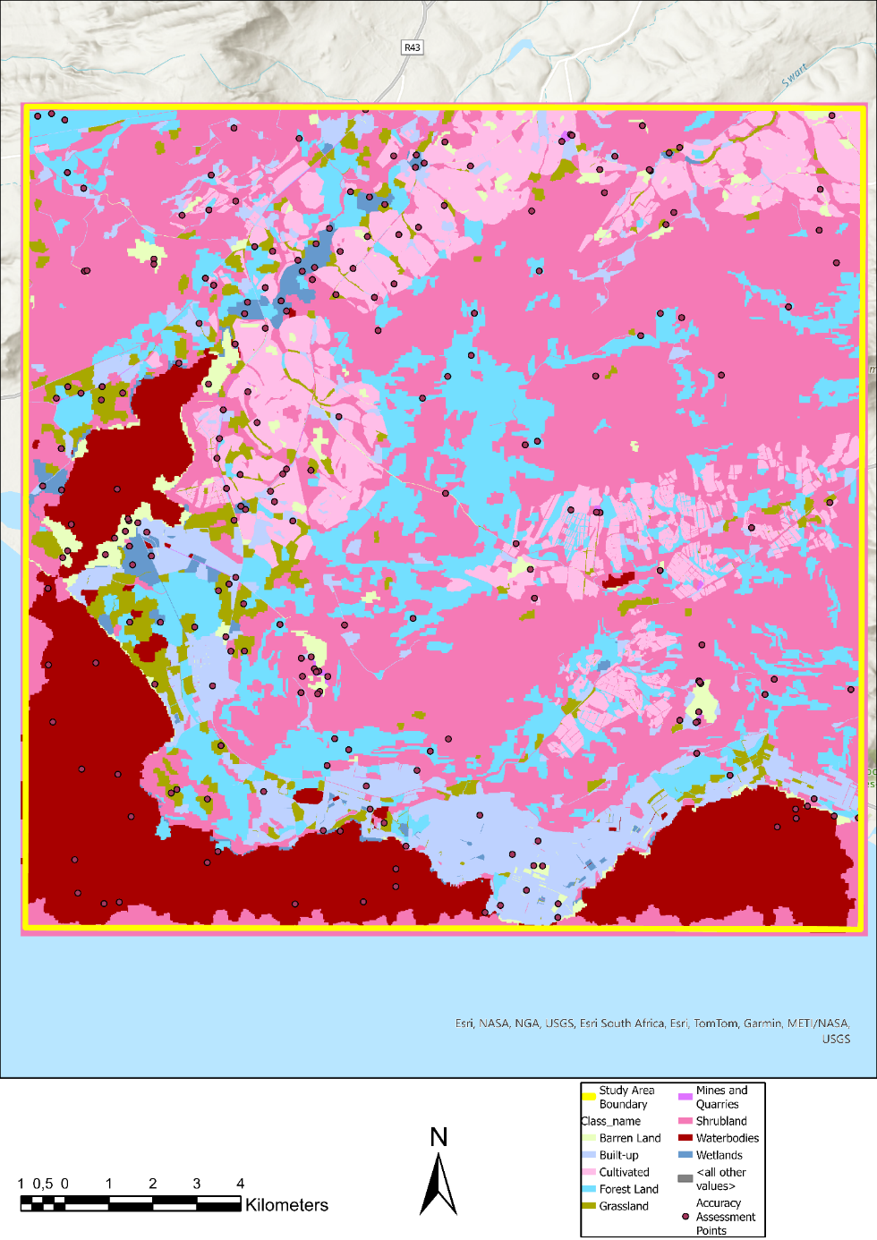
Figure 3: Land Cover Classification Map
Random points from the land cover classification (Figure 3) were used to create the error matrix, shown in Table 13.
Table 13: Error Matrix

The overall accuracy of the rule-based classification was 53.8%. This is subpar with land cover classification, as Foody (2002) states that the target accuracy should be 85%. A kappa value of 49.1% indicates poor classification performance, falling in the fair agreement range of Talukdar (2020). The mines and quarries class had 0% user and producer accuracy, contributing to poor overall accuracy.

Figure 3 shows that the rule-set classified most of the study area as shrublands, while mines and quarries had the least classification. It misclassifies some water bodies and features as shrublands. This likely occurred because one or more Sentinel-2 image bands did not cover the entire study area, causing misclassification around the edges.

The land cover classification map and error matrix together provide a good indication of the performance of rule-based classification which will be discussed in the next section.

DISCUSSION
This study evaluated the effectiveness of rule-based land cover classification using image objects. The results showed that rule-based land cover classification was somewhat effective, as seen in the error matrix (Table 13), where cultivated, shrubland, and waterbody classes had high user accuracies, indicating the correct classification of objects in those classes. This result suggests that rule-based classification may be a suitable alternative to supervised classification, as stated in the introduction. However, some unexpected results were obtained.

The overall accuracy of the classification was 53.8%, indicating relatively poor classification performance. This was most likely due to the classifier’s poor classification of the mines and quarries class, in which no points were correctly classified. If this class were to be removed, the overall accuracy would be 61.1% which is a relatively substantial improvement in the performance.

The built-up class included roads, residential buildings, and commercial buildings. Any point in this class could have included buildings with lawns or roads with bare ground nearby, as shown in Table 13, which was frequently misclassified as almost every other class. This was likely due to random point locations and class makeup.

The model’s poor performance was encapsulated by the low kappa index, which was 0.491, indicating that the model had a fair agreement between the predicted and true values (Talukdar, 2020). Therefore, these results are not encouraging indicators of the performance of rule-based classifiers versus supervised classifiers.

CONCLUSION
This study evaluated the performance and reliability of a rule-based approach to land cover classification as an alternative to supervised classification. Rules were developed for nine land cover classes using spectral indices and ancillary data from Sentinel-2 imagery. The resulting classification was compared against the reference data using an error matrix to determine the overall accuracy, user’s and producer’s accuracy, and kappa index.

This study demonstrated that rule-based classification can be effectively applied to land cover mapping. The results showed that cultivated land, shrubland, and water bodies were classified with high accuracy, confirming that expert-driven rule-sets can capture spectral and contextual features well.
However, the overall accuracy of 53,8% and kappa value of 0.491 indicate that rule-based classification underperformed compared to expected mapping standards, due to poor classification of mines, quarries and built-up classes. This suggests that although the rule-based method shows promise, but cannot yet fully replace supervised classification approaches without refinement.

Future work could enhance accuracy by refining rules for heterogeneous classes, such as built-up areas, adding spectral indices, or incorporating machine learning hybrid models. Manual classification can improve the accuracy of rule-based classification for small classes, such as mines and quarries. Overall, while achieving its aim, the findings highlight both the potential and limitations of rule-based classification for operational land cover mapping.

In conclusion, the overall aim and objectives of this study were successfully achieved. Each objective was systematically completed, as planned. This study effectively evaluated the performance of rule-based land cover classification as an alternative to supervised methods. Therefore, the study fulfilled its aim of assessing the accuracy and effectiveness of rule-based classification.

3273 without title page, ToC, reference list, titles, and captions

BIBLIOGRAPHY
Albert, T.H., 2002. Evaluation of remote sensing techniques for ice-area classification applied to the tropical Quelccaya Ice Cap, Peru. Polar Geography, 26(3), pp.210-226.
Antonelli, M., Ducange, P., Lazzerini, B. and Marcelloni, F., 2016. Multi-objective evolutionary design of granular rule-based classifiers. Granular Computing, 1(1), pp.37-58.
Bolstad, P. and Lillesand, T.M., 1992. Rule-based classification models- Flexible integration of satellite imagery and thematic spatial data. Photogrammetric Engineering and Remote Sensing, 58(7), pp.965-971.
Blaschke, T., Hay, G.J., Kelly, M., Lang, S., Hofmann, P., Addink, E., Feitosa, R.Q., Van der Meer, F., Van der Werff, H., Van Coillie, F. and Tiede, D., 2014. Geographic object-based image analysis–towards a new paradigm. ISPRS journal of photogrammetry and remote sensing, 87, pp.180-191.
Chen, G., Weng, Q., Hay, G.J. and He, Y., 2018. Geographic object-based image analysis (GEOBIA): Emerging trends and future opportunities. GIScience & Remote Sensing, 55(2), pp.159-182.
Congalton, R.G., 1991. A review of assessing the accuracy of classifications of remotely sensed data. Remote sensing of environment, 37(1), pp.35-46.
Congalton, R.G. and Mead, R.A., 2007. A review of three discrete multivariate analysis techniques used in assessing the accuracy of remotely sensed data from error matrices. IEEE Transactions on Geoscience and Remote Sensing, (1), pp.169-174.
Conrad, C., Fritsch, S., Zeidler, J., Rücker, G. and Dech, S., 2010. Per-field irrigated crop classification in arid Central Asia using SPOT and ASTER data. Remote Sensing, 2(4), pp.1035-1056.
Department of Forestry, Fisheries and the Environment (DFFE). 2024, The 2022 South African National Land Cover Data and its operational use, presentation delivered at the National NCA Forum, 7 August 2024, Pretoria: Statistics South Africa. Compiled by the Chief Directorate: Environmental Knowledge and Information Management. Presented by Dr Zakariyyaa Oumar.
Foody, G.M., 2002. Status of land cover classification accuracy assessment. Remote sensing of environment, 80(1), pp.185-201.
Hay, G.J., Niernann, K.O. and Goodenough, D.G., 1997. Spatial thresholds, image-objects, and upscaling: a multiscale evaluation. Remote Sensing of Environment, 62(1), pp.1-19.
Jog, S. and Dixit, M., 2016, June. Supervised classification of satellite images. In 2016 Conference on Advances in Signal Processing (CASP) (pp. 93-98). IEEE.
Liu, B., Du, S., Du, S. and Zhang, X., 2020. Incorporating deep features into GEOBIA paradigm for remote sensing imagery classification: A patch-based approach. Remote Sensing, 12(18), p.3007.
Ma, L., Cheng, L., Li, M., Liu, Y. and Ma, X., 2015. Training set size, scale, and features in Geographic Object-Based Image Analysis of very high resolution unmanned aerial vehicle imagery. ISPRS Journal of Photogrammetry and Remote Sensing, 102, pp.14-27.
Myint, S.W., Gober, P., Brazel, A., Grossman-Clarke, S. and Weng, Q., 2011. Per-pixel vs. object-based classification of urban land cover extraction using high spatial resolution imagery. Remote sensing of environment, 115(5), pp.1145-1161.
Platt, R.V. and Rapoza, L., 2008. An evaluation of an object-oriented paradigm for land use/land cover classification. The Professional Geographer, 60(1), pp.87-100.
Reis, M.S., de Oliveira, M.A.F., Körting, T.S., Pantaleão, E., Sant’Anna, S.J.S., Dutra, L.V. and Lu, D., 2015, July. Image segmentation algorithms comparison. In 2015 IEEE International Geoscience and Remote Sensing Symposium (IGARSS) (pp. 4340-4343). IEEE.
Rujoiu-Mare, M.R., Olariu, B., Mihai, B.A., Nistor, C. and Săvulescu, I., 2017. Land cover classification in Romanian Carpathians and Subcarpathians using multi-date Sentinel-2 remote sensing imagery. European Journal of Remote Sensing, 50(1), pp.496-508.
Talukdar, S., Singha, P., Mahato, S., Pal, S., Liou, Y.A. and Rahman, A., 2020. Land-use land-cover classification by machine learning classifiers for satellite observations—A review. Remote sensing, 12(7), p.1135.
Weih, R.C. and Riggan, N.D., 2010. Object-based classification vs. pixel-based classification: Comparative importance of multi-resolution imagery. The International Archives of the Photogrammetry, Remote Sensing and Spatial Information Sciences, 38(4), p.C7.
Whiteside, T.G., Boggs, G.S. and Maier, S.W., 2011. Comparing object-based and pixel-based classifications for mapping savannas. International Journal of Applied Earth Observation and Geoinformation, 13(6), pp.884-893.
Witharana, C. and Lynch, H.J., 2016. An object-based image analysis approach for detecting penguin guano in very high spatial resolution satellite images. Remote Sensing, 8(5), p.375.

DECLARATION OF GENERATIVE AI AND AI-ASSISTED TECHNOLOGIES IN THE WRITING PROCESS
During the preparation of this assignment, from 20 to 22 October 2025, I used Open Paperpal to improve the readability and language of the paper, such as grammar, punctuation, and style. ChatGPT assisted in the formulising the workflow diagram, presented as Figure 2. No written content was generated with AI.

