Temporal Analysis of the Effects of Warfare on Vegetation in Gaza
Tiaan Henrico ^{a,}*, Zander Lourens ª, Dashlin Naidoo ª, Zahn Munch ª
ª Stellenbosch University, 25872230@sun.ac.za, 22784136@sun.ac.za, 27048942@sun.ac.za, zmunch@sun.ac.za
* Corresponding author

Keywords: NDVI, temporal analysis, Gaza Strip, vegetation analysis, warfare

Abstract:
This study presents a comprehensive analysis of vegetation dynamics in the Gaza Strip (Figure 1a) during the 2023 Israel-Hamas war (ongoing), utilising the Normalized Difference Vegetation Index (NDVI) as a primary tool for assessing changes in vegetation. Employing ArcGIS Pro 3.2.2 for spatial analysis, a per pixel change detection technique was employed to compare NDVI values, aiming to identify and quantify alterations in vegetation cover within the region. Per-pixel change detection was used because the Sentinel-2 imagery used was of a high enough resolution to allow changes to be viewed on a pixel level. The NDVI, a globally recognised remote sensing index, offers a robust measure of plant health and vegetation density by calculating the difference between near-infrared (which vegetation strongly reflects) and red light (which vegetation absorbs) from satellite imagery.
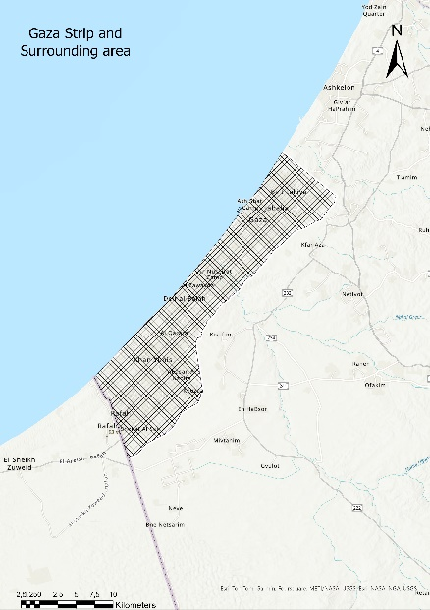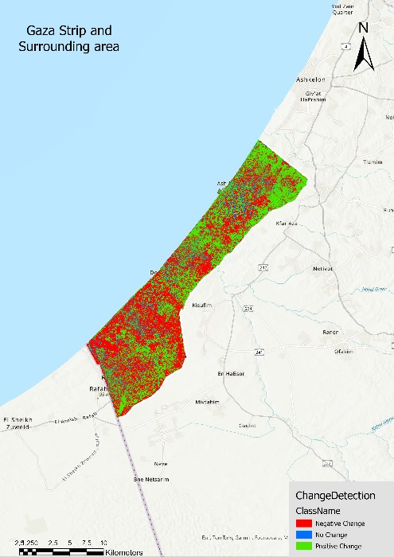
a
b
Figure 1. (a) Study area: analysing the impact of warfare on Gaza’s vegetation over time; (b) Change detection of the NDVI of the Gaza Strip from March 2023 to March 2024.
The methodology involved generating NDVI maps for early March 2023 and early March 2024, followed by a detailed pixel-by-pixel comparison to detect changes in vegetation cover. This approach enabled precise pinpointing areas depicting significant vegetation growth or decline within the Gaza Strip. The study's findings reveal critical insights into the spatial distribution of vegetation changes (Figure 1b), its potential link to the ongoing warfare and subsequently the impact of refugee migration, as well as other environmental factors. The results from the change detection analysis offer valuable information regarding the effects of the targeted attacks in the area.
Furthermore, this research underscores the utility of NDVI in environmental studies, demonstrating its effectiveness in monitoring vegetation dynamics over time. The application of such technologies is essential for the timely detection of ecological changes, providing a basis for informed decision-making in the military geoscience environment. This study contributes to the growing body of knowledge on vegetation monitoring and change detection, highlighting the impact of military activities on vegetation while underscoring the importance of ongoing observation and analysis of ecological systems within politically sensitive and environmentally challenged regions such as the Gaza Strip.

