ALSTEF GROUP
Support Services Team

Queenstown Airport – BHS Performance Review
Period covered: July 2026 (1–31 July, 31 days)
Prepared by: Tiaan Botha, Alstef Group

Executive Summary
- The system processed 119,227 bags through the main outbound line in July (as asked excluding oversize), plus a further 10,445 through the oversize line, averaging just under 3,850 bags per day.
- Of those, 3,023 bags (2.5%) were ultimately rejected after full screening, this is the number that matters operationally, and it held steady all month.
- A much larger share (34.1%) gets flagged at the first automated scan, but the vast majority of those clear on the second, more thorough scan. This is normal, expected behaviour for a two-tier EDS system, not a fault.
- Bag tracking reliability was strong: 1,756 lost-bag events against 691,736 tracked scans, a 0.25% rate. One notable spike on 14 July is worth a mention (see Observations).
- Nothing in the data points to a system health or security issue, the trends are consistent with normal within-month volume swings.

1. Total Throughput (excluding oversize)
You asked for total bag throughput excluding oversize bags. The GlideView main-line counter (T101) is the right number for this, it tracks every bag on the primary outbound system, separate from the oversize induct (OS104).
Metric | Value | Note
Main line throughput (T101), July 2026 | 119,227 bags | Excludes oversize
Oversize line (OS104), July 2026 | 10,445 bags | Separate system
Average daily throughput (main line) | ~3,846 bags/day | Range: 2,660 – 4,933

2. Reject Bags
Queenstown's EDS screening runs in two stages.
- Level 1 (automated CT scan): flags any bag it can't clear with full confidence and sends it for a second look. In July, 40,174 bags (34.1% of all screened bags) were flagged this way.
- Level 2 (secondary screening): re-examines everything L1 flagged. Of those, 36,445 cleared and only 3,023 (7.5% of L1-flagged bags, or 2.5% of total throughput) were confirmed as genuine rejects.

For reporting purposes, the 3,023 figure (2.5% of throughput) is the meaningful "reject bag" number, it reflects bags that actually required manual handling after full screening, not bags that simply needed a second automated look.
Metric | Value | Note
L1 flagged for re-screen | 40,174 bags (34.1%) | Sent to L2, not a final reject
L2 cleared after re-screen | 36,445 bags | 90.8% of L1-flagged bags
L2 confirmed reject (final) | 3,023 bags (2.5% of throughput) | The operational reject figure
L2 timeout | 706 bags | Rescreen not completed in time

3. Comparative Percentage
Reject rate stayed remarkably consistent across the month, daily final-reject rate ranged 1.5%–3.3%, averaging 2.5%, with no sustained upward or downward trend. The L1 auto-flag rate did drift up slightly in the second half of July (33.6% average in the first 15 days vs. 34.7% in the last 16), but the L2 clear rate absorbed it, so the end result for the terminal was stable.

Trend Charts
Daily throughput against L1 and L2 (final) reject volumes, July 2026:
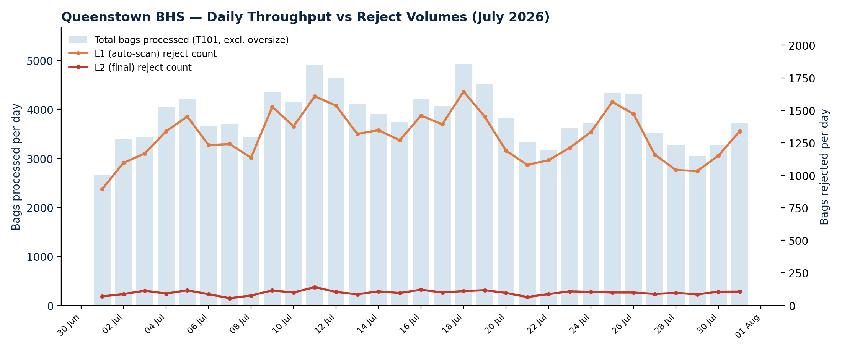
Reject rate as a percentage, July 2026, L1 auto-flag rate vs. final (L2) reject rate:
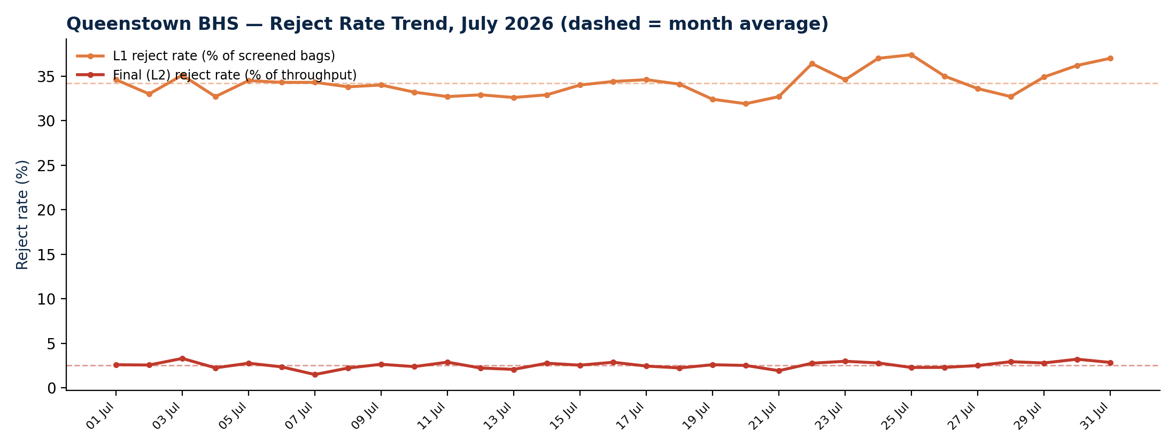
Bag tracking reliability, lost-bag events per day, July 2026:
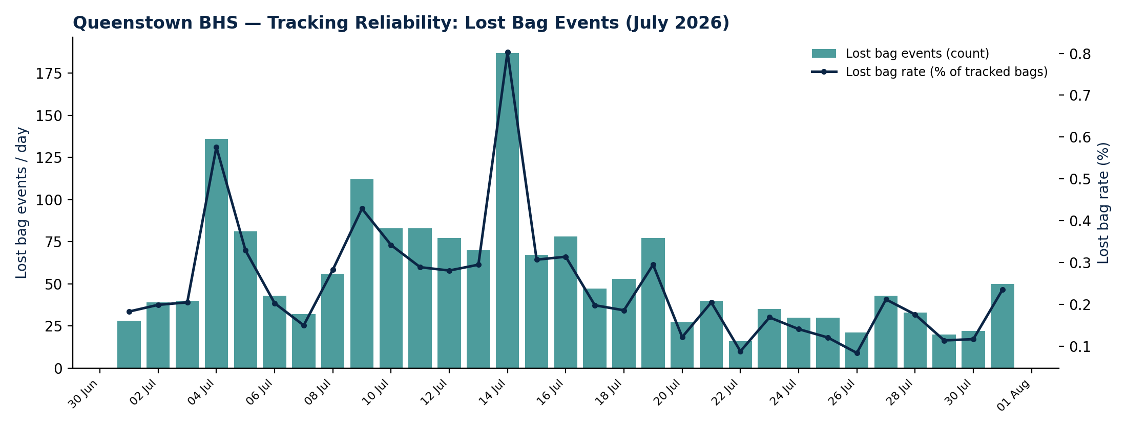

Snapshot: Final Week of July (25–31 July 2026)
A closer look at the most recent full week within the reporting month, useful if Sean wants to compare against next month's opening week.
Metric | Value
Total throughput (main line) | 25,493 bags
L1 flagged for re-screen | 8,759 bags (35.4%)
L2 confirmed reject (final) | 678 bags (2.66% of throughput)
Lost-bag events | 219 (0.15% of tracked scans)

Observations & Discussion Points
- 14 July lost-bag spike: 187 lost-bag events that day (vs. a ~52/day average for the rest of the month), concentrated around T110PC.
- Slight L1 auto-flag drift: the automated reject rate crept from a 33.6% average in the first half of July to 34.7% in the second half. Since the final (L2) reject rate stayed flat, this looks like normal scan sensitivity variation rather than a developing fault, but it's worth keeping an eye on if it continues climbing into August.
- Oversize volumes trending up: oversize bag counts roughly doubled across the month, from a ~209/day average in the first week to ~416/day in the last week, likely seasonal, but useful context if Sean is looking at capacity.

