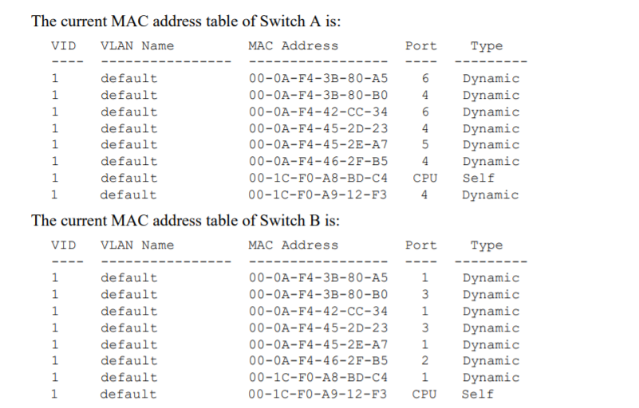

* 1. With the provided information, indicate and justify the Ethernet addresses of all switches and all PCs

PC A: 00-0A-F4-3B-80-A5 - Destination

PC B: 00-0A-F4-42-CC-34 - Switch A (Since there is only 2 addresses associated with port 6 and one of them is used by PC A, the other must be PC B)

PC C: 00-0A-F4-45-2E-A7 - Switch A (Only PC associated with port 5)

PC D: 00-0A-F4-46-2F-B5 - Switch B (Only PC associated with port 2)

PC E: 00-0A-F4-45-2D-23 - Switch B (Since there is only 2 addresses associated with port 3 and one of them is used by PC F, the other must be PC E)

PC F: 00-0A-F4-3B-80-B0 - Source

* 1. What type of ICMP packet is the one shown above? Justify

ICMP Reply: Source

2. What PC B and PC C capture

2.1 Running a ping command on PC D to the address 192.1.1.3

PC B: nothing

PC C: 1 ARP 5 ICMP

2.2 Running a ping command on PC A to the address 192.1.1.200

PC B: 1 ARP

PC C: nothing

2.3 Running a ping command on PC F to the address 192.1.1.4

PC B: nothing

PC C: nothing

2.4. Running a ping command on Switch A to the address 192.1.1.10

PC B: 1 ARP

PC C: 1 ARP

3. Starting on the initial state (where all MAC address tables and all ARP tables are empty), consider that experiments 2.1, 2.2, 2.3 and 2.4 were all run. Indicate and justify the resulting MAC address table of Switch A

Switch A:

00-0A-F4-46-2F-B5 4

Switch B 4

00-0A-F4-45-2E-A7 5

00-0A-F4-3B-80-A5 6

4. Consider the network shown in the following figure. The figure shows all IP addressing information of PC A and PC C and the name of the interfaces used on the routers. Routers have static routing. PC B is used only to capture packets through WireShark (and it is why it is connected through a hub, to be able to observe of packets in that link).

4.1 With the provided information, indicate and justify the IP addresses of all router interfaces.