# ddurdle's XBMC / KODI Cloud Service Plugins

Some comments about the dmdsoftware.net pass-through:

* One-time use code.  
  You provide the Google Drive plugin with a code that you receive from Google when you authenticate my plugin to access your account. This is a one-time use code that you provide the XBMC / KODI plugin, which is passed through dmdsoftware.net where the server appends my client ID and client secret, and the responding authorization and refresh tokens is sent back to the XBMC / KODI plugin, where it is stored. At no time is the code, refresh or authorization tokens saved on dmdsoftware.net. The one-time code immediately expires when it is used to redeem an authorization token.
* Renewing authorization  
  When the authorization token expired (after 60 mins), a refresh token is passed by XBMC / KODI plugin is passed through dmdsoftware.net where the server appends my client ID and client secret, and the responding authorization token is sent back to the XBMC / KODI plugin, where it is stored. At no time is the refresh or authorization tokens saved on dmdsoftware.net.
* Revoking authorization  
  You can revoke any authorization and refresh tokens by visiting <https://security.google.com/settings/security/permissions>

## Getting Started

1. Setup an account in the plugin.  
   Go into the **Add-on Settings** for the plugin. Select the **dmdsoftware OAUTH2** under *Login Type*. Enter a username. You can enter your Google Drive username, but this value is not used other than to remind you what account is authenticated. Leave the *OAUTH2 code empty*. Click **OK**. 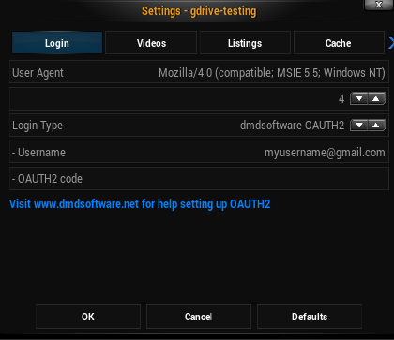
2. Authorize for READ-ONLY Google Drive access.  
   Open in a web browser the following URL <https://accounts.google.com/o/oauth2/auth?approval_prompt=force&scope=https://www.googleapis.com/auth/drive.readonly&redirect_uri=urn:ietf:wg:oauth:2.0:oob&response_type=code&client_id=772521706521-bi11ru1d9h40h1lipvbmp3oddtcgro14.apps.googleusercontent.com>. Authorize the KODI GDrive plugin. You will be presented with a "code". This is the OAUTH2 code. Keep a copy of this code for the following step. 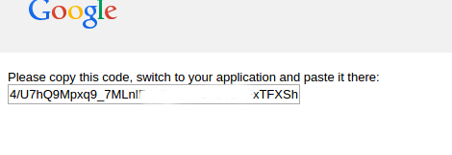
3. Add OAUTH2 code to the XBMC / KODI plugin using **any ONE** of the following options.
   * Type the code into the OAUTH2 code field in the **Add-on Settings**.
   * Edit the **settings.xml** file in the operating system file *~/.xbmc/userdata/addon_data/plugin.video.gdrive/settings.xml*. Locate the field <setting id="gdrive#_code" value="" /> where # represents the # corresponding to the account # you entered in the prior step when you set the username. Enter the code inside the quotes for value="".
   * **[best option]** Create a .STRM file to create your username + code all in a single step.  
     Best option for systems without a keyboard. Create a .STRM file that contains the following entry. Then load this .STRM file in XBMC-> Videos -> Files. This will register the account and code without having to manually entering them.  
     filename: enroll.strm  
     *containing the following inside enroll.strm*  
     plugin://plugin.video.gdrive-testing/?mode=enroll&username=myusername@gmail.com&code=MyCodeThatIReceivedFromGoogle

To support the continued development of this any ddurdle's other XBMC / KODI plugins, please considering donating using Paypal at the following URL [**http://goo.gl/j7v7SD**](http://goo.gl/j7v7SD)