OAKBERRY BENCHMARK
International location strategy | Evidence for CORSA Jakarta
01 Orlando — first international test
Florida Mall, United States | July 2018
Why Orlando, and why this location?
OAKBERRY had originally considered the U.S. for its launch, but started in Brazil in 2016. Its first overseas store was located in Florida Mall, an established Orlando retail destination. Management described the opening as a test.
The business was initially structured with 50% ownership by OAKBERRY and 50% by a local operator. The arrangement divided operating responsibility. After opening additional kiosks in Florida, the company shifted toward local leadership and territorial master-franchise partners.
The Brazilian market connection — useful context, not confirmed causation
2022 Orlando indicator | Evidence
33,437 | Brazilian-born residents (American Community Survey, 2022).
4th-largest | Brazilian-born population among large U.S. regions.
Florida Mall | One of Central Florida’s major shopping attractions, drawing both domestic and international visitors. Its proximity to Orlando International Airport and major theme parks provides exposure to tourists beyond the local population, including Brazilian visitors.
These facts offered a potentially familiar audience for a Brazilian-origin food concept.

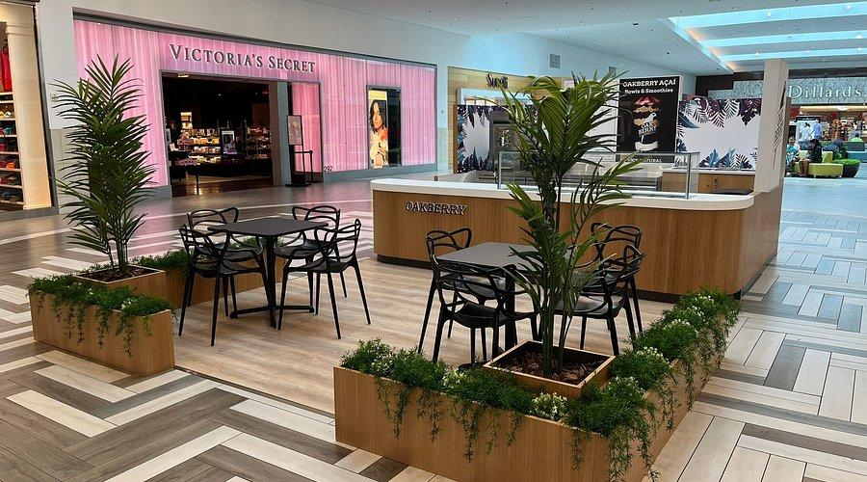 | 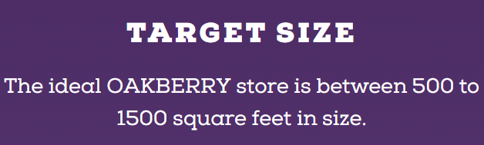  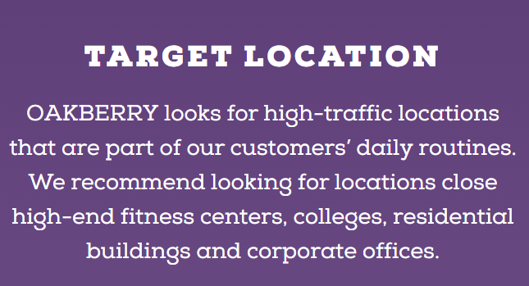
GOOGLE MAPS Florida Mall — original location

BENCHMARK INSIGHT
OAKBERRY paired a recognizable, high-traffic commercial destination with a local operating partner and used the first U.S. outlet to test whether its concept could travel.

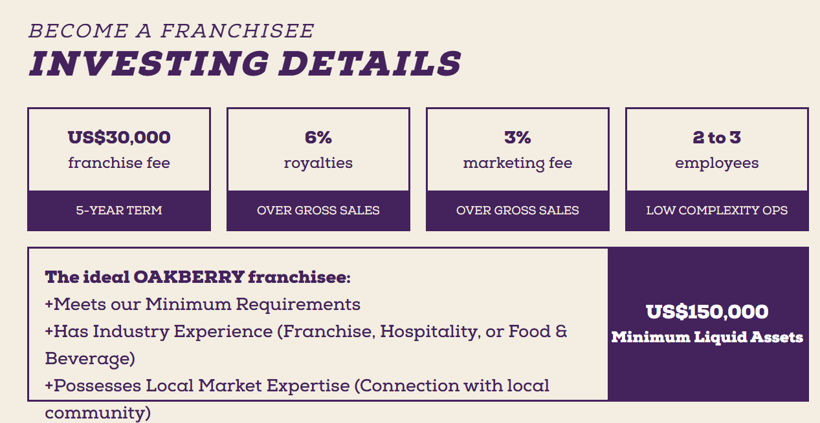
According to: https://www.oakberryfranchise.com/ focusing in USA franchise

02 Indonesia — the first locations
Bali | Canggu and Ubud, November 2023
The first Indonesian openings were in Canggu (19 November) and Ubud (26 November 2023). Both connected a healthy convenience product with environments where tourism, cafés or wellness activities already shaped customer routines. These are location-fit observations, not a confirmed internal OAKBERRY site-selection scorecard.
Location comparison
First two locations | Surrounding environment | Why it mattered to the concept
CANGGU | 19 Nov 2023  Jl. Munduk Catu No. 3 | Coastal Batu Bolong/Canggu area, near Batu Bolong Beach, surrounded by cafés, restaurants and tourist attractions. | Exposure to visitors and an audience already familiar with smoothie, açaí and healthy-food concepts.
UBUD | 26 Nov 2023  Jl. Wanawarna / Monkey Forest | Located approximately 700 m from Monkey Forest, one of Ubud’s main tourist attractions, in an area known for its rich cultural heritage, temples, yoga and hikes. | A landmark-led tourist circuit and a wellness-oriented consumer profile aligned with brand positioning.
GOOGLE MAPS Canggu • Ubud
What the Indonesia Growth team actually said
• On Ubud, Syauqi Al Ibrama explicitly highlighted the store’s roughly 700-metre distance from Monkey Forest and the area’s yoga and wellness-retreat identity. [6]
• On a later Seminyak location, he emphasized proximity to the beach, hotels, spas, restaurants and shopping districts; the store was planned as Indonesia’s first shopping-mall unit. This is supporting evidence of the brand’s broader site logic, not a claim about its first two stores. [7]
• In a separate post, he described the use of locally sourced fruit, granola and toppings in Bali, connecting a standardized global product to local suppliers and consumer tastes. [8]
GOOGLE MAPS Seminyak — later location
BENCHMARK INSIGHT
Bali illustrates a location filter based on proximity to relevant destinations, neighborhood identity and customer behavior. Canggu and Ubud occupy different tourism circuits, but both are compatible with OAKBERRY’s healthy-lifestyle promise.
04 OAKBERRY Jakarta location
OAKBERRY Indonesia provided unusually direct site-selection criteria in a LinkedIn call for Jakarta retail spaces: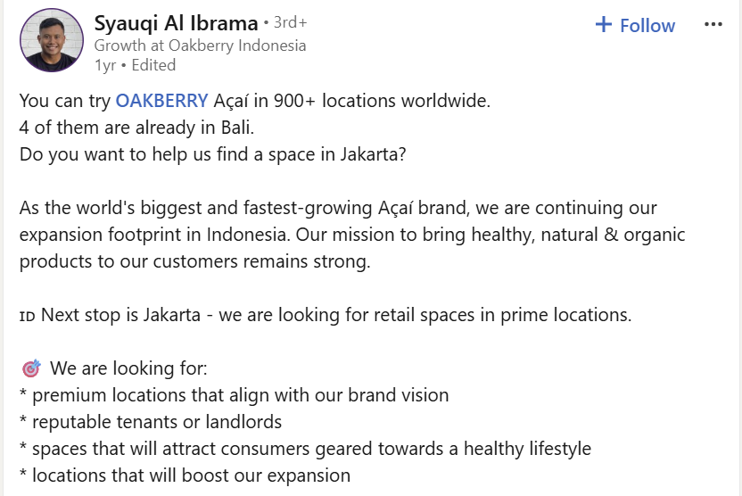

In another Jakarta post, the same representative cited Grand Indonesia, Pondok Indah Mall and PIK2/Aloha as examples of the city’s evolving retail landscape; those are observations, not confirmed OAKBERRY lease targets. [16]

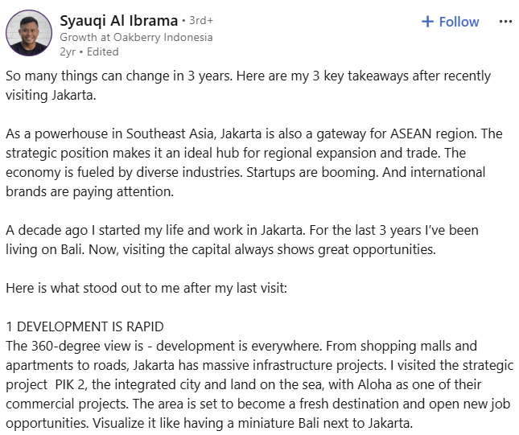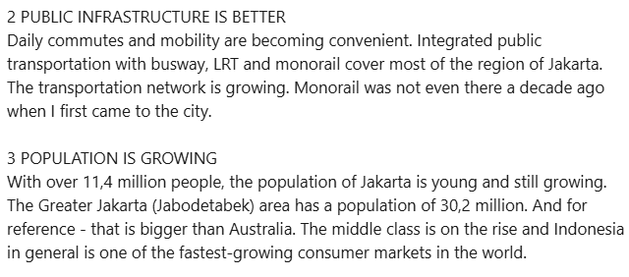
03 South Korea — create desire first
Seoul | Pop-up activation, then permanent retail
OAKBERRY entered South Korea through a temporary pop-up at The Hyundai Seoul (7 May–2 June 2024), an established destination for retail discovery. The event operator describes product trials, branded merchandise, multilingual staff and managed visitor flow. It made the first interaction with the brand an experience rather than a conventional store opening. [9]
The first standalone street store followed on 19 June 2025 at Apro Square near Sinnonhyeon Station, after the brand had already appeared in department stores and malls. ABF also records influencer marketing, digital campaigns and collaboration with a local entrepreneur as features of the Korean expansion. [10][11]
GOOGLE MAPS The Hyundai Seoul — 2024 pop-up • Sinnonhyeon — street store
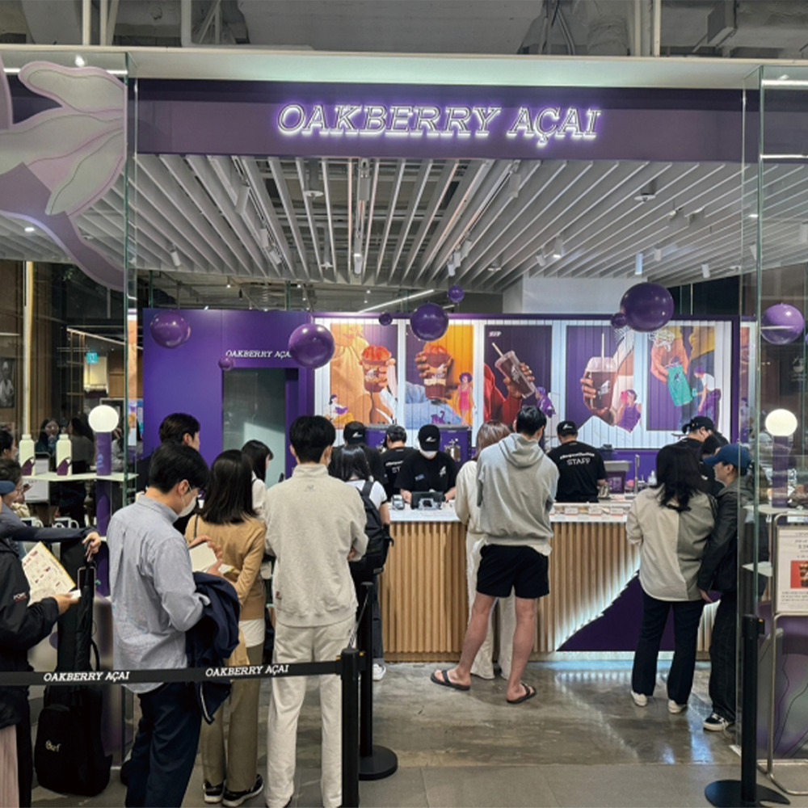
BENCHMARK INSIGHT
Prominent temporary retail + influencers + a local operating network can create recognition and social demand before the first standalone street-format location.

Cross-market summary
Orlando | Bali | South Korea
Use a first foreign store to validate a model with local operating support. | Select neighborhood ecosystems already associated with the target lifestyle. | Build awareness through a high-visibility experience before relying on street-store discovery.
06 Sources & location links
Evidence base | Direct links to original publications
Source hierarchy: OAKBERRY/industry publications and local business sources for reported events; first-person LinkedIn posts for the Indonesia team’s stated priorities; commercial franchise disclosures only for market-level investment references.
[1] HSM Management — Empresa brasileira se globaliza em apenas sete anos
Orlando market test, 50/50 ownership, and later shift to territorial master-franchising.
[2] ABF — Expansão acelerada leva Oakberry à final do Prêmio de Internacionalização
Orlando Florida Mall as first international location and healthy fast-food concept test.
[3] Orlando Economic Partnership — Global Orlando, 2022 ACS estimates (p. 4)
33,437 Brazilian-born residents in the Orlando metro in 2022; Brazil 6th among country origins.
[4] Bali Keizai — OAKBERRY launches in Bali (5 Dec 2023)
Canggu on 19 Nov and Ubud on 26 Nov 2023, with street addresses and product format.
[5] OAKBERRY Indonesia — Official store locator
Current official listed addresses for Canggu, Ubud and Seminyak.
[6] Syauqi Al Ibrama / LinkedIn — Ubud opening and Monkey Forest proximity
About 700 m from Monkey Forest; Ubud tourism, yoga and wellness positioning.
[7] Syauqi Al Ibrama / LinkedIn — Indonesia location rationale: Seminyak
Nearby beach, hotels, spas, shopping/dining; first Indonesia mall format.
[8] Syauqi Al Ibrama / LinkedIn — Local suppliers and Bali customers
Locally sourced toppings and product-localization signals.
[9] TL Creative — The Hyundai Seoul OAKBERRY pop-up, 7 May–2 June 2024
Pop-up timing, venue, multilingual promoters, on-site activation.
[10] The Big Data News / OAKBERRY Korea — First standalone Sinnonhyeon store, 19 June 2025
Location at Apro Square; shift from mall/pop-up channels to street store.
[11] ABF — 2025 internationalization award: OAKBERRY South Korea
Influencer marketing, digital campaigns, local entrepreneur and network growth.
[12] Syauqi Al Ibrama / LinkedIn — Jakarta site-selection call
Premium and brand-aligned sites, reputable tenants/landlords, healthy-lifestyle audiences.
[13] OAKBERRY Franchise US — Official US investment guide
Current investment guideline: US$150k–320k per store; franchise fee listed separately.

[14] Jeompo Guide (Korean disclosure summary) — OAKBERRY franchise registration, Korea (Aug 2026)
~KRW 200.18m per representative 50 m² franchise; not the recorded cost of a named Seoul unit.
[15] OAKBERRY franchise materials — US store size and location standards
500–1,500 sq ft and high-traffic, daily-routine location criteria; not verified for Bali.
[16] Syauqi Al Ibrama / LinkedIn — Jakarta urban retail observations
Mentions Grand Indonesia, Pondok Indah Mall and PIK2/Aloha as examples visited; not Oakberry store announcements.
Google Maps — locations analyzed
GOOGLE MAPS Orlando Florida Mall • Canggu • Ubud
GOOGLE MAPS Seminyak • Hyundai Seoul • Sinnonhyeon

