OAKBERRY BENCHMARK
Research notes for CORSA Jakarta
Business model: replicable by design

Evidence
• OAKBERRY was conceived for replication across countries and cultures. HSM Management reports that its first kiosk in São Paulo measured only 6 m² and that product standardization was treated as a logistical advantage.
• Founder Georgios Frangulis told QSR Magazine that scalability was a priority “from day one”, with small footprints and simple execution.
• QSR Magazine reports a preferred U.S. store size of approximately 46,5 m², an estimated investment of US$100,000–320,000, and a staffing model of one employee during normal shifts and up to three at peak periods. Together, these figures indicate a model with low space, labor and capital requirements per unit, which helps explain why the concept could be replicated quickly by third-party franchisees across different markets.

Preferred footprint | Store investment (U.S.) | Labor intensity
~500 sq. ft. | US$100k–320k | 1 normal / ≤3 peak

Customization without menu proliferation
• The customer builds a bowl from a standardized açaí base, size and predefined toppings. Choice is high, but the preparation system remains bounded and teachable.
• This is the relevant mechanism for CORSA: perceived variety can come from combinations of standardized components rather than from a long list of independent dishes.

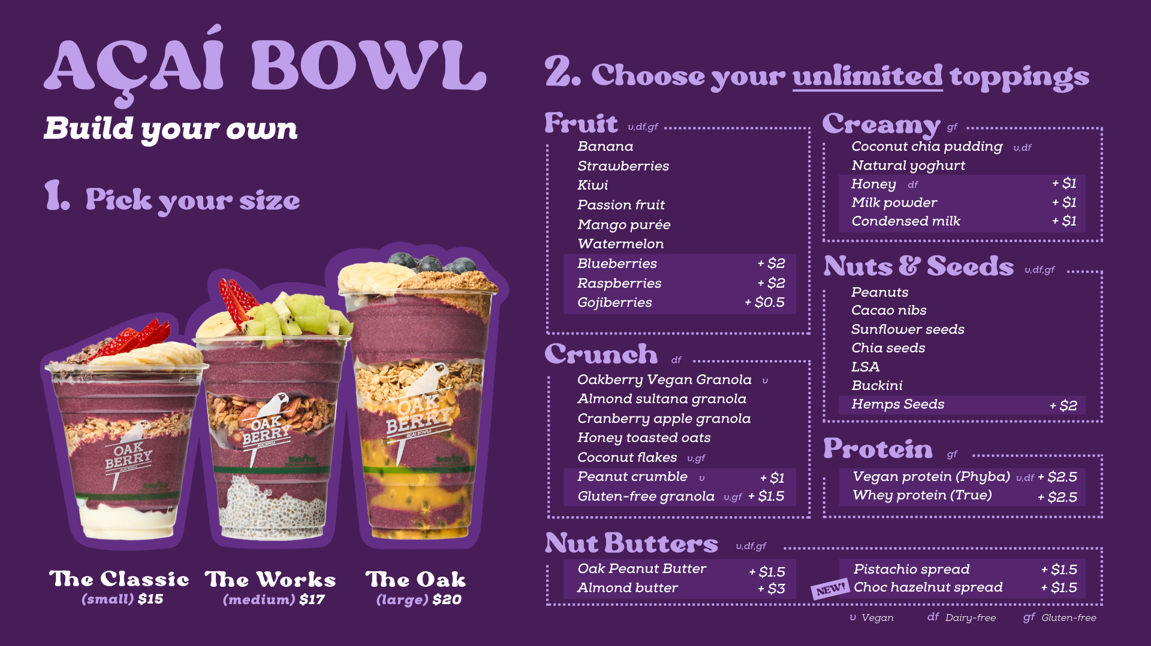

CORSA RELEVANCE
If personalization is validated in Jakarta, the useful benchmark is the operating logic: limited bases + controlled options + standardized execution.

02 International entry: the model changed after the first test

2016 -18 | Brazil | OAKBERRY reached nearly 100 stores in Brazil before expanding internationally, strengthening brand recognition and validating its replicable model.
Jul 2018 | Orlando | First international unit. OAKBERRY/franchisor held 50% of the business and a local operator held 50%.
2018 | Florida | Two additional kiosks opened. Management concluded the 50/50 structure was not sustainable for the scale of expansion planned.
Next phase | U.S. scaling | OAKBERRY created a local franchisor office, installed local leadership and shifted toward master franchisees by territory, while retaining selected company-owned stores and JVs.
2021 | Asia expansion | OAKBERRY entered China with its first store in Shanghai. Expansion was later slowed by the Covid-19 pandemic.
2023 | Indonesia | OAKBERRY entered Indonesia through Bali, opening four more stores ,with Jakarta and Surabaya identified as next expansion markets.
2025 | South Korea | Expansion through a local business partner, influencer-led brand awareness and digital campaigns, opening 36 stores in less than one year.
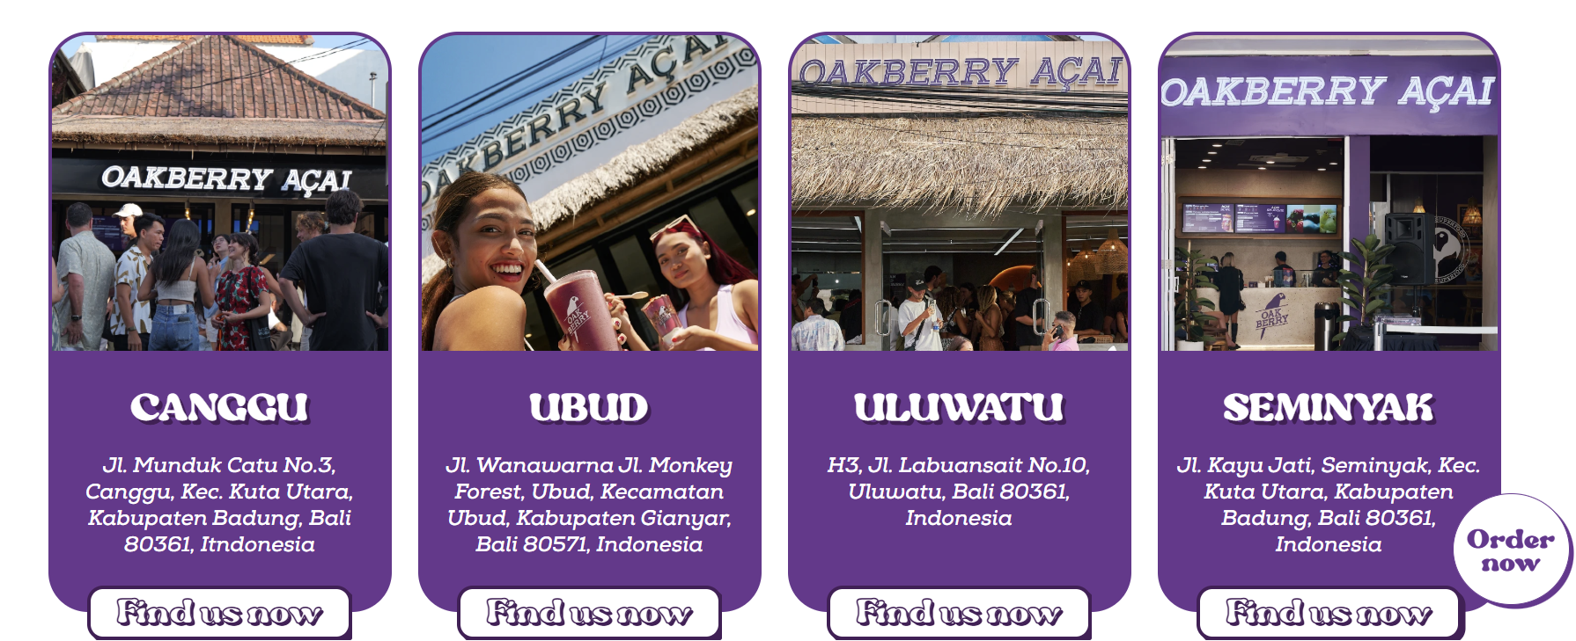

Why the 50/50 in US case matters
• The first foreign market was not handed to a passive franchisee: OAKBERRY kept direct ownership alongside a local operator.
• The structure worked for market testing but was later judged insufficient for broad, sustainable territorial expansion.
• For CORSA, the more comparable question today is partner/JV participation in the first Jakarta unit.

The public source confirms 50/50 ownership, not a 50/50 cash contribution. The amount invested by each party in the first U.S. unit has not been publicly disclosed.

03 Funding architecture over time

Stage | Source of funds | Documented amount | Main use / role
2016–18 | Founders + franchisees | Not disclosed | Initial stores, franchisees increasingly fund store-level expansion.
2019 | SMZTO minority equity | Not disclosed | Capital at franchisor level, company still in early growth.
2021 | Monte Bravo / Kilima equity | R$84m | Verticalization: own production and distribution infrastructure.
2022 | Green CRA (debt) | R$50m | Supplier chain, production, processing and industrialization.
2023–24 | BTG Pactual transaction | R$325m total transaction | Primary + secondary capital, expansion abroad and greater direct investment in selected markets.
2024 | Debentures (debt) | R$100m | Corporate funding; first public debenture issuance by OAK Holding.
2024–25 | Southern Europe JV | €14.5m total | €10.47m Fortitude + €4.03m OAKBERRY, Portugal, Spain and Italy.
What changes across the stages
• Early growth: third-party capital increasingly funds individual stores and territories.
• Scale-up: institutional equity and debt fund capabilities shared by the network: production, supply chain and corporate infrastructure.
• More mature stage: OAKBERRY begins committing more capital to selected owned markets and regional JVs rather than remaining purely asset-light.
RESEARCH POINT FOR CORSA
The useful question is not only “How much does Jakarta cost?” but “Which layer should CORSA fund itself?” Store CAPEX, working capital, shared systems and local operating capability do not have to come from the same source.

04 Cash impact of scaling

OAK Holding — consolidated figures (R$ million)
Metric | 2023 | 2024 | 2025
Net revenue | 173.2 | 264.8 | 441.0
Operating result | 19.4 | 19.3 | -11.1
Net income / (loss) | 2.1 | -3.1 | -88.4
Operating cash flow | -8.8 | -43.2 | -32.1
PPE + intangible investment | 33.5 | 44.1 | 162.0
Cash at year-end | 7.9 | 72.8 | 68.8
Observed pattern
• Net revenue grew from R$173.2m in 2023 to R$441m in 2025.
• Operating cash flow remained negative across the three years.
• Investment in property/equipment and intangibles rose sharply in 2025 as the group expanded owned infrastructure and operations.
• Financing flows (equity and debt) remained material to growth. This is not evidence that every store was unprofitable, the figures are consolidated and include manufacturing, corporate functions, leases, owned stores and international subsidiaries.
2025 scale reference
The 2025 financial statements report 982 units in total: 373 in Brazil and 609 abroad.

05 Transferability to CORSA

OAKBERRY element | Use for CORSA now? | Reason
Controlled customization | YES — test | Could give Jakarta consumers choice without multiplying independent recipes.
Small / flexible formats | YES — as a design question | Useful for testing whether the first site needs the full 120–180 m² assumption.
Local operator / co-investor | YES — scenario to model | Closest parallel to OAKBERRY’s first U.S. entry; could reduce capital and local execution risk.
Master franchising | LATER | Requires a proven, standardized unit and a partner willing to develop an entire territory.
OAKBERRY CAPEX / staffing ratios | NO — direct transfer | CORSA has a hot kitchen, specialty coffee and functional drinks; operating complexity is materially higher.
Centralized single-product supply | PARTIAL | The logic of standardization transfers, the supply-chain structure does not.

Potential benchmark extension — Spoleto
Why add it: OAKBERRY is strong for replicability and capital structure, but weak as a direct food-operation comparison. Spoleto is a more relevant benchmark for pasta customization and standardized assembly.
• Grupo Trigo describes Spoleto as a personalized Italian-food concept with 400+ units. Current public franchise data indicate investment from R$635k for the traditional format, 8–12 employees, 6% royalty and 2% advertising fee; the smaller Piccolo format starts at R$375k with 7 employees. [10]
• Research question: can CORSA use a controlled “choose pasta + sauce + add-ons” architecture to capture personalization demand without increasing kitchen complexity excessively?
• Spoleto should be treated as a complementary operating benchmark, not a substitute for OAKBERRY’s international financing benchmark.

Adicionar:
Participação da marca em eventos esportivos (sobretudo corrida)
Design/ criatividade
Supply
Entender melhor a entrada no mercado coreano e na influencia do networking
Entender a trajetória da oakberry para entrar no mercado de jakarta pela primeira vez, como eles escolheram o local, o tamanho da loja...

06 Source base
Sources used in this research draft

QSR Magazine — “OAKBERRY Puts Açaí on the Map Worldwide”
https://www.qsrmagazine.com/story/oakberry-puts-acai-on-the-map-worldwide/

HSM Management — “Empresa brasileira se globaliza em apenas sete anos”
https://hsmmanagement.com.br/empresa-brasileira-se-globaliza-em-apenas-sete-anos/

OAKBERRY Sustainability / Framework US
https://www.oakberry.com/uploads/Oakberry_Framework_US.pdf

Snowbank — Western Canada master franchise rights
https://snowbankbrands.com/news/oakberry

Snowbank — Franchise FAQ
https://snowbankbrands.com/franchises

OAK Holding S.A. — 2024 audited financial statements
https://www.oakberry.com/pt-BR/uploads/Complete_with_Docusign_OAKHOLDING24DEZ.pdf

Exame — OAKBERRY funding / verticalization coverage
https://exame.com/insight/oakberry-capta-r-325-milhoes-com-btg-para-internacionalizar-ainda-mais-o-acai/p

Fortitude Capital — Southern Europe partnership
https://fortitudecapital.pt/fortitude-capital-and-oakberry-join-forces-in-a-strategic-partnership-for-expansion-in-southern-europe/

OAK Holding S.A. — 2025 published financial statements
https://datamercantil.com.br/wp-content/uploads/2026/06/25-06-2026-Data-Mercantil-certificado.pdf
.
Grupo Trigo — Spoleto franchise page
https://www.grupotrigo.com.br/franquias/spoleto

Oakberry Indonesia
https://oakberry.id/

