01 CULTURE | CAGE FRAMEWORK

CORSA Jakarta Culture
Jakarta evidence supports coffee, healthier food and group activities as relevant habits. CORSA should adapt the food and social experience; demand for its complete concept still needs a local trial.

How do customers use cafés?
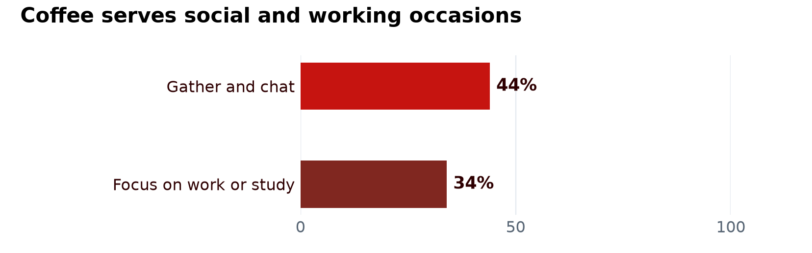
Jakpat 2025 • Indonesia coffee survey, n = 1,002. Responses are separate indicators, not shares of café visits.
Provide space for friends and short working visits alongside takeaway service. A separate single-café study found 17 of 20 participants stayed one to four hours; that small sample confirms the behaviour exists, not a citywide average.
Sources Jakpat wellness and coffee 2025 • BORDER third place study 2025

Which audience has research support?
Evidence | What it supports | What it cannot prove
IPB 2024  210 Jakarta Gen Z healthy-food buyers | Health motivation and lifestyle were associated with purchasing. | How many Jakarta residents want CORSA.
IPB journal 2024  146 DKI Gen Z respondents | Lifestyle and brand image were associated with coffee purchases. | That a racing identity causes repeat visits.

Recruit people who already buy café meals and healthier food. Young professionals and active communities are useful starting groups; their spending and concept preference must be measured.
Sources IPB healthy food thesis • IPB lifestyle and coffee study
Charts redraw source data; they are not sales forecasts.

What do restaurant reviews suggest?
Tiago analysed 3,061 Google reviews of 36 Jakarta Italian and pasta restaurants, collected on 24 September 2026. Flavour and slow service emerged as critical themes. For CORSA, test the actual recipes and portions, and time ordering and meal delivery during a trial.
These are self-selected reviews, not a representative customer survey. The underlying reviews and coding were not supplied, so use the themes as testing priorities rather than population complaint rates.
Source: Tiago Reimann, Customer Behaviour Extended Data, pp 4 and 9; dataset reference 29 on p 11. Supplied team report; no public dataset link.

How could Ramadan change visit patterns?
Tiago flags Ramadan as a period to investigate different opening hours and group dining. Ask local customers about evening meals when breaking the fast, takeaway timing and group orders. Test staffing and service around those occasions; do not assume every customer fasts or that Ramadan automatically increases sales.
Source: Tiago Reimann, Customer Behaviour Extended Data, pp 3, 7 and 9. These are questions for local validation, not a CORSA demand forecast.

02 IMPLICATIONS FOR CORSA

What should CORSA adapt?
Keep the Italian lifestyle identity while making taste, fillingness and halal status clear. The East Jakarta halal study (n = 100) linked certification with purchase intention; it does not show how many customers would reject CORSA. Halal assurance does not require religious brand positioning.
Do not assume a small halal kitchen corner is sufficient. LPPOM describes dedicated restaurant facilities and storage; the operational choices are explained in Administrative.
Sources Syarikat halal study 2025 • LPPOM restaurant facility rules

Does a café and running community already exist?
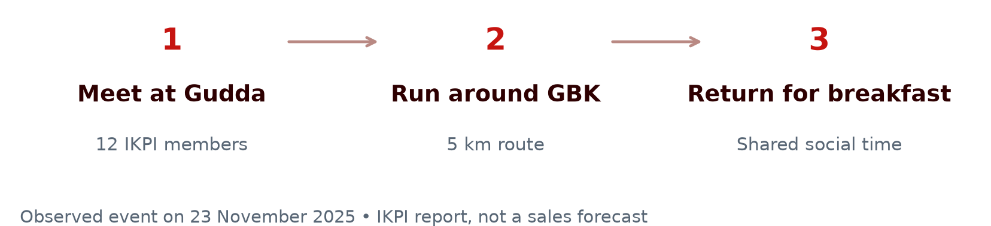
IKPI documents an actual return to Gudda for breakfast after the run. This confirms the food-and-activity occasion. Gudda and Kopi Sana are also reported as running-group gathering places; no source establishes CORSA’s likely sales.
Sources IKPI run and breakfast 2025 • The Coffee Run 2025

Which concepts provide useful comparisons?
Comparable | Relevant offer | Lesson for CORSA
Common Grounds and Pison | Coffee and café meals | Food and atmosphere already compete for visits.
SaladStop and Burgreens | Salads and plant-based food | Health positioning alone is not distinctive.
HONU | Bowls and matcha | Compare taste, portions and meal occasions.

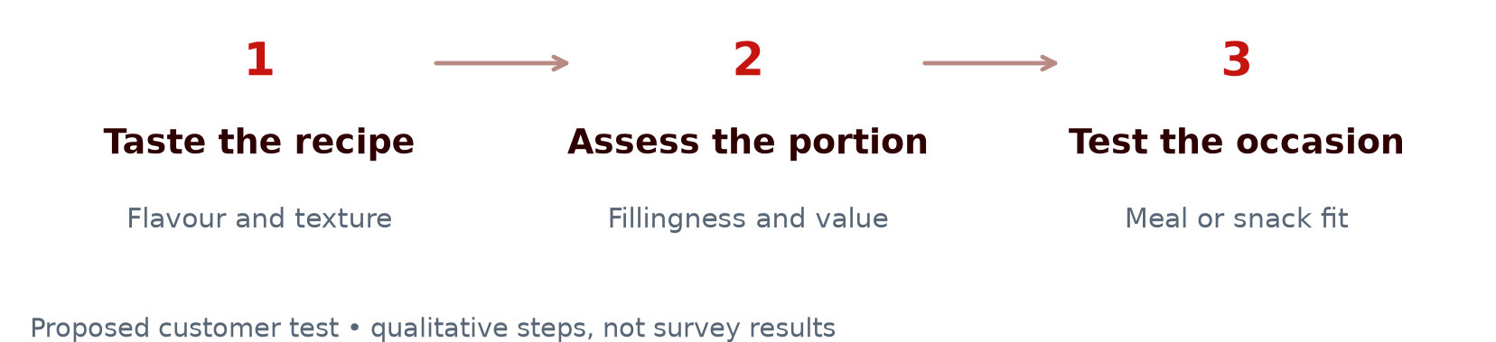
Rice consumption does not establish rejection of pasta. Select menu adaptations from actual tasting responses.
Sources Common Grounds • Pison • SaladStop • Burgreens • HONU • Cipete café thesis

