01 ADMINISTRATIVE | CAGE FRAMEWORK

CORSA Jakarta Administrative
Halal requirements affect sourcing and restaurant operations. CORSA can retain a broad lifestyle identity, but its menu claims and preparation arrangements must match the applicable certification rules.

When do the requirements apply?
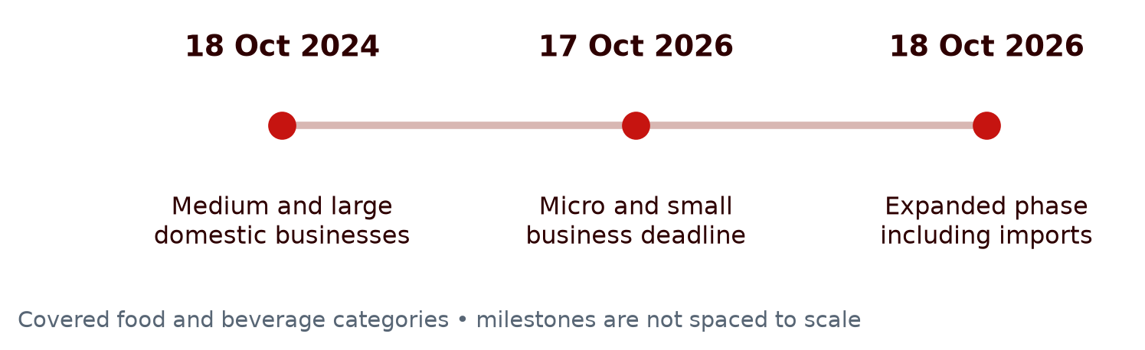
BPJPH reaffirmed on 9 October 2026 that the 18 October phase would proceed without postponement. Special provisions for certain micro/small businesses and imports were still being prepared; they are not an established exemption for CORSA.
Question | Answer for launch planning
Does every business start in 2026? | No. Covered medium and large domestic businesses entered the mandatory phase in 2024.
Does a small first outlet qualify as micro or small? | Not automatically. Confirm the Indonesian business classification and route.
Are restaurants included? | Yes. The USDA report includes food and beverage preparation in restaurants and cafés. Ingredients alone do not certify the outlet process.

Sources BPJPH 2024 phase • BPJPH 2026 categories • BPJPH update 9 October 2026 • USDA halal report 2025 Table 1

Which sources should govern the decision?
Source | Use
Indonesian law and BPJPH | Determine obligations and current implementation.
LPPOM halal inspection guidance | Explain how restaurant facilities and processes are assessed.
USDA FAS reports 2025 | Credible regulatory and foodservice background, not Indonesian law. The HRI report cites the halal report.

Sources Government Regulation 42 of 2024 • USDA HRI report 2025

02 IMPLICATIONS FOR CORSA

Can a small halal area solve the issue?
A kitchen corner is not a demonstrated compliance solution. LPPOM states that certified restaurant facilities must be dedicated to halal production, including relevant storage. Shared equipment and contact with non-halal products require more than a label on one preparation area.
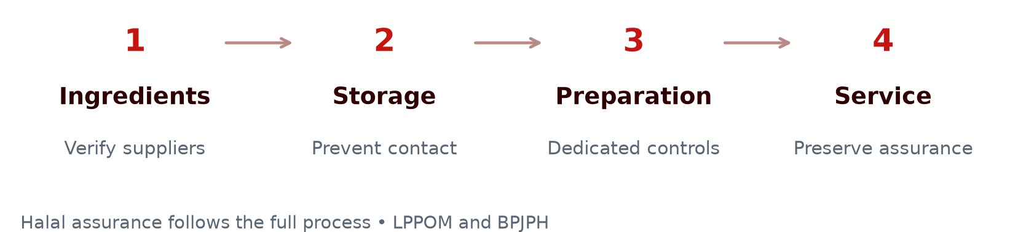
Operating choice | What it means
Halal-certified restaurant offer | Plan compatible ingredients, dedicated facilities and documented controls across the process.
Mixed menu with a halal corner | Do not claim this is certifiable. Obtain a written assessment of the exact premises, storage, equipment and certification scope.
Non-halal products | BPJPH permits their trade with clear non-halal information under applicable rules. This does not allow unsupported halal claims.

Sources LPPOM dedicated restaurant facilities • BPJPH non-halal trade and foreign certificates • BPJPH restaurant outlet controls

What must CORSA confirm before launch?
Check | Concrete output
Menu and suppliers | Document meat, cheese enzymes, sauces and additives; check each imported certificate’s recognition and registration.
Facilities and classification | Confirm the business route, certification scope, storage and preparation layout with BPJPH or an authorised inspection body.
Cost and timing | Obtain quotations and an implementation schedule before adding assumptions to Team B’s model.

Sources USDA halal standards 2025 • BPJPH foreign certificate registration

