01 ECONOMIC | CAGE FRAMEWORK

CORSA Jakarta Economic
The evidence supports testing a healthier café offer, but it does not establish a viable selling price. Price acceptance and repeat purchases must be measured among reachable Jakarta customers.

Will customers pay more for healthier food?
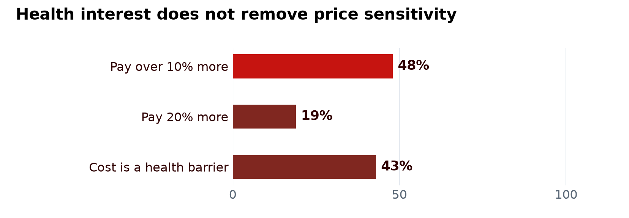
NIQ 2025 • Indonesian adult grocery shoppers. Stated willingness to pay for nutritionally enhanced food; separate indicators, not mutually exclusive groups. Indonesia sample size is not stated in the release.
These figures cannot set a restaurant markup. The questions concern food products and healthier living, not CORSA meals. Use them to test the value of a specific recipe and portion at a local price.
Sources NIQ Indonesian health priorities 2025

What makes a meal feel worth buying?
Evidence | Implication for CORSA
Jakpat 2025  995 respondents in eight Java urban areas | The public summary highlights affordability and flavour as dining-place drivers. Test both together.
Cipete Raya thesis 2019  Ten South Jakarta cafés | Price, taste and comfort feature in purchasing decisions. The older local study cannot supply a current price list.
IPB Jakarta studies 2024 | Income relates to healthy-food and coffee purchasing. Professional status alone does not establish spending capacity.

Compare a meal-and-drink basket with what respondents bought on their last similar visit. Record actual spending, acceptable price and expected visit frequency.
Sources Jakpat local food and beverage 2025 • Cipete café thesis • IPB healthy food • IPB coffee purchases

02 IMPLICATIONS FOR CORSA

Which groups should be tested first?
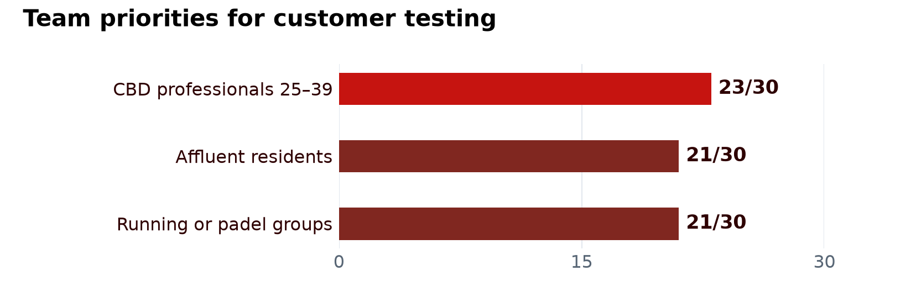
Tiago’s team assessment • judgement scores out of 30, not market shares or survey demand. The groups overlap; do not add them as separate customer pools.
Prioritise professionals and residents who already buy café meals, with running groups as one way to reach them. Students and expats can be included, but age, occupation or nationality does not establish a premium budget.
Source: Tiago Reimann, Customer Behaviour Report and Extended Data, pp 7–8; Paul, Report 1, pp 5–6. These are supplied team files, without public links.

How does a community become revenue?
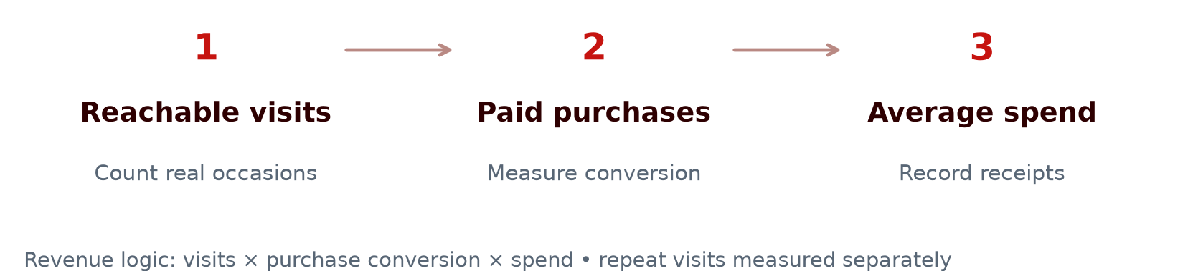
Measure in two trial events | Decision it supports
Attendance and proportion purchasing | Does participation lead to paid demand?
Actual spend and product cost | Does the basket generate enough contribution?
Return visits outside events or discounts | Is demand recurring rather than promotion-dependent?
Seat time and additional orders | Can longer social visits support revenue per seat?

Comparable concepts confirm competition, not an available profit pool. Add halal compliance and supplier costs only after quotations. Team B needs paid transactions and repeat behaviour before using a sales forecast.
Sources: Tiago, Extended Data, pp 6–8 and 10, for the trial proposal; financial interpretation by the CORSA team.
Sources BORDER café visit study • USDA halal costs and process context

