01 GEOGRAPHIC FIT

Where should the CORSA Pit Stop go?
Start with SCBD, Senopati and Kuningan. Keep Kemang and PIK as secondary options. The scope identifies five candidate areas rather than confirmed properties; the geographic task is to compare their reachable customers and access.
- The scope asks for location logic that connects customer profile, visibility, footfall and operating format.
- The scope shortlist and Tiago’s mapped areas; BPS municipality figures provide context on page 2.
3 PRIORITY AREAS / 2 SECONDARY AREAS / AREA SHORTLIST
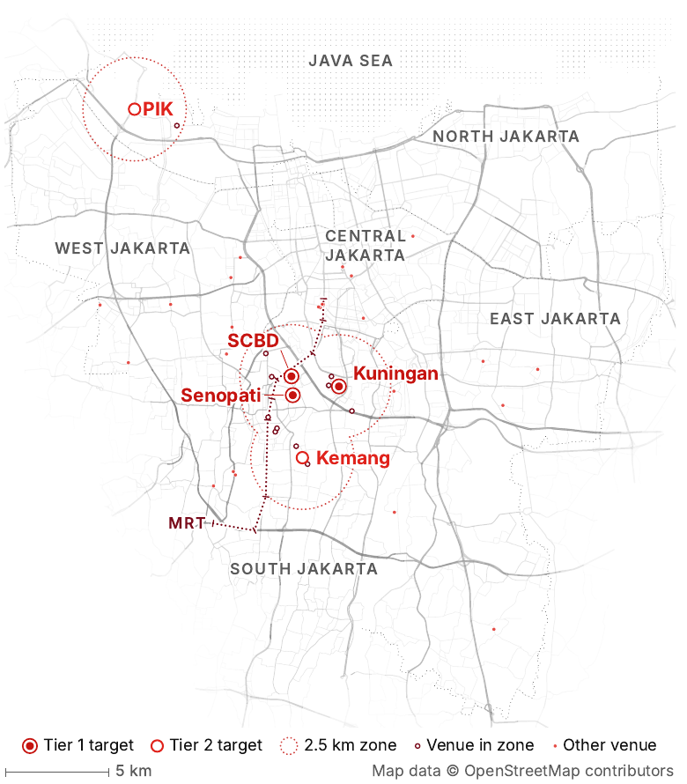
Map reproduced from Tiago, Customer Behaviour Report, PDF page 3. Original base map © OpenStreetMap contributors. The dotted 2.5 km zones are the report’s comparison radii, not measured walking catchments. Venue dots belong to its review dataset; they do not show CORSA premises.

WHY SCBD AND SENOPATI REMAIN RELEVANT?
Resident totals describe where people live. A Pit Stop can also serve office workers, hotel guests and dining visitors. SCBD and adjacent Senopati therefore deserve testing even though South Jakarta has fewer residents than East or West. This is a location hypothesis, not proof of higher spending or sales.
One concrete example is Accor’s 25hours Hotel in District 8: hotel rooms and serviced apartments sit above ASHTA Mall in the SCBD–Senopati area. This shows how several visit purposes can coexist locally. Colliers’ Q2 2026 retail report also highlights footfall, tenant mix and experiential consumption; its mall findings provide context, not a forecast for a street-level CORSA store.
Source Shortlist and tiers: scope, Location Economics, and revised proposal. Map: Tiago, PDF page 3. SCBD and Senopati can share customers; Kemang and PIK require separate catchment tests.
Sources Accor 25hours Hotel and ASHTA setting • Colliers Jakarta Retail Q2 2026 • OpenStreetMap attribution

02 COMPARE THE FIVE AREAS

Choose by customer routine and access
Retain the scope’s tiers as research priorities. The table sets out what each area should be tested for; it is not a measured ranking of sales potential.
Candidate area | Customer occasion to test | Geographic check before shortlisting
TIER 1 SCBD | Weekday office lunch, coffee and after-work visits. | Count target customers at lunch and after work; check the actual walk from offices and transit.
TIER 1 Senopati | Social meals and coffee, including spillover from nearby SCBD. | Check street visibility, safe pedestrian access and overlap with the SCBD catchment.
TIER 1 Kuningan | Office lunch and repeat purchases from nearby workers or residents. | Identify specific office/residential clusters; measure access to the proposed street, not the whole district.
TIER 2 Kemang | Resident, social and activity-related visits. | Compare weekday and weekend presence; check access, parking and nearby community partners.
TIER 2 PIK | Resident, group and destination visits. | Define the exact PIK subarea first; check travel time, arrival mode and repeat-visit feasibility.

Source Area names and tiers: scope and revised proposal. Audience direction: Tiago, PDF page 3. Occasions and checks above are proposed field tests, not established demand.

POPULATION DENSITY AND RETAIL DEMAND
Population counts all residents inside a boundary. Density divides that count by land area: residents ÷ km². A smaller municipality can therefore be denser while having fewer people. Neither measure counts daytime visitors or predicts purchases.
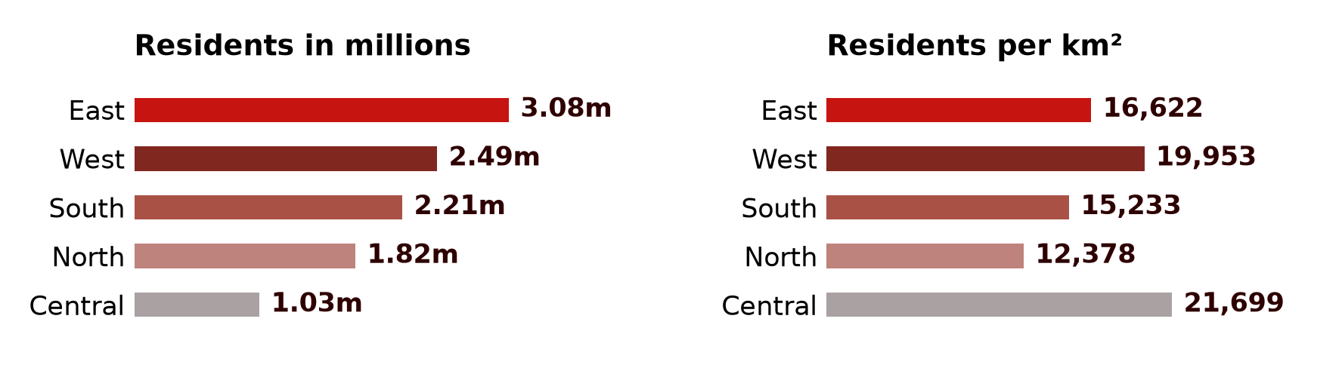
2026 projections by administrative city. East has the most residents; Central is the densest. The five cities are much larger than the candidate neighbourhoods. Sources: BPS; population totals cross-checked against the Ministry of Health’s BPS-based 2026 table.
Retail attractiveness depends on who can reach the premises, why they visit, how often they return and what they buy. West Jakarta’s large residential base does not establish that it is better or worse for CORSA than SCBD or Senopati. Also because West Jakarta is mainly a residential area; Central Jakarta is not.
Sources BPS population and density 2026 • Ministry of Health BPS population totals
Source Five-variable comparison and observation protocol: geographic team recommendation. Format: scope, Location Economics.

03 POPULATION CONTEXT

Population map with the different possible locations:

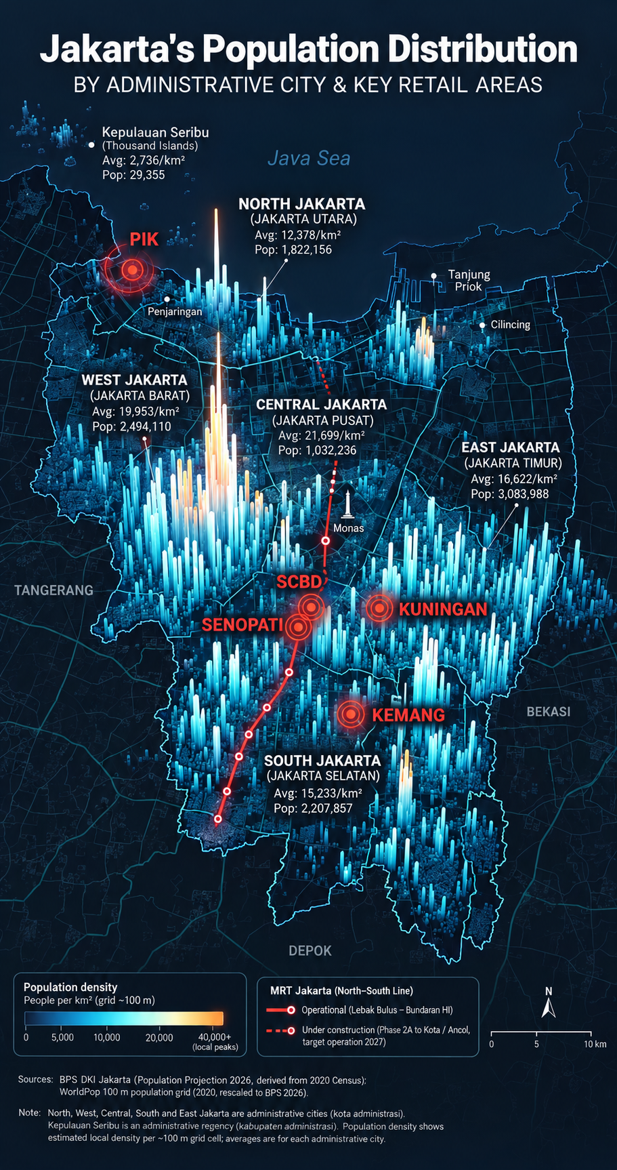
Illustrative AI-generated image supplied for the project.
Sources BPS city-level population and density reference

