Muhammad Tiamour Abdullah
Sp24-Bse-056
Information Security
Lab Assignment-01

Study Salsa20 Cipher and do the following activity.
1. Write python code for your designed stream cipher approach for encryption decryption, you can use approach from more than one already developed ciphers as given in lab practice exercises.
2. Design and implement an adversarial attack approach for your proposed stream cipher approach.

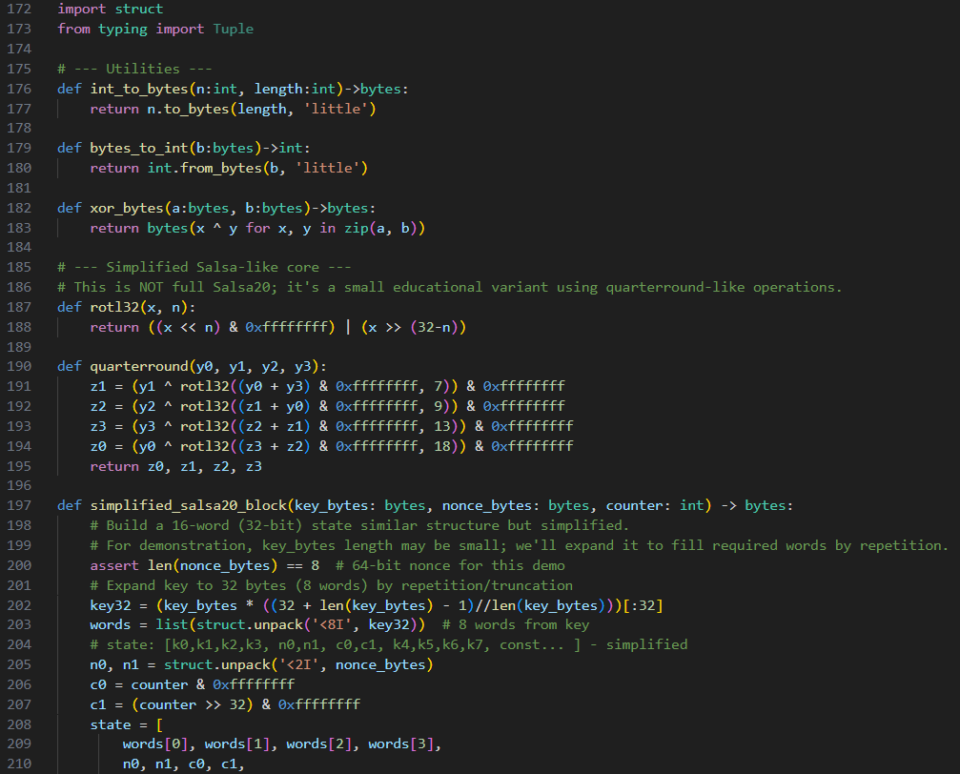
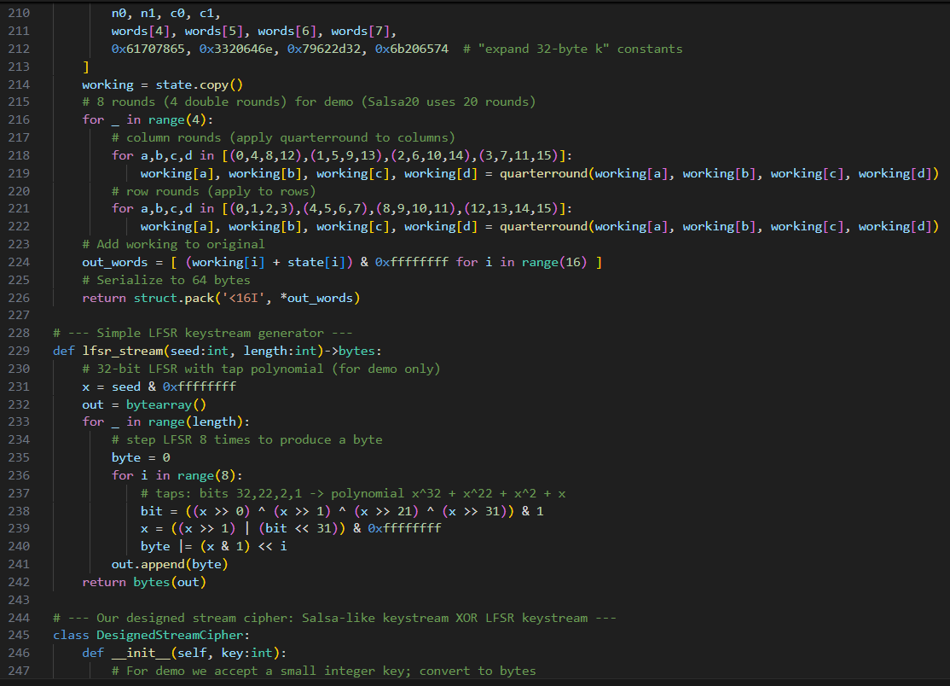
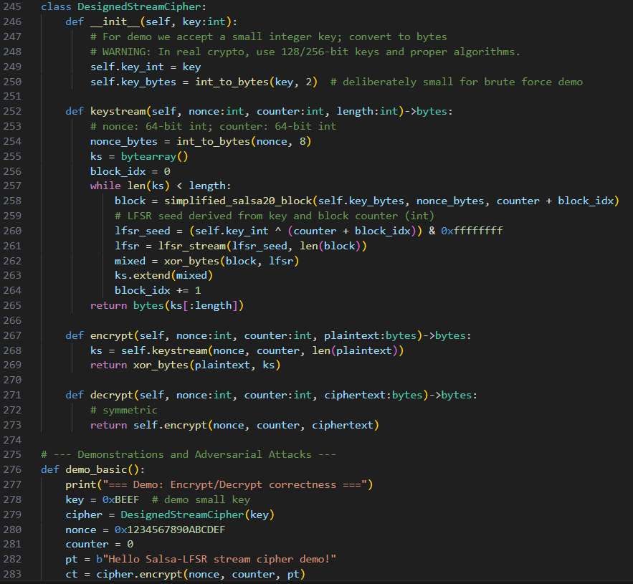
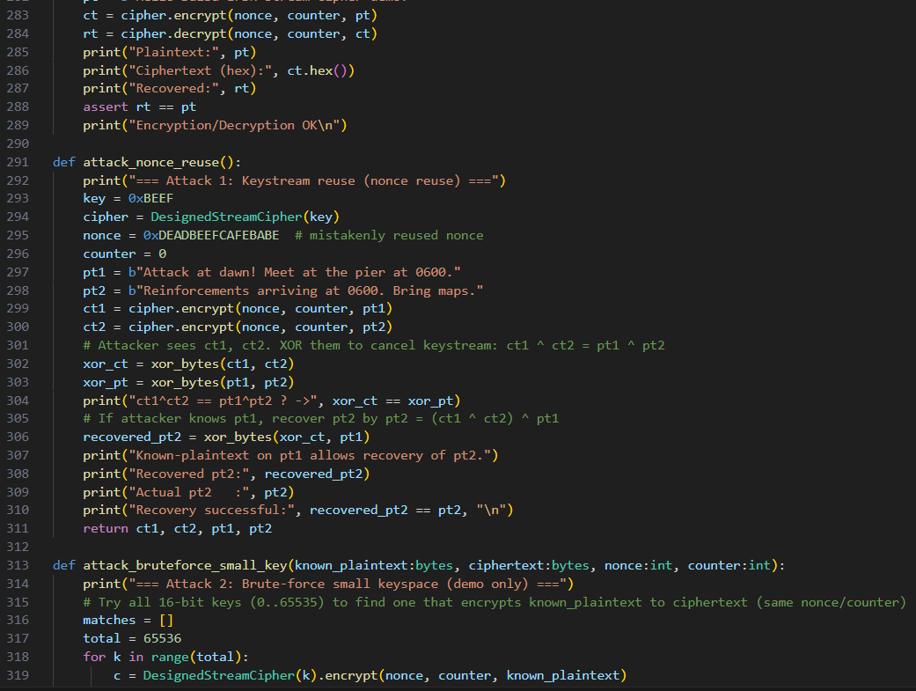
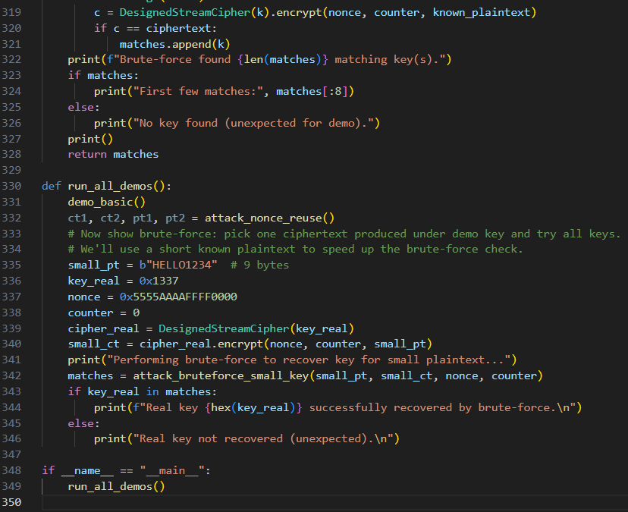

OUTPUT:

