Muhammad Tiamour Abdullah
Sp24-Bse-056
Lab Final

Q1. Scenario: You are designing a secure email communication system that ensures confidentiality, integrity, and authenticity of messages. The system uses RSA for encryption and the Eelgamal for signing messages.
Tasks:
1. Key Generation:
2. Encryption/Decryption using RSA:
3. Digital Signature and Verification using Elgamal:
Answer:
Task 1: Key Generation.
RSA key Generation:
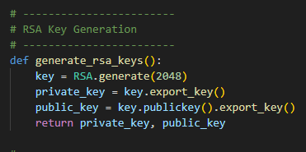
Elgamal Key Generation:
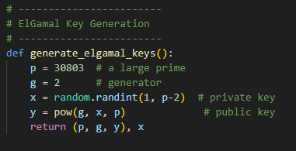
Task 2:
Encryption and Decryption using Rsa:

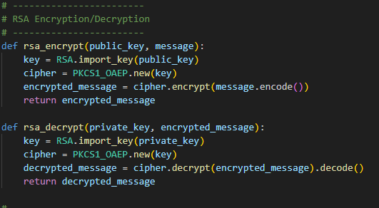
Task 3:
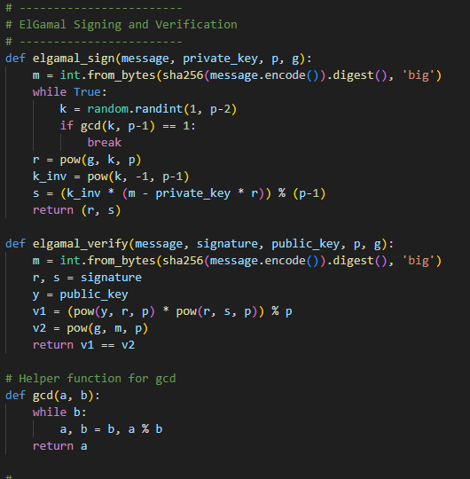
Outputs:
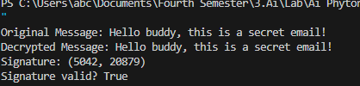
Question 2:
Q2. You have developed a project during this course as your final submission. Using that same project:
1. Justify your security method: Why is it suitable or better than other possible methods for your type of project?
2. Identify one possible vulnerability or weakness in your current system. How could an attacker misuse it?
3. Suggest one realistic improvement to enhance the security of your project. Briefly explain how it would work.
Task 1:
Justify your security method:
The ElGamal algorithm is suitable for your project because it is an asymmetric encryption system. Unlike symmetric encryption, it uses a public/private key pair, which ensures that only the intended recipient can decrypt messages. The security of ElGamal relies on the Discrete logarithm system, which is computationally hard to reverse, making it very difficult for attackers to derive the private key even if they know the public key. Compared to other methods like RSA, ElGamal provides stronger semantic security because it incorporates randomness in encryption, ensuring that encrypting the same message twice produces different ciphertexts. This makes it highly appropriate for secure communication projects like yours.
Identify one possible vulnerability:
One potential weakness of ElGamal is chosen-ciphertext attacks (CCA). An attacker could trick a recipient into decrypting a manipulated ciphertext, gaining information about the private key or the message. If proper validation or message integrity checks are not implemented, this could be exploited to gradually compromise security.
Suggest one realistic improvement:
A realistic improvement is to implement message authentication using digital signatures or HMACs alongside ElGamal encryption. By signing each message with the sender’s private key (or adding a cryptographic hash check), the recipient can verify that the message has not been tampered with and confirm the sender’s identity. This would prevent attackers from exploiting the system with manipulated ciphertexts and enhance overall security.

