# INTE2401/2402 Lab 5

Student ID: _____________________________ Name: _______________________________________

In this week’s lab, we implement the $χ\left(chi\right)$ step function of the Keccak (pronounced [kɛtʃak], like “ketchak”) hash function which is the basis of SHA-3. The state is organized as a matrix of $(5×5)$ bits. We denote the state b as S = S[0],…S[x × y], for which $0≤x<5, 0≤y<5$. As usual, you may use Notepad(or other text editor) to write a JavaScript file with the extension name **.html** and then open it with Internet Explore(or other web browser).

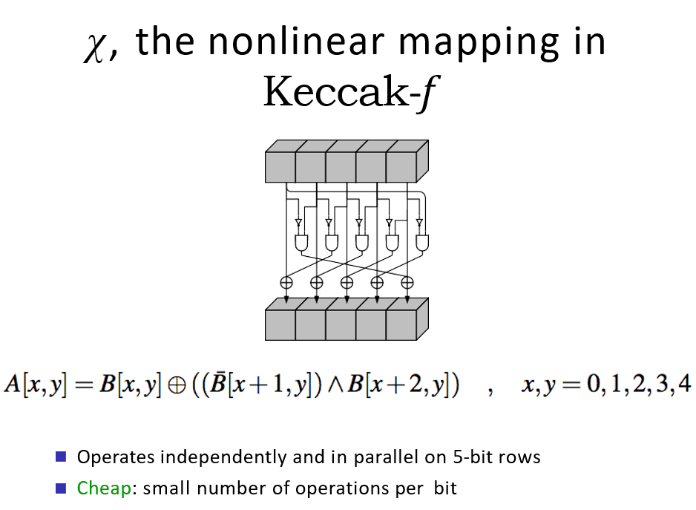

Figure 1. $χ$ step function shown in lecture slides

Q. Write a JavaScript program to perform chi $χ$ step function.

The input is a matrix B[x, y] of $5×5$ bits, where.

The output is the array A[x, y] after performing the $χ$ step function over B[x, y].

The sample form below will give the example input and output.

