Report

1. Project Idea
Our project is a skill-sharing website for university students. Students use the website map to find paid tasks. They can gain practical experience and prepare for careers.
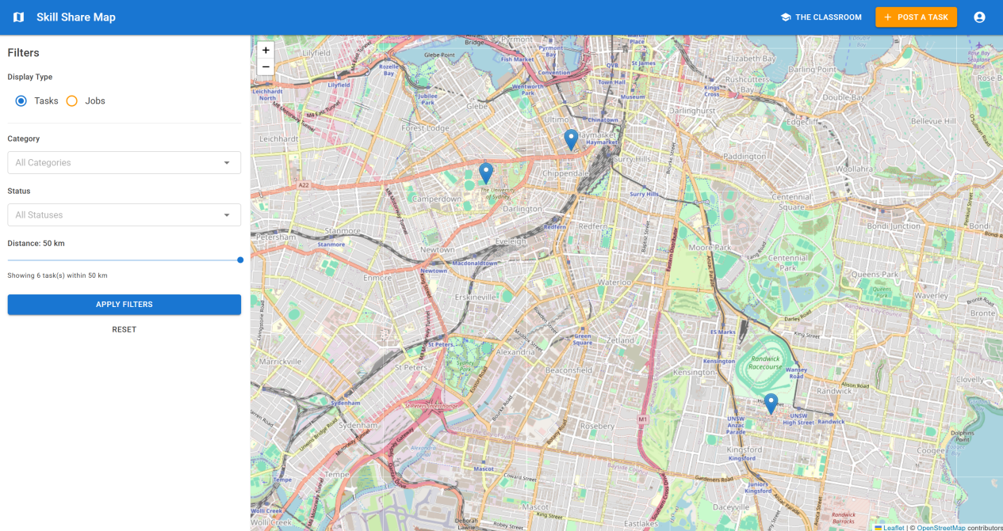
Figure 1: The Main Map Interface

2. Project Motivation
University students face intense job competition. They need practical experience to find good jobs. Many job platforms are not designed for students. These sites can have poor verification. This exposes students to scams.
Current job sites also focus on long-term internships. Students need flexible, short-term work that uses their degree skills. They must balance study schedules with the high cost of living.
We are building a one-stop platform just for university students. Our site helps students find small, paid tasks nearby. They can apply classroom knowledge. They can earn money on their own schedule. This process helps them build experience and clarify their career path.
The platform uses rewards to motivate students. We want to change how students show their abilities. The system uses skill bars and badges. A student's profile displays their completed work and skills. This gives employers a clear picture of what the student can do.

3. Key Features

3.1 Interactive Skill Map
The website’s main tool is an interactive campus map. The map shows two types of postings. These are short-term Tasks and Jobs. Tasks appear as blue dot pins. Jobs appear as orange pins. A top-level filter lets users view tasks or jobs.
A student posts a task, like needing help with a C# program. They fill in task location, such as the UTS library. The map refreshes automatically. It shows new tasks or status changes instantly. The map only displays all tasks that are currently 'open' or 'assigned'.
Other students browse the map to find tasks. They can apply filters such as Category, Status and Distance to narrow their search.
A click on a pin opens a summary card, which shows the publisher, location, payment amount, task status and category. A click on a Job pin opens a different summary card. This card shows the job title, company name and job type.

3.2 Task Confirmation and Deposits
When a helper accepts a task, the poster pays a 10% deposit. The app deducts it from the poster and credits the helper at once. The task moves Open → PendingDeposit → Assigned.
The system uses a dual confirmation process. The helper first marks the task as complete. The poster then reviews the work and cofirm task complete.

3.3 Game Mechanics: Reputation and Badges
Reputation System
After a task is complete, the poster can rate the helper. The poster gives a star rating and a public comment. When a user submits a rating, the system updates the reputation score for both the rater and the person being rated. This feedback also appears on the user's profile page under "Recent Reviews".
Badges
The rating grants XP to the helper. The XP amount depends on the stars. XP is stored per task category (for example, Tech Help). When total XP in a category reaches a tier (Newbie, Skilled, Advanced, Expert, Master), the profile earns a badge for that category.

3.4 Virtual Wallet
Each user has a wallet page. This page shows an Available Balance and a Transaction History table. It also displays cards for Total Earned, Total Spent, and Pending amounts. The "Pending" amount is a placeholder and is set to $0.00.
The wallet manages all task payments.
- Deposit: When a helper accepts a task, the poster pays a 10% deposit. The system deducts this from the poster's balance and credits it to the helper's balance. It records a "TaskDeposit" transaction for both users.
- Payment: When the task is confirmed complete, the app pays the remaining balance to the helper. This is recorded as a "TaskPayment" transaction.
- Refund: If a task is cancelled after the deposit is paid, the system issues a refund. It deducts the deposit from the helper and returns it to the poster. This creates "TaskRefund" entries.
All transactions are simulated. The ADD FUNDS and WITHDRAW buttons are not functional. This version does not connect to a real payment provider.

3.5 The Classroom
The Classroom is a page for learning resources. It lists courses and workshops. Users can filter these resources by category.
This page also shows an "AI Study Assistant". This feature is a placeholder and is not functional.

4. Usage Instructions

4.1 Prerequisites
- .NET SDK 9.0
- A modern browser (Chrome, Edge, Firefox, Safari)
- Internet access for OpenStreetMap tiles and Nominatim geocoding
- Database: The project uses an SQLite file (Data/app.db) that includes seed data. EF Core applies migrations at startup. If you delete the file, the system will recreate and reseed it.

4.2 How To Run
- Navigate to the project folder.
- Run the command: dotnet restore
- Run the command: dotnet run
- Open the URL shown in the console, or go to https://localhost:7289/login.
You can also run the project by pressing F5 in Visual Studio or VS Code.

4.3 Demo Accounts
- Student: alice_student / password123
- Company: techcorp / password123

4.4 Function Walkthrough

4.4.1 Registration & Login

Login
To access your account, enter your Username and Password on the "Welcome to Skill Share Map" page. Select the LOGIN button to proceed.
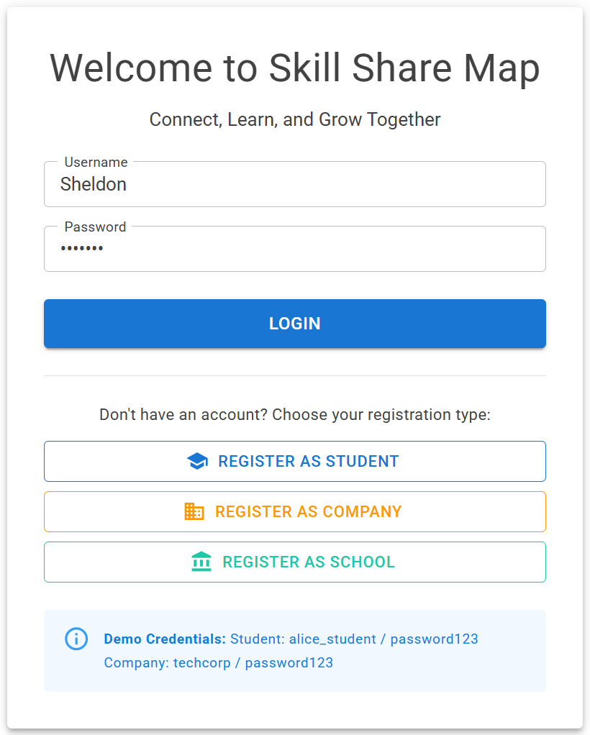
Figure 2: Login & Registration Interface

Registration
If you do not have an account, you must register. The login page offers three registration types. Each registration type involves three steps. Select the option that matches your role.

Student Registration
- Basic Info: Provide your account details, including username, email, and name.
- Skills: Select the skill categories you can help with.
- Location: Set your home base address so we can find nearby tasks and opportunities.
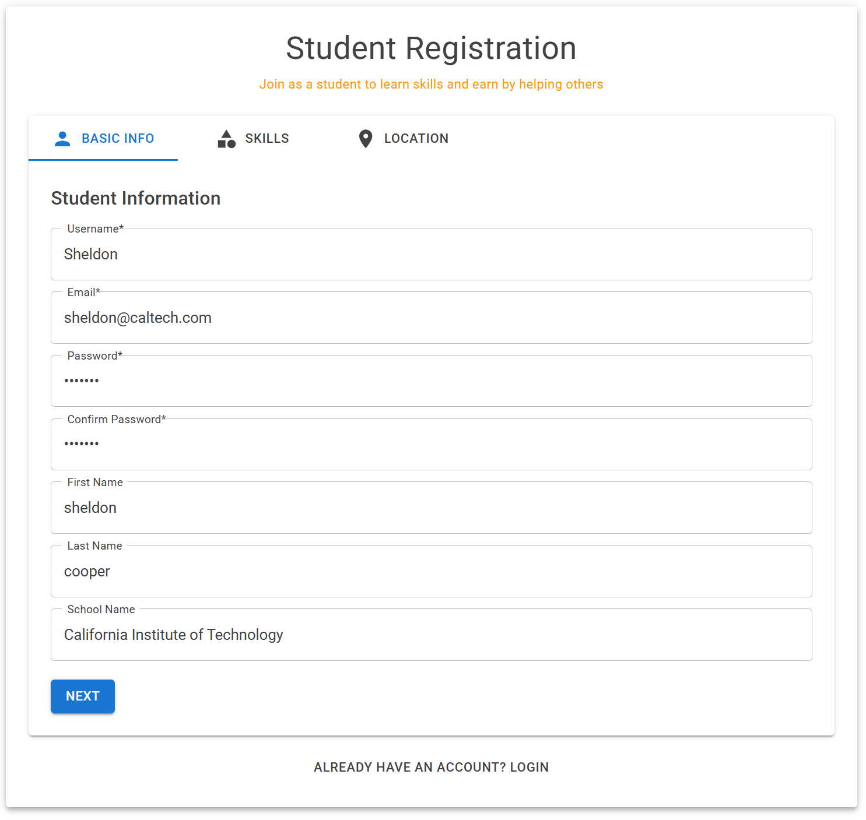 | 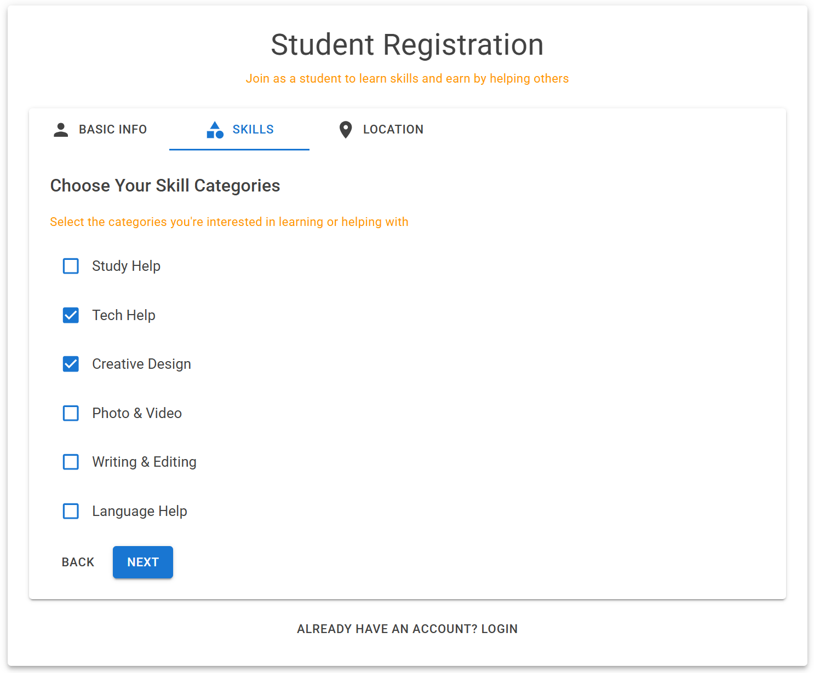 | 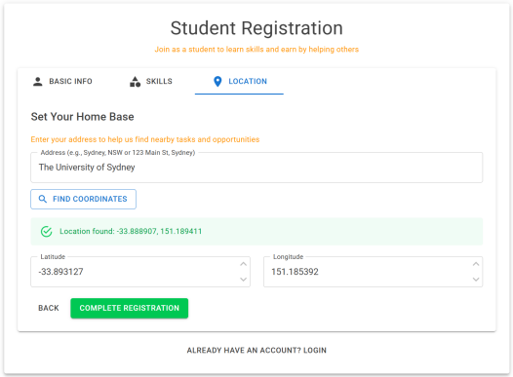
Figure 3: Student Account Creation Interface

Company Registration
- Account: Enter your account and contact information.
- Company Info: Add your company details, such as your website and a company description.
- Location: Provide the company's main address.
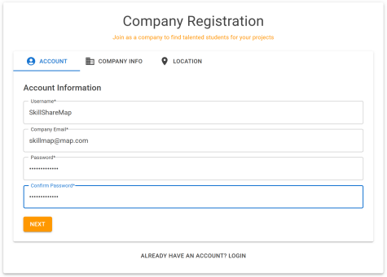 | 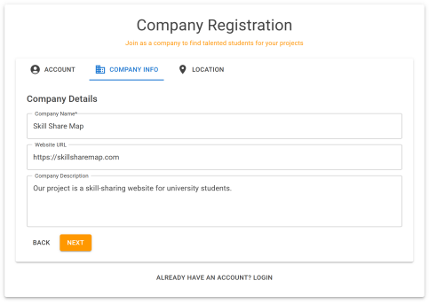 | 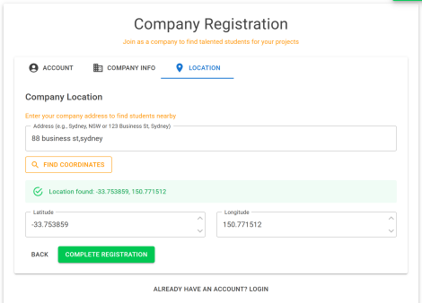
Figure 4: Company Account Creation Interface

School Registration
- Account: Set up your account and login credentials.
- School Info: Enter details about your school.
- Location: Input the school's address.
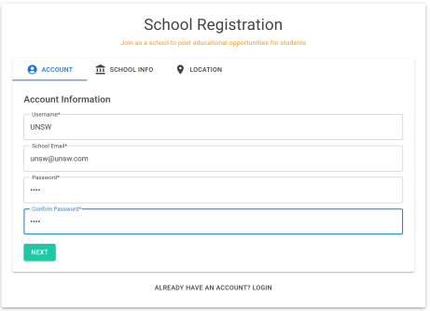 | 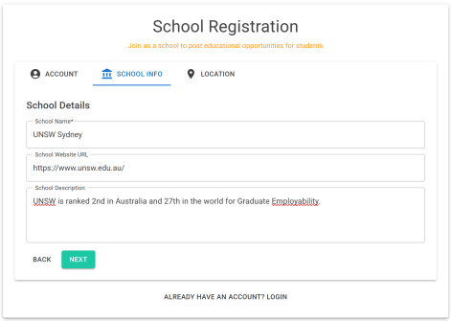 | 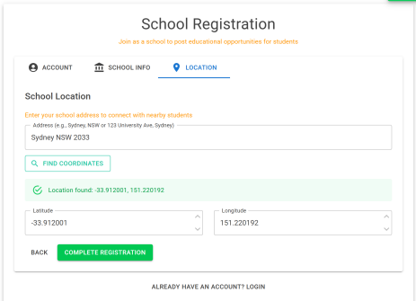
Figure 5: School Account Creation Interface

4.4.2 Skill Map
After you log in, you see the main map page. This page displays available tasks and jobs as pins.
Use the "Filters" panel on the left to adjust your search. You can filter by several options:
- Display Type: Choose to see "Tasks" or "Jobs".
- Category: Select a skill, such as "Tech Help", "Study Help" or "Creative Design".
- Status: Filter by "Open" or "Assigned".
- Distance: Adjust the slider to set a search radius.
Select the "APPLY FILTERS" button to update the map results.
Click any pin on the map to open a summary card. This card shows a brief overview. Select the "VIEW DETAILS" button to open the full task or job page.
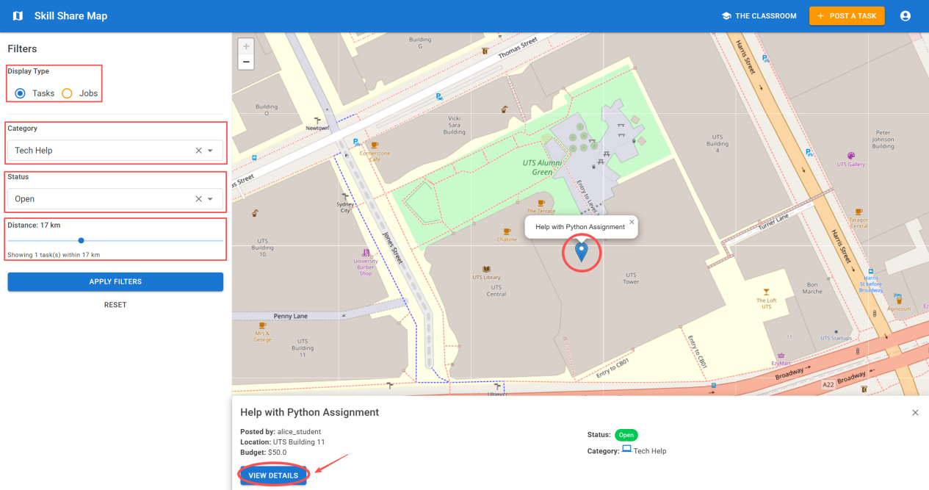
Figure 6: Task Filter Page
The detail page shows all information for a post. A map on the right shows the specific location. You can zoom in or zoom out on this map. Action buttons appear at the bottom of the page.
- Task Details: On a task page, you can select ACCEPT TASK to take the assignment.
- Job Details: On a job page, this button is not available.
Both pages show an OPEN CHAT button to contact the poster. Both pages also have a REPORT button to flag the post for review.
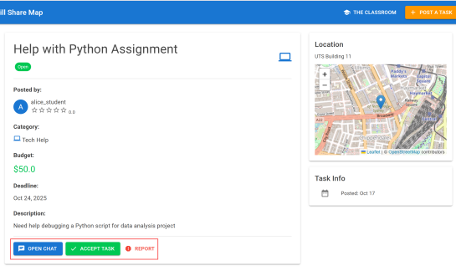  Figure 7: Task Details (View by Student User) | 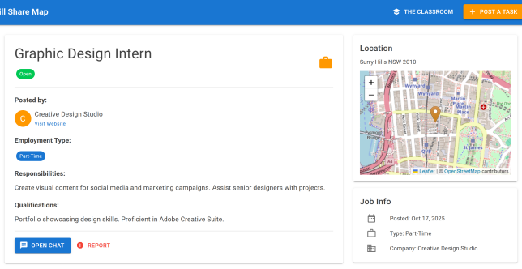  Figure 8: Job Details (View by Student User)
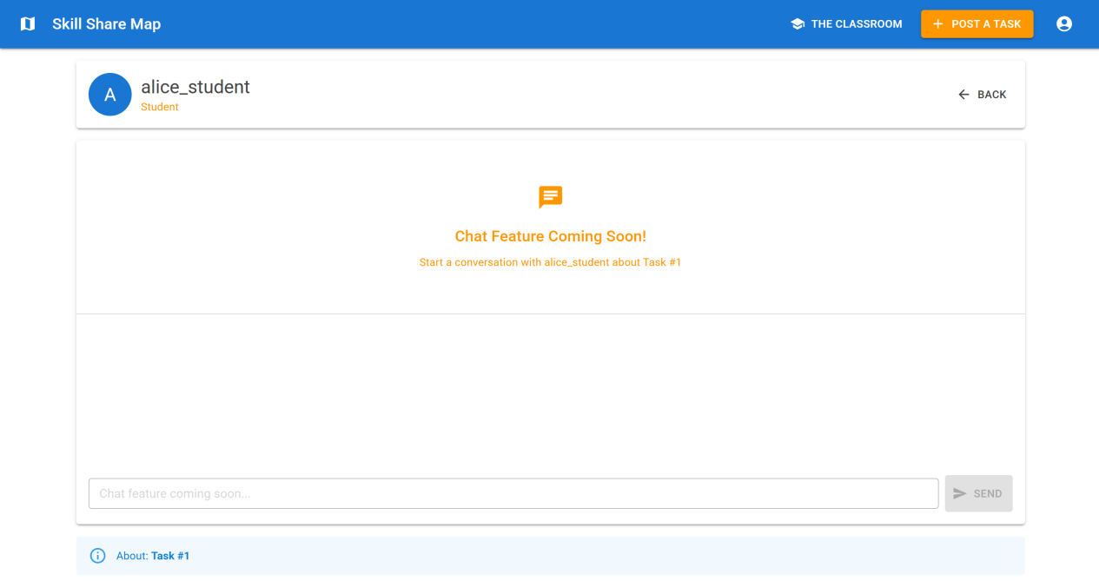
Figure 9: Chat Page
Company and school users can post jobs and chat, but they cannot accept tasks.
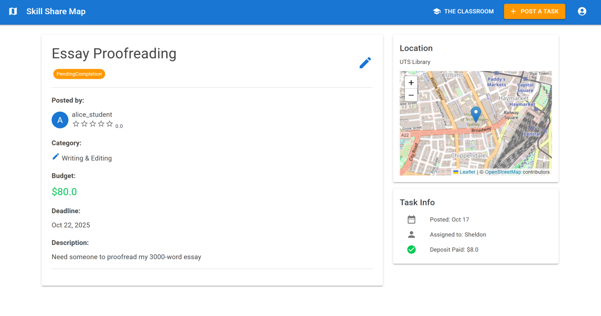
Figure 10: Task Details (View by School/Company Users)

4.4.3 Post and Manage Tasks
This section explains how to create a new task and how to manage your created or accepted tasks.

Post a New Task
Select the POST A TASK button in the top navigation bar. Then fill in the required fields for your task. This includes the title, description, category budget and location.
Select POST TASK at the bottom to publish your task on the map.
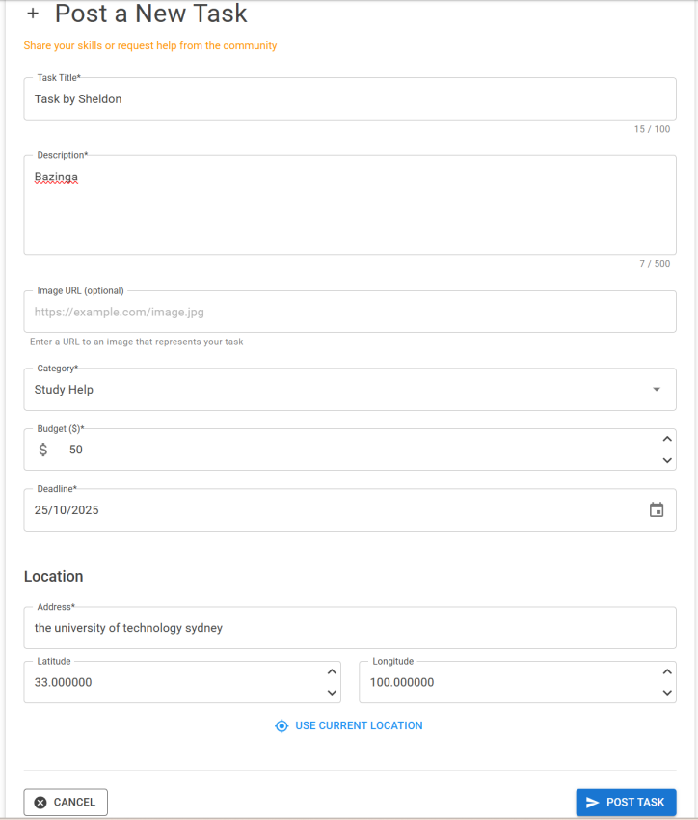  Figure 11: Post a New Task Form | 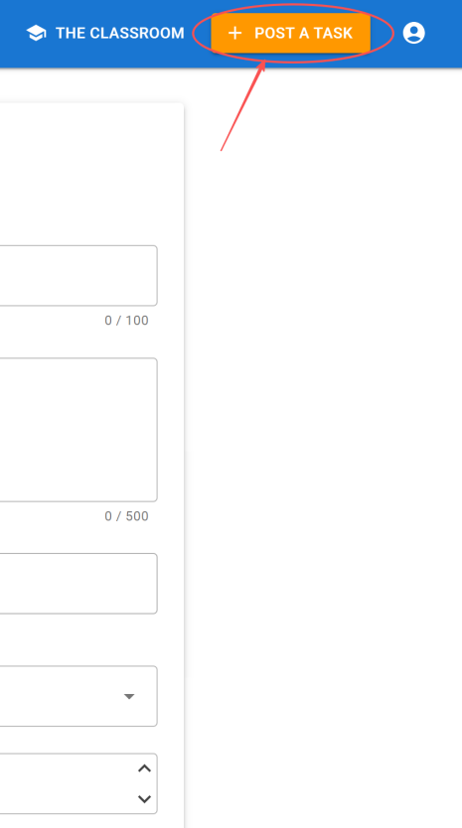  Figure 12: POST A TASK button

Manage Your Tasks
You can manage all your tasks from your profile page. To access it, select the profile icon in the top-right corner and choose MY PROFILE.
Your profile page shows two tabs: CREATED TASKS and ACCEPTED TASKS.
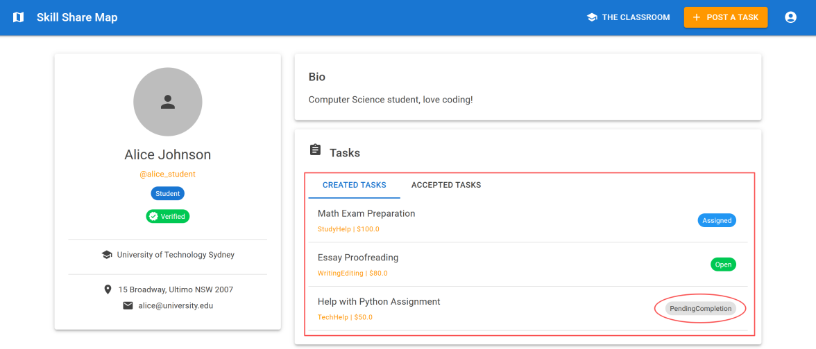  Figure 13: My Profile Page | 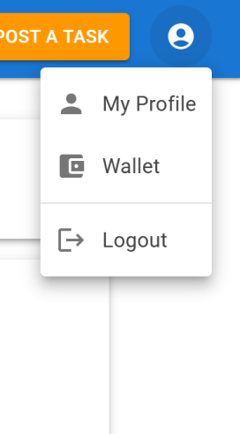  Figure 14: My Profile button
- Created Tasks: This lists all the tasks you have posted. You can select a task to open its detail page. From there, you can select EDIT to change the task details or CANCEL TASK to delete the post.
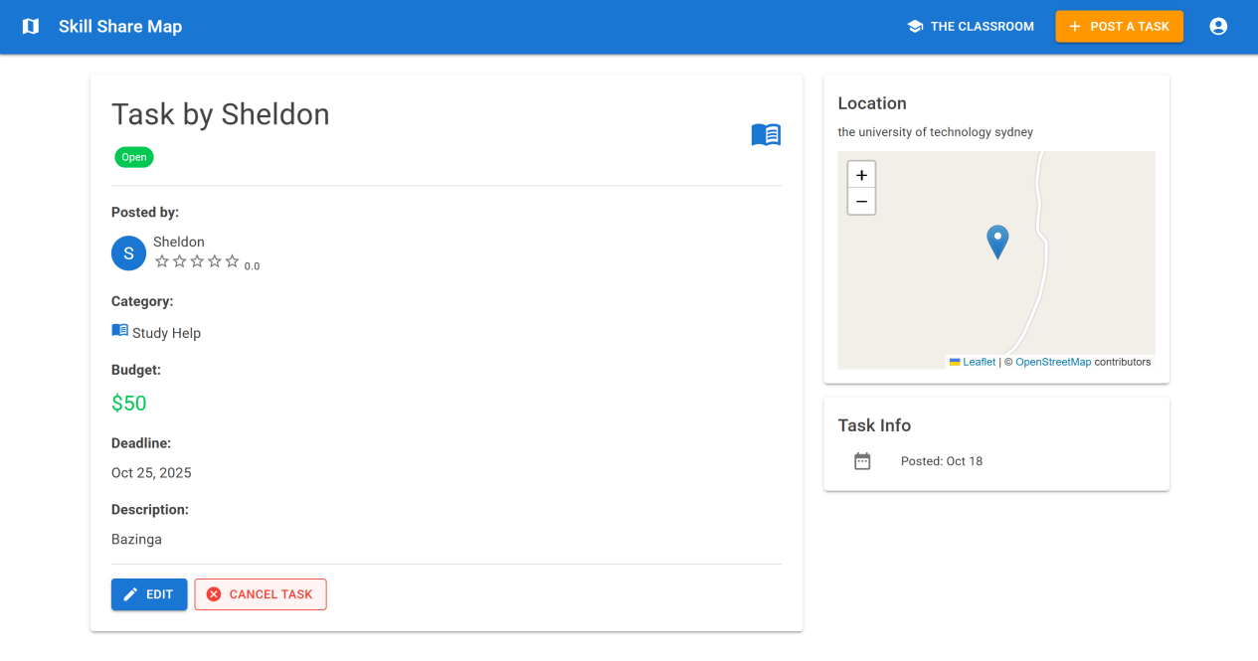
Figure 15: Task Details (View by Task Creator)
- Accepted Tasks: This lists all the tasks you have accepted. When you finish the work, you can mark the task as complete.
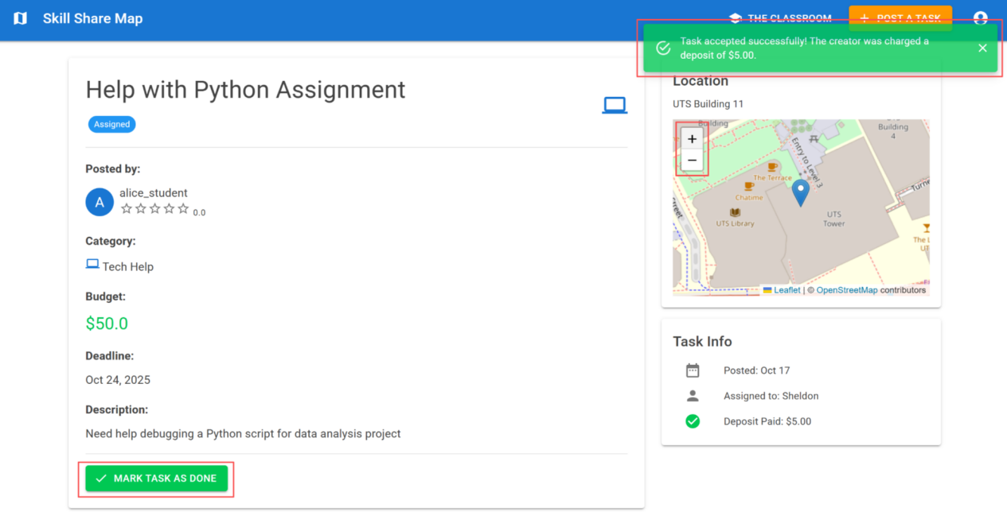
Figure 16: Task Details (View by Helper)

Deposits and Dual Confirmation
If you accept a task, you can get paid of 10% deposit of the task's budget. This payment acts as a guarantee for the helper. The "Task Info" card shows the "Deposit Paid" amount.
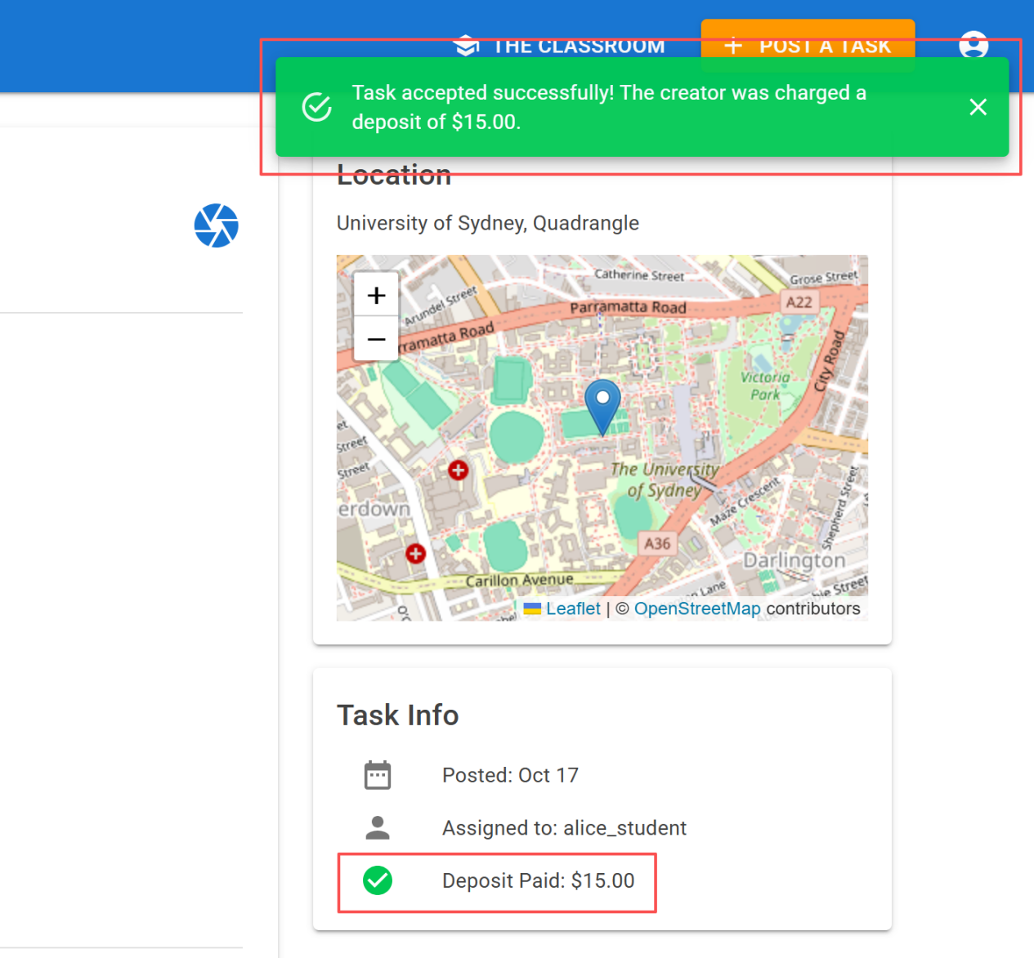
Figure 17: Deposit Paid after Task Acceptance (View by Helper)
The completion process requires confirmation from both users.
- The helper selects MARK TASK AS DONE in the task detail page.
- The task creator then reviews the work and selects CONFIRM TASK COMPLETE to approve it.
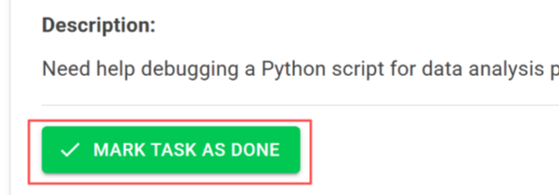
Figure 18: MARK TASK AS DONE (View by Helper)
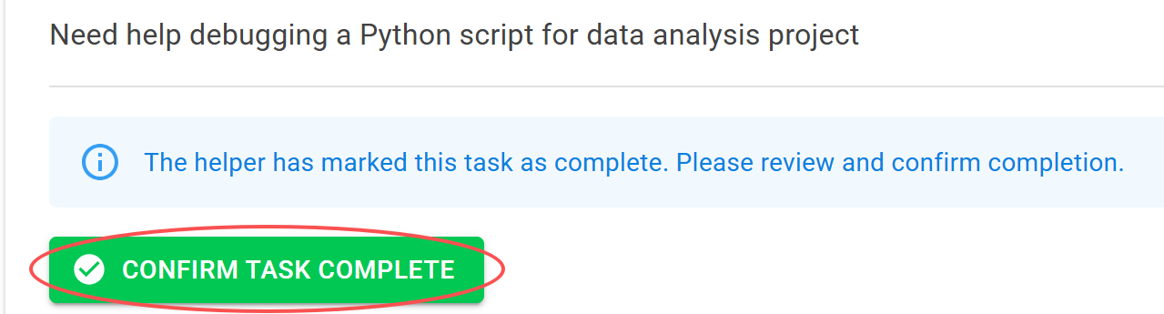
Figure 19: CONFIRM TASK COMPLETE (View by Task Creator)
After confirmation, the poster can rate the helper. The poster gives a star rating and a comment. This review appears on the helper's profile. Completed tasks also add skill badges to the helper's profile.
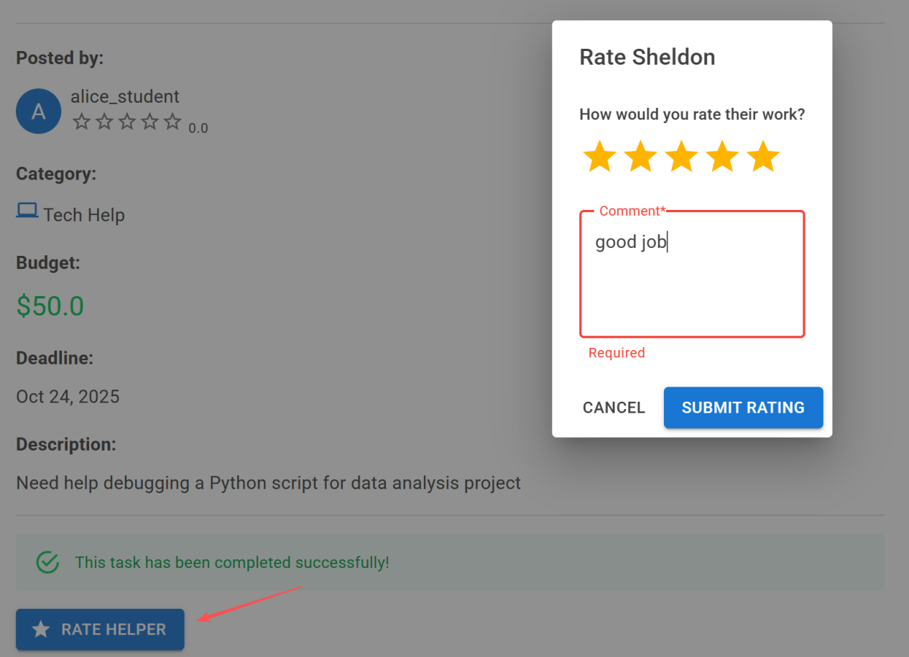
Figure 20: Rating Process Interface
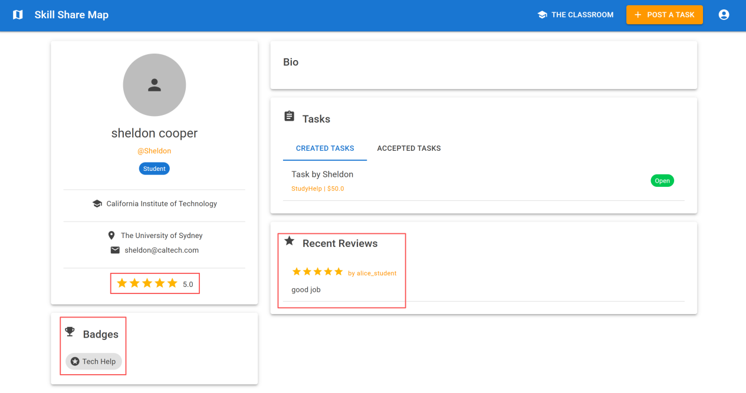
Figure 21: Rating Displayed on User Profile

4.4.4 Wallet
You can manage your platform funds in the wallet. To access this page, select the profile icon in the top-right corner and choose WALLET.
The page shows your Available Balance. It has ADD FUNDS and WITHDRAW buttons. These specific buttons are not functional. All transactions shown on the platform are simulated.
The page also displays summary cards for Total Earned, Total Spent, and Pending amounts.
A Transaction History table at the bottom lists all your past platform transactions. This table shows the date, type, description, amount, and status for each entry.
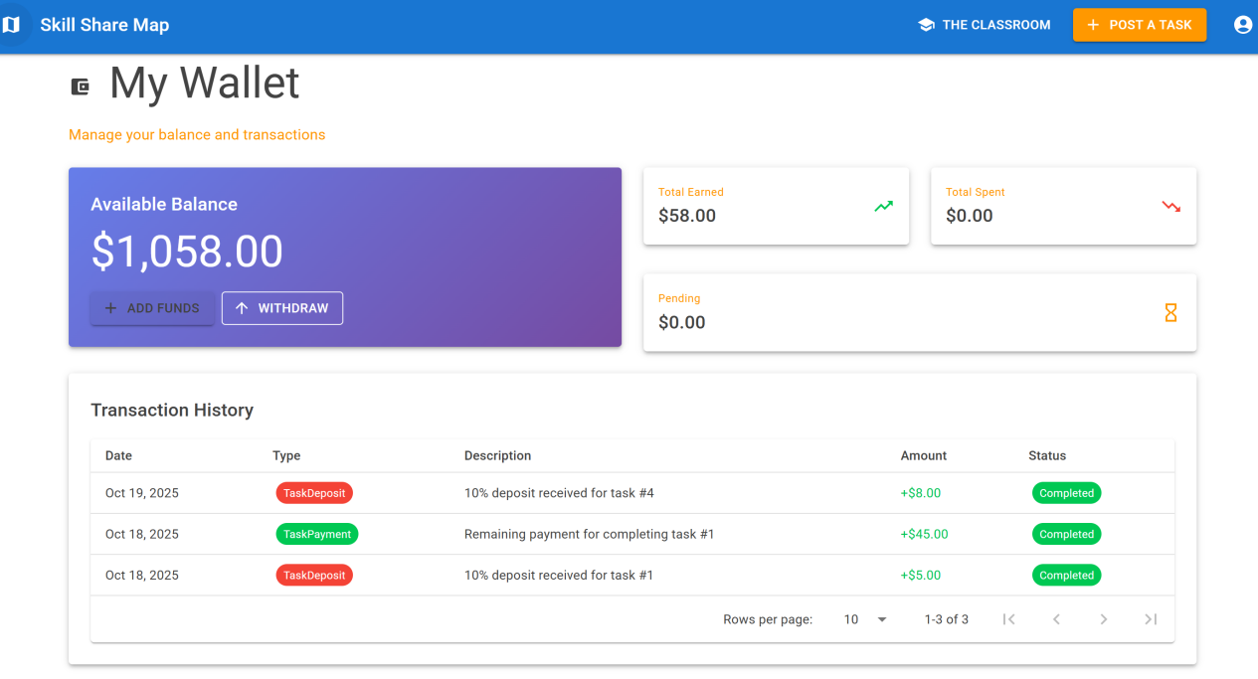
Figure 22: Wallet Page

4.4.5 The Classroom
Select THE CLASSROOM from the top navigation bar to find learning resources. This page shows available courses and workshops.
This page also has an "AI Study Assistant" section. This feature is not functional, and the "ASK AI" button is disabled.
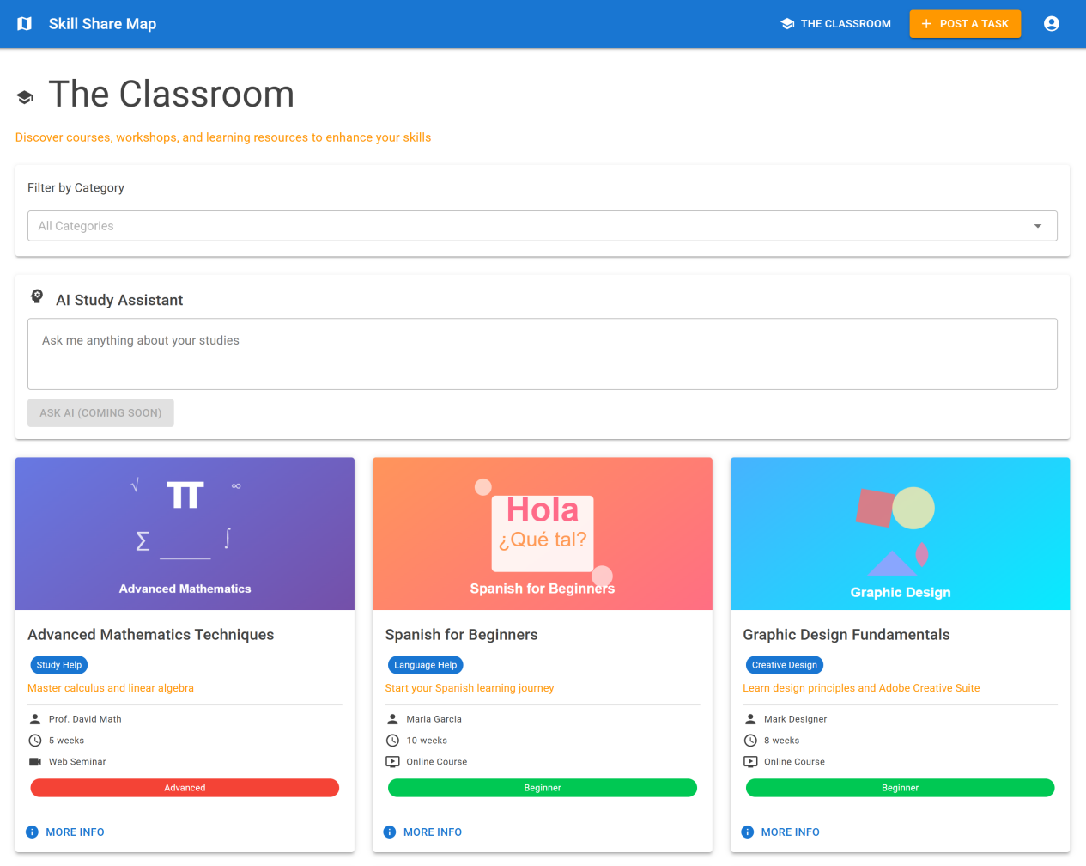
Figure 23: The Classroom Page
You can search for specific topics using the "Filter by Category" dropdown menu. Selecting a category, such as "Photo & Video", updates the list to show only related courses.
Each course appears on a card. Select the MORE INFO link on any card to view its full details.
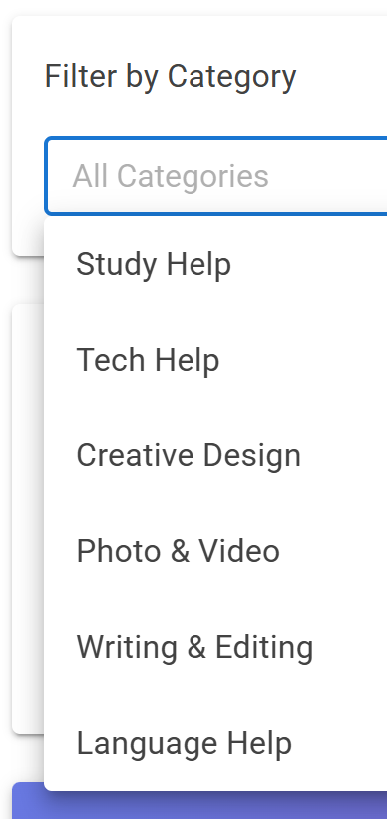 | 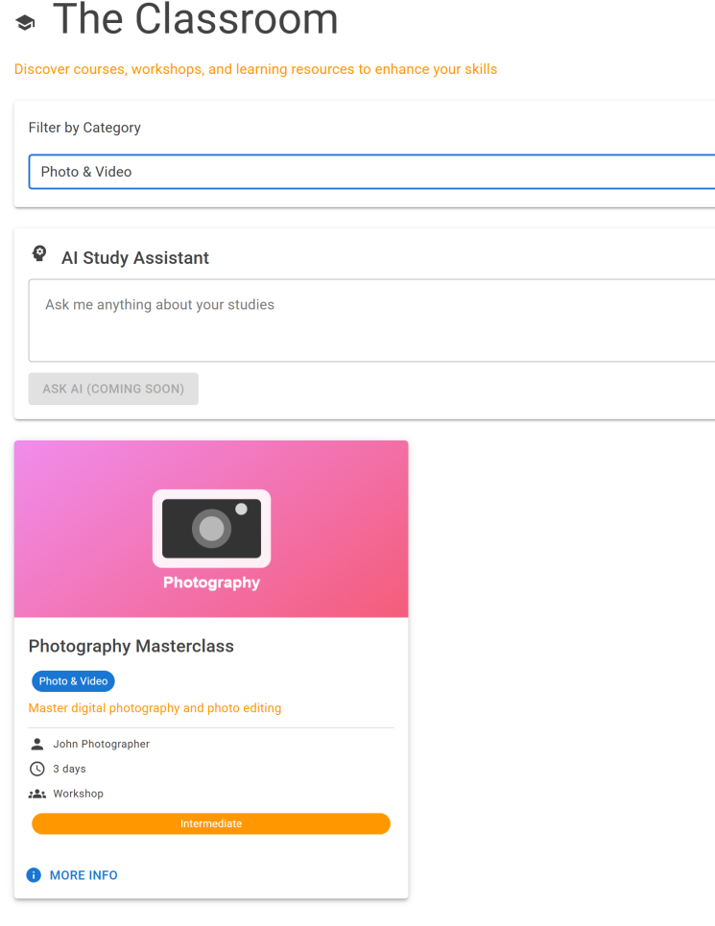
Figure 24: Category Function in The Classroom Interface
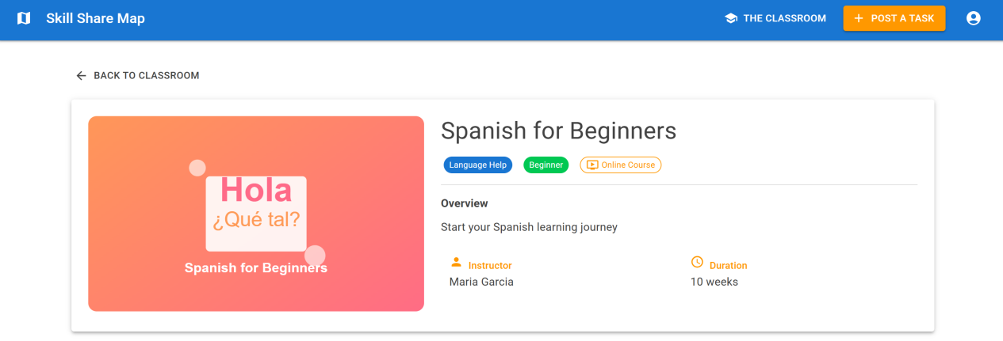
Figure 25: Course Detail Page

4.5 Future Work
Payment Integration: We will integrate a real payment system. The virtual wallet will be updated to handle actual deposits and withdrawals.
AI Study Assistant: We will activate the AI assistant. It will analyze user profiles and task history to recommend courses and career skills.
Price Negotiation: We will add a chat-based negotiation feature. Users will be able to send and accept price offers.
Skill Progression: We will implement a skill progression system. Students will earn experience points (XP) for tasks. Profiles will display these points as skill bars.
Profile Verification: We will add advanced verification for all user profiles. We will also create separate private and public versions of student profiles.

5. Team Contributions
Jinhao Feng  25744780 | - Designed data models and the database context.  - Created seed data for demonstration accounts.  - Implemented backend services for tasks, wallet, ratings, and authentication.  - Wrote unit tests for the user registration process.  - Configured the database setup and migration flow.
Tiantian Hong  25953391 | - Built the main user interface pages and workflows using Blazor.  - Developed the map, task posting, wallet, chat, and profile pages.  - Integrated the interactive map and geolocation features.  - Wrote JavaScript helpers to control map and geolocation functions.  - Designed the application's main layout, navigation, and login screen.  - Added form validations and styled the user interface with MudBlazor.

