1.which git  
解释：查看 git 程序地址

vim .bash_profile

source .bash_profile

pip3 install requests

# 快速清屏

Command+k

# 环境变量，有空格问题

The space in between both options makes the shell interpret this as two different arguments. You need to protect the options with quotes:

export MAVEN_OPTS="-Xms256m -Xmx512m"

# 解压

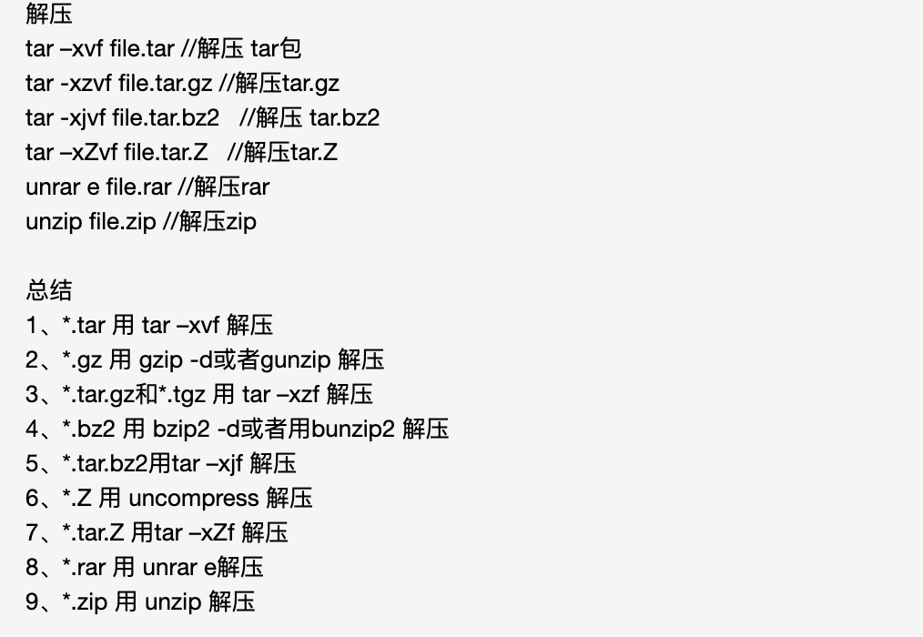

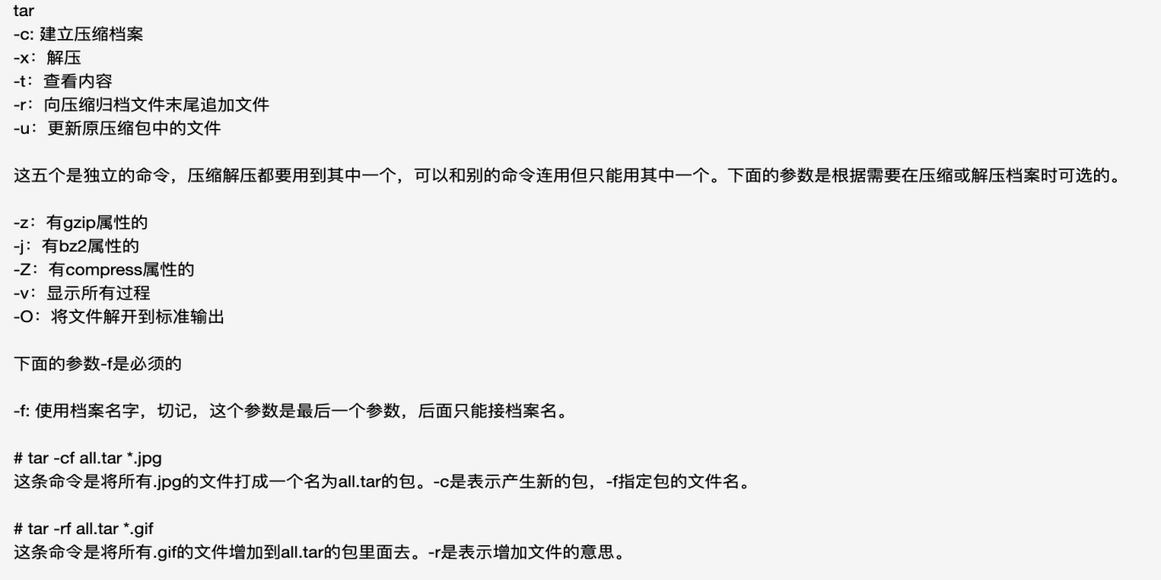

# 复制

cp -ri testdubbo/ /Users/tianchengbei/word/ideaproject/testdubbo/

