WS P1-1
PRIMARY 1 MATHEMATICS • ENRICHMENT
WHOLE NUMBERS: NUMBER PATTERNS
Name: ______________________ Class: P1-_______ Date: ____________
COUNT WITH THE FROG!
Look for the pattern. Fill in the missing numbers.
1. Skip counting. Fill in the blanks.
(a) Counting in 2s: 2, 4, 6, ____, ____, 12, ____, 16
(b) Counting in 5s: 5, 10, ____, 20, ____, 30, ____
(c) Counting in 3s: 3, 6, ____, 12, ____, 18
2. What is the rule? Fill in the rule and the next two numbers.
(a) 4, 7, 10, 13, ____, ____ Rule: ______________
(b) 30, 27, 24, 21, ____, ____ Rule: ______________
(c) 2, 6, 10, 14, ____, ____ Rule: ______________
3. A frog starts at 0 and hops 4 steps each time. Colour the numbers where the frog lands.
0 | 1 | 2 | 3 | 4 | 5 | 6 | 7 | 8 | 9 | 10 | 11 | 12 | 13 | 14 | 15 | 16 | 17 | 18 | 19 | 20

(a) A second frog also starts at 0 but hops 5 steps each time. Mark its landing numbers with a cross (X) above the number line.
(b) Besides 0, which number do BOTH frogs land on?
Answer: ______________________________
4. Ali counts in 2s from 2 up to 50. Mei counts in 5s from 5 up to 50.
(a) Which numbers will BOTH of them say?
Answer: ______________________________
(b) What do you notice about these numbers?

5. Mei puts stickers in boxes. Box 1 has 2 stickers. Each box after it has 3 more stickers than the box before.
Box | 1 | 2 | 3 | 4 | 5 | 6 | 7 | 8 | 9 | 10
Stickers | 2 | 5

(a) Fill in the table. How many stickers are in Box 10?
Answer: ______________________________
(b) Look at the numbers of stickers. Are they odd or even? What pattern do you see?

WS P1-2
PRIMARY 1 MATHEMATICS • ENRICHMENT
PICTURE GRAPHS
Name: ______________________ Class: P1-_______ Date: ____________
LET’S PLAN THE FRUIT PARTY!
Our teacher wants to buy fruit for a class party. Every child voted for ONE fruit. The picture graph shows the votes.
Key: ● = 1 child
Fruit | Votes
Apple | ● ● ● ● ● ●
Banana | ● ● ● ● ●
Orange | ● ● ● ● ● ● ● ●
Grape | ● ● ●
Watermelon | ● ● ● ● ●

Part A: Read the graph
1. Which fruit got the most votes?
Answer: ______________________________
2. Which fruit got the fewest votes?
Answer: ______________________________
3. How many more children chose orange than grape?
Answer: ______________________________
4. Two fruits got the same number of votes. Which two fruits are they?
Answer: ______________________________
5. How many children voted altogether? (Hint: each child had only 1 vote.)
Answer: ______________________________
6. Mei says, “Orange is the best fruit for the whole school!”
(a) Is Mei right? Yes / No
(b) Why do you think so?

7. What else should the teacher think about before buying fruit for the party?

Part B: Now it’s your turn!
Ask your own class to vote. Each child votes for ONE fruit. Make a tally mark for each vote.
Fruit | Tally | Total
Apple
Banana
Orange
Grape
Watermelon
8. Which fruit did YOUR class like best? ____________________ Is it the same as the graph above? Yes / No
9. Why might two classes choose different fruits?

WS P1-3
PRIMARY 1 MATHEMATICS • ENRICHMENT
PATTERNS
Name: ______________________ Class: P1-_______ Date: ____________
PATTERN INQUIRERS
1. Look at the shape pattern. Draw the missing shapes in places 8 and 9.

2. The pattern keeps going in the same way.
(a) What shape will be in place 10? ____________________
(b) What shape will be in place 12? ____________________
(c) Without drawing, what shape will be in place 30? ____________________
(d) How do you know?

3. Ben makes a row of triangles with matchsticks.
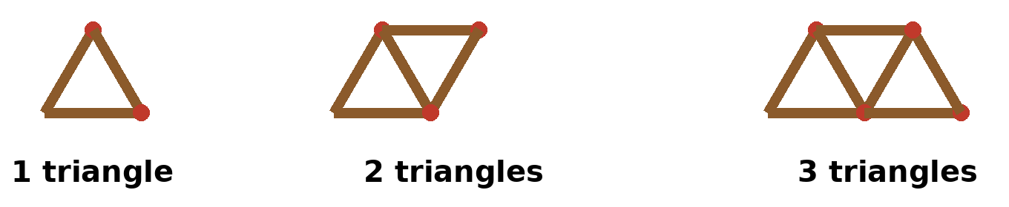
(a) Count the sticks. Fill in the table. Keep going until you reach 10 triangles.
Triangles | 1 | 2 | 3 | 4 | 5 | 6 | 7 | 8 | 9 | 10
Sticks | 3 | 5 | 7

(b) Each time Ben adds 1 more triangle, how many more sticks does he need?
Answer: ______________________________
(c) Why does he need only that many more sticks? (Look at the picture.)

(d) How many sticks are needed for 10 triangles?
Answer: ______________________________
4. Challenge! Ben has 15 sticks. How many triangles in a row can he make?
Answer: ______________________________
Show how you worked it out:

WS P1-4
PRIMARY 1 MATHEMATICS • ENRICHMENT
MONEY
Name: ______________________ Class: P1-_______ Date: ____________
COIN COMBOS
We have 5¢, 10¢, 20¢ and 50¢ coins. You can use the same kind of coin more than once.
1. Show different ways to make exactly 20¢ using only 20¢, 10¢ and 5¢ coins. Write how many of each coin in the table.
Way | Number of 20¢ | Number of 10¢ | Number of 5¢
A
B
C
D
E

(a) Which way uses the FEWEST coins?
Answer: ______________________________
(b) Which way uses the MOST coins?
Answer: ______________________________
(c) How do you know you have found ALL the ways?

2. Challenge! Find ALL the ways to make 30¢ using 20¢, 10¢ and 5¢ coins. Write each way like this: 1 × 20¢ + 2 × 5¢

3. Mei wants to pay exactly 45¢. She can use 5¢, 10¢, 20¢ and 50¢ coins. What is the smallest number of coins she can use? Which coins are they?
Answer: ______________________________
4. Ben has 3 coins. They are worth 35¢ altogether. Which coins does he have?
Answer: ______________________________
5. Can Ben make 35¢ using only 2 coins? Explain your answer.

