MATH INQUIRERS HOLIDAY PROGRAM
Notice it. Test it. Explain why.
Primary 1 Holiday Program • 10 lessons • Student workbook
Name: ______________________________ Group: __________
My Inquirer Rules
1. Notice the pattern.
2. Test it with objects first.
3. Check your answer.
4. Explain why.

My Inquiry Journal (your tutor stamps each lesson)

Lesson 1  Count with the Frog | Lesson 2  Number Bond Inquiry
Lesson 3  Let’s Plan the Fruit Party | Lesson 4  Pattern Inquiry
Lesson 5  Mystery Number | Lesson 6  Coin Combos
Lesson 7  Shape Safari | Lesson 8  Logic Lab
Lesson 9  Measure It! | Lesson 10  Puzzle Day
Tutor: ______________________ Program dates: ______________________
Start here • Lesson 1
MATH INQUIRERS HOLIDAY PROGRAM • PRIMARY 1
WHOLE NUMBERS: NUMBER PATTERNS
Name: ______________________ Class / Group: _________ Date: ____________
COUNT WITH THE FROG!
After question 3 you may choose: carry on, or try Think harder.
Fill in the missing numbers. Your number strip is in the kit at the back.
1. Skip counting. Fill in the blanks.
(a) Counting in 2s: 2, 4, 6, ____, ____, 12, ____, 16
(b) Counting in 5s: 5, 10, ____, 20, ____, 30, ____
(c) Counting in 3s: 3, 6, ____, 12, ____, 18
2. What is the rule? Fill in the rule and the next two numbers.
(a) 4, 7, 10, 13, ____, ____ Rule: ______________
(b) 30, 27, 24, 21, ____, ____ Rule: ______________
(c) 2, 6, 10, 14, ____, ____ Rule: ______________
3. A frog starts at 0 and hops 4 steps each time. Colour the numbers where the frog lands.
0 | 1 | 2 | 3 | 4 | 5 | 6 | 7 | 8 | 9 | 10 | 11 | 12 | 13 | 14 | 15 | 16 | 17 | 18 | 19 | 20

(a) A second frog also starts at 0 but hops 5 steps each time. Mark its landing numbers with a cross (X) above the number line.
(b) Besides 0, which number do BOTH frogs land on?
Answer: ______________________________
4. Ali counts in 2s from 2 up to 30. Mei counts in 5s from 5 up to 30. Write both lists first.
(a) Which numbers will BOTH of them say?
Answer: ______________________________
(b) What do you notice about these numbers?

5. Mei puts stickers in boxes. Box 1 has 2 stickers. Each box after it has 3 more stickers than the box before.
Box | 1 | 2 | 3 | 4 | 5 | 6 | 7 | 8 | 9 | 10
Stickers | 2 | 5

(a) Fill in the table. How many stickers are in Box 10?
Answer: ______________________________
(b) Look at the numbers of stickers. Are they odd or even? What pattern do you see?

Lesson 1 • NUMBER PATTERNS • Choose, then look back

Investigation: What if we change the hops?
Choose this any time you like. You do not have to finish it.
Easy first step: Frog 1 hops in 2s from 0. Frog 2 hops in 3s from 0. Write the numbers up to 30 that BOTH frogs land on.
Then: Now change frog 2 to hops of 4, then 5, then 6, and do it again each time. What stays the same? What changes?

Look-back Three minutes. There are no right answers. You can pass. Nobody reads it out.
Something I did well: ______________________________________________
The hardest part was ...  the hops finding the rule saying why something else: ____________
What helped me: counters or objects drawing it trying again I asked for help I was not stuck
Next time I will try: drawing it using objects checking my answer asking a question
I am still stuck (my tutor will come and help) I would like to pass
Lesson 1
MATH INQUIRERS HOLIDAY PROGRAM • PRIMARY 1
NUMBER PATTERNS
Name: ______________________ Class / Group: _________ Date: ____________
Think harder
Use objects, draw a picture or make a table. Then write how you know. Choose any question you like, in any order.
Think harder
T1. Fill in the missing numbers: 3, 8, __, 18, __, 28

T2. Fill in the missing numbers: 40, __, 28, __, 16, 10

T3. Is 30 in the pattern 4, 8, 12, 16 … ? How do you know?

T4. Ali counts in 2s from 2 up to 50. Mei counts in 5s from 5 up to 50. Which numbers do both of them say? What do you notice?

Lesson 1 • NUMBER PATTERNS
Go further
C1. 1, 2, 4, 7, 11, 16 … What is the 8th number? Explain how the pattern grows.

C2. Ali counts up from 2 in 3s. Mei counts up from 1 in 4s. Which numbers up to 50 are in both patterns? What do you notice about the gaps between them?

C3. Make up your own two counting patterns: choose a start and a jump for each, so that they share some numbers up to 50. Write both patterns and ring the shared numbers. What do you notice about the gaps between the shared numbers?

Start here • Lesson 2
MATH INQUIRERS HOLIDAY PROGRAM • PRIMARY 1
WHOLE NUMBERS: NUMBER BONDS
Name: ______________________ Class / Group: _________ Date: ____________
NUMBER BOND INQUIRY
After question 3 you may choose: carry on, or try Think harder.
1. Number bonds of 10. Fill in the blanks.
10 = 3 + ____ | 10 = ____ + 6 | 10 = 8 + ____ | 10 = ____ + 5 | 10 = 0 + ____
2. List the pairs that make 10, from the smallest first number.
(a) 0 + 10, 1 + 9, 2 + ____, 3 + ____, 4 + ____, 5 + ____
(b) When the first number goes up by 1, what happens to the second number?

(c) How many different pairs make 10 if 3 + 7 and 7 + 3 count as the SAME pair?
Answer: ______________________________
3. Use bonds of 10 to help you with bonds of 20.
(a) 6 + 4 = 10, so 16 + 4 = ____ and 6 + 14 = ____
(b) 7 + 3 = 10, so 17 + 3 = ____ and 7 + 13 = ____
(c) 20 = 12 + ____ 20 = ____ + 9 20 = 15 + ____
4. The = sign means “is the same as”. Use counters or draw dots to make both sides the same. Fill in the blanks.
(a) 5 + 3 = 4 + ____ (b) 7 + ____ = 9 + 2
(c) 3 + 8 = ____ + 5 (d) 6 + 6 = 10 + ____
(e) Mei says “4 + 4 = 8 + 1 is true.” Is she right? Explain.

5. Magic triangle. Put 1, 2, 3, 4, 5 and 6 in the circles so that each side adds up to 9. Start with 1, 2 and 3 in the corners.
Hint: use counters. Find the number between each pair of corners.
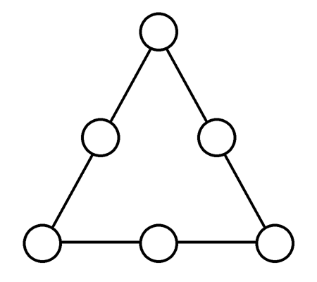
(a) Which numbers go between the corners? ______________
(b) If you have time: now make each side add up to 10. Which numbers are in the corners this time? ______________
6. Two numbers add up to 10. One is 2 more than the other. What are the numbers?
Answer: ______________________________
If you have time: two numbers add up to 12. One is 4 more than the other. What are they? ___________

Lesson 2 • NUMBER BONDS • Choose, then look back

Investigation: Is it always true?
Choose this any time you like. You do not have to finish it.
Easy first step: Write all the pairs that make 10, from 0 + 10 and 1 + 9 down to 10 + 0. Look at each pair. Are both numbers odd, both even, or one of each?
Then: Mei says: "When two numbers make 10, they are both odd or both even." Is Mei always right? Now test the pairs that make 20. Why do you think it works?

Look-back Three minutes. There are no right answers. You can pass. Nobody reads it out.
Something I did well: ______________________________________________
The hardest part was ... the bonds the = sign saying why something else: ____________
What helped me: counters or objects drawing it trying again I asked for help I was not stuck
Next time I will try: drawing it using objects checking my answer asking a question
I am still stuck (my tutor will come and help) I would like to pass
Lesson 2
MATH INQUIRERS HOLIDAY PROGRAM • PRIMARY 1
NUMBER BONDS
Name: ______________________ Class / Group: _________ Date: ____________
Think harder
Use objects, draw a picture or make a table. Then write how you know. Choose any question you like, in any order.
Think harder
T1. Mei says 7 + 5 = 8 + 4. Ben says 7 + 5 = 8 + 5. Who is right? Show how you know without adding both sides.

T2. Siti puts 10 stickers into two pockets. The left pocket must have MORE stickers than the right pocket, and each pocket has at least 1 sticker. How many ways can she do it? List them in order.

T3. 7 + 3 = 10. What is 8 + 4? What is 8 + 2? What happened to the total each time, and why?

T4. Find all the pairs of numbers from 1 to 11 that make 12. (3 + 9 and 9 + 3 count as the same pair.) How many pairs are there?

Lesson 2 • NUMBER BONDS
Go further
C1. Two circles and one square add up to 12. One circle and two squares add up to 9. What number is each shape? Explain how you found it.

C2. Ali has 20 stickers. He keeps 9 and shares the rest between Ben and Mei. Ben gets 3 more than Mei. How many does each get?

C3. Change the magic triangle: use the numbers 2, 3, 4, 5, 6 and 7 instead of 1 to 6. Can you make every side add to the same total? Try it. Which totals can you make?

Start here • Lesson 3
MATH INQUIRERS HOLIDAY PROGRAM • PRIMARY 1
PICTURE GRAPHS
Name: ______________________ Class / Group: _________ Date: ____________
LET’S PLAN THE FRUIT PARTY!
After question 3 you may choose: carry on, or try Think harder.
Our teacher wants to buy fruit for a class party. Every child voted for ONE fruit. The picture graph shows the votes.
Key:  = 1 child
Fruit | Votes
Apple | 
Banana | 
Orange
Grape | 
Watermelon | 

Part A: Read the graph
1. Which fruit got the most votes?
Answer: ______________________________
2. Which fruit got the fewest votes?
Answer: ______________________________
3. How many more children chose orange than grape?
Answer: ______________________________
4. Two fruits got the same number of votes. Which two fruits are they?
Answer: ______________________________
5. How many children voted altogether? (Hint: each child had only 1 vote.)
Answer: ______________________________
6. Mei says, “Orange is the best fruit for the whole school!”
(a) Is Mei right? Yes / No
(b) Why do you think so?

7. What else should the teacher think about before buying fruit for the party?

Part B: Now it’s your turn!
Ask your own group to vote. Each child votes for ONE fruit. Make a tally mark for each vote.
Fruit | Tally | Total
Apple
Banana
Orange
Grape
Watermelon
8. Which fruit did YOUR group like best? ____________________ Is it the same as the graph above? Yes / No
9. Why might two groups choose different fruits?

Lesson 3 • PICTURE GRAPHS • Choose, then look back

Investigation: What if we change the key?
Choose this any time you like. You do not have to finish it.
Easy first step: Draw a picture graph with 1 picture = 1 child: Cats 4, Dogs 6, Fish 2.
Then: Now draw it again with 1 picture = 2 children. What stays the same? What changes? Could you use 1 picture = 3 children? Why or why not?

Look-back Three minutes. There are no right answers. You can pass. Nobody reads it out.
Something I did well: ______________________________________________
The hardest part was ... reading the key comparing saying why something else: ____________
What helped me: counters or objects drawing it trying again I asked for help I was not stuck
Next time I will try: drawing it using objects checking my answer asking a question
I am still stuck (my tutor will come and help) I would like to pass
Lesson 3
MATH INQUIRERS HOLIDAY PROGRAM • PRIMARY 1
PICTURE GRAPHS
Name: ______________________ Class / Group: _________ Date: ____________
Think harder
Use objects, draw a picture or make a table. Then write how you know. Choose any question you like, in any order.
Think harder
T1. 1 picture = 2 children. Red has 3 pictures, blue has 5 and green has 4. How many children chose blue?

T2. 1 picture = 2 children. Red has 3 pictures, blue has 5 and green has 4. How many children voted altogether?

T3. 1 picture = 2 children. Six children chose pizza. How many pictures should we draw?

T4. 1 picture = 2 children. A half picture means 1 child. Apple has 3 pictures and a half. How many children chose apple?

Lesson 3 • PICTURE GRAPHS
Go further
C1. 24 children voted. Apple got 6 votes. Orange got 6 more votes than banana. How many votes did banana and orange get?

C2. 1 picture = 2 children. 20 children voted for three fruits. A has 3 pictures. B has 2 more pictures than A. How many children chose C?

C3. Make up your own: 15 children vote for three fruits. Draw a picture graph where banana wins by exactly 2 votes (banana has 2 more than the fruit in second place) and no two fruits are tied. Then try to find a second graph that works.

Start here • Lesson 4
MATH INQUIRERS HOLIDAY PROGRAM • PRIMARY 1
PATTERNS
Name: ______________________ Class / Group: _________ Date: ____________
PATTERN INQUIRY
After question 3 you may choose: carry on, or try Think harder.
1. Look at the shape pattern. Draw the missing shapes in places 8 and 9.
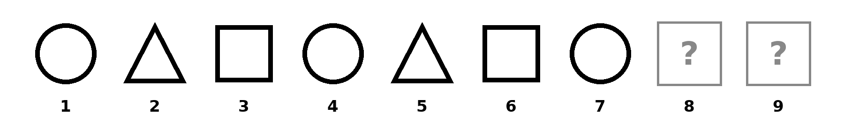
2. The pattern is circle, square, triangle, circle, square, triangle, circle … What is the 10th one? (Keep writing the pattern until you get there.)
Answer: ______________________________
3. The pattern is red, red, blue, red, red, blue, red … What is the 8th one?
Answer: ______________________________
4. The pattern keeps going in the same way.
(a) What shape will be in place 10? ____________________
(b) What shape will be in place 12? ____________________
(c) What shape will be in place 30? (Keep drawing, or look for a shortcut.) ____________
(d) How do you know?

5. The pattern is cat, dog, dog, cat, dog, dog, cat … What is the 12th one?
Answer: ______________________________
6. The pattern is A, B, C, D, A, B, C … What is the 11th one? (Write the letters in a row and number them.)
Answer: ______________________________
7. Ben makes a row of triangles with sticks.
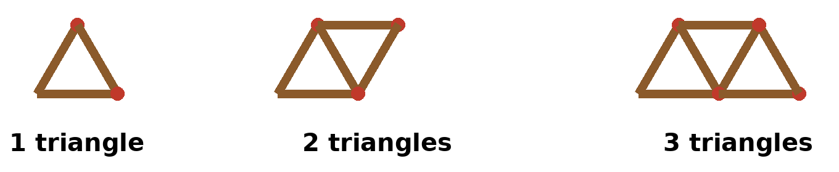
(a) Count the sticks. Fill in the table. Keep going until you reach 10 triangles.
Triangles | 1 | 2 | 3 | 4 | 5 | 6 | 7 | 8 | 9 | 10
Sticks | 3 | 5 | 7

(b) Each time Ben adds 1 more triangle, how many more sticks does he need?
Answer: ______________________________
(c) Why does he need only that many more sticks? (Look at the picture.)

(d) How many sticks are needed for 10 triangles?
Answer: ______________________________
8. If you have time: Ben has 15 sticks. How many triangles in a row can he make?
Answer: ______________________________
Show how you worked it out:

Lesson 4 • REPEATING AND GROWING PATTERNS • Choose, then look back

Investigation: Is it always true?
Choose this any time you like. You do not have to finish it.
Easy first step: Draw your own pattern of 3 shapes that repeats (for example circle, square, triangle, circle, square, triangle ...) up to place 9.
Then: Mei says: "In a pattern that repeats every 3 shapes, place 30 is the same shape as place 3." Test Mei on places 6 and 9, then on place 30. Is she always right? What about a pattern that repeats every 4 shapes: which places match place 4?

Look-back Three minutes. There are no right answers. You can pass. Nobody reads it out.
Something I did well: ______________________________________________
The hardest part was ... the core the 30th place the sticks something else: ____________
What helped me: counters or objects drawing it trying again I asked for help I was not stuck
Next time I will try: drawing it using objects checking my answer asking a question
I am still stuck (my tutor will come and help) I would like to pass
Lesson 4
MATH INQUIRERS HOLIDAY PROGRAM • PRIMARY 1
REPEATING AND GROWING PATTERNS
Name: ______________________ Class / Group: _________ Date: ____________
Think harder
Use objects, draw a picture or make a table. Then write how you know. Choose any question you like, in any order.
Think harder
T1. Pattern: circle, triangle, triangle, square, circle, triangle, triangle, square … What is the 14th shape?

T2. Same pattern: how many triangles are in the first 20 shapes?

T3. Red, blue, blue, red, blue, blue … What colour is the 20th bead?

T4. Squares in a row need 4, 7, 10, … sticks. With 20 sticks, how many squares can you make? How many sticks are left over?

Lesson 4 • REPEATING AND GROWING PATTERNS
Go further
C1. Beads repeat in a pattern of 5: red, red, blue, blue, green. How many green beads are in the first 47 beads?

C2. Dots: 1, 3, 6, 10, 15 … What are the next two numbers? What is the 10th number?

C3. Make up your own repeating pattern with a core of 5 beads (use up to 3 colours). Ask a partner: what colour is the 33rd bead? Write the answer and how you know.

Start here • Lesson 5
MATH INQUIRERS HOLIDAY PROGRAM • PRIMARY 1
WORKING BACKWARDS
Name: ______________________ Class / Group: _________ Date: ____________
MYSTERY NUMBER
After question 3 you may choose: carry on, or try Think harder.
Find each mystery number. Try a number and check it.
1. I think of a number. Find it and write it in the yellow box.
(a) I add 5. I get 12.
? | → | + 5 | → | 12

(b) I take away 3. I get 9.
? | → | − 3 | → | 9

(c) I add 4. Then I take away 2. I get 10.
? | → | + 4 | → | − 2 | → | 10
2. A number machine adds the same number every time.
(a) It adds 6. Fill in the table.
IN | 2 | 5 | 9
OUT | 8 | 11 |  | 14

(b) A different machine. What does it do?
IN | 3 | 6 | 10 | 15
OUT | 7 | 10 | 14
Rule: ______________ If you have time: OUT 30 means IN ______
3. Ali has 8 marbles. Mei has 5 more marbles than Ali.
(a) How many marbles does Mei have? ____
Ben has 6 fewer marbles than Mei.
(b) How many marbles does Ben have? ____
(c) How many more marbles does Mei have than Ben? ____
(d) If you have time: how many marbles do they have altogether? ____
Colour one box for each marble to help you. Ali’s bar is done for you.
Ali
Mei
Ben

4. Queue puzzles.
(a) There are 20 children in a queue. Mei is 7th from the front. How many children are behind her?
Answer: ______________________________
(b) Ali is 3rd from the front AND 3rd from the back. How many children are in the queue? Draw the children as circles first.
Answer: ______________________________

5. ★ Take-home (if you have time, or at home): make your own mystery number story. Give it to a friend to solve!

Lesson 5 • WORKING BACKWARDS • Choose, then look back

Investigation: Is it always true?
Choose this any time you like. You do not have to finish it.
Easy first step: A number machine adds 6 and then takes away 6. Try IN = 3, 10 and 25. What comes OUT each time?
Then: Mei says: "OUT is always the same as IN." Test one number you choose. Is Mei always right? Now change the machine: add 6, then take away 4. What happens to every number? Why?

Look-back Three minutes. There are no right answers. You can pass. Nobody reads it out.
Something I did well: ______________________________________________
The hardest part was ... the machine undoing the steps the queue something else: ____________
What helped me: counters or objects drawing it trying again I asked for help I was not stuck
Next time I will try: drawing it using objects checking my answer asking a question
I am still stuck (my tutor will come and help) I would like to pass
Lesson 5
MATH INQUIRERS HOLIDAY PROGRAM • PRIMARY 1
WORKING BACKWARDS
Name: ______________________ Class / Group: _________ Date: ____________
Think harder
Use objects, draw a picture or make a table. Then write how you know. Choose any question you like, in any order.
Think harder
T1. Ben had some marbles. He gave 5 to Mei, then won 3. Now he has 12. How many did he start with?

T2. Ben had some stickers. He gave away 6, got 4, then gave away 3. Now he has 10. How many did he have at first?

T3. A number machine adds the same number each time. IN 4 gives OUT 9. What is the rule? What is OUT when IN is 12? What is IN when OUT is 20?

T4. I think of a number. I add 4, then I take away 7. I get 8. What is my number?

Lesson 5 • WORKING BACKWARDS
Go further
C1. A number machine has two steps: add 3, then add 4. IN 5 gives OUT 12. What goes IN to give OUT 20? Can you make a one-step machine that does the same job?

C2. A snail climbs 3 cm each day and slides back 1 cm each night. It starts at the bottom of a 9 cm wall. On which day does it reach the top?

C3. Make up a mystery number story with THREE steps whose answer is 10. Write the story. Show how a partner can work backwards to find 10, and how they can check by going forwards.

Start here • Lesson 6
MATH INQUIRERS HOLIDAY PROGRAM • PRIMARY 1
MONEY
Name: ______________________ Class / Group: _________ Date: ____________
COIN COMBOS
After question 3 you may choose: carry on, or try Think harder.
We have 5¢, 10¢, 20¢ and 50¢ coins. You can use the same kind of coin more than once.
1. Show different ways to make exactly 20¢ using only 20¢, 10¢ and 5¢ coins. Write how many of each coin in the table.
Way | Number of 20¢ | Number of 10¢ | Number of 5¢
A
B
C
D
E
You may not need every row.

(a) Which way uses the FEWEST coins?
Answer: ______________________________
(b) Which way uses the MOST coins?
Answer: ______________________________
(c) How do you know you have found ALL the ways?

2. Find ALL the ways to make 25¢ using 20¢, 10¢ and 5¢ coins. Start with the biggest coin. Write each way like this: 20¢ + 5¢ (Hint: there are 4 ways.)

3. Mei wants to pay exactly 85¢ using 5¢, 10¢, 20¢ and 50¢ coins.
Tip: use play coins. Pay 85¢ any way you can, then try to use fewer coins.
(a) What is the smallest number of coins she can use? Which coins are they?
Answer: ______________________________
(b) If you have time: find a different way that uses exactly 6 coins.
Answer: ______________________________
4. Can Ben make 35¢ using only 2 coins? Explain your answer.

5. Ali has a 20¢ coin, a 10¢ coin and a 5¢ coin. How much money does he have?
Answer: ______________________________
6. Mei has two 20¢ coins and one 5¢ coin. How much money does she have?
Answer: ______________________________

Lesson 6 • MONEY • Choose, then look back

Investigation: What if we take a coin away?
Choose this any time you like. You do not have to finish it.
Easy first step: Our coins are 5¢, 10¢, 20¢ and 50¢. Put the 5¢ coin away. Use your coins to make 10¢, then 20¢, then 15¢.
Then: Which amounts from 5¢ to 50¢ (5¢, 10¢, 15¢ ... 50¢) can you NOT make with the 10¢, 20¢ and 50¢ coins? What do those amounts have in common? Why?

Look-back Three minutes. There are no right answers. You can pass. Nobody reads it out.
Something I did well: ______________________________________________
The hardest part was ... finding all the ways knowing I had them all the coins something else: ____________
What helped me: counters or objects drawing it trying again I asked for help I was not stuck
Next time I will try: drawing it using objects checking my answer asking a question
I am still stuck (my tutor will come and help) I would like to pass
Lesson 6
MATH INQUIRERS HOLIDAY PROGRAM • PRIMARY 1
MONEY
Name: ______________________ Class / Group: _________ Date: ____________
Think harder
Think harder
T1. Make 70¢ using exactly 4 coins from 5¢, 10¢, 20¢ and 50¢. Find every set.

T2. Sam has only 10¢ and 20¢ coins. He pays exactly 90¢ using 6 coins. How many of each coin does he use?

T3. What is the fewest number of coins to make 45¢?

T4. Find ALL the ways to make 30¢ using 20¢, 10¢ and 5¢ coins. How do you know you have found them all?

T5. Dollars! We also have $1 coins and $2, $5, $10 and $50 notes.
(a) A toy costs $17. Pay exactly with the fewest notes and coins.
(b) Mei has one $50 note and two $10 notes. A bicycle costs $65 and a helmet costs $8. Does she have enough money for both? Explain.

Lesson 6 • MONEY
Go further
C1. You have one 5¢, one 10¢, one 20¢ and one 50¢ coin. How many different amounts can you make using any of them? What if you also had a $1 coin (100¢)?

C2. A sweet costs 15¢ and a biscuit costs 20¢. Ben spends exactly 90¢ and buys some of each. How many sweets and biscuits does he buy?

C3. Make up your own coin puzzle that has exactly ONE answer (for example: "exactly 3 coins that make 35¢"). Write it, swap with a partner and check their answer by listing every possibility.

Start here • Lesson 7
MATH INQUIRERS HOLIDAY PROGRAM • PRIMARY 1
SHAPES
Name: ______________________ Class / Group: _________ Date: ____________
SHAPE SAFARI
After question 3 you may choose: carry on, or try Think harder.
1. Count the shapes in the house picture.
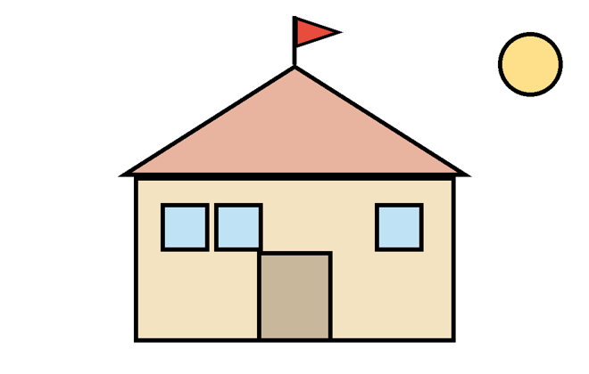
Circle | Triangle | Square | Rectangle

(a) Which shape is there the most of? ____________ (b) How many shapes altogether? ____
2. Sides and corners. Look at the shapes, then fill in the table.
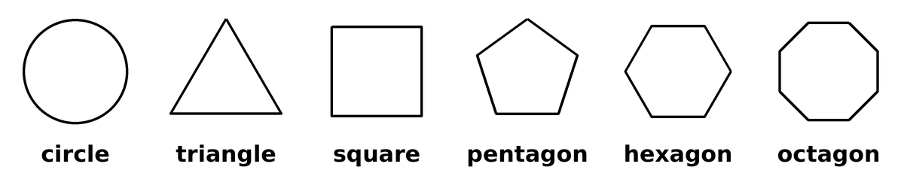
Shape | Straight sides | Corners
Circle | 0 | 0
Triangle | 3 | 3
Square
Pentagon
Hexagon
Octagon

(a) What do you notice about the number of sides and corners? ______________________
(b) A shape has 7 sides. How many corners does it have? ____
3. Who am I?
(a) I have 4 sides, all the same length, and 4 square corners. ____________
(b) I have no corners and no straight sides. ____________
(c) I have 6 sides. ____________
4. How many triangles can you find in each picture? Count the small ones first, then the bigger ones.
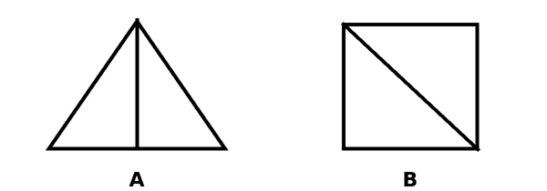
A: ____ B: ____
5. Two triangles of the same size are put together along one side. Draw one shape you can make. What is it called?

Shape name: ____________________
6. How many squares can you find in this picture? Count the small ones first, then the bigger one.
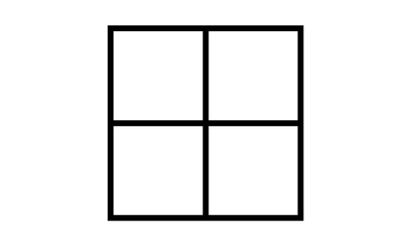
Number of squares: ______________________________

Lesson 7 • 2D SHAPES • Choose, then look back

Investigation: Find all the shapes
Choose this any time you like. You do not have to finish it.
Easy first step: Join 3 squares so that whole sides touch. Draw one shape you can make.
Then: How many different shapes can you make with 3 squares? Turning or flipping a shape does not make a new one. Draw each shape. Then try with 4 squares. Use paper squares or counters to help.

Look-back Three minutes. There are no right answers. You can pass. Nobody reads it out.
Something I did well: ______________________________________________
The hardest part was ... sides and corners counting triangles naming shapes something else: ____________
What helped me: counters or objects drawing it trying again I asked for help I was not stuck
Next time I will try: drawing it using objects checking my answer asking a question
I am still stuck (my tutor will come and help) I would like to pass
Lesson 7
MATH INQUIRERS HOLIDAY PROGRAM • PRIMARY 1
2D SHAPES
Name: ______________________ Class / Group: _________ Date: ____________
Think harder
Use objects, draw a picture or make a table. Then write how you know. Choose any question you like, in any order.
Think harder
T1. Two same-size triangles can make a square. Can they also make a bigger triangle? Draw how.

T2. How many squares are in a grid 3 squares long and 2 squares high?

T3. A square has both diagonals drawn (lines joining opposite corners). How many triangles can you find? Count the small ones first.

T4. Draw a shape with 4 straight sides that is NOT a square. Is it a rectangle? How do you know?

Lesson 7 • 2D SHAPES
Go further
C1. A big triangle has lines drawn from its top corner to the bottom. With 1 line there are 3 triangles, with 2 lines 6, with 3 lines 10. How many triangles with 4 lines? With 5 lines? Draw it to check.
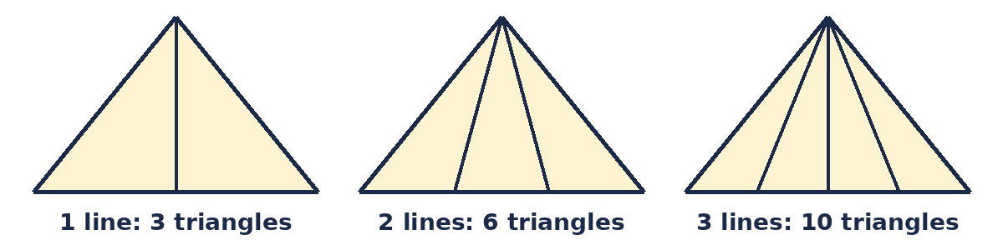

C2. Draw a square and cut it into 4 equal squares. Then cut ONE of those small squares into 4 even smaller squares. How many squares can you find altogether? Count the small ones first, then the bigger ones.
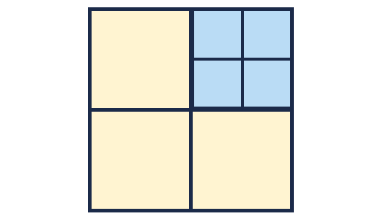

C3. Draw your own triangle-counting puzzle: a big triangle with some lines inside. Count the triangles. Swap with a partner. Do you both get the same number? If not, find out who missed some.

Start here • Lesson 8
MATH INQUIRERS HOLIDAY PROGRAM • PRIMARY 1
LOGIC AND SORTING
Name: ______________________ Class / Group: _________ Date: ____________
LOGIC LAB
After question 3 you may choose: carry on, or try Think harder.
1. Put them in order using the clues.
(a) Ali is taller than Ben. Ben is taller than Mei. Tallest: ________ Shortest: ________
(b) The cat is heavier than the dog. The hen is lighter than the dog. Heaviest: ________ Lightest: ________
(c) The red ribbon is longer than the blue one.
The green one is shorter than the blue one.
The yellow one is longer than the red one.
Write them from longest to shortest:
______________, ______________, ______________, ______________
2. Write the numbers 1 to 10 in the two-loop picture.
Odd numbers end in 1, 3, 5, 7 or 9. Even numbers end in 0, 2, 4, 6 or 8.

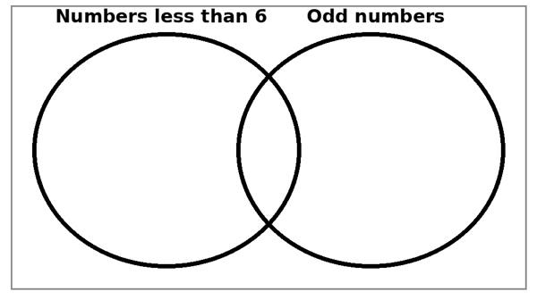
(a) Numbers in BOTH circles: ____________________
(b) Why are they in the middle?

3. Who has which pet? Ali, Mei and Ben each have a different pet: cat, dog or fish.
Clue 1: Ali has no cat and no dog.
Clue 2: Mei does not have a dog.
Tick where it fits, cross where it cannot. Clue 1 is crossed for you.
 | Cat | Dog | Fish
Ali | X | X
Mei
Ben
Ali has the ______. Mei has the ______. Ben has the ______.
4. Four children stand in a line: Ali, Ben, Mei and Sam.
Mei is first. Ali is in front of Ben. Ben is in front of Sam. Who stands where?
1st | 2nd | 3rd | 4th
5. If you have time: number riddle.
(a) I am between 10 and 20. I am odd. You say me counting in 5s. ____
6. If you have time: which one does NOT belong? 3, 6, 9, 11
Explain why. Find a second reason.

Lesson 8 • LOGIC AND SORTING • Choose, then look back

Investigation: Find all the ways
Choose this any time you like. You do not have to finish it.
Easy first step: Ali, Mei and Ben stand in a line. Write one order they can stand in. Now write a different order.
Then: Write ALL the different orders they can stand in. How do you know you have them all? Now add a clue: "Ali is not first." How many orders are left? Make up your own clue so that only ONE order is left.

Look-back Three minutes. There are no right answers. You can pass. Nobody reads it out.
Something I did well: ______________________________________________
The hardest part was ... the grid the two-loop picture the clues something else: ____________
What helped me: counters or objects drawing it trying again I asked for help I was not stuck
Next time I will try: drawing it using objects checking my answer asking a question
I am still stuck (my tutor will come and help) I would like to pass
Lesson 8
MATH INQUIRERS HOLIDAY PROGRAM • PRIMARY 1
LOGIC AND SORTING
Name: ______________________ Class / Group: _________ Date: ____________
Think harder
Think harder
T1. In a race, Sam is ahead of Tia. Tia is ahead of Raj. Mei is ahead of Sam. Who is third?

T2. Ana, Bo and Cy each have a different toy: a ball, a kite or a yo-yo. Bo does not have the kite. Cy has the ball. Who has which toy?

T3. Numbers 1 to 12. Which do we say when counting in 2s? Which when counting in 3s? Which in both?

T4. Numbers 1 to 12. Which do we NOT say when counting in 2s or when counting in 3s?

T5. Number riddles. Who am I?
(a) I am between 20 and 40. When you count in 2s you say me. When you count in 5s you say me too.
(b) I have 2 digits. When I add my two digits I get 5. I am less than 20.

Lesson 8 • LOGIC AND SORTING
Go further
C1. A secret number is between 10 and 30. It is even, and you say it when counting in 3s. It is 2 more than a number you say when counting in 5s. What is it?

C2. Numbers 1 to 20. Sort them in a two-loop picture with the loops "I say it counting in 2s" and "I say it counting in 3s". How many numbers go in each part? Then use the loops "counting in 2s" and "counting in 4s". What is different, and why?

C3. Make up your own "Who has which pet?" puzzle with three friends and three pets. Write clues so that there is only ONE answer. Swap with a partner and check that they find your answer.

Start here • Lesson 9
MATH INQUIRERS HOLIDAY PROGRAM • PRIMARY 1
LENGTH
Name: ______________________ Class / Group: _________ Date: ____________
MEASURE IT!
After question 3 you may choose: carry on, or try Think harder.
1. Three ribbons are made of equal squares.
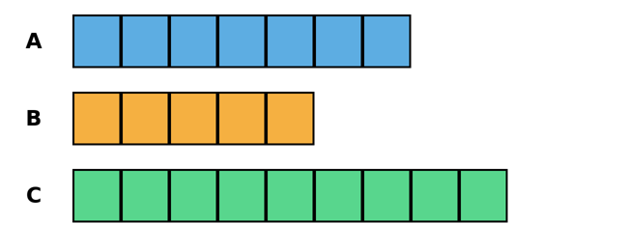
(a) Which ribbon is the longest? ____ (b) Which is the shortest? ____
(c) How many squares longer is ribbon A than ribbon B? ____
(d) Ribbon A and ribbon B are put end to end. How many squares long is that? ____
(e) Ribbon C is cut shorter by 2 squares. Which ribbon is it now the same length as? ____
2. Write what you guessed, what you measured, and how far off your guess was. In the last row, guess first, then measure it with the cube strip from the back of the workbook.
Object | My guess | Measured | How far off my guess was
A pencil
A book
A shoe
My choice: ____________
(a) Why must every cube be the same size?

3. Ali’s desk is 6 spans long. Mei measures the same desk: 8 spans.
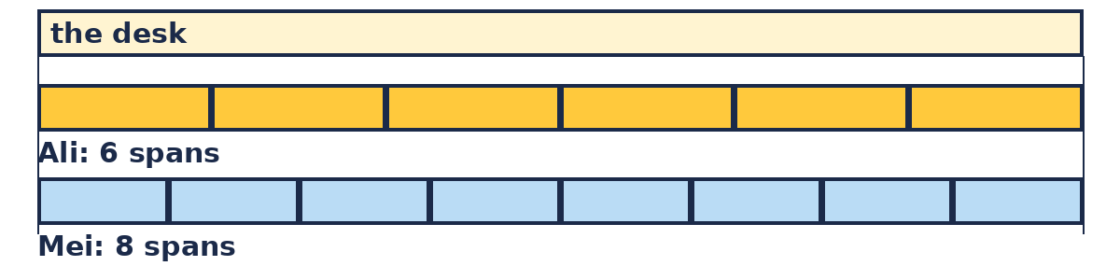
(a) Whose span is longer? ____________
(b) How do you know?

4. If you have time: 1 clip = 2 erasers.
(a) A desk is 5 clips. How many erasers? (Draw it or count in 2s.) ____
(b) A pencil is 12 erasers long. How many clips? ____
5. Mei’s pencil is 8 cubes. Ali’s is 3 cubes longer. Ben’s is 2 cubes shorter.
(a) How long is Ali’s pencil? ____ cubes
(b) How long is Ben’s pencil? ____ cubes
(c) All three end to end: ____ cubes?
6. Read the ruler.
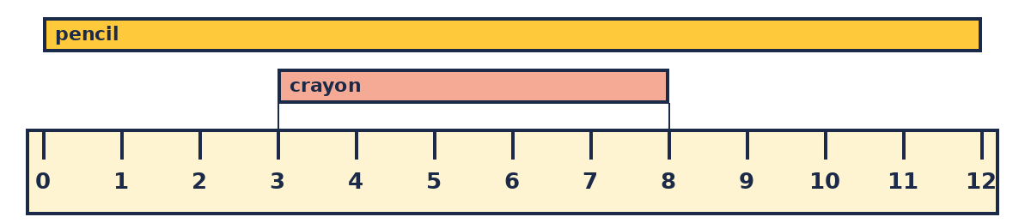
(a) The pencil goes from 0 to 12 cm. How long? ____ cm
(b) The crayon goes from 3 to 8 cm. How long? (Hop from 3 to 8.) ____ cm
(c) My pencil: ____ cm. Longer or shorter than 10 cm? ________

Lesson 9 • LENGTH • Choose, then look back

Investigation: Is it always true?
Choose this any time you like. You do not have to finish it.
Easy first step: Measure your pencil with the cube strip. Write the number. Then measure it with a paper clip (or your finger width). Write the number.
Then: Which unit is shorter? Which one gave the bigger number? Ben says: "If I measure the same thing with a SHORTER unit, I always get a BIGGER number." Is Ben right? Guess: if a unit is half as long as a cube, what number would you get for your pencil?

Look-back Three minutes. There are no right answers. You can pass. Nobody reads it out.
Something I did well: ______________________________________________
The hardest part was ... the ruler the units guessing something else: ____________
What helped me: counters or objects drawing it trying again I asked for help I was not stuck
Next time I will try: drawing it using objects checking my answer asking a question
I am still stuck (my tutor will come and help) I would like to pass
Lesson 9
MATH INQUIRERS HOLIDAY PROGRAM • PRIMARY 1
LENGTH
Name: ______________________ Class / Group: _________ Date: ____________
Think harder
Use objects, draw a picture or make a table. Then write how you know. Choose any question you like, in any order.
Think harder
T1. A ribbon lies from the 3 cm mark to the 11 cm mark on a ruler. How long is it?

T2. A red ribbon lies from the 2 cm mark to the 9 cm mark. A blue ribbon lies from the 5 cm mark to the 11 cm mark. Which ribbon is longer? By how many cm?

T3. 1 clip is as long as 3 cubes. A pen is 12 cubes long. How many clips long is the pen? A ruler is 5 clips long. How many cubes long is the ruler?

T4. A pencil is 3 erasers long. A ruler is 2 pencils long. A desk is 4 rulers long. How many erasers long is the desk?

Lesson 9 • LENGTH
Go further
C1. A train has 3 carriages. Each is 6 cubes long. There is a gap of 1 cube between carriages. How long is the whole train? What if there are 5 carriages?

C2. A ribbon 30 cubes long is cut into three pieces. The first is 4 cubes longer than the second. The third is 4 cubes shorter than the second. How long is each piece?

C3. Make up your own measuring puzzle that uses TWO different units (for example clips and cubes). Write the puzzle and its answer. Give it to a partner and check their answer.

Start here • Lesson 10
MATH INQUIRERS HOLIDAY PROGRAM • PRIMARY 1
MIXED PUZZLES
Name: ______________________ Class / Group: _________ Date: ____________
PUZZLE DAY!
After question 3 you may choose: carry on, or try Think harder.
Show how you know. Remember the inquirer rules!
1. Pattern: 3, 8, 13, 18, ____, ____ Rule: ______________
2. Two numbers add up to 12. One is 2 more than the other. What are they? ____ and ____
3. The graph shows pets in a street.
Dog | 
Cat | 
Fish | 
Bird
= 1 pet
(a) How many more cats than birds? ____
(b) How many pets are there altogether? ____
(c) Which two kinds of pet together make exactly 10? ______________
4. You have one 20¢ coin, two 10¢ coins and two 5¢ coins.
(a) How much money do you have? ____
(b) Which of your coins make exactly 35¢? ______________
5. Shapes
(a) I have 4 sides, all the same length, and 4 square corners. What am I? ____________
(b) How many triangles are in this picture? ____
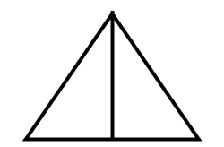
6. Ali is older than Ben. Mei is younger than Ben. Who is the youngest? ____________
7. If you have time: I think of a number. I add 9, then take away 4. I get 10. What is it? (Try a number and check.) ____
8. A pencil is 6 cubes long. A pen is 4 cubes longer than the pencil.
(a) How long is the pen? ____ cubes
(b) Put the pen and the pencil end to end. How long are they together? ____ cubes
9. Make a puzzle for a friend. Write the puzzle and the answer here. (We swap puzzles in talk time.)

The puzzle I liked best today was ______________________ because ______________________

Lesson 10 • MIXED PUZZLES • Choose, then look back

Investigation: What if we change the jump?
Choose this any time you like. You do not have to finish it.
Easy first step: Three numbers in a row start at 5 and jump by 3: 5, 8, 11. Add them up. What is the total?
Then: Now change the jump to 1, 2, 4 and 5 and find each total. What stays the same? What changes? Can you find a shortcut for the total?

Look-back Three minutes. There are no right answers. You can pass. Nobody reads it out.
Something I did well: ______________________________________________
The hardest part was ... the patterns the puzzles the explaining something else: ____________
What helped me: counters or objects drawing it trying again I asked for help I was not stuck
Next time I will try: drawing it using objects checking my answer asking a question
I am still stuck (my tutor will come and help) I would like to pass
Lesson 10
MATH INQUIRERS HOLIDAY PROGRAM • PRIMARY 1
MIXED PUZZLES
Name: ______________________ Class / Group: _________ Date: ____________
Think harder
Use objects, draw a picture or make a table. Then write how you know. Choose any question you like, in any order.
Think harder
T1. A pattern starts at 4 and adds 6 each time. What is the 8th number? Is 50 in the pattern?

T2. Mei thinks of a number, adds 7, takes away 2 and gets 19. Ben does the same and gets 25. How much bigger is Ben's number?

T3. Ali has 5 coins worth 60¢. He has only 5¢, 10¢ and 20¢ coins. Find every possible set.

T4. Votes: Apple 6, Banana 9, Orange 7. Then 5 more children vote and all choose apple. Which fruit wins now? By how many votes?

Lesson 10 • MIXED PUZZLES
Go further
C1. Triangles in a row use 3, 5, 7 … sticks. Squares in a row use 4, 7, 10 … sticks. Which numbers of sticks, up to 31, can make a row of triangles AND (with the same number of sticks) a row of squares, with none left over? What do you notice?

C2. Ali has some stickers. Ben has 4 more than Ali. Mei has 3 fewer than Ben. Together they have 29. How many does each have?

C3. Pick any puzzle from today (a puzzle card or a worksheet question). Change ONE thing about it (a number, a rule or a condition) to make a new puzzle. Solve your new puzzle and say what changed in the answer, and why.

Cut-outs
For Lesson 6 (Coin Combos) and Lesson 9 (Measure It!). Print, cut along the dashed lines, and keep in an envelope.
Play coins
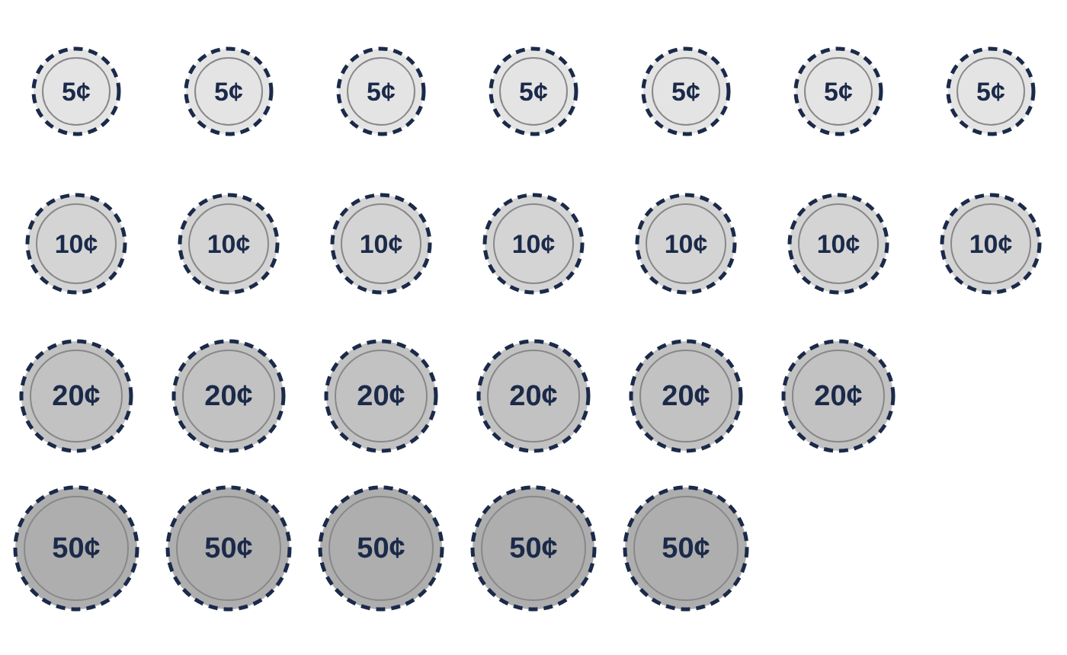
Paper cube strips (every square is the same size)
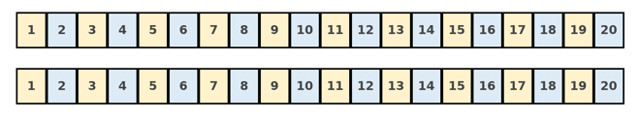
Play notes and $1 coins
For Lesson 6 (Coin Combos). Cut along the dashed lines.
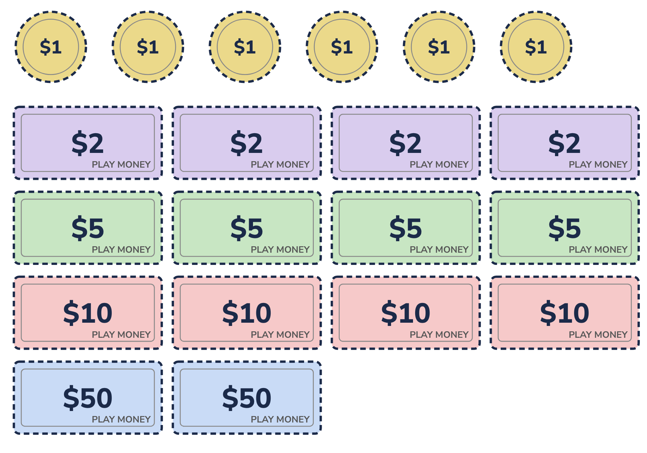
Inquirer Kit
Nothing needs to be bought. Print, cut out and keep everything in one envelope.
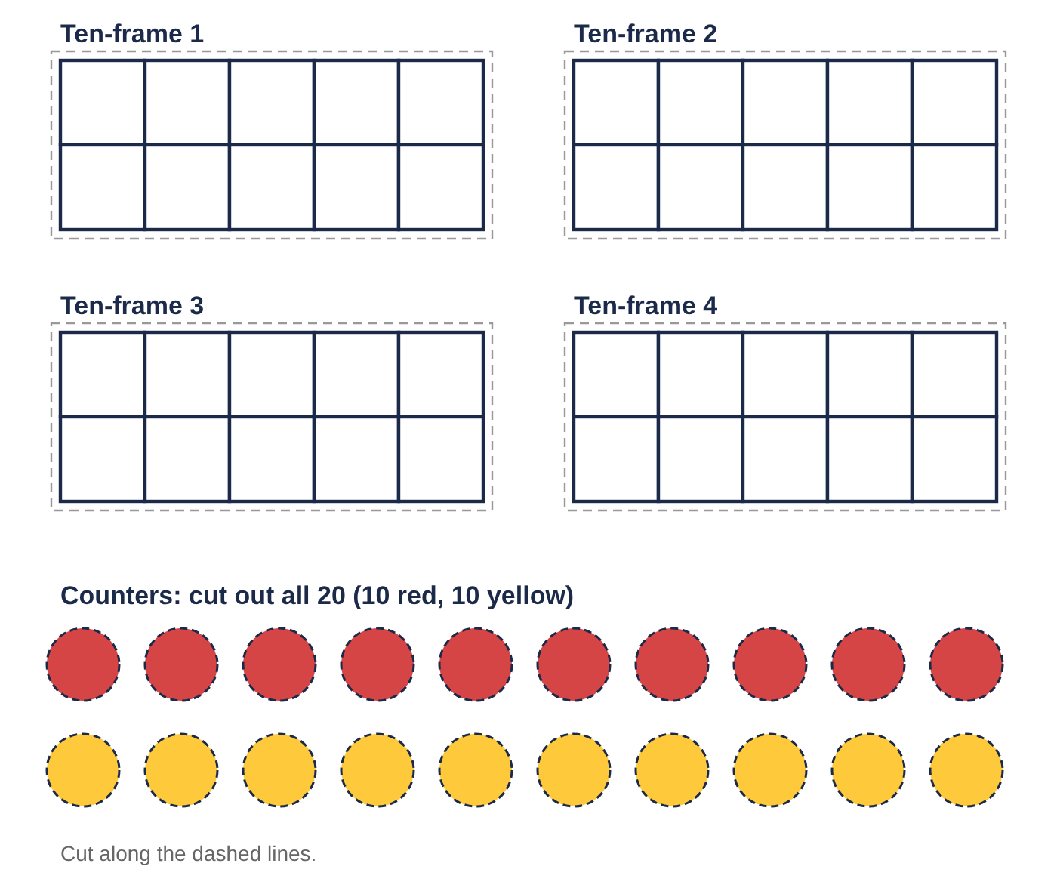
Number strips and sorting tiles
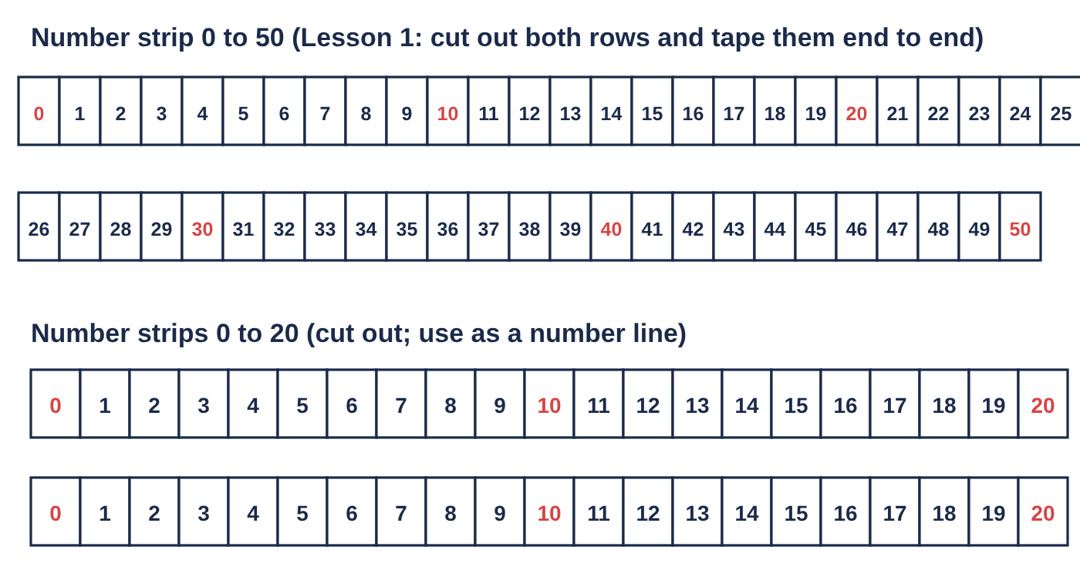
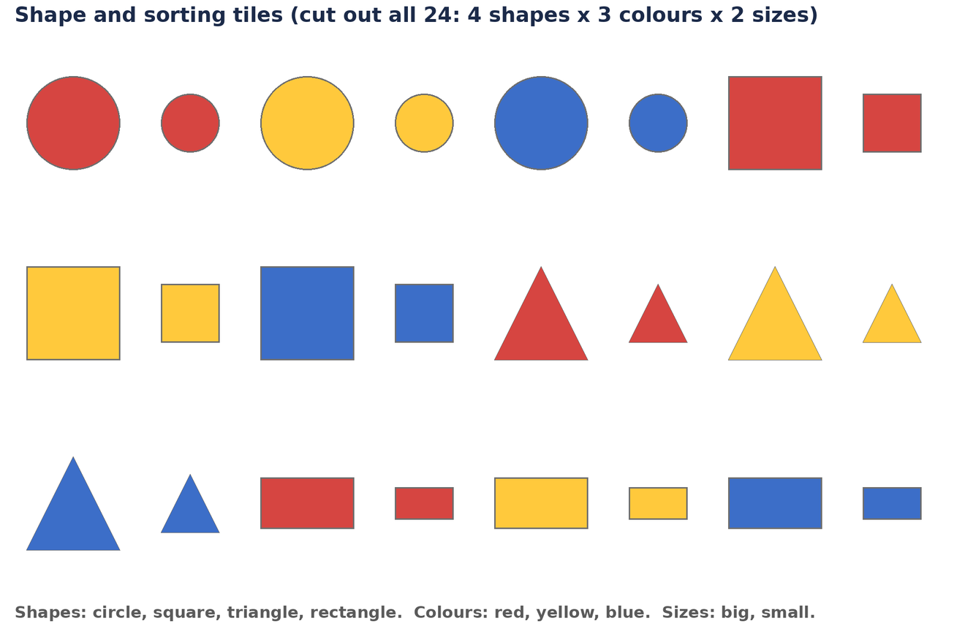
Puzzle cards
For Lesson 10 (Puzzle Day). Cut out the four cards. Choose a card to start with. You may swap with another pair later. Show how you know on a whiteboard or on paper.
1. COINS  Make 45¢ with exactly 3 coins from 5¢, 10¢, 20¢ and 50¢. | 2. PATTERNS  5, 8, 11, 14 … What is the 10th number? Show how you know.
3. LOGIC  Mei is taller than Ben. Ben is taller than Sam. Ali is shorter than Sam. Put them in order, tallest first. | 4. MEASURING  A pencil is 6 cubes long. A pen is 4 cubes longer than the pencil. Put them end to end. How many cubes long is that?

CERTIFICATE OF COMPLETION
Math Inquirers Holiday Program
Primary 1 Holiday Program
This certifies that
________________________________
completed all 10 lessons, solved puzzles, spotted patterns and explained their thinking.
Notice it. Test it. Explain why.
Tutor: ____________________ Date: ________________

