Welcome to
Tian OS
Your AI-Powered Learning Platform
Student Getting Started Guide
Your teacher or tutor has set up your learning account.
This guide shows you how to get started!

Step 1: Log In
Your teacher will give you an email address and a password. Use these to sign in.
- Open the website link your teacher gave you
- Type your email in the Email box
- Type your password in the Password box
- Click the green "Sign in" button
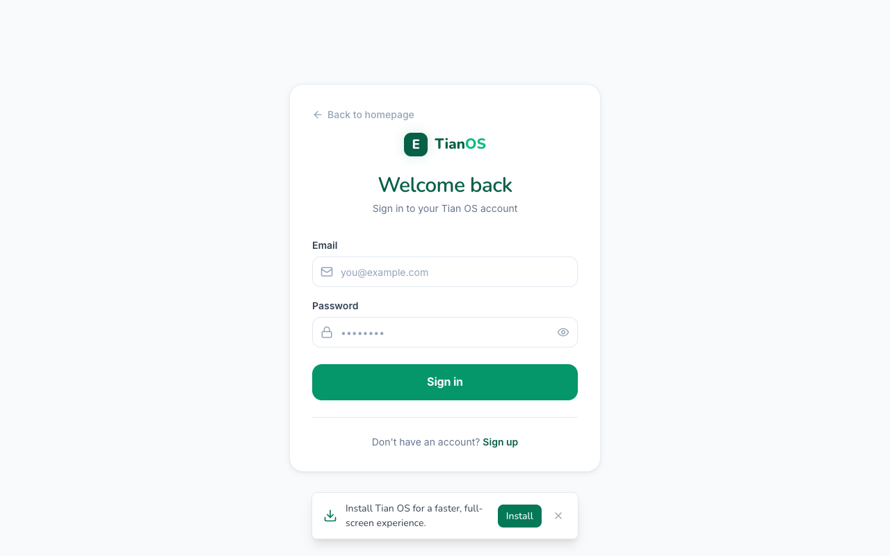
The login screen

Step 2: Your Home Dashboard
After you sign in, you will see your Home page. This is your learning hub!
- Today's Mission shows the skill you should work on today
- Today's Highlights shows your day streak, Learning XP, and skills mastered
- Click Start Practice to begin!
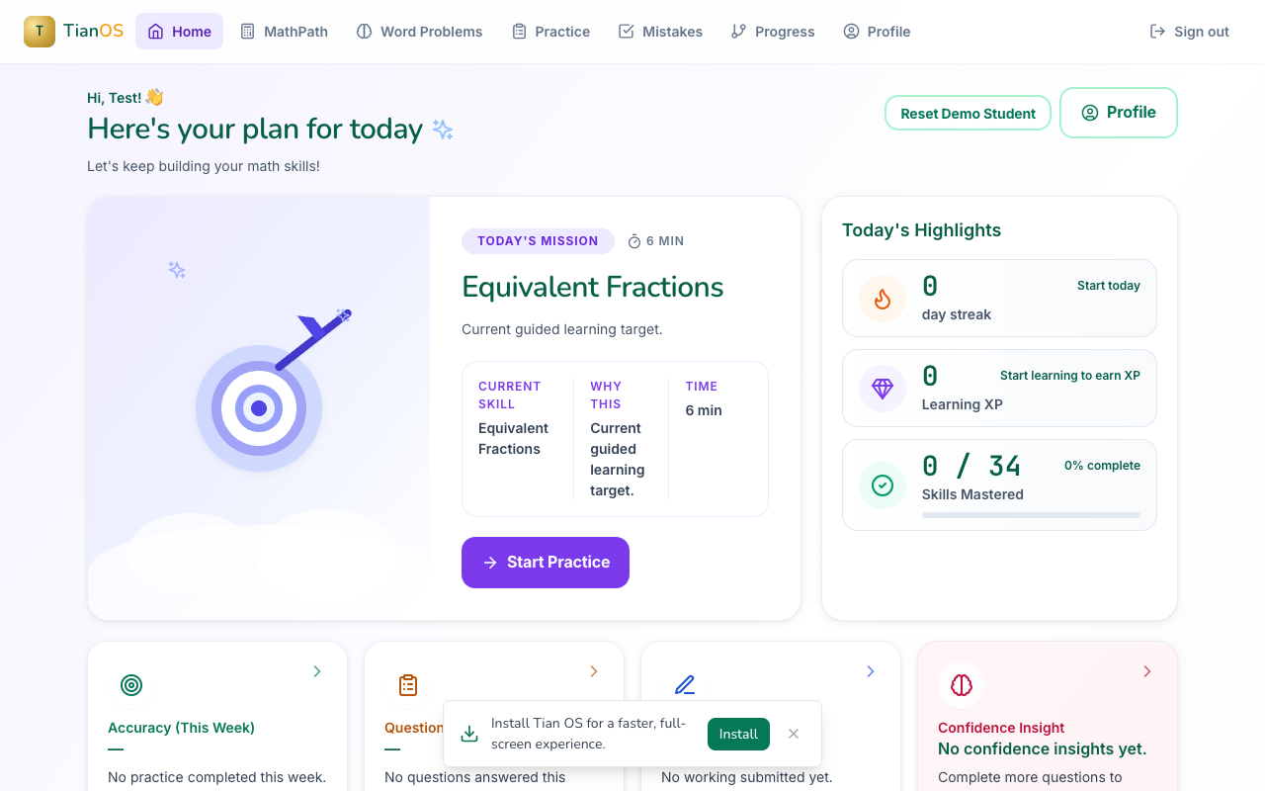
Your home dashboard

Step 3: MathPath
MathPath is your maths learning journey. It finds where you are and helps you improve step by step.
- Click MathPath in the top menu
- Start with the Fractions Check-In — it finds your best starting point
- Explore different maths levels (P1–P6) at the bottom
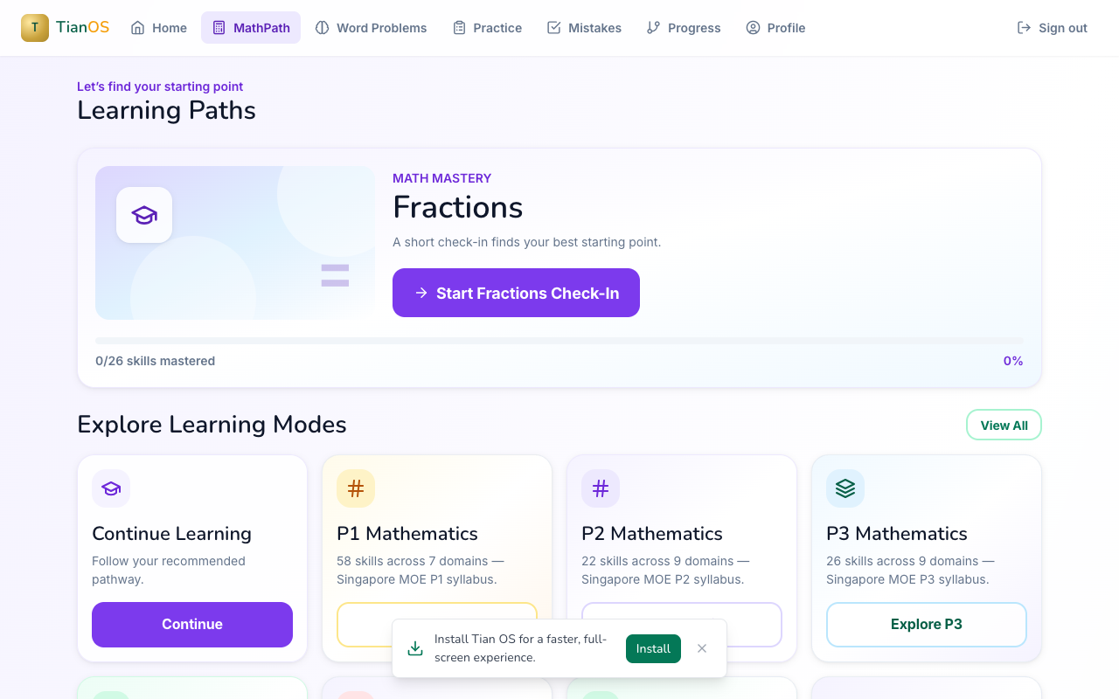
MathPath — your maths learning paths

Step 4: Word Problems
The Problem Solving Lab helps you learn to solve word problems step by step.
- Click Word Problems in the top menu
- The system recommends which skill to practise next
- Click Start on the recommended skill
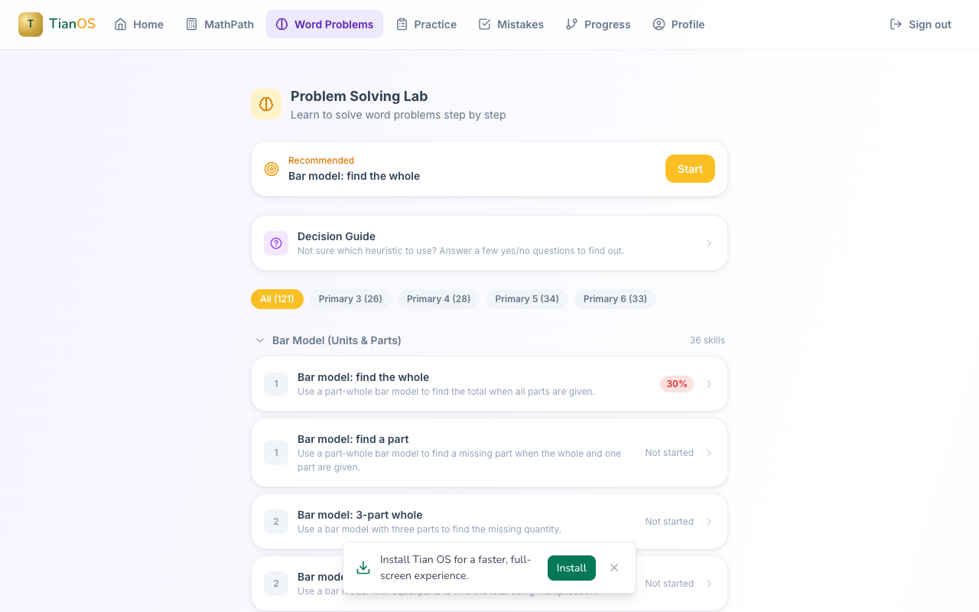
Problem Solving Lab — word problems step by step

Step 5: Track Your Progress
The Progress page shows how you are doing!
- Click Progress in the top menu
- See your Mastered, Working On, and Not Started skills
- Your goal is to turn all the skills green!
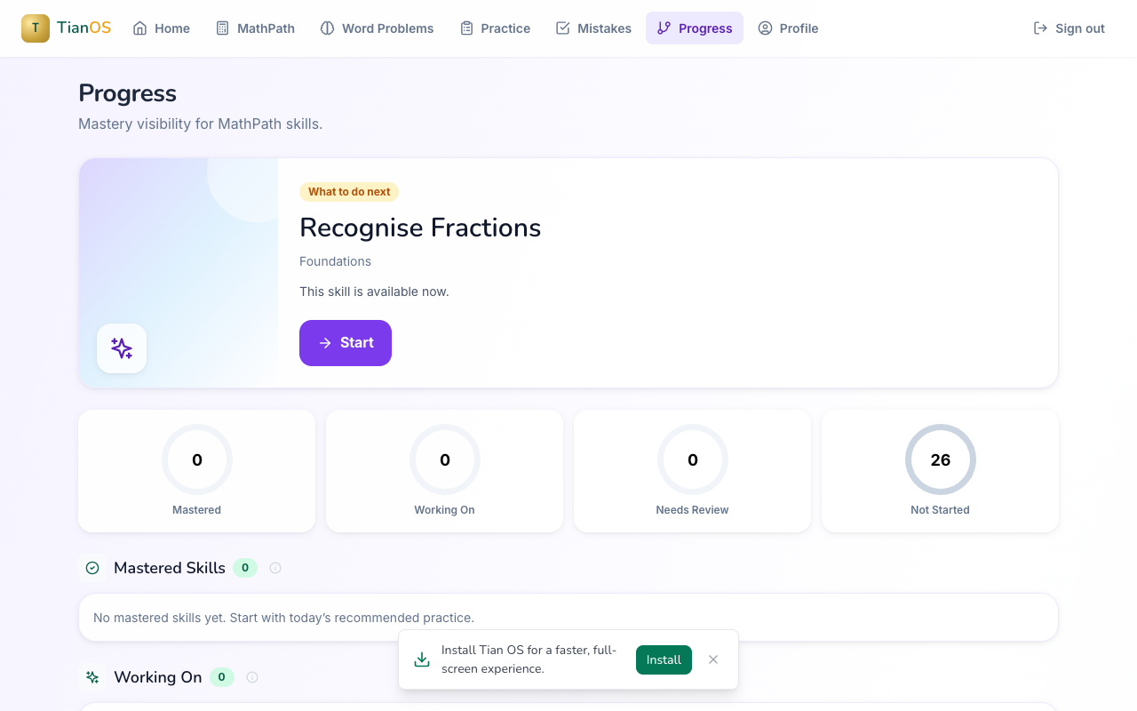
Track your mastery progress

Tips for Success
- Practise a little bit every day to build your streak
- Don’t worry about getting things wrong — that’s how you learn!
- If you get stuck, the system will give you hints
- Always show your working when solving problems
- Check your Mistakes page to review what you got wrong — it helps you improve!

Need Help?
- Can’t log in? Ask your teacher or tutor to check your email and password
- Something not working? Tell your teacher and they will sort it out
- Forgot your password? Your teacher can reset it for you
Happy learning! 🚀

