Modeling

Kill Switch Model

SLIM NAU -China 2020

**Kill Switch Model**

## Q&A

### 1. How to control the amount of CI protein?

The amount of CI protein is controllable. We can change RBS strength to change mRNA translation rate or add degradation label to change the degradation rate.

### 2. How to explain the effectiveness of the kill switch?

The modified <i>*Bacillus subtilis</i>* did not commit suicide in the laboratory and in the intestine of earthworms because the CI protein bound to the DNA inhibition site to prevent the Toehold Switch from being produced. The kill switch cannot be turned on.

### 3. Which is the best RBS and degradation rate combination?

In the intestine of earthworms, the production of MazF is the key. Due to the possibility of leakage, the production of MazF is not always set at 0. We simulated the leakage of MazF in the intestinal environment to find the combination that generated the least MazF leakage. If the combinations were not unique, considering that we hoped the kill switch could be turned on as soon as possible after the engineered bacteria were discharged out of the intestine, the RBS and a faster degradation rate combination was considered to be the best combination.

# Content

Q&A 2

1. How to control the amount of CI protein? 2

2. How to explain the effectiveness of the kill switch? 2

3. Which is the best RBS and degradation rate combination? 2

Content 3

1 Abstract 5

2 Background 5

3 Model Hypothesis 6

4 Symbol Description 6

5 Design 7

5.1 RBS and Degradation Tag 7

⬥ RBS Selection 7

⬥ CⅠ Degradation Tags 7

5.2 CⅠ Rules 8

6 Modeling 10

6.1 In the Intestine 10

⬥ 6.1.1 CⅠ Protein Production 11

⬥ 6.1.2 Trigger RNA Production 12

⬥ 6.1.3 Toehold Switch Production 12

⬥ 6.1.4 MazF Production 13

6.2 Out the Intestine 14

7 Results & Analysis 14

8 Sensitivity Analysis 15

Reference 16

## 1 Abstract

To avoid biological pollution，we modified the gene pathway of Bacillus subtilis by introducing kill switch making that the engineered bacteria do not commit suicide in the intestine, but switch on the suicide mode after it was expelled out of the intestine. To verify the feasibility of the kill switch, we built the Kill Switch model, which combined the degradation rate of CI protein with different strength RBS. After we quantitatively simulated the effect of the kill switch under various combinations, the best degradation rate and the combination of RBS are given. By adding **the LVA tag** and selecting **B0034**, the kill switch can operate effectively.

## 2 Background

The level of MazF is directly affected by the RBS and the degradation rate of CI protein, so we chose to adjust the two to find the best combination. There are three stages involved in CI protein concentration and MazF.

* **Laboratory Culture Phase**

Add IPTG to induce the production of enough CI protein, no MazF.

* **In the Intestine of an Earthworm**

The accumulated CI protein induced in laboratory degraded, and in the absence of oxygen, Bacillus subtilis express CI protein and Trigger RNA, maybe MazF because of leakage.

* **External Environment**

When *Bacillus subtilis* is expelled out of the intestine. CI protein and Trigger RNA are no longer produced and are always degraded. As the concentration of CI decreases and the number of free inhibition sites increases, more and more Toehold Switches are produced, which can combine with Trigger RNA to produce more and more MazF.

## 3 Model Hypothesis

Modeling

Cellular Automaton Model

SLIM NAU -China 2020

* The degradation rate of mRNA is a constant.
* The mRNA is generated at a constant constitutive transcription rate.
* The copy number of plasmids is kept as a constant.
* Other species such as RNAP polymerases and ribosomes are kept constant as well.
* Reactions are at equilibrium, steady state, or quasi-steady state[1].
* Each RBS part has a native strength irrespective of the promoter and protein-coding part it can be used with, and the translation rate with the same RBS has a linear relationship with the mRNA length[1].
* Toehold Switch will not be generated only when both inhibition sites are occupied.
* Since the probability of gene mutation is very small, our model did not consider gene mutation.

## 4 Symbol Description

|  |  |  |  |
| --- | --- | --- | --- |
| **Symbol** | **Explanation** | **Value** | **Unit** |
| $$h$$ | Percentage of earthworms entering the target cell in the original cell | $10$* | $$cm$$ |
| $$ρ_{soil}$$ | Soil density | $$1.5$$ | $$g/{{cm}^{3}}$$ |
| $$ρ_{{Pb}_{0}}$$ | The amount of lead in the soil at the initial time | [[1]](https://2019.igem.org/Team:NAU-CHINA/CA_Model#i4) |  |
|  | Weight of mature earthworm | $$1.2$$ | $$g$$ |
| $$m_{soil}$$ | Weight of soil to be treated within each cell | $$3750$$ | $$kg$$ |

Note: 1. Calculation method of transcription rate: The general transcription rate is 40~80 nt/s. We took 80nt/s as the standard to calculate the transcription rate according to the length of NDA sequence.

2. Calculation method of translation rate: The general translation rate range is 10~20 aa/s. Except for CI proteins, 20 aa /s was used as the standard to calculate the translation rate according to the mRNA sequence length. The CI protein translation rate at the highest RBS strength was set as 20 aa /s, and the translation rates at other RBS strengths were calculated in turn according to the intensity ratio.

## 5 Design

By regulating the amount of CI protein, we can control the kill switch. In the laboratory, we selected the concentration of IPTG which could produce the most CI protein. After entering the intestine, RBS strength and CI protein degradation rate were adjusted by using our model to achieve the minimum amount of MazF.

### 5.1 RBS and Degradation Tag

#### RBS Selection

RBS sequence, also called SD (Shine-Dalgarno) sequence, is a key controlling the initiation of translation and the expression of proteins. Therefore, it determines the level of translation, increasing yield of target product[3]. We can change the production of CI protein by selecting suitable RBS strength.

To select a more suitable RBS, We selected RBS with different strengths, as shown in **Table 5.1.1**.

Table 5.1.1. Four types of RBS

|  |  |  |
| --- | --- | --- |
| **Name of RBS** | **strength** | **translation rate ()** |
| B0034_CI_LVA | 36680.2 | 5.342068074 |
| B0064_CI_LVA | 22866.88 | 3.330309802 |
| B0029_CI_LVA | 3932.93 | 0.572788038 |
| B0033_CI_LVA | 312.26 | 0.045477238 |

#### CⅠ Degradation Tags

The exact rate of protein degradation depends on a number of factors: the concentration of CLPXP and ClpAP protease and SspB medium; the stability of the protein; the km with the protease binds; the temperature, etc. But we can change the rate of degradation by adding tags. The tags can be recognized by the CLPX foldase and forms a complex with the ClpP protease. The last three residues of the tag determine the strength of the interaction with Clpx, thus determining the ultimate protein degradation rate.

We chose three tags: LVA, AAV and ASV. Under the LVA tag, the degradation rate of CI reached 0.1733 min-1 , and the degradation rate reached 0.0173 min-1 and 0.0087 min-1 due to AAV and ASV tag [4].

Bacillus subtilis expresses CI protein both in the laboratory and in the intestine of earthworms. We can control the degradation rate of both stages at the same time, and choose two degradation tags for the two stages. Respectively, we got three different degradation rate effects, as shown in **Table 5.1.2**.

Table 5.1.2 C1 degradation rate combinations

|  |  |  |  |
| --- | --- | --- | --- |
| **CI-1**  **CI-2** | **LVA** | **AAV** | **ASV** |
| **LVA** | 0.1733 | 0.0173/ 0.1733 | 0.0087 /0.1733 |
| **AAV** | 0.1733/ 0.0173 | 0.0173 | 0.0087 / 0.0173 |
| **ASV** | 0.1733 / 0.0087 | 0.0173 / 0.0087 | 0.0087 |

### 5.2 CⅠ Rules

Since CI proteins were produced to form dimer and inhibitory site binding, in this section we had formulated rules for such binding, with CI2 representing the dimer CI repressor and OCI-1 and OCI-2 representing the two CI suppressor sites [4].

**Dimer C1 repressor**

$[{C12}_{f}]$ + $\left[O_{C1-1f}\right]⇌[C12:O_{C1-1}]$

$[{C12}_{f}]$ + $\left[O_{C1-2f}\right]⇌[C12:O_{C1-2}]$

$\left[C12:O_{C1-1}\right]+ \left[O_{C1-2f}\right]$ $⇌ \left[O_{C1-1}:C12:O_{C1-2}\right]⇌ \left[C12:O_{C1-2}\right]+\left[O_{C1-1f}\right]$

$[{C12}_{f}]$ + $\left[D\right]⇌[C12:D]$

**Operating area 1**

$[{C12}_{f}]$ + $\left[O_{C1-1f}\right]⇌[C12:O_{C1-1}]$

$\left[C12:O_{C1-1}\right]+ \left[O_{C1-2f}\right]$ $⇌ \left[O_{C1-1}:C12:O_{C1-2}\right]⇌ \left[C12:O_{C1-2}\right]+\left[O_{C1-1f}\right]$

**Operating area 2**

$[{C12}_{f}]$ + $\left[O_{C1-2f}\right]⇌[C12:O_{C1-2}]$

$\left[C12:O_{C1-1}\right]+ \left[O_{C1-2f}\right]$ $⇌ \left[O_{C1-1}:C12:O_{C1-2}\right]⇌ \left[C12:O_{C1-2}\right]+\left[O_{C1-1f}\right]$

**Relationship:**

$\left[C12\right]= \left[{C12}_{f}\right]+\left[C12:O_{C1-1}\right]+$ $\left[C12:O_{C1-2}\right]+\left[O_{C1-1}:C12:O_{C1-2}\right]$ + $[C12:D]$

$\left[O_{C1-1}\right]=\left[O_{C1-1f}\right]+ \left[C12:O_{C1-1}\right]+$ $\left[O_{C1-1}:C12:O_{C1-2}\right]$

$\left[O_{C1-2}\right]=\left[O_{C1-2f}\right]+ \left[C12:O_{C1-2}\right]+$ $\left[O_{C1-1}:C12:O_{C1-2}\right]$

**Where:**

$$\left[C12:O_{C1-1}\right]=K_{C1o1·}\left[{C12}_{f}\right]. \left[O_{C1-1f}\right]$$

$$\left[C12:O_{C1-2}\right]=K_{C1o2·}\left[{C12}_{f}\right]. \left[O_{C1-2f}\right]$$

$\left[O_{C1-1}:C12:O_{C1-2}\right]$ = $K_{C1o2·}λ_{12}\left[C12:O_{C1-1}\right]. \left[O_{C1-2f}\right]= K_{C1o1·}\left[C12:O_{C1-2}\right]. \left[O_{C1-1f}\right]$

$$\left[C12:D\right]=K_{C1d·}\left[{C12}_{f}\right]. \left[D_{f}\right]$$

[D] $= \left[C12:D\right]+\left[D_{f}\right]$

## 6 Modeling

### 6.1 In the Intestine

Constitutive expression, not affected by time, place, or environment, has no spatiotemporal specificity. The gene that encodes the protein is not dependent on any transcription factor, so it will continuously transcribe mRNA molecules, and then the translation of the protein will be out of control<sup>[2]<.sup>. The expression of CI protein in the intestine of earthworm can be easily described in <b>**Figure 6.1**.</b> The process of generating Toehold Switch and Trigger RNA was similar to the process of producing ${mRNA}_{CI}$ in the figure.

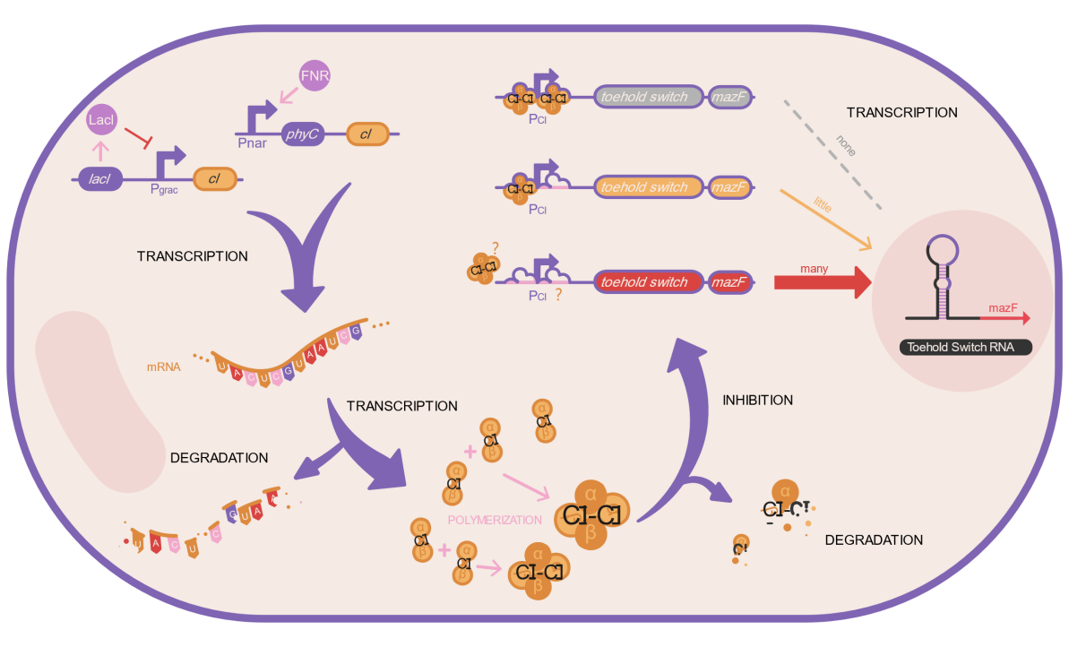

Fig.6.1．Production and Inhibition Effect of CI Protein

The CI protein, Toehold Switch and Trigger RNA expression can be simply translated into the following biochemical reactions,

$${DNA}_{C1}\underset{→}{K_{mRNA-C1}} {mRNA}_{C1}$$

$${mRNA}_{C1}\underset{→}{K_{C1}} C1$$

$${mRNA}_{C1}\underset{→}{K_{mRNA-C1}}∅$$

$$C1\underset{→}{d_{C1}}∅$$

$${DNA}_{TR}\underset{→}{K_{TR}} Trigger RNA$$

$$Trigger RNA\underset{→}{d_{TR}}∅$$

$${DNA}_{TS}\underset{→}{K_{TS}} Tohold Switch$$

$$Tohold Switch\underset{→}{d_{TS}}∅$$

#### 6.1.1 CⅠ Protein Production

Here, we use a differential equation to represent the concentration of each substance. The concentration of ${mRNA}_{CI}$ can be expressed as follows:

$$\frac{d[{mRNA}_{C1}]}{dt}= V_{mRNA-C1}- [{mRNA}_{C1}]d_{mRNA-C1}$$

Where, $d_{mRNA-C1}$ (*0.1386 $\min^{-1}$*) is the degradation rate of ${mRNA}_{C1}$ and $V_{mRNA-C1}$ is the generation rate of ${mRNA}_{C1}$, which can be expressed as follows:

$$V_{mRNA-CI}= K_{mRNA-CI} [G_{CI}]$$

Where, $K_{mRNA-CI}$ is the transcription rate, and $K_{mRNA-C1}=5.39 \min^{-1}$. $[G_{C1}]$ is the copy number of plasmids.

Here's what follows:

$$\frac{d[C1]}{dt}= V_{C1}- \left[CI-1\right]d_{Ci-1}- \left[CI-2\right]d_{CI-2}$$

Here, $d_{CI-1}$ is the laboratory-induced degradation rate of CI protein, $d_{CI-2}$ is the degradation rate of CI protein produced by earthworm intestines, both of which can be adjusted, and $V_{C1}$ is the production rate:

$V_{C1}= K_{CI-2} [{mRNA}_{CI-2}]$

$K_{CI-2}$ $=4.84 \min^{-1}$ is the translation rate of CIgenerated in intestine, which could be changed by adjusting RBS. The total amount of CI in intestine was shown in **<b>Figure 6.1.1**.</b>

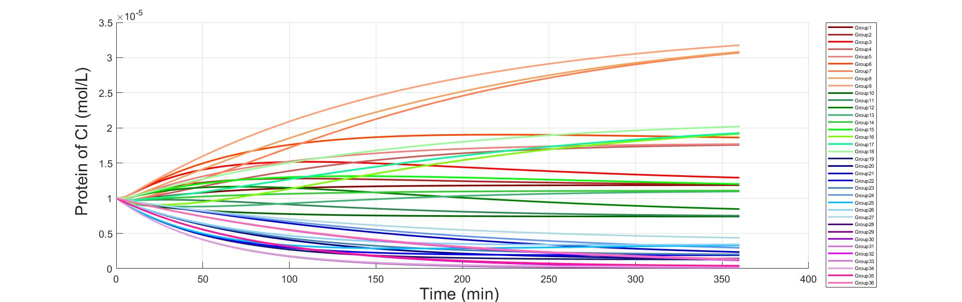

Fig.6.1.1. The Total Amount of CI in Intestine

#### 6.1.2 Trigger RNA Production

Similarly, the concentration of Trigger RNA in the intestine can be calculated:

$$\frac{d[TR]}{dt}= V_{TR}- [TR]d_{TR}$$

Where $d_{TR}$ is constant, $d_{TR}=0.365\min^{-1}$ and $V_{TR}$ is generation rate of ${mRNA}_{TR }$, given by the following formula:

$$V_{TR}= K_{TR} [G_{TR}]$$

$K_{TR}=19.12 \min^{-1}$, $\left[G_{TR}\right]=500$. is the copy number of plasmids.

The amount of Trigger RNA in the intestine is shown in **Figure 6.1.2**.

#### 6.1.3 Toehold Switch Production

In order to solve the concentration problem of Toehold Switch, we also assumed:

$$\frac{d[TS]}{dt}= V_{TS}- [{mRNA}_{TS}]d_{TS}$$

Where $d_{TS}$ is constant, $d_{TS}=0.18\min^{-1}$ and $V_{TS}$ is generation rate of Toehold Switch，given by the following formula:

$$V_{TS}= K_{TS} ε_{1}[G_{TS}]$$

$K_{TS}=2.52 \min^{-1}$, $\left[G_{TS}\right]=500$. $ε_{1}$ indicates the binding of CI and inhibition sites, which can be expressed as follows:

$$ε_{1}=\left(\frac{[O_{C1-1f}]}{[O_{C1-1}]}\right)\left(\frac{[O_{C1-2f}]}{[O_{C1-2}]}\right)$$

The amount of Toehold Switch in intestine was shown in **Figure 6.1.3**.

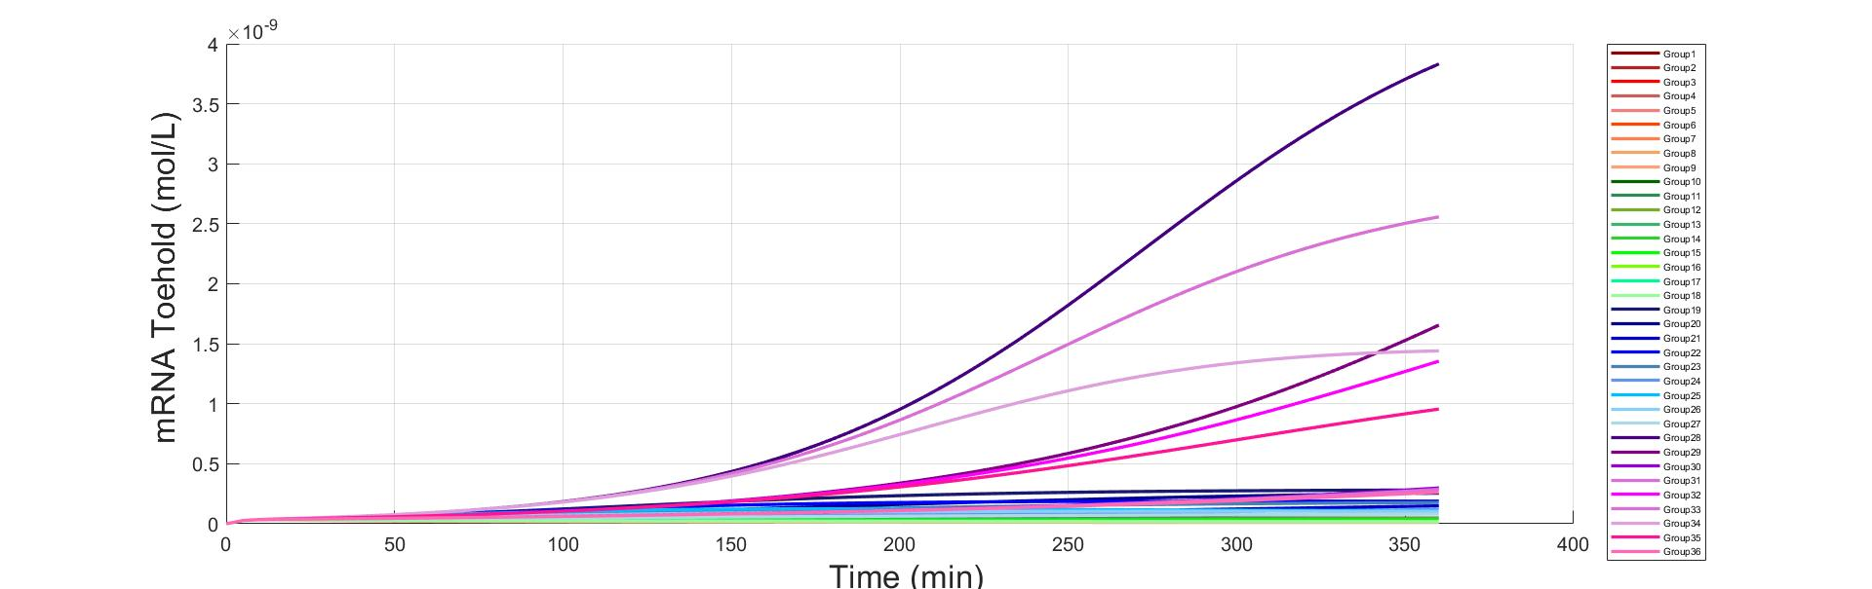

Fig.6.1.3. The Amount of Toehold Switch In Intestine

#### 6.1.4 MazF Production

The expression of MazF in the intestine of earthworm can be easily described in <b>**Figure 6.1.4**.1.</b>

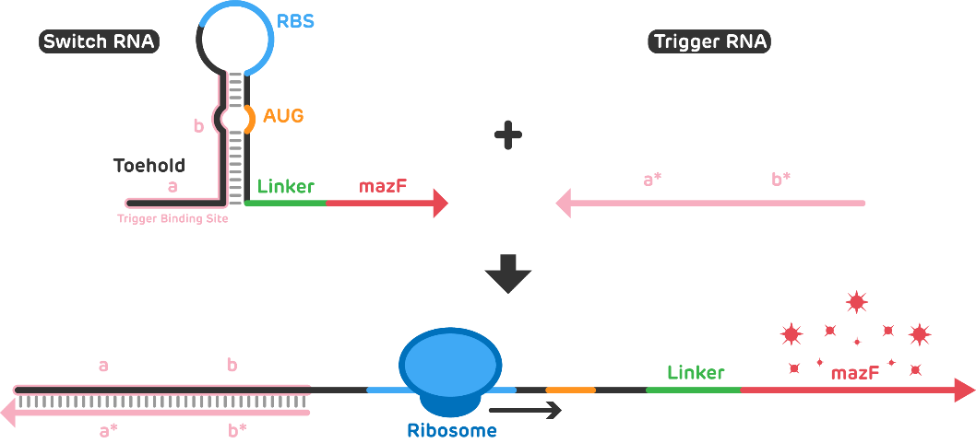

Fig.6.1.4.1. The Production of MazF

The specific process of generating MazF is represented by the following formula,

$$\left[trRNA\right]+\left[tsRNA\right]⇌[tr.tsRNA]$$

$\left[tr.tsRNA\right]\underset{→}{K_{tr.ts}}[mazF$]

Among them, $K_{tr.ts}$ is the translation rate of generating MazF. The reaction equilibrium constant is described as follows,

$$K_{1}=\frac{[tr.tsRNA]}{\left[trRNA\right]·\left[tsRNA\right]}$$

The total amount of Trigger RNA and Toehold Switch are shown as follows,

$\left[T_{tr}\right]=$ $\left[trRNA\right]+$ $[tr.tsRNA]$

$\left[T_{ts}\right]=$ $\left[tsRNA\right]+$ $[tr.tsRNA]$

The amount of MazF in intestine was shown in **Figure 6.1.4.2.**

### 6.2 Out the Intestine

After the engineered bacteria were expelled out of the intestine, Trigger RNA and CI protein no longer produced and were always degraded. Toehold Switch was produced in the same way as in the intestine. And with the gradual degradation of CI, Trigger RNA and Toehold Switch would combine to produce MazF. The expression of CI protein, Trigger RNA , Toehold Switch and MazF were obtained by applying differential equations above, as shown below.

Fig. 6.2.1．The Total Amount of CI out of Intestine

Fig.6.2.2. The Amount of Trigger RNA out of the Intestine

Fig.6.2.3. The Amount of Toehold Switch out of Intestine

Fig.6.2.4．The Amount of MazF out of Intestine

## 7 Results & Analysis

MazF directly determined whether the engineered bacteria will commit suicide or not. In order to ensure the kill switch to work, we analyzed the concentration of MazF under different combinations in and out of the intestine **Figure 7.1**.

Fig.7.1. MazF Under Different Combinations in and out of the Intestine

We found that under the threshold set by us, only three combinations can meet the requirement of MazF generated in earthworm intestines less than the threshold of suicide, and far less than MazF generated out of intestine. In addition, MazF generated out of intestine is higher than the threshold, which can make the engineered bacteria commit suicide.

Considering the simplicity of the pathway design, we hope to add the same degradation tag for CI-1 and CI-2. Therefore, our choice was: Under this combination, the quantities of various substances are shown in **Figure 7.2**.

Fig.7.2. Various Substances Concentration

## 8 Sensitivity Analysis

In fact, data related to promoter strength is difficult to obtain, and the influence of promoter strength on CI is difficult to determine. Therefore, sensitivity analysis was performed on promoter strength, as shown in <b>**Figure 8.1**.</b>

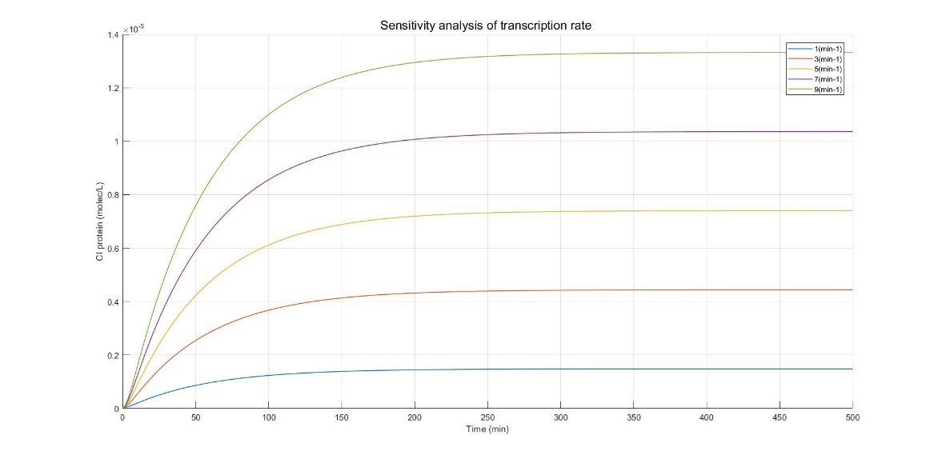

Fig.8.1. After simulating each

The engineered bacteria were induced to produce CI proteins by IPTG in the laboratory. we had selected the concentration of IPTG that could produce the most CI proteins to inhibit the production of Toehold Switch. And in order to explore the influence of CI-1 concentration on the subsequent generation of CI-2 concentration, we conducted a sensitivity analysis on the CI protein concentration of engineered bacteria when they entered the earthworm intestine, as shown in **Figure 8.2.**

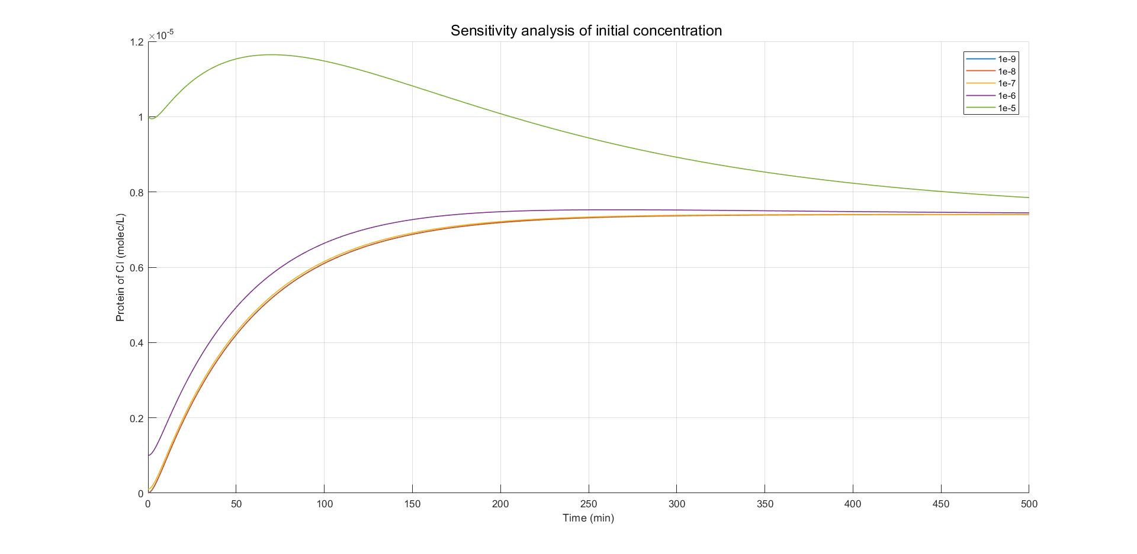

Fig.8.2. Sensitivity Analysis of Initial Concentration.

## Reference

1. Zheng Y , Sriram G . Mathematical Modeling: Bridging the Gap between Concept and Realization in Synthetic Biology[J]. Journal of Biomedicine and Biotechnology, 2010, 2010(1110-7243):541609.
2. Luan Ming Moon. Efficient expression of Glutamate decarboxylase by RBS sequence and promoter strategy. Kangnam University, 2018:3-5.
3. Andersen JB, Sternberg C, Poulsen LK, Bjorn SP, Givskov M, Molin S. New unstable variants of green fluorescent protein for studies of transient gene expression in bacteria. Appl Environ Microbiol. 1998 Jun;64(6):2240-6.
4. KIM, J. G.; TAKEDA, Y.; MATTHEWS, B. W.; ANDERSON, W. F. Kinetic studies on Cro repressor-operator DNA interaction. J Mol Biol, 196, n. 1, p. 149-158, Jul 1987