RE
- re.compile(pattern, flag=0)方法
Compile a regular expression pattern into a regular expression object, which can be used for matching using its match(), search() and other methods
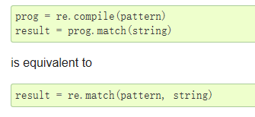

- re.search(pattern, string, flag=0)方法
Scan through string looking for the first location where the regular expression pattern produces a match, and return a corresponding match object. Return None if no position in the string matches the pattern;

- re.match(pattern, string, flag=0)方法
If zero or more characters at the beginning of string match the regular expression pattern, return a corresponding match object. Return None if the string does not match the pattern;
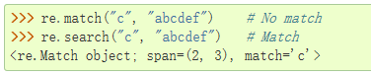
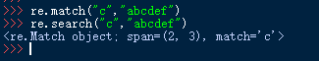
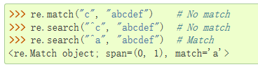
Note that even in MULTILINE mode, re.match() will only match at the beginning of the string and not at the beginning of each line.If you want to locate a match anywhere in string, use search() instead
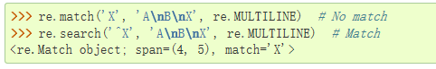

- re.fullmatch(pattern, string, flag=0)方法
If the whole string matches the regular expression pattern, return a corresponding match object. Return None if the string does not match the pattern;

- re.split(pattern, string, maxsplit=0, flags=0)方法
Split string by the occurrences of pattern. If capturing parentheses are used in pattern, then the text of all groups in the pattern are also returned as part of the resulting list. If maxsplit is nonzero, at most maxsplit splits occur, and the remainder of the string is returned as the final element of the list.

