1. Normal Sinus Rhythm (NSR)

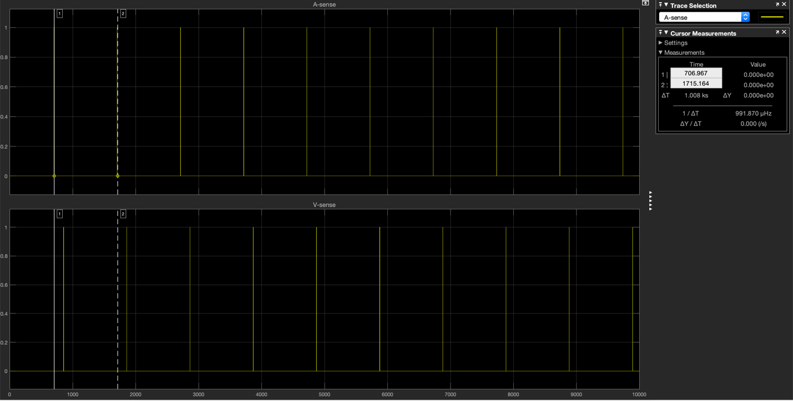

2. Sinus Bradycardia

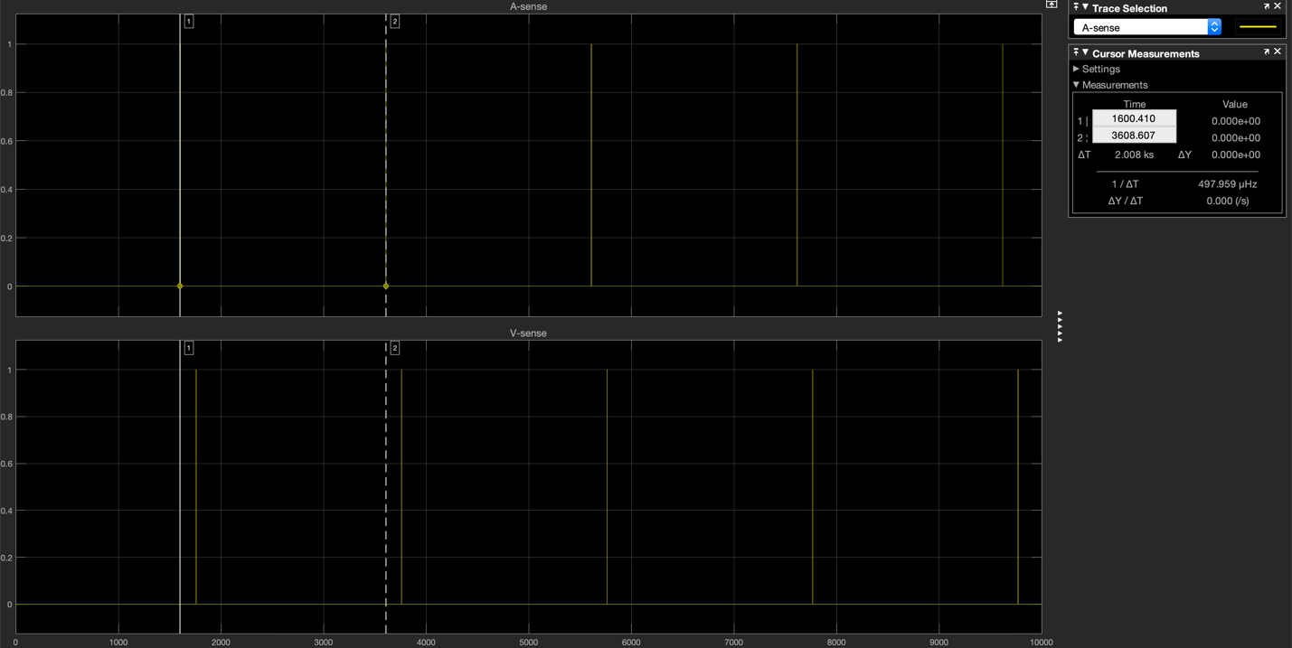

3. Sinus Tachycardia

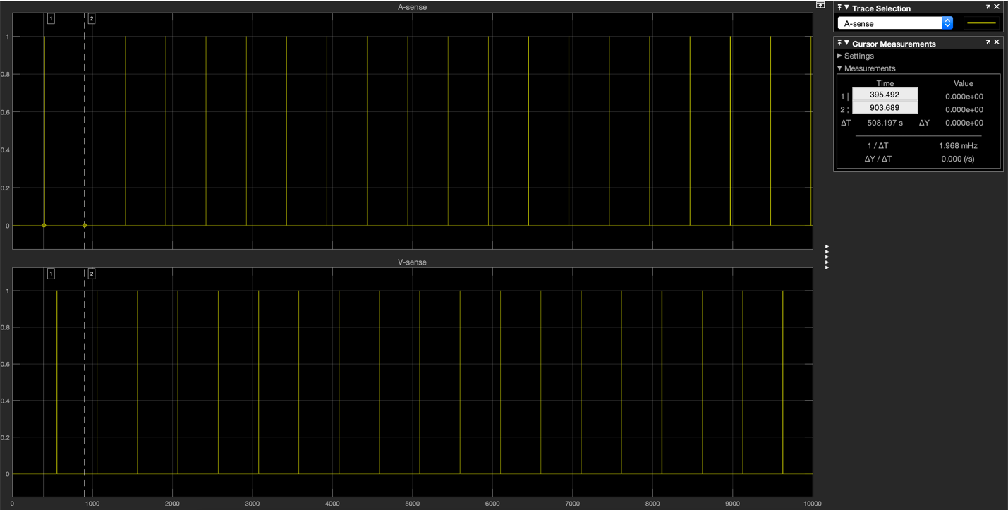

4. AV Block

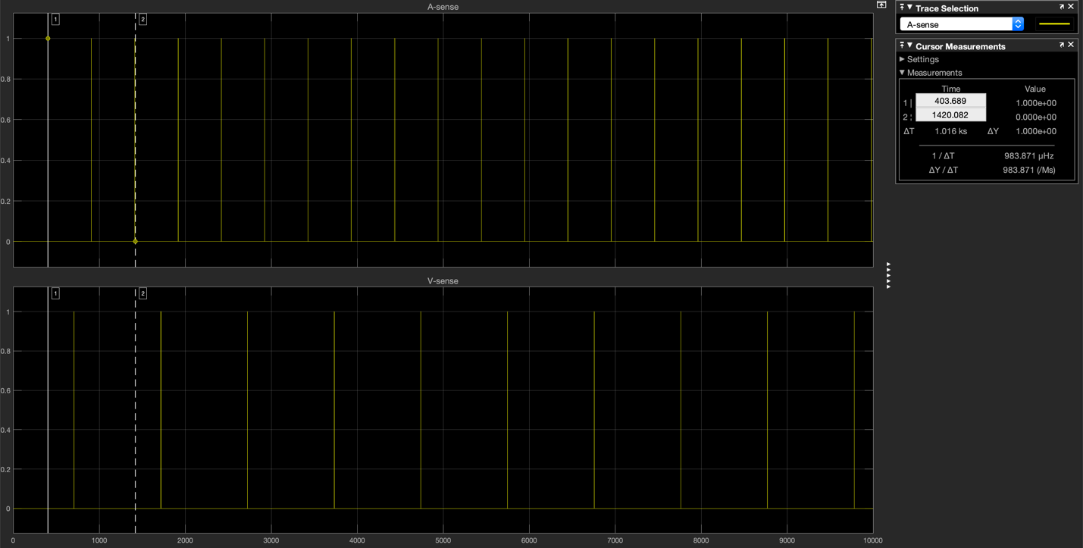

5. AV delay

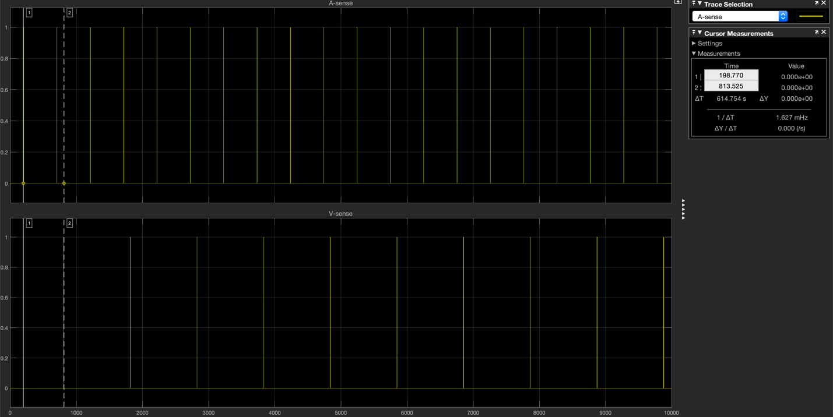

When should the chart enter the Dwell location? When should it move on to location temp?

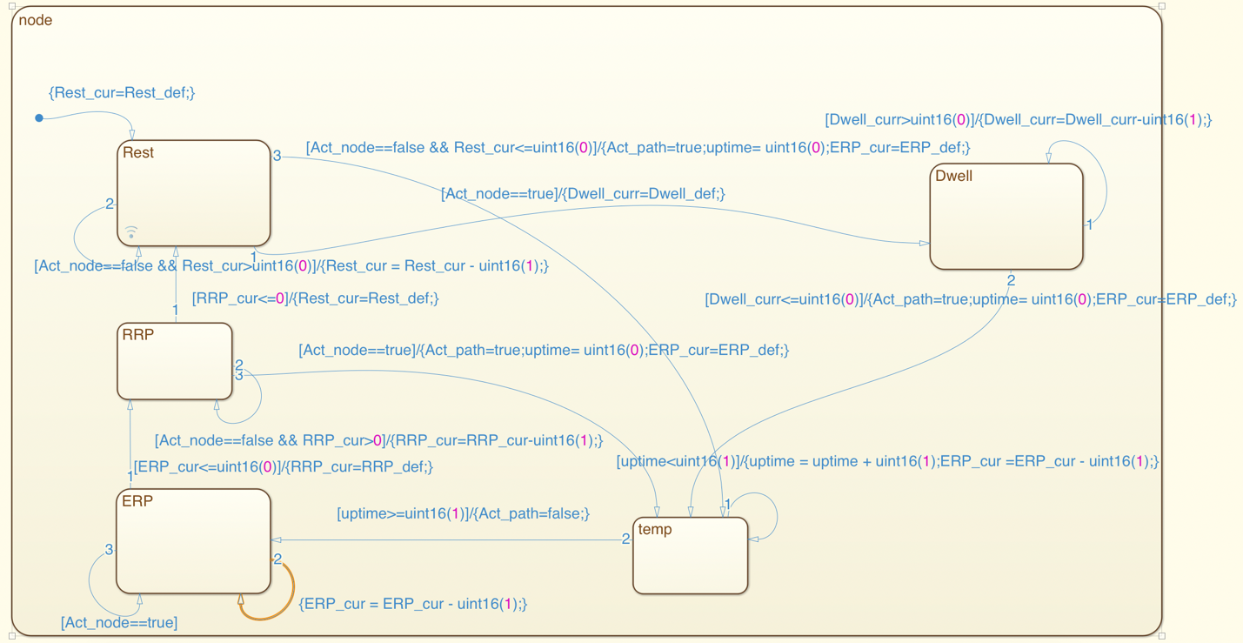

It should enter the Dwell location when Act_node is detected. When Dwell_curr counts down from Dwell_def to 0, it should move on to location temp.

6. Premature Ventricular Complex

With PVC, we can see the affected A senses. Between channel 1 and channel 2, we can see the A event propagated from the PVC.

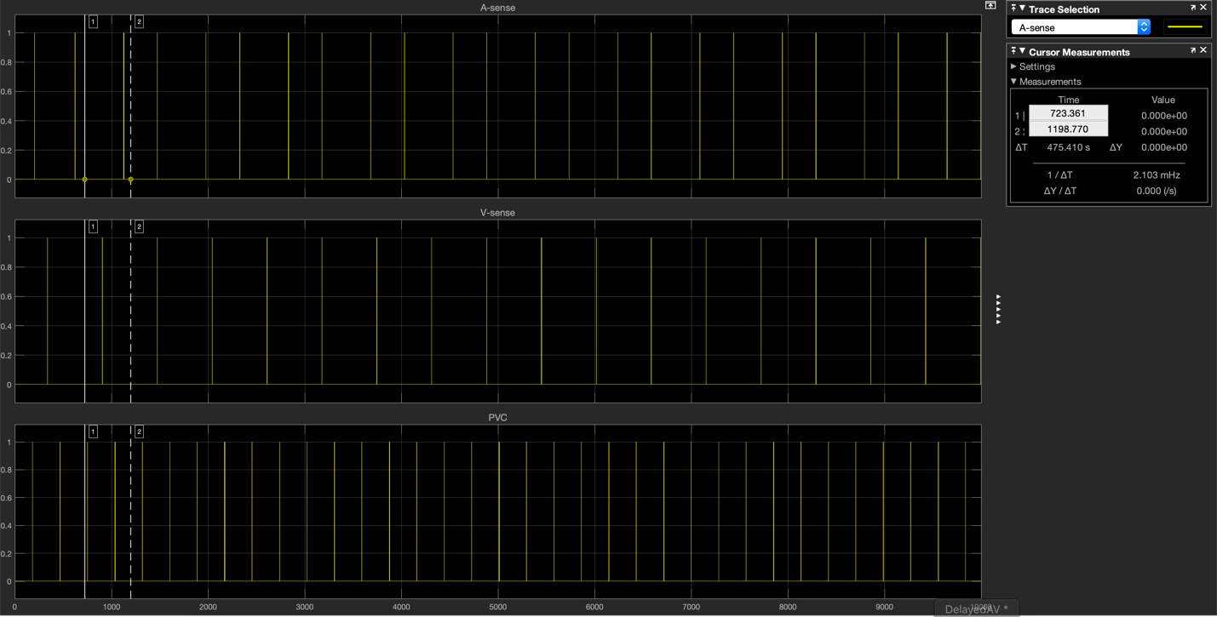

What should the Rest_def of PVCNode be set to, to guarantee that we observe a V event that propagates back up to the atria?

Rest_def of PVCNode should be set to a value that let a fire from PCVNode avoid the ERP period of the AVNode and the Atrium node.

1. Observe VVI pacemaker

Do you see the PM pacing? Why, or why not?

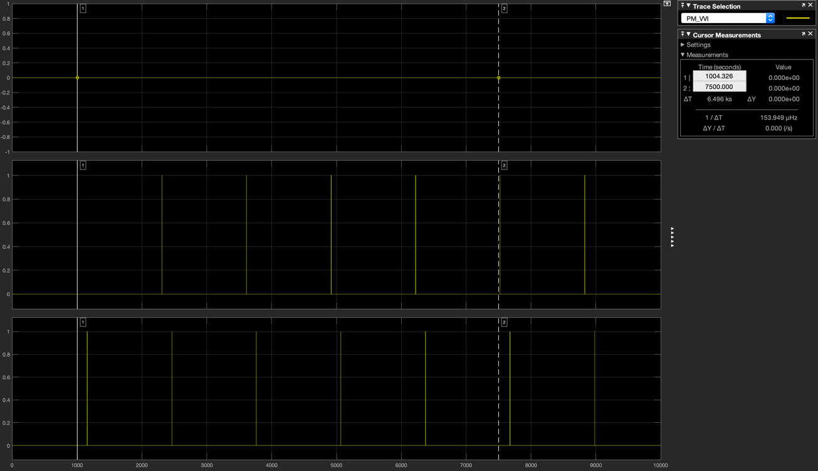

From the screenshot of the scope, PM is not pacing.

The uppermost scope view represents PM pacing. It is constantly 0. So, PM is not pacing.

Explain how the LRI_def value of 1300 prevents any pacing.

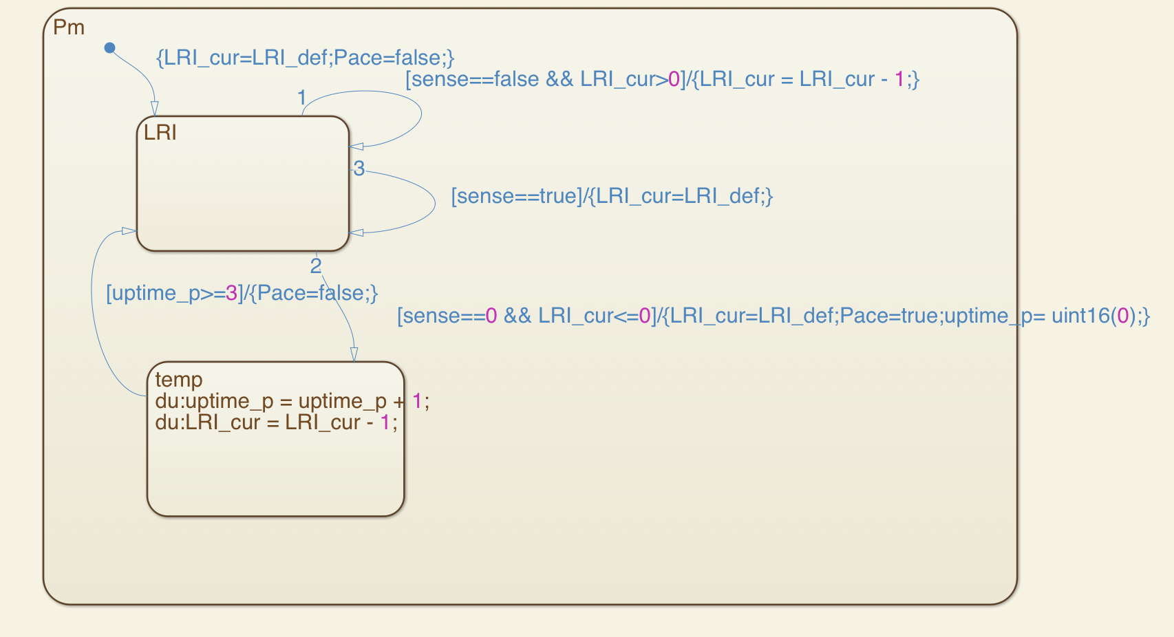

For PM to pace, LRI_def should be smaller than the V-sense period. Or LRI_cur will always be set to the default LRI_def value when it counts down because it will receive a V even while it’s counting down. Since V sense period is the same as the atrium period, and 1300 is the same as the atrium period, so it will not pace.

2. Debugging the VVI

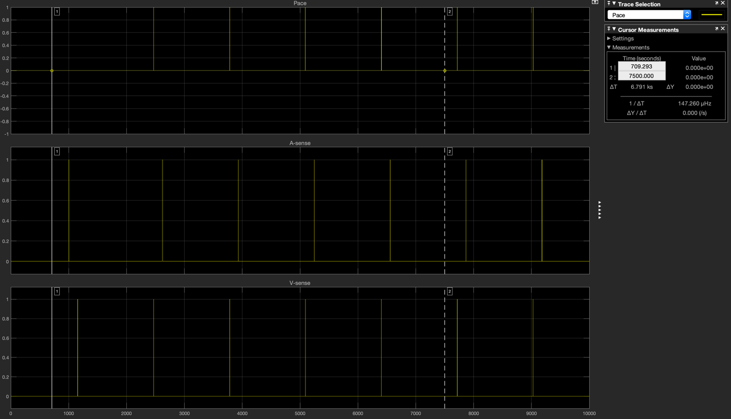

The PM will pace because 1310ms is shorter than 1800ms. The period for V sense is 1800ms.The PM will pace when it doesn’t receive a V event after 1310 count-down.

We need to set LRI_def to be larger than 1800 to make the PM not pace. The screen shot below is for LRI_def equal to 1810.

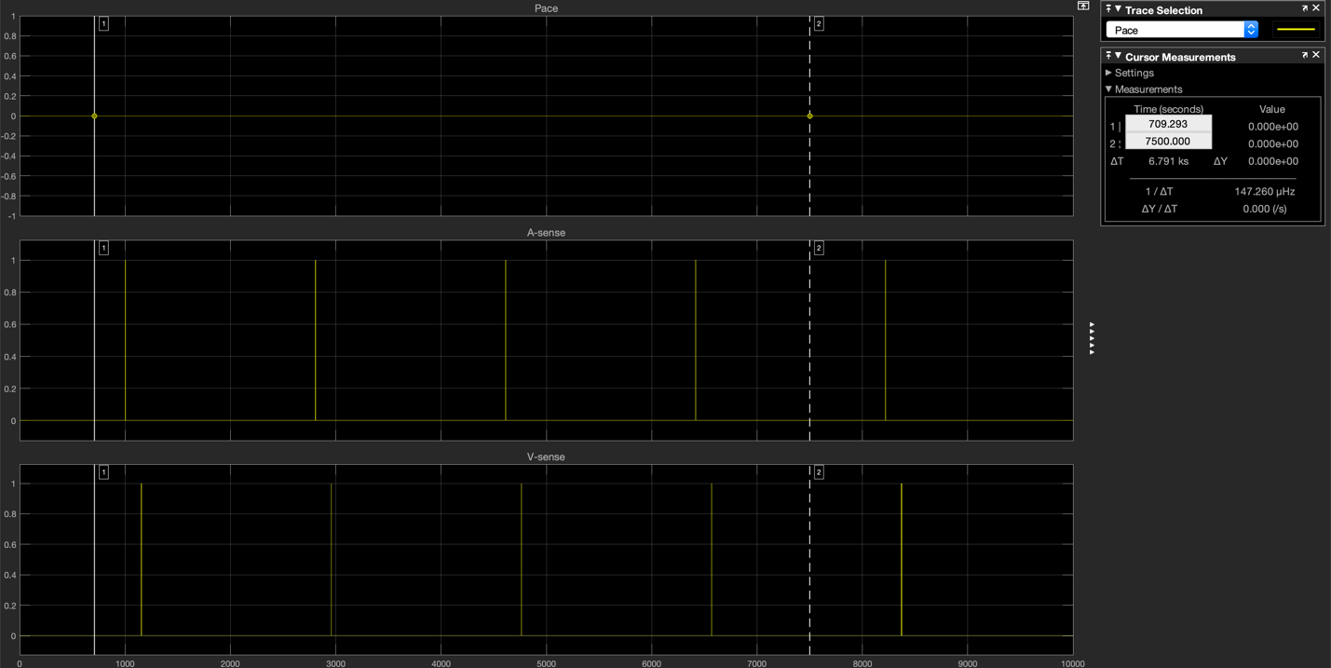

3. Maintaining the minimum heart rate

Where should you connect Asense and Vsenseports?  
Where should you connect Apace and Vpace ports, and how?

As below.

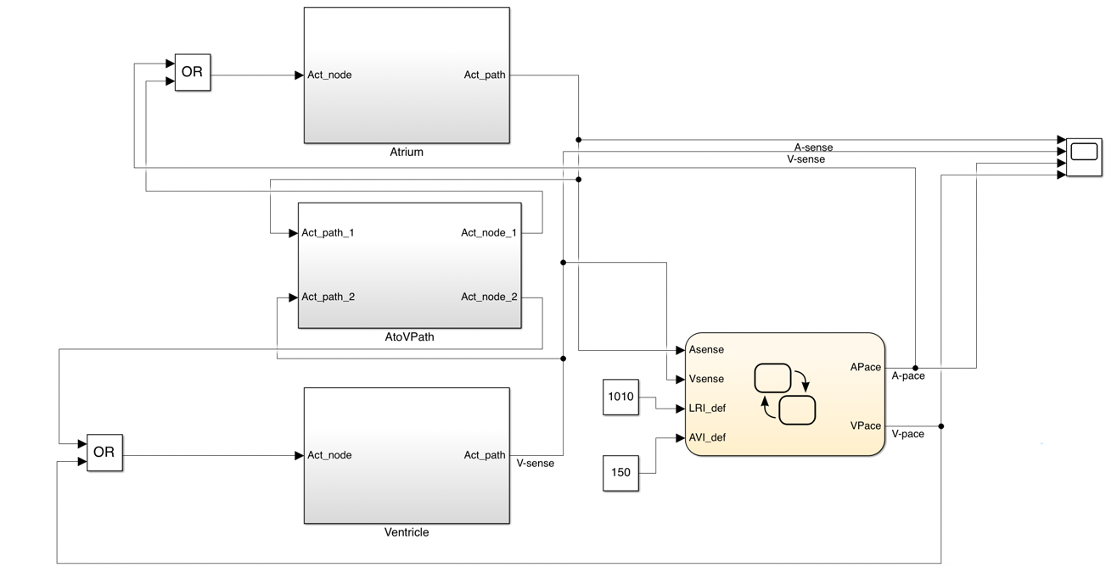  
What should you set the LRI_def to so a heart rate of about 60bpm is maintained?

Set LRI_def to be larger than 1000ms which is the period of Asense to make sure there is not Apace.  
What should you set AVI_def to?

Set AVI_def to 150 to ensure a 150ms delay instead of 500ms. So AVI_def should be set to be the maximum delay between A event and V event to avoid excessive delay.

The scope result is as below.

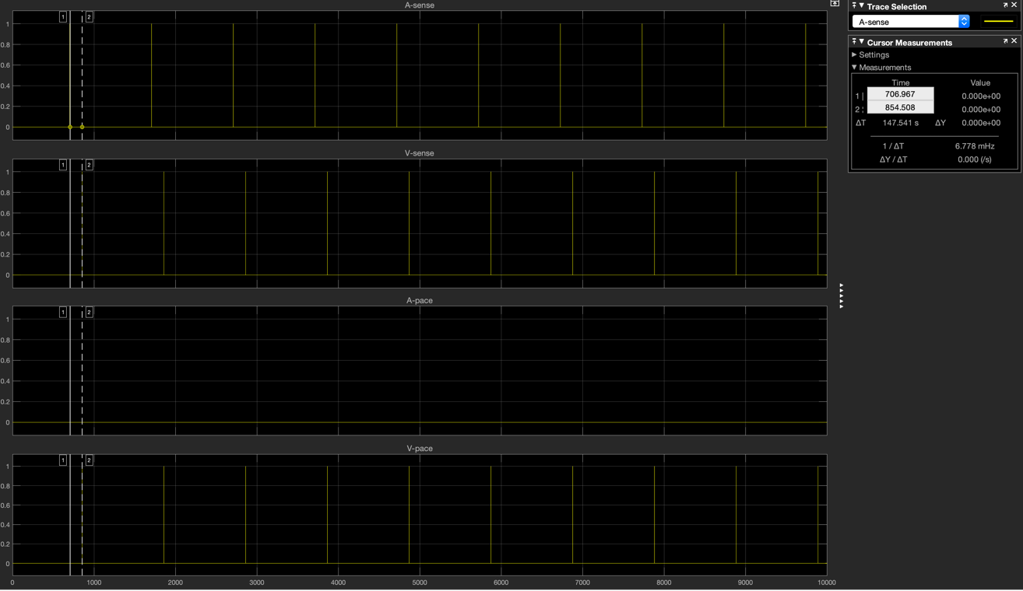

4. Getting familiar with the pacemaker

a. Adjust the heart model parameters

i. I changed the conduction delay from 500ms to 140ms.

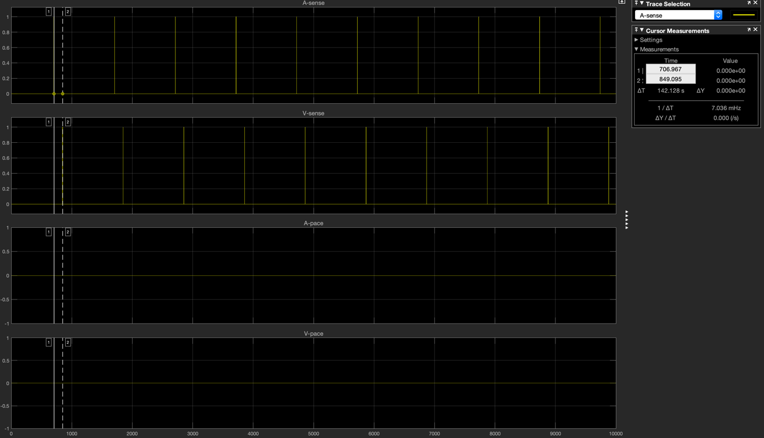

ii. I changed the conduction delay to 160ms.

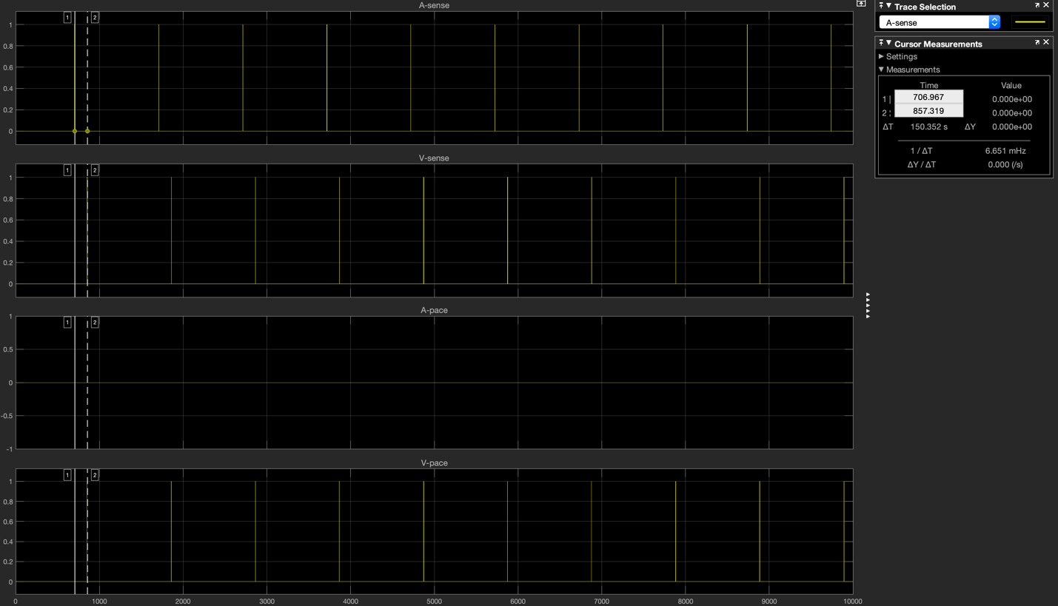

iii. I changed the conduction delay to 140ms and the ERP_def for the atrium to 400ms. The Rest_def for the atrium stays 700ms.

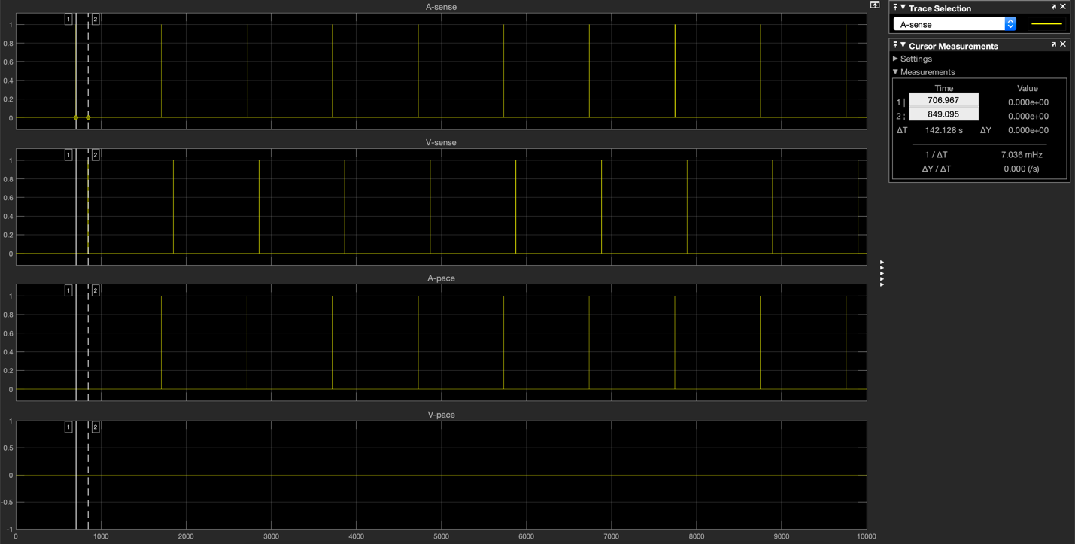

iv. I changed the conduction delay from 500ms to 160ms and the ERP_def for the atrium to 400ms. The Rest_def for the atrium stays 700ms.

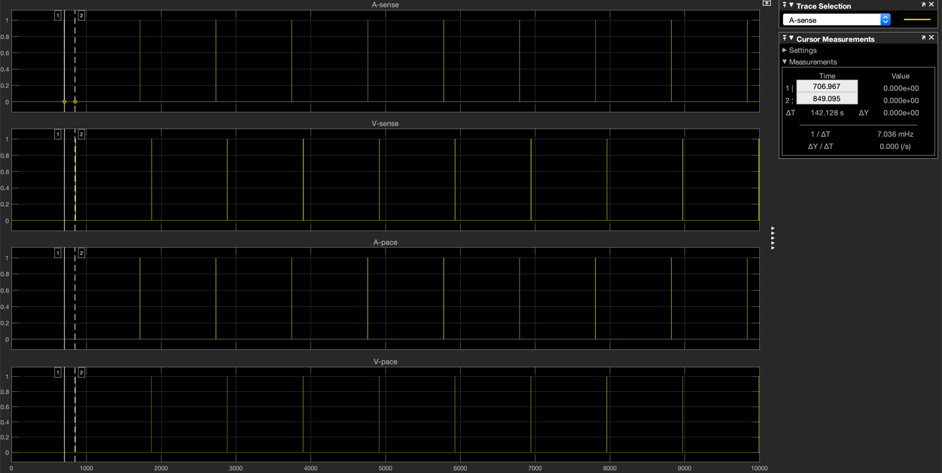

b. They correspond to (1) normal sinus rhythm, (2) excessive AVNode delay, (3) bradycardia, (4) both brady cardia and excessive AVNode dealy respectively.

5. What is the set of values of LRI_def and AV_def that produces each of the above observations?

Let Atrium’s rest period be Ar, Atrium’s ERP period be Ae, conduction delay be cd

(1) LRI_def > Ar + Ae AV_def > cd

(2) LRI_def > Ar + Ae AV_def < cd

(3) LRI_def < Ar AV_def > cd

(4) LRI_def < Ar AV_def < cd