HW2

110550085房天越

1. ER diagram with entity sets and relationship sets, with or without attributes. Add constraints if needed. (30pts) (if it is hard to include your ER diagram in the .pdf file, you can submit the diagram separately)

Ans:

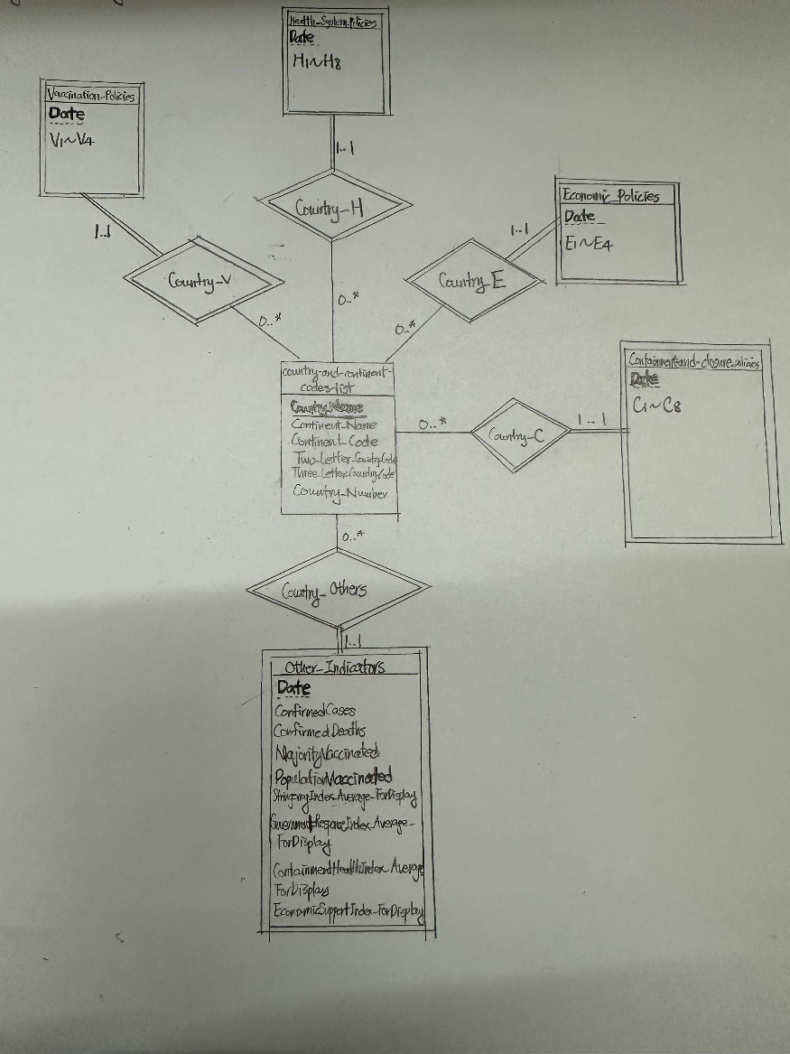

1. Provide print screens of the 1) AWS RDS lunch page, and 2) the way you connect to the AWS RDS (PostgreSQL console tool, pgAdmin, or other IDE’s connection page, with the same IP or URL with your AWS RDS) (10pts)

Ans:

1)

2)

Following the steps given.

1. I first open “Server…”.

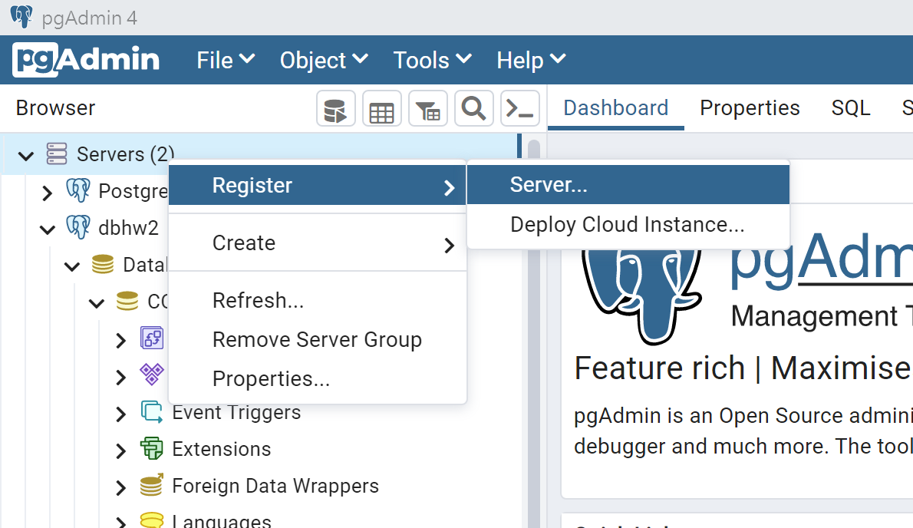

1. Then insert the IP and password.

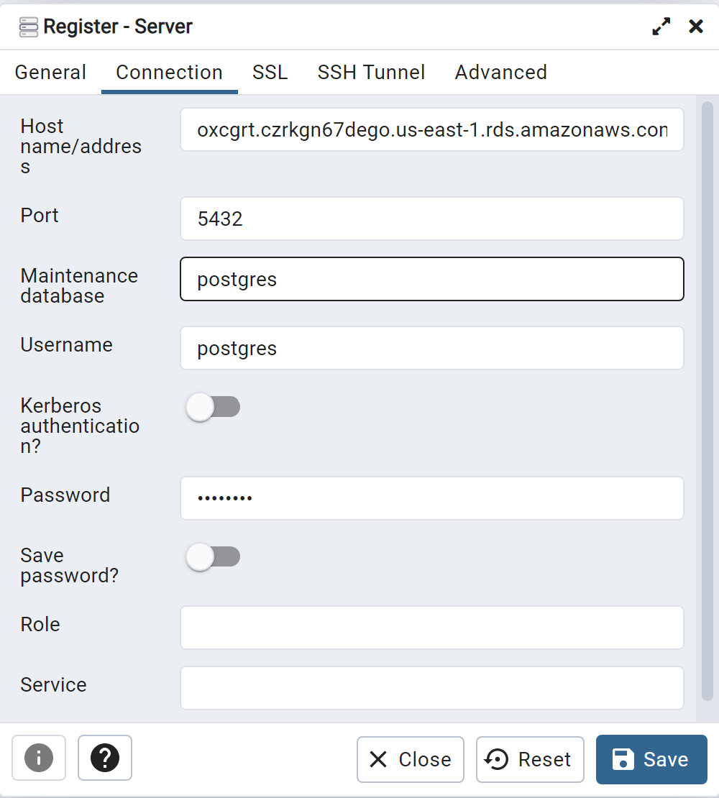

1. Then we can see that it is connected to my advice.

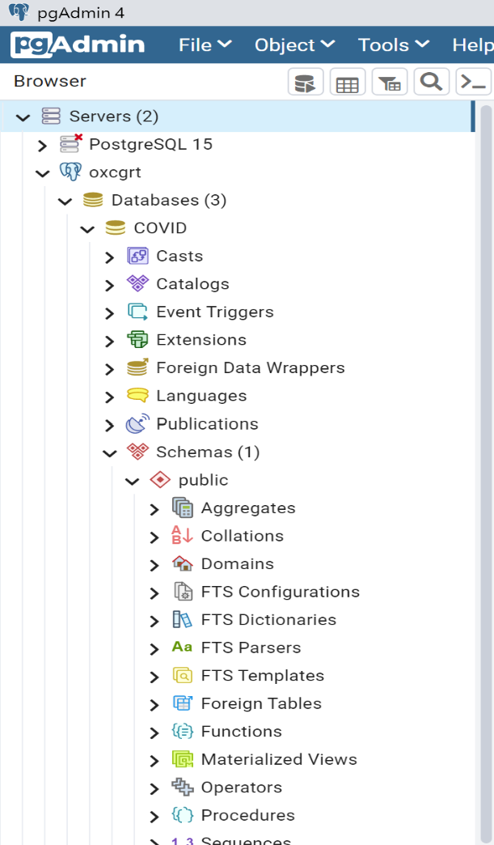

1. Please provide the schema after decomposition, of each table, and a print screen to show that the tables have been created in your database on AWS RDS. (10+10pts)

Ans:

Schemas:

Country_and_Continent_list:

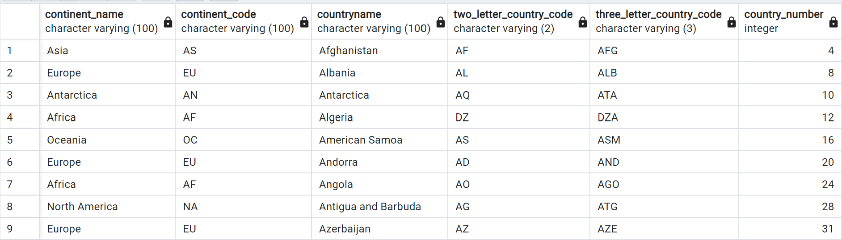

Country_C(there are still some columns of C as drew in the ER diagram):

Country_E:

Country_V(there are still some columns of V as drew in the ER diagram):

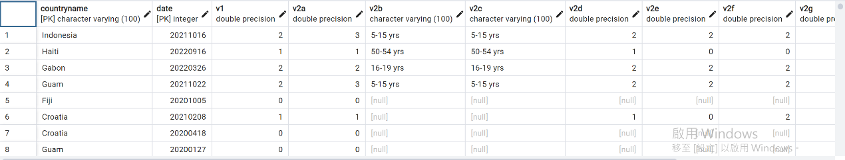

Country_H:

Country_Others:

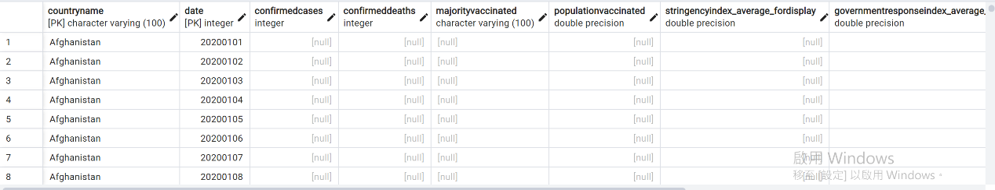

Then below is the picture to show that these tables are on oxcgrt in AWS:

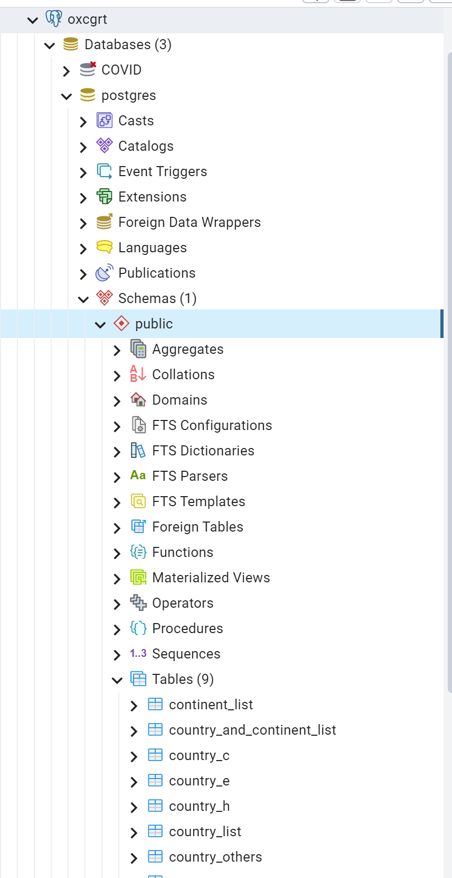



(Country_V is below the first picture, but it is obvious that it is there, screenshot cannot include all the tables.)

1. Clearly indicate the level of normal form, test the level of normal form for each table (10pts)

Ans:

First, the tables are in 1NF since all the attributes are single valued, not divisible and are in the same type.

Then, the tables are in 2NF since they are in 1NF, and all the columns other than primary keys are fully dependent on primary keys, they are thus in 2NF.

Third, they are in 3NF, because there are no transitive dependencies, since they are all only depend on primary keys, which means that there are no columns that can be determined by other columns other than primary keys.

Thus, these tables are in 3NF, even though they look ugly.

1. List the functional dependency of each table. (10pts)

Ans:

Country_and_Continent_list:

CountryName->Two_Letter_Country_Code

CountryName->Three_Letter_Country_Code

CountryName->Country_Number

CountryName->Continent_Name

CountryName->Continent_Code

Country_C:

(CountryName, Date)->C1~C8

Country_E:

(CountryName, Date)->E1~E4

Country_V:

(CountryName, Date)->V1~V8

Country_H:

(CountryName, Date)->H1~H4

Country_Others:

(CountryName, Date)->Those data

(The specific names of “Those data” are in the ER diagram.)

1. The SQL statements (in .sql file) and output results of 4a (10pts)

Ans:

1. The SQL statements (in .sql file) and output results of 4b (10pts)

Ans:

Too difficult, and it is now 12/8 23:45.

I am really sorry.

1. Database auto-update (from the data provider’s GitHub repo) strategy and implementation (bonus 20pts)

Ans:

The time is not enough, I am sorry.